Comparison of Bench-Scale and Manikin Tests 49
of Protective Clothing Systems During Low-Level Radiation
Ming Fu, Wenguo Weng, Jie Yang, and Qian Zhang
Abstract
A bench-scale apparatus producing the liquid droplets and a sweating manikin were used to study the heat and moisture transfer through the multilayer protective clothing system during the low-level radiation of 2.5 kW/m². The results show the cooling effect of the absorbed liquid transfer and the heating effect of condensation at the bench-scale test. In addition, the wicking effect from sweating water with the stored thermal energy influences the heat transfer of the clothing system during the exposure and cooldown periods at the manikin test. Although the comparison of the bench- and full-scale tests with some differences during the moisture condition, both methods can be used to investigate heat and moisture transfer through protective ensemble exposed to and after ending the low-level thermal radiation.
Keywords
Protective clothing Thermal protective performance Thermal radiation Manikin
Bench-scale test

49.1 Introduction  Thermal protective clothing is designed to protect firefighters during firefighting or exposed to other thermal radiation. Heat from the fire or thermal radiation and moisture from the perspiration can be transferred within the clothing, through the solid fabric layer and gaseous air [1].  The exposure conditions of firefighters have been classified as emergency, routine, and hazardous conditions by the different levels of air temperature and radiant flux. Skin burn | injuries most frequently occur when firefighters are exposed to routine and hazardous conditions, with low-level thermal radiation less than 12 kW/m² [2].  There are few studies on the comparison of the manikin and bench-scale tests to study the effect of multiple air gaps on the protective performance of protective clothing [3, 4]. Lee et al. [3] compared thermal performance of a single-layer clothing with the manikin test and the benchscale test during flash fire exposure. It was shown that the bench-scale test could predict the full-scale manikin test if the air gap distribution was measured. Many burn injuries

could occur under lower thermal exposure than under flash fire exposure [5]. A bench-scale test and a full-scale manikin test were conducted by Stroup et al. [4], to evaluate the thermal performance of firefighter protective clothing exposed to low-level heat flux. The differences of the fabric layers between the two scale tests indicated that the air gaps had great influence on the heat transmission through the protective clothing. However, those two studies were studied at the dry test and did not consider the moisture transfer within the clothing. The effect of air gap was affected by the
M. Fu (*)
Hefei Institute for Public Safety Research, Tsinghua University, Hefei Anhui Province 230601, China e-mail: fm10@mails.tsinghua.edu.cn
W. Weng J. Yang
Department of Engineering Physics, Institute of Public Safety
Research, Tsinghua University, Beijing 100084, China
Q. Zhang
Kunming Firefighting Command School, Yunnan Kunming 652028, China
# Springer Science+Business Media Singapore 2017
- K. Harada et al. (eds.), Fire Science and Technology 2015, DOI 10.1007/978-981-10-0376-9_49
- M. Fu et al.

cooling effect between the skin and the wet fabric [6] and moisture content in the fabric layers [7].
The objective of this study is to compare the heat and moisture transfer within the clothing system between the bench-scale and manikin tests during low-level radiation. The research findings might provide comprehensive understanding on the thermal performance of protective clothing exposed to low-level radiation. It can also provide some useful information on the correlation of bench-scale and manikin tests of clothing systems, giving guidance to the test methods of protective clothing.

49.2 Experimental
Details of the testing methods and experimental setup on the bench-scale and manikin tests have been reported previously [8, 9]. They are briefly described here.

49.2.1 Bench-Scale Test
A bench-scale test apparatus was constructed and used to investigate the thermal protective performance of multilayer fabric systems under the moisture test [8]. The apparatus consisted of a cone calorimeter radiating the low-level heat, vertically downward of 25 mm to a 10 cm 10 cm fabric sample, seen in Fig. 49.1. A removable radiation shield was
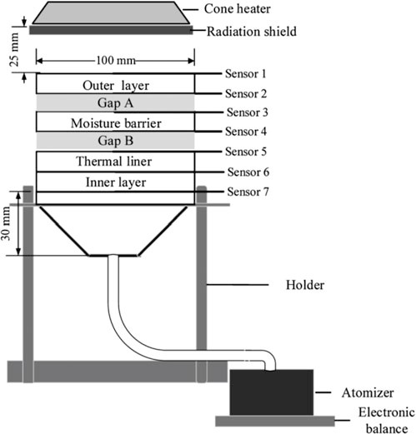
positioned between the cone heater and the clothing system, to provide the desired exposure time on the fabric sample.
An atomizer with a heater was used to produce liquid droplets with a constant temperature of 35 C. The diameters of the liquid droplets were less than 14 μm; therefore, the atomized liquid droplets can be assumed to simulate human perspiration transferring from the skin to the fabric sample [8]. Metal spacers with different thicknesses were used to design different air gap sizes between the outer shell and moisture barrier (Gap A) and/or the moisture barrier and thermal liner (Gap B) [5].
A four-layer clothing system was used including the outer shell, moisture barrier, thermal liner, and inner layer. The Nomex-based fabrics used in each layer and their properties are shown in Table 49.1 [8].

49.2.2 Manikin Test
The thermal manikin is commonly used to measure the thermal insulation and evaluate the thermal performance provided by a full-scale protective clothing [6]. In this study, a sweating thermal manikin “Newton” (MTNW, USA) was used in a chamber, seen in Fig. 49.2 [9]. A close-fitting cotton layer was put on the manikin surface to provide a sweating skin layer. Infrared silicon carbide radiant plates were used to produce the thermal radiation. The manikin could be moved relative to the radiant plates for a

Fig. 49.1 Schematic diagram of the bench-scale test [8]

desired heat flux level. A radiation shield was placed in front of the radiant plates, to provide the desired exposure time on the protective clothing.
A kind of the full-scale clothing system with the four fabric layers was made from the same composite materials as those of the bench-scale tests. The testing garment in size 40 (provided by the manufacturers) was of appropriate size for the manikin. The clothing consisted of an upper outer garment and pants. It also had inside zippers and snap fasteners for closure. The value of thermal insulation was
2.4 clo [9].

49.2.3 Protocol
The air gap distribution within the single clothing layer was determined from the 3D scans of the nude and dressed manikin [1, 10, 11]. The air gap thickness in tight-fitting clothing was almost constant, in the range of 6–9 mm [10]. The mean gap sizes for the chest, stomach, shoulders, and back are near 9, 5, 0, and 5 mm, respectively [11]. In order to compare heat and moisture transfer with the manikin zones, the bench-scale tests with the Gap A of 0, 5, and 9 mm at the moisture condition were used. The thickness of the Gap B was 0 mm.
49 Comparison of Bench-Scale and Manikin Tests of Protective Clothing Systems During Low-Level Radiation 487
Table 49.1 Materials used for each fabric layer [8]
Layer | Component | Weave type | Weight (g/m²) | Thickness (mm)
Outer shell | 93 % Nomex, 5 % Kevlar, 2 % P140 | Twill | 200 | 0.44
Moisture barrier | 50 % Nomex, 50 % Kevlar | Water thorn felt with PTFE | 105 | 0.62
Thermal liner | Nomex | Needling nonwoven | 85 | 0.60
Inner layer | 50 % Nomex, 50 % FR-VISCOS | Plain weave | 120 | 0.31

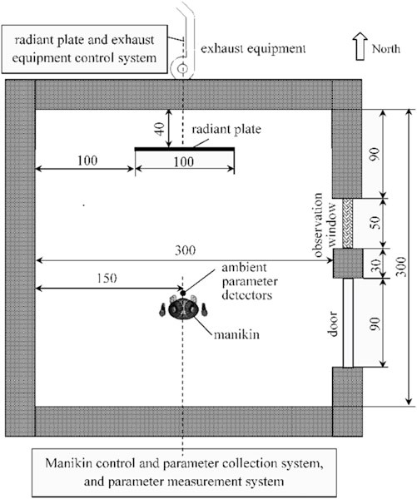
Fig. 49.2 Schematic diagram of the thermal manikin test [9] (Unit: cm)
For the bench-scale test, the temperature distribution through the fabric samples was measured by seven thermocouples of Type K with the diameter of 0.4 mm (Omega Engineering, USA) [5]. The serial numbers of the seven sensors were corresponding to the outside and inside of each layer.
For the manikin test, the distributions of the temperature and relative humidity of clothing layers and ambient environment were measured [9]. The temperature and relative humidity sensors with pins (SHT75, Sensirion, Switzerland) were placed on the sweating skin layer, the backside of inner layer, and the outside of outer shell. The ambient temperature and relative humidity near the manikin zones were measured by the temperature and relative humidity detectors (HMP60, Vaisala, Finland).
The experimental data were obtained for a total test time of 20 min. The sample system was exposed to the radiant flux for 10 min. The radiation shield was then moved back to block the thermal radiation for the remaining 10 min as the cooldown period.

49.3 Results and Discussion
Figure 49.3 shows the temperatures of the outside of the outer shell and the inside of the inner layer, compared with the bench-scale and manikin tests exposed to 2.5 kW/m². The data obtained from the bench-scale and manikin tests show similar trends.
For the outer shell, the peak temperatures at the bench-scale test are approximately 10 C higher than those at the manikin test. The temperature rising rates at the bench-scale test are higher for the first 3 min and lower for the 3–10 min during the expose period, compared to those of the manikin test. Once the exposure heat flux is stopped (after 10 min), the temperatures begin decreasing at a bigger rate at the bench-scale test. During the final 15–20 min, the temperatures for both scale tests are near to their values before exposure (0 min). These phenomena can be associated with the designed feature of the full ensemble [5]. The water from the manikin sweating can transfer from the inner layers to the outer layers, with wicking over a larger area across each fabric layer. Compared with the small size of the clothing system at the bench-scale test, this wicking effect combined with two-dimensional heat transfer across each fabric layer can slow down the temperature increase rate of each fabric layer. However, during the cooldown period, the stored thermal energy by the absorbed water within the clothing can release heat to the fabric layers [12], slowing down the temperature decrease rate of each fabric layer.
For the inside of the inner layer, the temperature distributions for the chest and the back zones agree well during the exposure period at the bench-scale and manikin test (Fig. 49.3a, c). Human sweating is simulated from the sweating fabric at the manikin test and from the atomized liquid droplets at the bench-scale test. The skin is close neighbor to the inside of the inner layer, which can be cooled by the sweating water. For the cooldown period, however, the stored thermal energy within the clothing system can heat the inner layer at the manikin test. Furthermore, the cooling down of the inner layer was much faster with the bench-scale test, probably showing that moisture was dissipating much faster during these tests than on the manikin. Therefore, the temperature of the inner layer decreases with a slower rate at the manikin test.
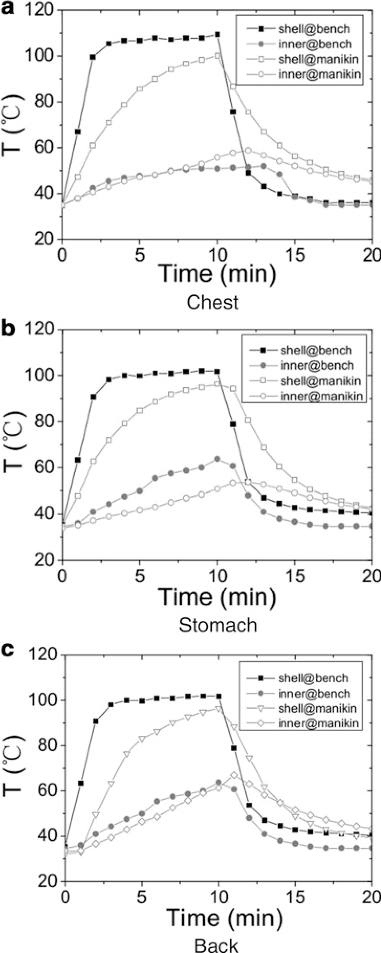
Fig. 49.3 Temperatures curves of the outside surfaces of the outer shell and the inside of the inner layer, compared with the bench-scale test and the manikin test under 2.5 kW/m²
488 M. Fu et al.
For the stomach zone, there is a significant higher temperature distribution at the bench-scale test. The moisture within the inner layer and sweating skin layer can transfer from the openings between the coat and the pants by the side heat flow [9]. Heat and mass transfer from the clothing openings absorb heat from the inner layer, except the cooling effect of sweating.
Stroup et al. [4] evaluated the performance of firefighter protective clothing under the dry tests, using a bench-scale test and a full-scale apparatus under 2.5 kW/m². In their study, the temperature of the shoulders zone at the manikin test was measured. The results at the moisture test under 2.5 kW/m² in this study are compared with their results, shown in Fig. 49.4.
It can be seen that the four temperature curves show similar trends for the outer shell and the inner layer, respectively. The peak temperatures and the temperature rising rates at the dry test are higher than those at the moisture test. It can be seen that internal moisture from human sweating has great effect on heat transfer and thermal performance of clothing under low-level radiation. During the cooldown period, the temperatures at the dry test decrease more quickly and are less than those at the moisture test after 12 min. The temperatures at the moisture test are higher than 45 C at 15 min, resulting into skin burn injuries or heat stain by the stored heat releasing to the human body when contacting with the solid or the human moving [12].
From the above comparison of the bench-scale and manikin tests under dry and wet conditions, it can be seen that there are some differences with the temperature distribution and peak temperature. These differences indicate the different applications of those two testing methods to study the heat and mass transfer through the fire fighter ensemble. The bench-scale test apparatus is developed to evaluate the thermal protective performance of the materials used in each layer of the protective clothing system. The manikin tests are capable of exposing the firefighter ensemble into thermal radiation, to study the heat and mass transfer of clothing system in overall. The effect of the design of the protective clothing, such as zippers and snap fasteners to closure, and openings in neck and wrist [13], and the wicking effect might be determined by the comparison of those two tests. The sweating water with wicking across each fabric layer slows down the temperature increase during exposure at the manikin test. The stored thermal energy by the moisture can release heat to the fabric layers, slowing down the temperature decrease during the cooldown period.

49.4 Conclusions
The heat and moisture transfer of the protective clothing system were investigated by a bench-scale apparatus and a sweating thermal manikin exposed to low-level radiation. The surface temperature of the outer shell and inner layer were both measured at the same condition of thermal radiation. The measured results obtained from the bench-scale and full-scale tests were compared. It can be seen that there are some differences with the temperature distribution and peak temperature. The effect of the moisture transfer from sweating water can be predicted well with the small size of the clothing system at the bench-scale test. While there are some differences with the comparison of data from the bench-scale and full ensemble tests, either test can be as a
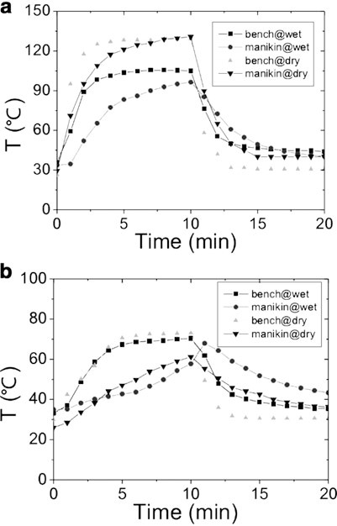
Fig. 49.4 Temperatures curves of the outside surfaces of the outer shell and the inside of the inner layer for the shoulders zone, compared with the bench-scale test and the manikin at the dry tests [3] and the wet tests under 2.5 kW/m²
49 Comparison of Bench-Scale and Manikin Tests of Protective Clothing Systems During Low-Level Radiation 489
means for different purposes to investigate heat and moisture transfer through protective ensemble.
Acknowledgment This paper was supported by the National Natural Science Foundation of China (Grant No. 51076073), China National Key Basic Research Special Funds Project (Grant No. 2012CB719705), Tsinghua University Initiative Scientific Research Program (Grant No. 2012THZ02160), and Open Foundation of Hefei Institute for Public Safety Research, Tsinghua University.

References
- Kim IY, Lee C, Li P, Corner BD, Paquette S (2002) Investigation ofair gaps entrapped in protective clothing systems. Fire Mater 26:121–126
- Hoschke BN (1981) Standards and specifications for firefighters’ clothing. Fire Saf J 4:125–137
- Lee C, Kim IY, Wood A (2002) Investigation and correlation ofmanikin and bench-scale fire testing of clothing systems. Fire Mater 26:269–278
- Stroup DW, McLane RA, Willey WH (2007) Full ensemble andbench scale testing of fire fighter protective clothing, National Institute of Standards and Technology Report NISTIR 7467, Gaithersburg, pp 1–75
- Fu M, Weng WG, Yuan HY (2014) Thermal insulations of multilayer clothing systems measured by a bench scale test in low level heat exposures. Int J Cloth Sci Tech 26:412–423
- Hes L, Araujo M (2010) Simulation of the effect of air gapsbetween the skin and a wet fabric on resulting cooling flow. Text Res J 80:1488–1497
- Lu YH, Li J, Li XH, Song GW (2013) The effect of air gaps in moistprotective clothing on protection from heat and flame. J Fire Sci 31:99–111
- Fu M, Weng WG, Yuan HY (2014) Quantitative investigation of airgaps entrapped in multilayer thermal protective clothing in low level radiation at the moisture condition. Fire and Materials 26, published online, October 10, 2014, doi:10.1002/fam.2278
- Fu M, Weng WG, Yuan HY (2014) Combined effects of moistureand radiation on thermal performance of protective clothing: experiments by a sweating manikin exposed to low level radiation. Int J Cloth Sci Tech (in press)
- Psikuta A, Frackiewicz J, Frydrych I, Rossi R (2012) Quantitativeevaluation of air gap thickness and contact area between body and garment. Text Res J 82:1405–1413
- Mah T, Song GW (2010) Investigation of the contribution ofgarment design to thermal protection. Part 1: characterizing air gaps using three-dimensional body scanning for women’s protective clothing. Text Res J 80:1317–1329
- Song GW, Paskaluk S, Sati R, Crown E, Dale J, Ackerman M(2011) Thermal protective performance of protective clothing used for low radiant heat protection. Text Res J 81:311–323
- Fu M, Weng WG, Han XF (2013) Effects of moisture transfer andcondensation in protective clothing based on thermal manikin experiment in fire environment. In: 9th Asia-Oceania symposium on Fire Science and Technology (AOSFST), 17–20 October, 2012, Hefei, China. Procedia Engineering 62, pp 760–768

