Bevans_Final_Project

Rebecca Bevans

December 13, 2016

This code can be used to reproduce the analyses and figures created for Rebecca Bevans' Ecostats final project (fall 2016): "Biodiversity, Resource Availability, and Invasion Density" in R studio.

Load data and packages:

library(tidyverse)

## Warning: package 'tidyverse' was built under R version 3.2.5

## Loading tidyverse: ggplot2  
## Loading tidyverse: tibble  
## Loading tidyverse: tidyr  
## Loading tidyverse: readr  
## Loading tidyverse: purrr  
## Loading tidyverse: dplyr

## Warning: package 'ggplot2' was built under R version 3.2.5

## Warning: package 'tibble' was built under R version 3.2.5

## Warning: package 'tidyr' was built under R version 3.2.5

## Warning: package 'readr' was built under R version 3.2.5

## Warning: package 'purrr' was built under R version 3.2.5

## Warning: package 'dplyr' was built under R version 3.2.5

## Conflicts with tidy packages ----------------------------------------------

## filter(): dplyr, stats  
## lag(): dplyr, stats

library(nlme)

## Warning: package 'nlme' was built under R version 3.2.5

##   
## Attaching package: 'nlme'

## The following object is masked from 'package:dplyr':  
##   
## collapse

library(picante)

## Warning: package 'picante' was built under R version 3.2.5

## Loading required package: ape

## Warning: package 'ape' was built under R version 3.2.5

## Loading required package: vegan

## Warning: package 'vegan' was built under R version 3.2.5

## Loading required package: permute

## Warning: package 'permute' was built under R version 3.2.5

## Loading required package: lattice

## Warning: package 'lattice' was built under R version 3.2.5

## This is vegan 2.4-1

library(AICcmodavg)

## Warning: package 'AICcmodavg' was built under R version 3.2.5

library(lme4)

## Warning: package 'lme4' was built under R version 3.2.5

## Loading required package: Matrix

## Warning: package 'Matrix' was built under R version 3.2.5

##   
## Attaching package: 'Matrix'

## The following object is masked from 'package:tidyr':  
##   
## expand

##   
## Attaching package: 'lme4'

## The following object is masked from 'package:nlme':  
##   
## lmList

library(labdsv)

## Warning: package 'labdsv' was built under R version 3.2.5

## Loading required package: mgcv

## Warning: package 'mgcv' was built under R version 3.2.5

## This is mgcv 1.8-15. For overview type 'help("mgcv-package")'.

## Loading required package: MASS

## Warning: package 'MASS' was built under R version 3.2.5

##   
## Attaching package: 'MASS'

## The following object is masked from 'package:dplyr':  
##   
## select

## Loading required package: cluster

## Warning: package 'cluster' was built under R version 3.2.5

##   
## Attaching package: 'labdsv'

## The following object is masked from 'package:AICcmodavg':  
##   
## importance

## The following object is masked from 'package:stats':  
##   
## density

invsoil<-read.csv("~/PRP_thesis/Data/invsoil.csv", header=TRUE, row.names=1)

Test correlations among variables:

library(GGally)

## Warning: package 'GGally' was built under R version 3.2.5

##   
## Attaching package: 'GGally'

## The following object is masked from 'package:dplyr':  
##   
## nasa

ggpairs(invsoil)

## Warning in cor(x, y, method = method, use = use): the standard deviation is  
## zero

## Warning in cor(x, y, method = method, use = use): the standard deviation is  
## zero  
  
## Warning in cor(x, y, method = method, use = use): the standard deviation is  
## zero  
  
## Warning in cor(x, y, method = method, use = use): the standard deviation is  
## zero  
  
## Warning in cor(x, y, method = method, use = use): the standard deviation is  
## zero  
  
## Warning in cor(x, y, method = method, use = use): the standard deviation is  
## zero  
  
## Warning in cor(x, y, method = method, use = use): the standard deviation is  
## zero  
  
## Warning in cor(x, y, method = method, use = use): the standard deviation is  
## zero  
  
## Warning in cor(x, y, method = method, use = use): the standard deviation is  
## zero  
  
## Warning in cor(x, y, method = method, use = use): the standard deviation is  
## zero  
  
## Warning in cor(x, y, method = method, use = use): the standard deviation is  
## zero  
  
## Warning in cor(x, y, method = method, use = use): the standard deviation is  
## zero  
  
## Warning in cor(x, y, method = method, use = use): the standard deviation is  
## zero  
  
## Warning in cor(x, y, method = method, use = use): the standard deviation is  
## zero  
  
## Warning in cor(x, y, method = method, use = use): the standard deviation is  
## zero

## `stat_bin()` using `bins = 30`. Pick better value with `binwidth`.

## `stat_bin()` using `bins = 30`. Pick better value with `binwidth`.  
## `stat_bin()` using `bins = 30`. Pick better value with `binwidth`.  
## `stat_bin()` using `bins = 30`. Pick better value with `binwidth`.  
## `stat_bin()` using `bins = 30`. Pick better value with `binwidth`.  
## `stat_bin()` using `bins = 30`. Pick better value with `binwidth`.  
## `stat_bin()` using `bins = 30`. Pick better value with `binwidth`.  
## `stat_bin()` using `bins = 30`. Pick better value with `binwidth`.  
## `stat_bin()` using `bins = 30`. Pick better value with `binwidth`.  
## `stat_bin()` using `bins = 30`. Pick better value with `binwidth`.  
## `stat_bin()` using `bins = 30`. Pick better value with `binwidth`.  
## `stat_bin()` using `bins = 30`. Pick better value with `binwidth`.  
## `stat_bin()` using `bins = 30`. Pick better value with `binwidth`.  
## `stat_bin()` using `bins = 30`. Pick better value with `binwidth`.  
## `stat_bin()` using `bins = 30`. Pick better value with `binwidth`.  
## `stat_bin()` using `bins = 30`. Pick better value with `binwidth`.  
## `stat_bin()` using `bins = 30`. Pick better value with `binwidth`.  
## `stat_bin()` using `bins = 30`. Pick better value with `binwidth`.  
## `stat_bin()` using `bins = 30`. Pick better value with `binwidth`.  
## `stat_bin()` using `bins = 30`. Pick better value with `binwidth`.  
## `stat_bin()` using `bins = 30`. Pick better value with `binwidth`.  
## `stat_bin()` using `bins = 30`. Pick better value with `binwidth`.  
## `stat_bin()` using `bins = 30`. Pick better value with `binwidth`.  
## `stat_bin()` using `bins = 30`. Pick better value with `binwidth`.  
## `stat_bin()` using `bins = 30`. Pick better value with `binwidth`.  
## `stat_bin()` using `bins = 30`. Pick better value with `binwidth`.  
## `stat_bin()` using `bins = 30`. Pick better value with `binwidth`.  
## `stat_bin()` using `bins = 30`. Pick better value with `binwidth`.  
## `stat_bin()` using `bins = 30`. Pick better value with `binwidth`.  
## `stat_bin()` using `bins = 30`. Pick better value with `binwidth`.  
## `stat_bin()` using `bins = 30`. Pick better value with `binwidth`.  
## `stat_bin()` using `bins = 30`. Pick better value with `binwidth`.

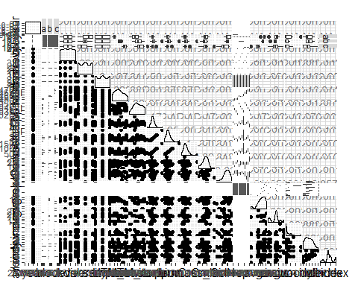

#77.5% correlation between individual Omloi and avg.c  
#66.7% correlation between individual kclN and avg.n  
#9.5% correlation between avg.c and avg.n  
#-19.9%correlation between avg.n and diversity  
#5.07% corr between avg.c and diversity  
#some significant variation between plot position and soilOM and N; this should be accounted for by using block as random effects variable

Build model sets:

#Global model using indexes  
all<-lmer(all.index ~ avg.c + avg.n + diversity + avg.c*diversity + avg.n*diversity + avg.c*avg.n + (1|rep), data=invsoil, REML=FALSE)  
summary(all)

## Linear mixed model fit by maximum likelihood ['lmerMod']  
## Formula:   
## all.index ~ avg.c + avg.n + diversity + avg.c * diversity + avg.n *   
## diversity + avg.c * avg.n + (1 | rep)  
## Data: invsoil  
##   
## AIC BIC logLik deviance df.resid   
## 136.7 151.0 -59.4 118.7 27   
##   
## Scaled residuals:   
## Min 1Q Median 3Q Max   
## -2.0112 -0.5463 0.3658 0.7218 2.1528   
##   
## Random effects:  
## Groups Name Variance Std.Dev.  
## rep (Intercept) 0.000 0.000   
## Residual 1.583 1.258   
## Number of obs: 36, groups: rep, 12  
##   
## Fixed effects:  
## Estimate Std. Error t value  
## (Intercept) 26.7338 38.2115 0.700  
## avg.c -7.2180 16.4586 -0.439  
## avg.n -6.5702 5.5338 -1.187  
## diversity 19.2897 8.4143 2.292  
## avg.c:diversity -12.9232 6.0036 -2.153  
## avg.n:diversity 0.5153 0.3792 1.359  
## avg.c:avg.n 2.9525 2.5050 1.179  
##   
## Correlation of Fixed Effects:  
## (Intr) avg.c avg.n dvrsty avg.c: avg.n:  
## avg.c -0.993   
## avg.n -0.987 0.974   
## diversity 0.788 -0.772 -0.869   
## avg.c:dvrst -0.867 0.840 0.933 -0.981   
## avg.n:dvrst 0.916 -0.867 -0.933 0.775 -0.883   
## avg.c:avg.n 0.986 -0.981 -0.997 0.874 -0.927 0.905

plot(resid(all))

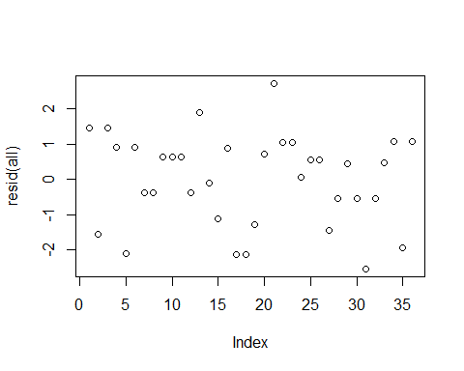

drop1(all, test="Chisq")

## Single term deletions  
##   
## Model:  
## all.index ~ avg.c + avg.n + diversity + avg.c * diversity + avg.n *   
## diversity + avg.c * avg.n + (1 | rep)  
## Df AIC LRT Pr(Chi)   
## <none> 136.70   
## avg.c:diversity 1 139.06 4.3588 0.03682 *  
## avg.n:diversity 1 136.50 1.8008 0.17961   
## avg.c:avg.n 1 136.06 1.3631 0.24301   
## ---  
## Signif. codes: 0 '***' 0.001 '**' 0.01 '*' 0.05 '.' 0.1 ' ' 1

all1.1<-lmer(all.index ~ avg.c + avg.n + diversity + avg.c*diversity + avg.n*diversity + (1|rep), data=invsoil, REML=FALSE)  
summary(all1.1)

## Linear mixed model fit by maximum likelihood ['lmerMod']  
## Formula:   
## all.index ~ avg.c + avg.n + diversity + avg.c * diversity + avg.n *   
## diversity + (1 | rep)  
## Data: invsoil  
##   
## AIC BIC logLik deviance df.resid   
## 136.1 148.7 -60.0 120.1 28   
##   
## Scaled residuals:   
## Min 1Q Median 3Q Max   
## -1.8396 -0.6866 0.1931 0.7123 1.9218   
##   
## Random effects:  
## Groups Name Variance Std.Dev.  
## rep (Intercept) 0.000 0.000   
## Residual 1.644 1.282   
## Number of obs: 36, groups: rep, 12  
##   
## Fixed effects:  
## Estimate Std. Error t value  
## (Intercept) -17.66041 6.55835 -2.693  
## avg.c 11.80311 3.29367 3.584  
## avg.n -0.06586 0.41947 -0.157  
## diversity 10.62524 4.17217 2.547  
## avg.c:diversity -6.36086 2.28866 -2.779  
## avg.n:diversity 0.11064 0.16407 0.674  
##   
## Correlation of Fixed Effects:  
## (Intr) avg.c avg.n dvrsty avg.c:  
## avg.c -0.811   
## avg.n -0.357 -0.250   
## diversity -0.893 0.890 0.055   
## avg.c:dvrst 0.741 -0.946 0.284 -0.936   
## avg.n:dvrst 0.327 0.251 -0.957 -0.076 -0.274

drop1(all1.1, test="Chisq")

## Single term deletions  
##   
## Model:  
## all.index ~ avg.c + avg.n + diversity + avg.c * diversity + avg.n *   
## diversity + (1 | rep)  
## Df AIC LRT Pr(Chi)   
## <none> 136.06   
## avg.c:diversity 1 141.04 6.9736 0.008272 **  
## avg.n:diversity 1 134.52 0.4519 0.501421   
## ---  
## Signif. codes: 0 '***' 0.001 '**' 0.01 '*' 0.05 '.' 0.1 ' ' 1

all1.2<-lmer(all.index ~ avg.c + diversity + avg.c:diversity + (1|rep), data=invsoil, REML=FALSE)  
summary(all1.2)

## Linear mixed model fit by maximum likelihood ['lmerMod']  
## Formula: all.index ~ avg.c + diversity + avg.c:diversity + (1 | rep)  
## Data: invsoil  
##   
## AIC BIC logLik deviance df.resid   
## 135.2 144.7 -61.6 123.2 30   
##   
## Scaled residuals:   
## Min 1Q Median 3Q Max   
## -2.3797 -0.4587 0.2193 0.6453 2.0311   
##   
## Random effects:  
## Groups Name Variance Std.Dev.  
## rep (Intercept) 0.000 0.00   
## Residual 1.795 1.34   
## Number of obs: 36, groups: rep, 12  
##   
## Fixed effects:  
## Estimate Std. Error t value  
## (Intercept) -17.433 6.393 -2.727  
## avg.c 11.450 3.330 3.439  
## diversity 11.297 4.338 2.604  
## avg.c:diversity -6.229 2.293 -2.717  
##   
## Correlation of Fixed Effects:  
## (Intr) avg.c dvrsty  
## avg.c -0.996   
## diversity -0.946 0.942   
## avg.c:dvrst 0.942 -0.943 -0.998

all1<-lmer(all.index ~ avg.c + avg.n + diversity + avg.n*diversity + avg.c*avg.n + (1|invsoil$rep), data=invsoil, REML=FALSE)  
summary(all1)

## Linear mixed model fit by maximum likelihood ['lmerMod']  
## Formula:   
## all.index ~ avg.c + avg.n + diversity + avg.n * diversity + avg.c *   
## avg.n + (1 | invsoil$rep)  
## Data: invsoil  
##   
## AIC BIC logLik deviance df.resid   
## 139.1 151.7 -61.5 123.1 28   
##   
## Scaled residuals:   
## Min 1Q Median 3Q Max   
## -1.9618 -0.6013 0.1457 0.6775 2.1093   
##   
## Random effects:  
## Groups Name Variance Std.Dev.  
## invsoil$rep (Intercept) 0.000 0.000   
## Residual 1.787 1.337   
## Number of obs: 36, groups: invsoil$rep, 12  
##   
## Fixed effects:  
## Estimate Std. Error t value  
## (Intercept) -44.6182 20.1965 -2.209  
## avg.c 22.5378 9.4908 2.375  
## avg.n 4.5406 2.1198 2.142  
## diversity 1.5289 1.7531 0.872  
## avg.n:diversity -0.2056 0.1890 -1.088  
## avg.c:avg.n -2.0482 0.9955 -2.058  
##   
## Correlation of Fixed Effects:  
## (Intr) avg.c avg.n dvrsty avg.n:  
## avg.c -0.981   
## avg.n -0.994 0.975   
## diversity -0.642 0.488 0.641   
## avg.n:dvrst 0.642 -0.492 -0.647 -0.987   
## avg.c:avg.n 0.974 -0.993 -0.980 -0.487 0.492

plot(resid(all1))

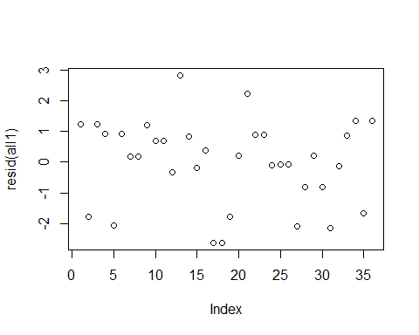

drop1(all1, test="Chisq")

## Single term deletions  
##   
## Model:  
## all.index ~ avg.c + avg.n + diversity + avg.n * diversity + avg.c *   
## avg.n + (1 | invsoil$rep)  
## Df AIC LRT Pr(Chi)   
## <none> 139.06   
## avg.n:diversity 1 138.22 1.1649 0.2805   
## avg.c:avg.n 1 141.04 3.9778 0.0461 *  
## ---  
## Signif. codes: 0 '***' 0.001 '**' 0.01 '*' 0.05 '.' 0.1 ' ' 1

anova(all1, all1.1, test="F")

## Data: invsoil  
## Models:  
## all1: all.index ~ avg.c + avg.n + diversity + avg.n * diversity + avg.c *   
## all1: avg.n + (1 | invsoil$rep)  
## all1.1: all.index ~ avg.c + avg.n + diversity + avg.c * diversity + avg.n *   
## all1.1: diversity + (1 | rep)  
## Df AIC BIC logLik deviance Chisq Chi Df Pr(>Chisq)   
## all1 8 139.06 151.73 -61.530 123.06   
## all1.1 8 136.06 148.73 -60.032 120.06 2.9957 0 < 2.2e-16 ***  
## ---  
## Signif. codes: 0 '***' 0.001 '**' 0.01 '*' 0.05 '.' 0.1 ' ' 1

all2<-lmer(all.index ~ avg.c + avg.n + diversity + avg.n*diversity + (1|invsoil$rep), data=invsoil, REML=FALSE)  
summary(all2)

## Linear mixed model fit by maximum likelihood ['lmerMod']  
## Formula: all.index ~ avg.c + avg.n + diversity + avg.n * diversity + (1 |   
## invsoil$rep)  
## Data: invsoil  
##   
## AIC BIC logLik deviance df.resid   
## 141.0 152.1 -63.5 127.0 29   
##   
## Scaled residuals:   
## Min 1Q Median 3Q Max   
## -1.8592 -0.2671 0.1618 0.7137 2.1883   
##   
## Random effects:  
## Groups Name Variance Std.Dev.  
## invsoil$rep (Intercept) 0.0525 0.2291   
## Residual 1.9444 1.3944   
## Number of obs: 36, groups: invsoil$rep, 12  
##   
## Fixed effects:  
## Estimate Std. Error t value  
## (Intercept) -4.15146 4.97845 -0.834  
## avg.c 3.14600 1.21036 2.599  
## avg.n 0.26519 0.45476 0.583  
## diversity -0.22839 1.66045 -0.138  
## avg.n:diversity -0.01425 0.17841 -0.080  
##   
## Correlation of Fixed Effects:  
## (Intr) avg.c avg.n dvrsty  
## avg.c -0.504   
## avg.n -0.882 0.058   
## diversity -0.845 0.039 0.949   
## avg.n:dvrst 0.821 -0.027 -0.954 -0.983

plot(resid(all2))

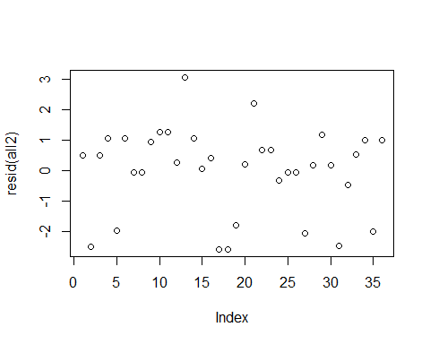

anova(all1, all2, test="F")

## Data: invsoil  
## Models:  
## all2: all.index ~ avg.c + avg.n + diversity + avg.n * diversity + (1 |   
## all2: invsoil$rep)  
## all1: all.index ~ avg.c + avg.n + diversity + avg.n * diversity + avg.c *   
## all1: avg.n + (1 | invsoil$rep)  
## Df AIC BIC logLik deviance Chisq Chi Df Pr(>Chisq)   
## all2 7 141.04 152.12 -63.519 127.04   
## all1 8 139.06 151.73 -61.530 123.06 3.9778 1 0.0461 *  
## ---  
## Signif. codes: 0 '***' 0.001 '**' 0.01 '*' 0.05 '.' 0.1 ' ' 1

anova(all, all2, test="F")

## Data: invsoil  
## Models:  
## all2: all.index ~ avg.c + avg.n + diversity + avg.n * diversity + (1 |   
## all2: invsoil$rep)  
## all: all.index ~ avg.c + avg.n + diversity + avg.c * diversity + avg.n *   
## all: diversity + avg.c * avg.n + (1 | rep)  
## Df AIC BIC logLik deviance Chisq Chi Df Pr(>Chisq)   
## all2 7 141.04 152.12 -63.519 127.04   
## all 9 136.70 150.95 -59.350 118.70 8.3366 2 0.01548 *  
## ---  
## Signif. codes: 0 '***' 0.001 '**' 0.01 '*' 0.05 '.' 0.1 ' ' 1

drop1(all2, test="Chisq")

## Single term deletions  
##   
## Model:  
## all.index ~ avg.c + avg.n + diversity + avg.n * diversity + (1 |   
## invsoil$rep)  
## Df AIC LRT Pr(Chi)   
## <none> 141.04   
## avg.c 1 144.40 5.3592 0.02061 *  
## avg.n:diversity 1 139.04 0.0064 0.93635   
## ---  
## Signif. codes: 0 '***' 0.001 '**' 0.01 '*' 0.05 '.' 0.1 ' ' 1

all3<-lmer(all.index ~ avg.n + avg.n*diversity + (1|rep), data=invsoil, REML=FALSE)  
summary(all3)

## Linear mixed model fit by maximum likelihood ['lmerMod']  
## Formula: all.index ~ avg.n + avg.n * diversity + (1 | rep)  
## Data: invsoil  
##   
## AIC BIC logLik deviance df.resid   
## 144.4 153.9 -66.2 132.4 30   
##   
## Scaled residuals:   
## Min 1Q Median 3Q Max   
## -2.1479 -0.4465 0.1253 0.6799 1.5880   
##   
## Random effects:  
## Groups Name Variance Std.Dev.  
## rep (Intercept) 0.447 0.6686   
## Residual 1.944 1.3944   
## Number of obs: 36, groups: rep, 12  
##   
## Fixed effects:  
## Estimate Std. Error t value  
## (Intercept) 2.371500 5.375399 0.441  
## avg.n 0.196741 0.567589 0.347  
## diversity -0.398454 2.074272 -0.192  
## avg.n:diversity -0.001805 0.222970 -0.008  
##   
## Correlation of Fixed Effects:  
## (Intr) avg.n dvrsty  
## avg.n -0.989   
## diversity -0.956 0.949   
## avg.n:dvrst 0.936 -0.954 -0.983

anova(all1.2, all3, test="F")

## Data: invsoil  
## Models:  
## all1.2: all.index ~ avg.c + diversity + avg.c:diversity + (1 | rep)  
## all3: all.index ~ avg.n + avg.n * diversity + (1 | rep)  
## Df AIC BIC logLik deviance Chisq Chi Df Pr(>Chisq)  
## all1.2 6 135.23 144.74 -61.617 123.23   
## all3 6 144.40 153.90 -66.198 132.40 0 0 1

drop1(all3, test="Chisq")

## Single term deletions  
##   
## Model:  
## all.index ~ avg.n + avg.n * diversity + (1 | rep)  
## Df AIC LRT Pr(Chi)  
## <none> 144.4   
## avg.n:diversity 1 142.4 6.5507e-05 0.9935

#The all3 model is the best for all invaders overall. Though it is hardly predictive. It's pretty bad.   
  
all4<-lmer(all.index ~ (1|rep), data=invsoil, REML=FALSE)  
summary(all4)

## Linear mixed model fit by maximum likelihood ['lmerMod']  
## Formula: all.index ~ (1 | rep)  
## Data: invsoil  
##   
## AIC BIC logLik deviance df.resid   
## 141.2 145.9 -67.6 135.2 33   
##   
## Scaled residuals:   
## Min 1Q Median 3Q Max   
## -1.8931 -0.4384 0.1735 0.4687 1.6496   
##   
## Random effects:  
## Groups Name Variance Std.Dev.  
## rep (Intercept) 0.7307 0.8548   
## Residual 1.9444 1.3944   
## Number of obs: 36, groups: rep, 12  
##   
## Fixed effects:  
## Estimate Std. Error t value  
## (Intercept) 3.361 0.339 9.915

anova(all1.2, all4, test="F")

## Data: invsoil  
## Models:  
## all4: all.index ~ (1 | rep)  
## all1.2: all.index ~ avg.c + diversity + avg.c:diversity + (1 | rep)  
## Df AIC BIC logLik deviance Chisq Chi Df Pr(>Chisq)   
## all4 3 141.16 145.91 -67.581 135.16   
## all1.2 6 135.23 144.74 -61.617 123.23 11.928 3 0.007635 **  
## ---  
## Signif. codes: 0 '***' 0.001 '**' 0.01 '*' 0.05 '.' 0.1 ' ' 1

anova(all1.2, all4)

## Data: invsoil  
## Models:  
## all4: all.index ~ (1 | rep)  
## all1.2: all.index ~ avg.c + diversity + avg.c:diversity + (1 | rep)  
## Df AIC BIC logLik deviance Chisq Chi Df Pr(>Chisq)   
## all4 3 141.16 145.91 -67.581 135.16   
## all1.2 6 135.23 144.74 -61.617 123.23 11.928 3 0.007635 **  
## ---  
## Signif. codes: 0 '***' 0.001 '**' 0.01 '*' 0.05 '.' 0.1 ' ' 1

#Test for woody invaders alone:  
lmwoody<-lmer(woody.index ~ avg.c + avg.n + diversity + avg.c*diversity + avg.n*diversity + avg.c*avg.n + (1|block/level), data=invsoil, REML=FALSE)  
summary(lmwoody)

## Linear mixed model fit by maximum likelihood ['lmerMod']  
## Formula: woody.index ~ avg.c + avg.n + diversity + avg.c * diversity +   
## avg.n * diversity + avg.c * avg.n + (1 | block/level)  
## Data: invsoil  
##   
## AIC BIC logLik deviance df.resid   
## 118.6 134.4 -49.3 98.6 26   
##   
## Scaled residuals:   
## Min 1Q Median 3Q Max   
## -2.24796 -0.61416 -0.06679 0.91827 2.00232   
##   
## Random effects:  
## Groups Name Variance Std.Dev.  
## level:block (Intercept) 0.0000 0.0000   
## block (Intercept) 0.0000 0.0000   
## Residual 0.9058 0.9517   
## Number of obs: 36, groups: level:block, 12; block, 3  
##   
## Fixed effects:  
## Estimate Std. Error t value  
## (Intercept) -58.21054 28.90454 -2.014  
## avg.c 30.66537 12.44992 2.463  
## avg.n 6.93630 4.18598 1.657  
## diversity -4.32698 6.36488 -0.680  
## avg.c:diversity 2.56603 4.54132 0.565  
## avg.n:diversity -0.06305 0.28686 -0.220  
## avg.c:avg.n -3.53958 1.89485 -1.868  
##   
## Correlation of Fixed Effects:  
## (Intr) avg.c avg.n dvrsty avg.c: avg.n:  
## avg.c -0.993   
## avg.n -0.987 0.974   
## diversity 0.788 -0.772 -0.869   
## avg.c:dvrst -0.867 0.840 0.933 -0.981   
## avg.n:dvrst 0.916 -0.867 -0.933 0.775 -0.883   
## avg.c:avg.n 0.986 -0.981 -0.997 0.874 -0.927 0.905

plot(resid(lmwoody))

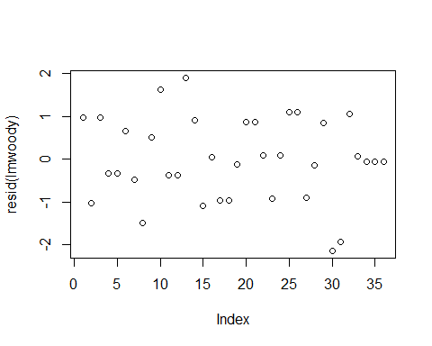

drop1(lmwoody)

## Single term deletions  
##   
## Model:  
## woody.index ~ avg.c + avg.n + diversity + avg.c * diversity +   
## avg.n * diversity + avg.c * avg.n + (1 | block/level)  
## Df AIC  
## <none> 118.60  
## avg.c:diversity 1 116.92  
## avg.n:diversity 1 116.65  
## avg.c:avg.n 1 119.93

lmwoody2<-lmer(woody.index ~ avg.c + avg.n + diversity + avg.c*diversity + avg.n*diversity + (1|block/level), data=invsoil, REML=FALSE)  
summary(lmwoody2)

## Linear mixed model fit by maximum likelihood ['lmerMod']  
## Formula: woody.index ~ avg.c + avg.n + diversity + avg.c * diversity +   
## avg.n * diversity + (1 | block/level)  
## Data: invsoil  
##   
## AIC BIC logLik deviance df.resid   
## 119.9 134.2 -51.0 101.9 27   
##   
## Scaled residuals:   
## Min 1Q Median 3Q Max   
## -2.2803 -0.5599 -0.0718 0.7819 1.7499   
##   
## Random effects:  
## Groups Name Variance Std.Dev.  
## level:block (Intercept) 0.0000 0.0000   
## block (Intercept) 0.0000 0.0000   
## Residual 0.9936 0.9968   
## Number of obs: 36, groups: level:block, 12; block, 3  
##   
## Fixed effects:  
## Estimate Std. Error t value  
## (Intercept) -4.9882 5.0984 -0.978  
## avg.c 7.8618 2.5605 3.070  
## avg.n -0.8614 0.3261 -2.642  
## diversity 6.0604 3.2434 1.869  
## avg.c:diversity -5.3013 1.7792 -2.980  
## avg.n:diversity 0.4221 0.1275 3.310  
##   
## Correlation of Fixed Effects:  
## (Intr) avg.c avg.n dvrsty avg.c:  
## avg.c -0.811   
## avg.n -0.357 -0.250   
## diversity -0.893 0.890 0.055   
## avg.c:dvrst 0.741 -0.946 0.284 -0.936   
## avg.n:dvrst 0.327 0.251 -0.957 -0.076 -0.274

plot(resid(lmwoody2))

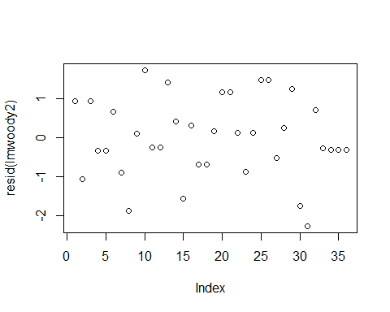

drop1(lmwoody2)

## Single term deletions  
##   
## Model:  
## woody.index ~ avg.c + avg.n + diversity + avg.c * diversity +   
## avg.n * diversity + (1 | block/level)  
## Df AIC  
## <none> 119.93  
## avg.c:diversity 1 125.51  
## avg.n:diversity 1 126.81

anova(lmwoody, lmwoody2, test="F")

## Data: invsoil  
## Models:  
## lmwoody2: woody.index ~ avg.c + avg.n + diversity + avg.c * diversity +   
## lmwoody2: avg.n * diversity + (1 | block/level)  
## lmwoody: woody.index ~ avg.c + avg.n + diversity + avg.c * diversity +   
## lmwoody: avg.n * diversity + avg.c * avg.n + (1 | block/level)  
## Df AIC BIC logLik deviance Chisq Chi Df Pr(>Chisq)   
## lmwoody2 9 119.93 134.19 -50.967 101.933   
## lmwoody 10 118.60 134.44 -49.301 98.603 3.3305 1 0.06801 .  
## ---  
## Signif. codes: 0 '***' 0.001 '**' 0.01 '*' 0.05 '.' 0.1 ' ' 1

lmwoody3<-lmer(woody.index ~ avg.c + avg.n + diversity + avg.c*diversity + (1|block/level), data=invsoil, REML=FALSE)  
   
summary(lmwoody3)

## Linear mixed model fit by maximum likelihood ['lmerMod']  
## Formula: woody.index ~ avg.c + avg.n + diversity + avg.c * diversity +   
## (1 | block/level)  
## Data: invsoil  
##   
## AIC BIC logLik deviance df.resid   
## 126.8 139.5 -55.4 110.8 28   
##   
## Scaled residuals:   
## Min 1Q Median 3Q Max   
## -1.7035 -0.8400 0.2039 0.7211 2.1114   
##   
## Random effects:  
## Groups Name Variance Std.Dev.  
## level:block (Intercept) 0.1849 0.4299   
## block (Intercept) 0.0000 0.0000   
## Residual 1.1111 1.0541   
## Number of obs: 36, groups: level:block, 12; block, 3  
##   
## Fixed effects:  
## Estimate Std. Error t value  
## (Intercept) -10.5116 6.2375 -1.685  
## avg.c 5.7378 3.2093 1.788  
## avg.n 0.1718 0.1220 1.408  
## diversity 6.8815 4.1871 1.644  
## avg.c:diversity -3.6885 2.2155 -1.665  
##   
## Correlation of Fixed Effects:  
## (Intr) avg.c avg.n dvrsty  
## avg.c -0.976   
## avg.n -0.160 -0.038   
## diversity -0.922 0.942 -0.065   
## avg.c:dvrst 0.914 -0.942 0.078 -0.998

drop1(lmwoody3)

## Single term deletions  
##   
## Model:  
## woody.index ~ avg.c + avg.n + diversity + avg.c * diversity +   
## (1 | block/level)  
## Df AIC  
## <none> 126.81  
## avg.n 1 126.65  
## avg.c:diversity 1 127.31

plot(resid(lmwoody3))

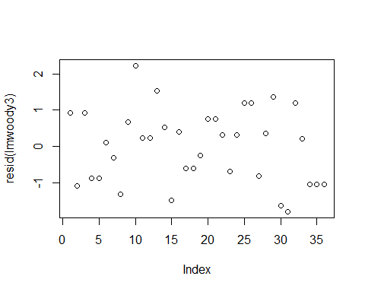

anova(lmwoody2, lmwoody3, test="F")

## Data: invsoil  
## Models:  
## lmwoody3: woody.index ~ avg.c + avg.n + diversity + avg.c * diversity +   
## lmwoody3: (1 | block/level)  
## lmwoody2: woody.index ~ avg.c + avg.n + diversity + avg.c * diversity +   
## lmwoody2: avg.n * diversity + (1 | block/level)  
## Df AIC BIC logLik deviance Chisq Chi Df Pr(>Chisq)   
## lmwoody3 8 126.81 139.48 -55.408 110.81   
## lmwoody2 9 119.93 134.19 -50.967 101.93 8.8816 1 0.002881 **  
## ---  
## Signif. codes: 0 '***' 0.001 '**' 0.01 '*' 0.05 '.' 0.1 ' ' 1

#Best model is lmwoody3; difference in model weights between lmwoody3 and lmwoody4 is not statistically significant.  
  
lmwoody4<-lmer(woody.index ~ avg.c + avg.n + diversity + (1|invsoil$rep), data=invsoil, REML=FALSE)  
  
summary(lmwoody4)

## Linear mixed model fit by maximum likelihood ['lmerMod']  
## Formula: woody.index ~ avg.c + avg.n + diversity + (1 | invsoil$rep)  
## Data: invsoil  
##   
## AIC BIC logLik deviance df.resid   
## 125.3 134.8 -56.7 113.3 30   
##   
## Scaled residuals:   
## Min 1Q Median 3Q Max   
## -1.8123 -0.7706 0.1815 0.6013 2.1266   
##   
## Random effects:  
## Groups Name Variance Std.Dev.  
## invsoil$rep (Intercept) 0.3131 0.5596   
## Residual 1.1111 1.0541   
## Number of obs: 36, groups: invsoil$rep, 12  
##   
## Fixed effects:  
## Estimate Std. Error t value  
## (Intercept) -1.01842 2.80511 -0.363  
## avg.c 0.70463 1.19500 0.590  
## avg.n 0.18768 0.13495 1.391  
## diversity -0.07489 0.29901 -0.250  
##   
## Correlation of Fixed Effects:  
## (Intr) avg.c avg.n   
## avg.c -0.845   
## avg.n -0.573 0.108   
## diversity -0.360 0.071 0.205

anova(lmwoody3, lmwoody4, test="F")

## Data: invsoil  
## Models:  
## lmwoody4: woody.index ~ avg.c + avg.n + diversity + (1 | invsoil$rep)  
## lmwoody3: woody.index ~ avg.c + avg.n + diversity + avg.c * diversity +   
## lmwoody3: (1 | block/level)  
## Df AIC BIC logLik deviance Chisq Chi Df Pr(>Chisq)  
## lmwoody4 6 125.31 134.81 -56.654 113.31   
## lmwoody3 8 126.81 139.48 -55.408 110.81 2.4937 2 0.2874

#Test for thistles only:  
thistle<-lmer(cirsium.index ~ avg.c + avg.n + diversity + avg.c*diversity + avg.n*diversity + avg.c*avg.n + (1|invsoil$rep), data=invsoil, REML=FALSE)  
summary(thistle)

## Linear mixed model fit by maximum likelihood ['lmerMod']  
## Formula: cirsium.index ~ avg.c + avg.n + diversity + avg.c * diversity +   
## avg.n * diversity + avg.c * avg.n + (1 | invsoil$rep)  
## Data: invsoil  
##   
## AIC BIC logLik deviance df.resid   
## 106.9 121.1 -44.4 88.9 27   
##   
## Scaled residuals:   
## Min 1Q Median 3Q Max   
## -1.9939 -0.5761 -0.3316 0.5292 1.9629   
##   
## Random effects:  
## Groups Name Variance Std.Dev.  
## invsoil$rep (Intercept) 0.0000 0.0000   
## Residual 0.6912 0.8314   
## Number of obs: 36, groups: invsoil$rep, 12  
##   
## Fixed effects:  
## Estimate Std. Error t value  
## (Intercept) 44.88446 25.24877 1.778  
## avg.c -23.15018 10.87528 -2.129  
## avg.n -8.45067 3.65655 -2.311  
## diversity 21.58493 5.55987 3.882  
## avg.c:diversity -12.19688 3.96695 -3.075  
## avg.n:diversity 0.08136 0.25058 0.325  
## avg.c:avg.n 4.52296 1.65520 2.733  
##   
## Correlation of Fixed Effects:  
## (Intr) avg.c avg.n dvrsty avg.c: avg.n:  
## avg.c -0.993   
## avg.n -0.987 0.974   
## diversity 0.788 -0.772 -0.869   
## avg.c:dvrst -0.867 0.840 0.933 -0.981   
## avg.n:dvrst 0.916 -0.867 -0.933 0.775 -0.883   
## avg.c:avg.n 0.986 -0.981 -0.997 0.874 -0.927 0.905

plot(resid(thistle))

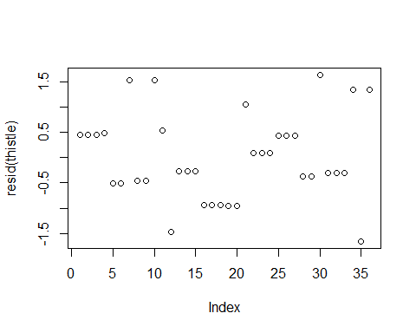

drop1(thistle, test="Chisq")

## Single term deletions  
##   
## Model:  
## cirsium.index ~ avg.c + avg.n + diversity + avg.c * diversity +   
## avg.n * diversity + avg.c * avg.n + (1 | invsoil$rep)  
## Df AIC LRT Pr(Chi)   
## <none> 106.87   
## avg.c:diversity 1 113.06 8.1902 0.004212 **  
## avg.n:diversity 1 104.97 0.1053 0.745604   
## avg.c:avg.n 1 111.61 6.7429 0.009412 **  
## ---  
## Signif. codes: 0 '***' 0.001 '**' 0.01 '*' 0.05 '.' 0.1 ' ' 1

thistle2<-lmer(cirsium.index ~ avg.c + avg.n + diversity + avg.c*diversity + avg.n*diversity + (1|invsoil$rep), data=invsoil, REML=FALSE)  
summary(thistle2)

## Linear mixed model fit by maximum likelihood ['lmerMod']  
## Formula: cirsium.index ~ avg.c + avg.n + diversity + avg.c * diversity +   
## avg.n * diversity + (1 | invsoil$rep)  
## Data: invsoil  
##   
## AIC BIC logLik deviance df.resid   
## 111.6 124.3 -47.8 95.6 28   
##   
## Scaled residuals:   
## Min 1Q Median 3Q Max   
## -1.80889 -0.66140 0.03034 0.50495 2.20699   
##   
## Random effects:  
## Groups Name Variance Std.Dev.  
## invsoil$rep (Intercept) 0.02899 0.1703   
## Residual 0.80556 0.8975   
## Number of obs: 36, groups: invsoil$rep, 12  
##   
## Fixed effects:  
## Estimate Std. Error t value  
## (Intercept) -23.1244 4.8321 -4.786  
## avg.c 5.9888 2.4267 2.468  
## avg.n 1.5135 0.3091 4.897  
## diversity 8.3116 3.0740 2.704  
## avg.c:diversity -2.1438 1.6862 -1.271  
## avg.n:diversity -0.5386 0.1209 -4.456  
##   
## Correlation of Fixed Effects:  
## (Intr) avg.c avg.n dvrsty avg.c:  
## avg.c -0.811   
## avg.n -0.357 -0.250   
## diversity -0.893 0.890 0.055   
## avg.c:dvrst 0.741 -0.946 0.284 -0.936   
## avg.n:dvrst 0.327 0.251 -0.957 -0.076 -0.274

plot(resid(thistle2))

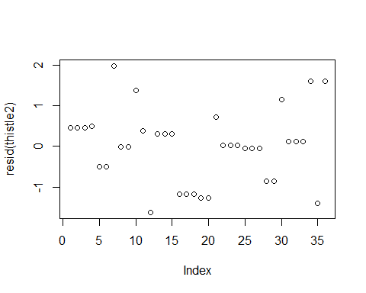

drop1(thistle2, test="Chisq")

## Single term deletions  
##   
## Model:  
## cirsium.index ~ avg.c + avg.n + diversity + avg.c * diversity +   
## avg.n * diversity + (1 | invsoil$rep)  
## Df AIC LRT Pr(Chi)   
## <none> 111.61   
## avg.c:diversity 1 111.13 1.5164 0.21816   
## avg.n:diversity 1 121.33 11.7148 0.00062 ***  
## ---  
## Signif. codes: 0 '***' 0.001 '**' 0.01 '*' 0.05 '.' 0.1 ' ' 1

thistle3<-lmer(cirsium.index ~ avg.c + avg.n + diversity + avg.c*diversity + (1|invsoil$rep), data=invsoil, REML=FALSE)  
summary(thistle3)

## Linear mixed model fit by maximum likelihood ['lmerMod']  
## Formula: cirsium.index ~ avg.c + avg.n + diversity + avg.c * diversity +   
## (1 | invsoil$rep)  
## Data: invsoil  
##   
## AIC BIC logLik deviance df.resid   
## 121.3 132.4 -53.7 107.3 29   
##   
## Scaled residuals:   
## Min 1Q Median 3Q Max   
## -2.28672 -0.47235 -0.04894 0.13523 1.97657   
##   
## Random effects:  
## Groups Name Variance Std.Dev.  
## invsoil$rep (Intercept) 0.5212 0.7219   
## Residual 0.8056 0.8975   
## Number of obs: 36, groups: invsoil$rep, 12  
##   
## Fixed effects:  
## Estimate Std. Error t value  
## (Intercept) -16.0769 7.4390 -2.161  
## avg.c 8.6989 3.8275 2.273  
## avg.n 0.1952 0.1455 1.341  
## diversity 7.2640 4.9936 1.455  
## avg.c:diversity -4.2017 2.6422 -1.590  
##   
## Correlation of Fixed Effects:  
## (Intr) avg.c avg.n dvrsty  
## avg.c -0.976   
## avg.n -0.160 -0.038   
## diversity -0.922 0.942 -0.065   
## avg.c:dvrst 0.914 -0.942 0.078 -0.998

plot(resid(thistle3))

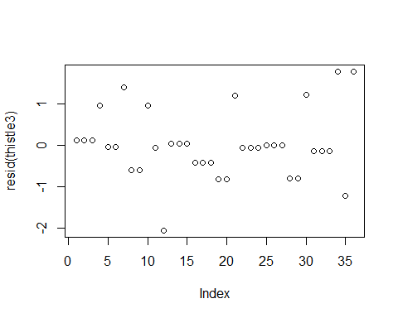

drop1(thistle3, test="Chisq")

## Single term deletions  
##   
## Model:  
## cirsium.index ~ avg.c + avg.n + diversity + avg.c * diversity +   
## (1 | invsoil$rep)  
## Df AIC LRT Pr(Chi)  
## <none> 121.33   
## avg.n 1 121.00 1.6761 0.1954  
## avg.c:diversity 1 121.62 2.2946 0.1298

#thistle3 is the best fitting model

Graphics:

library(ggplot2)  
library(gridExtra)

## Warning: package 'gridExtra' was built under R version 3.2.5

##   
## Attaching package: 'gridExtra'

## The following object is masked from 'package:dplyr':  
##   
## combine

#correlation between OM and invasive density  
#all invaders  
oplot<-ggplot(invsoil, aes(x=avg.c, y=all.index))  
oplot + geom_point() + geom_smooth()

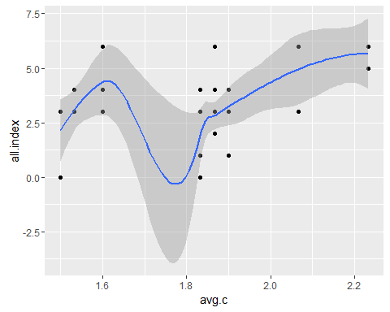

o<-oplot + geom_point() + geom_smooth()  
  
#woody invaders only  
woplot<-ggplot(invsoil, aes(x=avg.c, y=woody.index))  
woplot +geom_point() + geom_smooth()

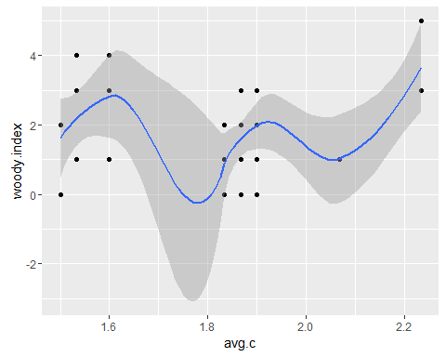

wo<-woplot +geom_point() + geom_smooth()  
  
#thistles  
toplot<-ggplot(invsoil, aes(x=avg.c, y=cirsium.index))  
toplot + geom_point() + geom_smooth()

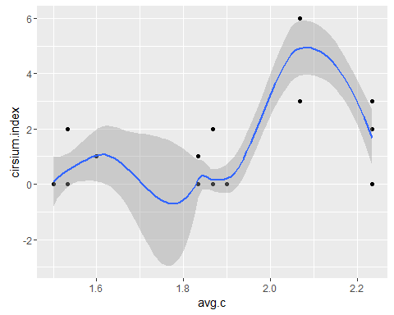

to<-toplot+geom_point() +geom_smooth()  
#all on same page:  
grid.arrange(o, wo, to, ncol=1)

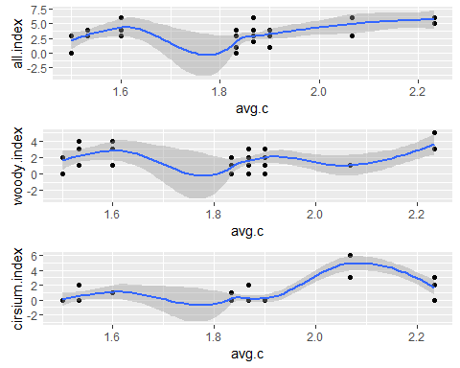

#correlation between N and invasive density  
#all invaders  
nplot<-ggplot(invsoil, aes(x=avg.n, y=all.index))  
nplot + geom_point() + geom_smooth()

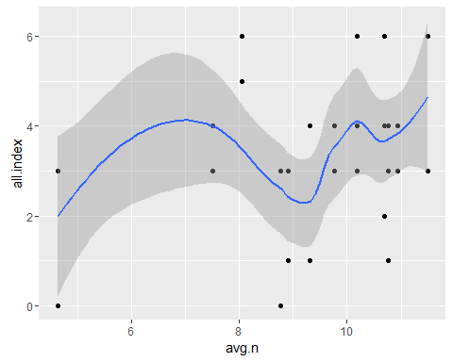

n<-nplot + geom_point() + geom_smooth()  
  
#woody invaders only  
wnplot<-ggplot(invsoil, aes(x=avg.n, y=woody.index))  
wnplot +geom_point() + geom_smooth()

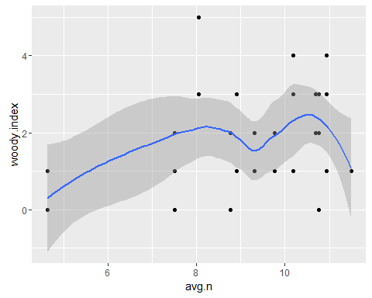

w<-wnplot +geom_point() + geom_smooth()  
  
#thistles  
tnplot<-ggplot(invsoil, aes(x=avg.n, y=cirsium.index))  
tnplot + geom_point() + geom_smooth()

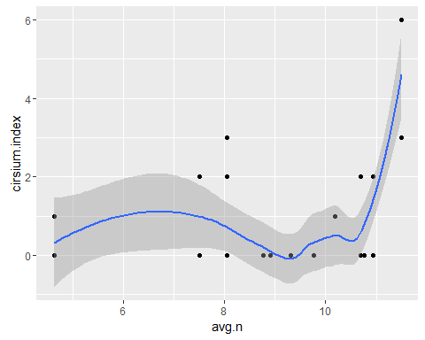

t<-tnplot+geom_point() +geom_smooth()  
#all on same page:  
grid.arrange(n, w, t, ncol=1)

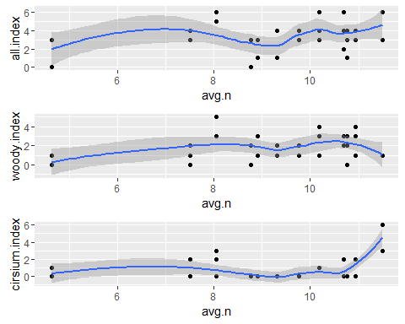

###  
#correlation (bwplot) between diversity and invasive density  
dplot<-ggplot(invsoil, aes(x=factor(diversity), y=all.index))  
dplot + geom_boxplot()

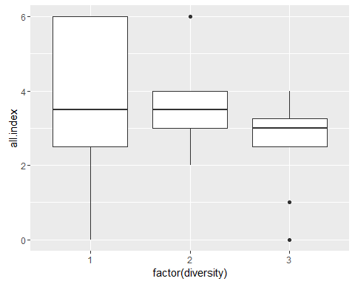

d<-dplot + geom_boxplot()  
  
wdplot<-ggplot(invsoil, aes(x=factor(diversity), y=woody.index))  
wdplot + geom_boxplot()

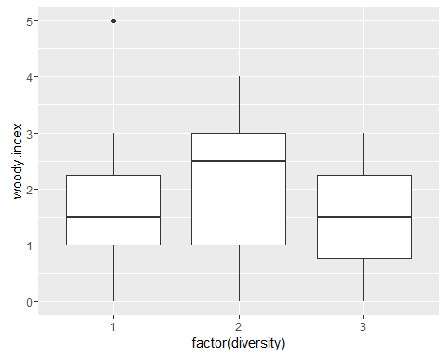

wd<-wdplot + geom_boxplot()  
  
tdplot<-ggplot(invsoil, aes(x=factor(diversity), y=cirsium.index))  
tdplot + geom_boxplot()

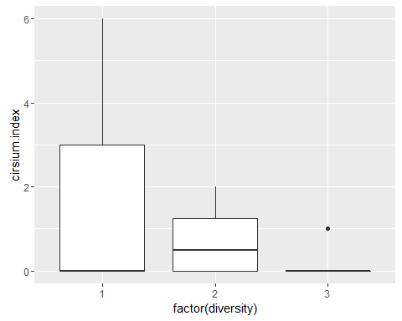

td<-tdplot + geom_boxplot()  
  
#all in same image  
grid.arrange(d, wd, td, ncol=1)

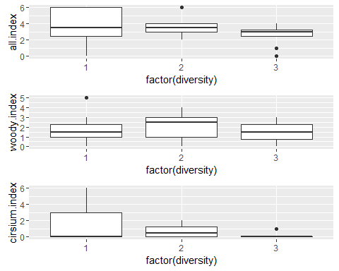

Linear interaction graphics:

#graphics theme - APA style  
apatheme=theme_bw()+  
 theme(panel.grid.major=element_blank(),  
 panel.grid.minor=element_blank(),  
 panel.border=element_blank(),  
 axis.line=element_line())  
   
  
#Average Nxdiversity effect on total invasion:  
dat=invsoil  
dat$diversity=as.factor(dat$diversity)  
nmod<-glm(all.index~avg.n*diversity, data=dat)  
dat$predicted<-predict(nmod)  
#all3 lmer: all.index ~ avg.n + avg.n*diversity + (1|rep)  
#make diversity a discrete variable for plotting  
  
  
  
#plot scatterplot with fit lines  
p=ggplot(dat, aes(x=avg.n, y=all.index, shape=diversity))+  
geom_point()+  
scale_shape_manual(values=c(1,0.2,16), name='Diversity', labels=c('LD','MD','HD'))+  
geom_line(aes(x = avg.n, y = predicted, linetype=diversity))+  
scale_linetype_discrete(name='Diversity', labels=c('LD','MD', 'HD'))+  
labs(x = 'Average Soil N', y = 'Total Invasion Density')+apatheme  
p

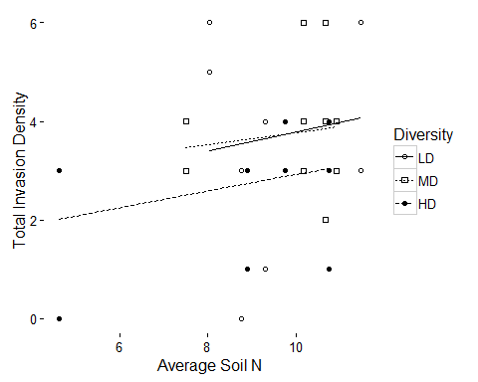

#do it with just thistles  
dat=invsoil  
dat$diversity<-as.factor(dat$diversity)  
nmod2<-glm(cirsium.index~avg.n*diversity, data=dat)  
dat$pred<-predict(nmod2)  
#plot scatterplot with fit lines  
p1.1=ggplot(dat, aes(x=avg.n, y=cirsium.index, shape=diversity))+  
geom_point()+  
scale_shape_manual(values=c(1,0.2,16), name='Diversity', labels=c('LD','MD','HD'))+  
geom_line(aes(x = avg.n, y = pred, linetype=diversity))+  
scale_linetype_discrete(name='Diversity', labels=c('LD','MD', 'HD'))+  
labs(x = 'Average Soil N', y = 'Thistle Invasion Density')+apatheme  
p1.1

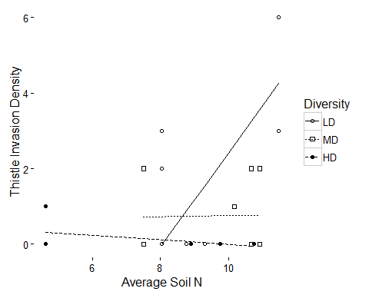

#do it with just woody  
dat=invsoil  
dat$diversity<-as.factor(dat$diversity)  
nmod3<-glm(woody.index~avg.n*diversity, data=dat)  
dat$pred<-predict(nmod3)  
#plot scatterplot with fit lines  
p1.2=ggplot(dat, aes(x=avg.n, y=woody.index, shape=diversity))+  
geom_point()+  
scale_shape_manual(values=c(1,0.2,16), name='Diversity', labels=c('LD','MD','HD'))+  
geom_line(aes(x = avg.n, y = pred, linetype=diversity))+  
scale_linetype_discrete(name='Diversity', labels=c('LD','MD', 'HD'))+  
labs(x = 'Average Soil N', y = 'Woody Invasion Density')+apatheme  
p1.2

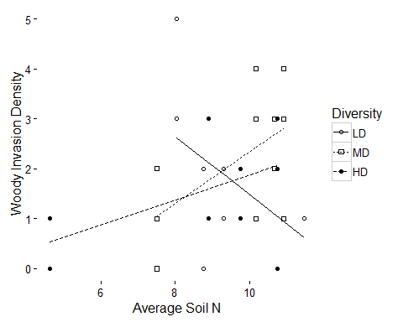

#Average C*diversity effect on thistle invasion:  
dat=invsoil  
predt<-glm(cirsium.index~avg.c*diversity, data=dat)  
dat$predt<-predict(predt)  
#all3 lmer: all.index ~ avg.n + avg.n*diversity + (1|rep)  
#make diversity a discrete variable for plotting  
dat$diversity<-as.factor(dat$diversity)  
  
#plot scatterplot with fit lines  
p=ggplot(dat, aes(x=avg.c, y=cirsium.index, shape=diversity))+  
geom_point()+  
scale_shape_manual(values=c(1,0.2,16), name='Diversity', labels=c('LD','MD','HD'))+  
geom_line(aes(x = avg.c, y = predt, linetype=diversity))+  
scale_linetype_discrete(name='Diversity', labels=c('LD','MD', 'HD'))+  
labs(x = 'Average Soil OM', y = 'Thistle Invasion Density')+ apatheme  
p

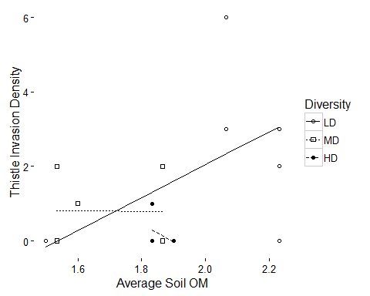

Barplot graphics code:

library(psych)

## Warning: package 'psych' was built under R version 3.2.5

##   
## Attaching package: 'psych'

## The following object is masked from 'package:labdsv':  
##   
## pca

## The following objects are masked from 'package:ggplot2':  
##   
## %+%, alpha

#p1 data  
dat<-invsoil  
dat$diversity=as.factor(dat$diversity)  
dat$avg.c=as.factor(dat$avg.c)  
dat2<-describeBy(dat$woody.index, list(dat$diversity), mat=TRUE, digits=3)  
names(dat2)[names(dat2)=='group1']= 'Diversity'  
  
  
dat2$se=dat2$sd/sqrt(dat2$n)  
  
#plot layout  
limits = aes(ymax = mean + (1.96*se), ymin=mean - (1.96*se))  
   
dodge = position_dodge(width=0.9)  
   
apatheme=theme_bw()+  
 theme(panel.grid.major=element_blank(),  
 panel.grid.minor=element_blank(),  
 panel.border=element_blank(),  
 axis.line=element_line())  
  
give.n<-function(x){  
 return(c(y=mean(x), label=length(x)))  
}  
  
#plot the interaction  
p1<-ggplot(dat2, aes(x=Diversity, y=mean, fill=Diversity))+  
 geom_bar(stat='identity', position=dodge)+  
 geom_errorbar(limits, position=dodge, width=0.25)+  
 ylab('Mean Shrub Density')+  
 scale_fill_grey()  
p1

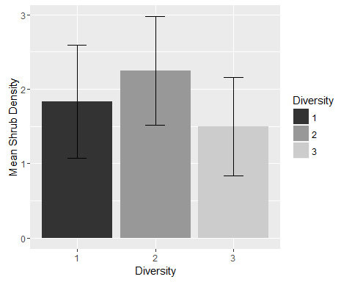

#thistle invasion by diversity  
dat<-invsoil  
dat$diversity=as.factor(dat$diversity)  
dat$cirsium.index=as.numeric(dat$cirsium.index)  
dat3<-describeBy(dat$cirsium.index, list(dat$diversity), mat=TRUE, digits=3)  
names(dat3)[names(dat3)=='group1']= 'Diversity'  
  
dat3$se=dat3$sd/sqrt(dat3$n)  
  
p2<-ggplot(dat3, aes(x=Diversity, y=mean, fill=Diversity))+  
geom_bar(stat='identity', position=dodge)+  
 geom_errorbar(limits, position=dodge, width=0.25)+  
 ylab('Mean Thistle Density')+  
 scale_fill_grey()   
p2

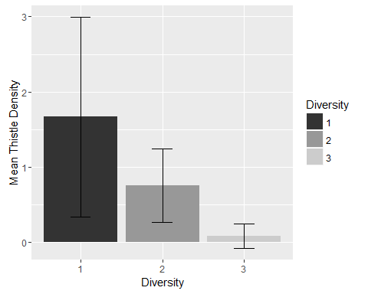

#all invasion by diversity  
dat<-invsoil  
dat$diversity=as.factor(dat$diversity)  
dat4<-describeBy(dat$all.index, list(dat$diversity), mat=TRUE, digits=3)  
names(dat4)[names(dat4)=='group1']= 'Diversity'  
  
dat4$se=dat4$sd/sqrt(dat4$n)  
  
p3<-ggplot(dat4, aes(x=Diversity, y=mean, fill=Diversity))+  
geom_bar(stat='identity', position=dodge)+  
 geom_errorbar(limits, position=dodge, width=0.25)+  
 ylab('Mean Invader Density')+  
 scale_fill_grey()   
p3

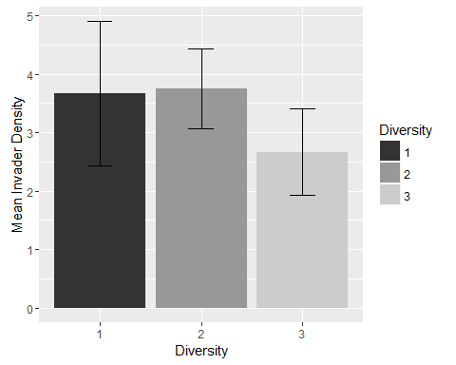

#p1 and p2 on same plot:  
grid.arrange(p1, p2, p3, ncol=3)

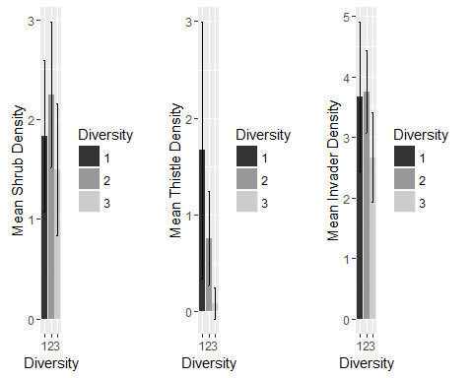

#tdplot<-ggplot(invsoil, aes(x=factor(diversity), #y=cirsium.index))  
#tdplot + geom_boxplot()  
#td<-tdplot + geom_boxplot()

ANOVAs for combined fixed and random factors:

library(nlme)  
library(lmerTest)

## Warning: package 'lmerTest' was built under R version 3.2.5

##   
## Attaching package: 'lmerTest'

## The following object is masked from 'package:lme4':  
##   
## lmer

## The following object is masked from 'package:stats':  
##   
## step

#for cirsium species  
z <- lme(cirsium.index ~ diversity*avg.c, random = ~ 1|rep, data = invsoil) # nlme package  
z <- lmer(cirsium.index ~ diversity*avg.c + (1|rep), data = invsoil)   
plot(z)

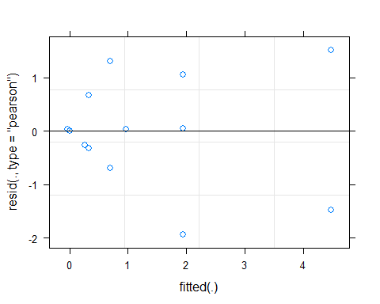

dat=invsoil  
  
#model-based fitted means for treatments:  
lsmeans(z, c("diversity", "avg.c"))

## Least Squares Means table:  
## Estimate Standard Error DF t-value Lower CI Upper CI p-value

lsmeans(z, c("diversity"))

## Least Squares Means table:  
## Estimate Standard Error DF t-value Lower CI Upper CI p-value

az<-anova(z)  
az

## Analysis of Variance Table of type III with Satterthwaite   
## approximation for degrees of freedom  
## Sum Sq Mean Sq NumDF DenDF F.value Pr(>F)  
## diversity 1.1148 1.1148 1 8.0002 1.3840 0.2732  
## avg.c 2.5245 2.5245 1 8.0002 3.1339 0.1146  
## diversity:avg.c 1.3503 1.3503 1 8.0002 1.6762 0.2315

#boxplot  
dat=invsoil  
dat$diversity=as.factor(dat$diversity)  
dat$predaz=predict(z)   
zplot<-ggplot(data=dat, aes(x=diversity, y=predaz, fill=diversity)) + scale_fill_grey(start=0.4, end=1.0) + geom_boxplot() + labs(x="Diversity", y="Thistle Invasion by diversity*soil OM + BlockID.rand.eff.")  
zplot

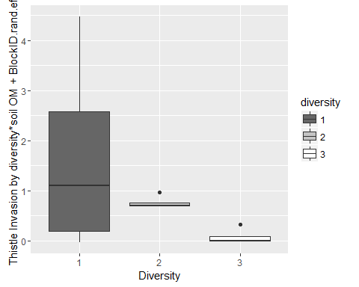

###for woody invaders  
z2 <- lme(woody.index ~ diversity*avg.c, random = ~ 1|rep, data = invsoil) # nlme package  
z2 <- lmer(woody.index ~ diversity*avg.c + (1|rep), data = invsoil)   
plot(z2)

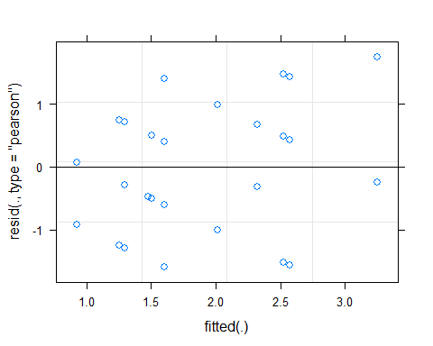

dat=invsoil  
dat$diversity=as.factor(dat$diversity)  
#model-based fitted means for treatments:  
lsmeans(z2, c("diversity", "avg.c"))

## Least Squares Means table:  
## Estimate Standard Error DF t-value Lower CI Upper CI p-value

lsmeans(z2, c("diversity"))

## Least Squares Means table:  
## Estimate Standard Error DF t-value Lower CI Upper CI p-value

az2<-anova(z2)  
az2

## Analysis of Variance Table of type III with Satterthwaite   
## approximation for degrees of freedom  
## Sum Sq Mean Sq NumDF DenDF F.value Pr(>F)  
## diversity 1.9217 1.9217 1 8 1.7295 0.2249  
## avg.c 2.1576 2.1576 1 8 1.9419 0.2010  
## diversity:avg.c 2.0153 2.0153 1 8 1.8138 0.2150

#boxplot  
dat$predaz2=predict(z2)   
zplot2<-ggplot(data=dat, aes(x=diversity, y=predaz2, fill=diversity)) + scale_fill_grey(start=0.4, end=1.0) + geom_boxplot() + labs(x="Diversity", y="Woody Invasion by diversity*soil OM + BlockID.rand.eff.")  
zplot2

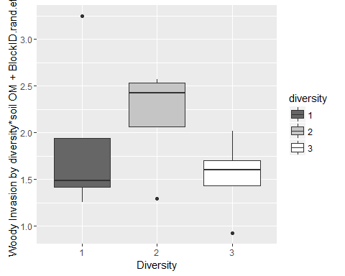

###for all invaders  
z1 <- lme(all.index ~ diversity*avg.c, random = ~ 1|rep, data = invsoil) # nlme package  
z1 <- lmer(all.index ~ diversity*avg.c + (1|rep), data = invsoil)   
plot(z)



dat=invsoil  
  
#model-based fitted means for treatments:  
lsmeans(z, c("diversity", "avg.c"))

## Least Squares Means table:  
## Estimate Standard Error DF t-value Lower CI Upper CI p-value

lsmeans(z, c("diversity"))

## Least Squares Means table:  
## Estimate Standard Error DF t-value Lower CI Upper CI p-value

az1<-anova(z1)  
az1

## Analysis of Variance Table of type III with Satterthwaite   
## approximation for degrees of freedom  
## Sum Sq Mean Sq NumDF DenDF F.value Pr(>F)   
## diversity 10.540 10.540 1 8 5.4208 0.04829 *  
## avg.c 18.377 18.377 1 8 9.4512 0.01525 *  
## diversity:avg.c 11.469 11.469 1 8 5.8982 0.04129 *  
## ---  
## Signif. codes: 0 '***' 0.001 '**' 0.01 '*' 0.05 '.' 0.1 ' ' 1

#boxplot  
dat$diversity=as.factor(dat$diversity)  
dat$predaz1=predict(z1)   
zplot1<-ggplot(data=dat, aes(x=diversity, y=predaz1, fill=diversity)) + scale_fill_grey(start=0.4, end=1.0) + geom_boxplot() + labs(x="Diversity", y="Total Invasion by diversity*soil OM + BlockID.rand.eff.")  
zplot1

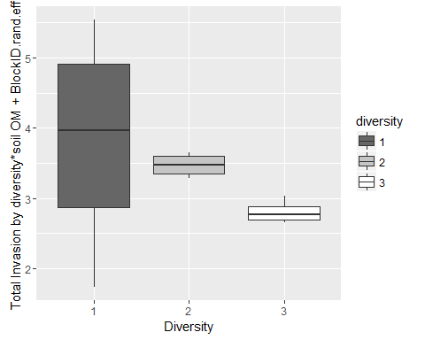

#plot all 3 together:  
grid.arrange(zplot1, zplot, zplot2, ncol=3)

