Telecom SudParis

Master of Science CCN

Evaluation of Network Algorithm Efficiency

December 9th, 2015

**Mostafa A.M. Fateen**

**Rebeca Machado**

Project Report

# Formulation

The simulation area covers a square 1 km × 1 km. A mobile agent moves in this area according to the Random Way Point model with speed in [2 km/h, 4 km/h] and pause time [10 seconds, 1 minute].  This mobile agent is observed during three hours. Its initial position (x,y) is chosen uniformly in both the axes. Compute the mean speed of the agent in time with the granularity of one minute with precision 5% on confidence level 0.05. Draw a diagram of the mean speed of this agent in function of time.

# Procedure

We started the project by implementing in ***Python*** the Random Way Point algorithm explained during the lectures:

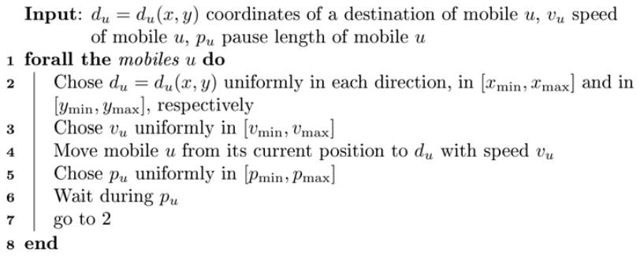

Figure : Random Way Point algorithm obtained from the course slides.

As for the uniformly distributed variables; we used the Python library ***numpy*** which already provides an implementation of randomly chosen numbers in an interval [x, y). Hence, the intervals proposed in the formulation of the project were not completely used (since the function used will never choose the upper bound of the interval).

The units where changed to meters (m) and minutes (min) to easily manage the granularity of the experiment. For each minute, we memorized the average speed of the mobile agent in a vector of 3 * 60 elements (3 hours of simulation). The following formula was used to compute the average speed:

Since the speed and the pause time are randomly picked, in a minute time-slot it is possible to have several different speeds; i.e. moving from the source point to the destination point with a speed of 3m/min during 30 seconds and then pause for 30 seconds. Replacing this in the formula we obtain:

We ran the simulation N times and output each time the vector of speeds to a file. The N was derived from the precision and confidence level as following:

1. First, we set a number N’ = 30 as a first size to obtain a sample mean. This number was chosen based on the Central Limit Theorem, which states:

“Given certain conditions, the arithmetic mean of a sufficiently large number of iterates of independent random variables, each with a well-defined expected value and well-defined variance, will be approximately normally distributed, regardless of the underlying distribution.” (Wikipedia, 2015)

It is well known that usually N ≥ 30 is sufficiently large for discrete samples.

1. First, we set a number N’ = 375 as a first size to obtain a sample mean. This number was chosen thanks to the formula to find the sample size obtained from (Scott Smith, s.f.).:

Knowing the standard deviation of the uniform distribution in the velocity is:

We replace this value, the precision (5%) and the Zscore (1.96 for 95% of confidence level) into the formula:

1. After obtaining a first sample mean of N’ elements, we used the formula explained during the lectures to obtain the real number of N needed to correctly represent the confidence interval and precision:

The sample mean was obtained from the N’ simulations done and the N’ vectors obtained (see *preliminary.out* file included). **For time purposes, we did not run the experiment for 3 hours but for X minutes to compare the mean values per minute.** **At the end, we obtained ??? A mean of means???** and replaced it in the formula (we transformed the units again to Km/h so it would match the standard deviation):

1. This N was finally used to run the simulation of 3 hours 57 times and derive the confidence interval.