**Menu Class**

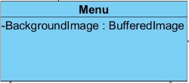

***Attributes:***

**private bufferedImage backgroundImage:** This attribute sets background image of the menu.

***Constructors:***

**public Menu:** Initializes background image.

**ShopMenu Class**

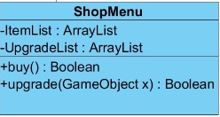

***Attributes:***

**private ArrayList<ItemList> itemList:** This attribute holds the items the player will buy.

**private ArrayList<UpgradeList> upgradeList:** This attribute holds the upgrade objects the player will shop.

***Constructors:***

**public ShopMenu:** Initializes item list and upgrade list.

***Methods:***

**public boolean buy() :** returns true if the player buys item.

**public boolean upgrade(Game object x):** returns true if the player upgrades his/her character.

**PauseMenu Class**

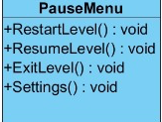

***Methods:***

**public void restartLevel():** This method restarts the level of the game.

**public void resumeLevel():** This method resumes the level.

**public void exitLevel():** This method ends the run of the level.

**public void settings():** This method applies the given settings to system.

**Main Menu Class**

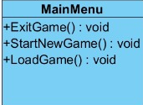

***Methods:***

**public void exitGame():** This method ends the run of application.

**public void startNewGame():** This methods starts a new game by resetting game datas.

**public void loadGame():** This method loads the game which the player previously played.

**SoundManager Class**

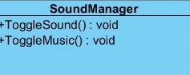

***Methods:***

**public void toggleSound():** This method enables the sounds of the game.

**public void toggleMusic():** This method sets the music of the game.