BilgiFit: Gym Reservation System
  - CMPE 372.02 — User Interface Design · Full Submission Report
Group 3
Ece Doğa Gül (121200123) · Berkay Özdelice (119200057) · Baki Kerem Artan (121200154)
Selim Şengil (122200085) · Cem Akçiçek (122200044)
Istanbul Bilgi University · June 2026
Table of Contents

Live demo: https://cmpe372-bilgifit-1.onrender.com/
Source code: https://github.com/Becho-png/CMPE372-Bilgifit
Figma prototype: https://www.figma.com/design/rs4aRJcavArfGf8ne2doTo/BilgiFit-Assignment-3—High-Fidelity-UI?node-id=1-852

Project Overview
This project designs and implements a data-driven gym reservation web application intended for use within a university campus sports center. The system provides a centralized digital platform that enables students, instructors, and administrators to reserve facilities, join group sessions, book personal trainers, and manage reservations efficiently.
Traditional campus facility access is often unstructured: users arrive at the gym only to find it overcrowded, a court already in use, or a class full. These approaches lead to wasted time, reservation conflicts, and frustration, and they make it difficult for instructors and administrators to coordinate sessions and capacity. The proposed system addresses these issues by offering a structured, real-time, and accessible web-based solution with role-based interactions.
The application allows:
- Students / members to view real-time availability, reserve facility slots, join group sessions, book personal trainers, and track their reservations.
- Instructors to reserve facilities for teaching and to create instructor-led group training sessions.
- Administrators to monitor reservation activity, occupancy, and capacity compliance.
From a UI/UX perspective, the project emphasizes user-centered design principles, clear information architecture, minimal cognitive load, and accessibility and usability across devices.
From a technical perspective, the system is designed as a data-driven web application, where user interfaces map directly to underlying data models, forms correspond to database entities, CRUD (Create, Read, Update, Delete) operations support core workflows, and asynchronous data interactions enable responsive user experiences.
The project follows an iterative design and validation process, beginning with user analysis (personas, user stories, journey maps), progressing through low- and high-fidelity prototyping, and culminating in an implementation-ready, deployed full-stack application with a relational database, CRUD matrices, and an asynchronous API. The final outcome is a scalable, maintainable gym reservation system that demonstrates how thoughtful UI/UX design combined with sound system architecture delivers real organizational value.

Personas
Personas were developed to represent the primary user groups of the BilgiFit system and to guide interface, functionality, and data-modeling decisions. Three main personas were identified based on typical campus stakeholders: students, instructors, and administrators.

Persona 1 – Student User
Field | Detail
Name | Zeynep Kaya
Age | 21
Role | Active gym user (Computer Engineering student)
Technology comfort | High
Goals | Reserve facilities quickly, view real-time availability, join classes, book a personal trainer
Frustrations | Arriving to an overcrowded gym, losing slots before booking, not knowing which facility is free
Typical tasks | Logging in, checking gym occupancy, reserving a basketball court, joining a group session, cancelling when plans change
System needs | Simple reservation flow, clear capacity info, mobile-friendly UI, confirmation feedback

Persona 2 – Instructor User
Field | Detail
Name | Emre Yıldırım
Age | 29
Role | Fitness instructor
Technology comfort | Medium
Goals | Reserve facilities for lessons, create group sessions, manage participants, avoid conflicts
Frustrations | Manual coordination, unclear reservations, last-minute facility conflicts, no view of existing sessions
Typical tasks | Reserving the boxing ring for training, creating a group class, checking participant counts, reviewing upcoming sessions
System needs | Reliable facility reservation, session creation tools, participant tracking, conflict prevention

Persona 3 – Administrator User
Field | Detail
Name | Derya Acar
Age | 35
Role | Sports center administrator
Technology comfort | Medium
Goals | Overview of facility usage, reservation activity, occupancy levels, and peak hours
Frustrations | Lack of visibility into daily usage, conflicts from overlapping reservations, manual monitoring
Typical tasks | Monitoring reservations, reviewing usage statistics, checking capacity compliance, resolving issues
System needs | Monitoring dashboard, usage statistics, capacity reporting, role-based permissions
These personas guided navigation structure, form design, database entity design, CRUD workflow definitions, and access-control policies.

User Stories

Student User Stories (Zeynep)
ID | User Story
US1 | As a student, I want to reserve a gym time slot, so that I can work out without overcrowding.
US2 | As a student, I want to reserve the basketball court, so that I can play at a scheduled time.
US3 | As a student, I want to reserve the boxing ring, so that I can train properly.
US4 | As a student, I want to see facility availability, so that I can choose the best time.
US5 | As a student, I want to book a personal trainer, so that I can get one-on-one training.
US6 | As a student, I want to join a group training session, so that I can train with others.

Instructor User Stories (Emre)
ID | User Story
US7 | As an instructor, I want to reserve facilities, so that I can conduct training sessions.
US8 | As an instructor, I want to create group classes, so that multiple users can join my sessions.

Shared & Administrator User Stories
ID | User Story
US9 | As a user, I want to receive confirmation after booking, so that I know the action succeeded.
US10 | As a user, I want to cancel my reservation, so that I can free my slot if my plans change.
US11 | As a user, I want the system to prevent double-booking, so that schedules remain accurate.
US12 | As an administrator, I want to monitor reservations, so that I can manage facility usage efficiently.

User Journey

Student User Journey Example
Step | Action | System Response
1 | User logs in | Authenticated, redirected to Dashboard
2 | User opens Facility Booking | Facility slots and capacity displayed
3 | User selects an available slot | Confirmation modal shown
4 | User confirms reservation | Slot booked, capacity updated
5 | User views Dashboard | Reservation appears in “Upcoming reservations”

User Journey Map
Persona: Student (Zeynep) · Scenario: discovers, joins, and attends a group training session.
Stage | Actions | Emotions | Pain Points | Opportunities
1. Login | Opens the app and logs in | Neutral, routine | Forgetting password slows the user down | Quick login with a remember-me option
2. Browse sessions | Views instructor-created classes | Curious, interested | Hard to find relevant sessions in a long list | Filters by facility type, instructor, or time
3. View details | Sees instructor, facility, time, open spots | Excited, evaluating | Not enough info about the session | Clear session cards with key details upfront
4. Join | Selects a session and confirms | Motivated, satisfied | Worries the session may fill before confirming | Real-time spot counter + instant confirmation
5. Confirmation | Receives a confirmation message | Reassured, confident | May forget the session time later | Confirmation summary + dashboard reminder
6. Pre-session check | Double-checks time/facility on dashboard | Calm, prepared | Dashboard may feel cluttered | Clean upcoming-sessions section
7. Attending | Arrives at the correct facility on time | Energized, ready | Anxiety if the room is overcrowded | Occupancy display reassures capacity is respected
8. Post-session | Considers booking again or cancelling | Satisfied, reflective | Cancellation process may not be obvious | Prominent cancel button with deadline reminder

Information Architecture (IA)

IA Goals
In this project, the information architecture is designed to:
- Reduce cognitive load by grouping tasks into clear modules (Dashboard, Facility Booking, Group Sessions, Personal Trainers, Profile).
- Support role-based navigation (Student / Instructor / Administrator) without hiding core discovery.
- Enable a fast reservation workflow: Browse → Select → Confirm → Manage.
- Ensure consistency across pages through predictable placement of navigation, filters, and actions.

Global Navigation Model
Primary navigation (persistent left sidebar), common to all roles: Dashboard, Facility Booking, Group Sessions, Personal Trainers, My Profile. Role-specific entry (visible by permission): Instructor Panel (for instructors); Admin Dashboard (for administrators). Secondary navigation (within modules): facility-type filters (All / Gym / Boxing / Basketball), session level badges, and modal confirmation steps.

Sitemap (Page Hierarchy)
Public area (no login required): Home / Login–Register.
Authenticated area (Student / Instructor): Dashboard (next reservation, KPIs, quick actions, upcoming reservations); Facility Booking (filters, capacity bars, reserve action); Group Sessions (session cards, join action); Personal Trainers (trainer cards, book action); My Profile (contact info, membership, reservations).
Instructor Panel (instructors): Create Session; Manage Sessions.
Admin Dashboard (administrators): Facility Usage; Reservation Monitoring.
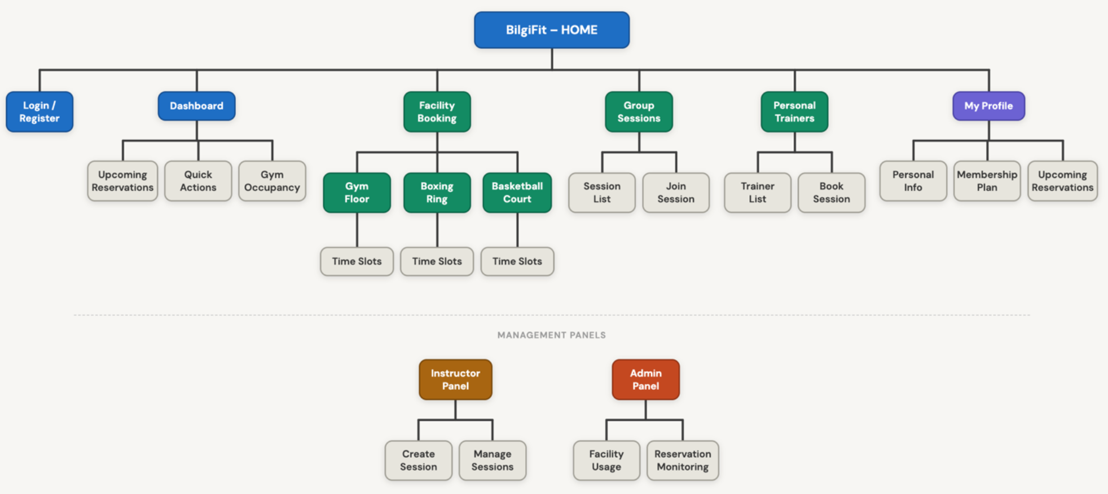
Figure 1. BilgiFit sitemap — the main navigation hierarchy, user-facing pages, and role-specific management panels.

Core Navigation Paths (Task Flows)
A. Facility Reservation Flow: Home → Login → Dashboard → Facility Booking → Filter → Select Slot → Confirm Modal → Confirmation → My Reservations.
B. Group Session Flow: Dashboard → Group Sessions → Select Session → Join → Joined State → Dashboard.
C. Personal Trainer Flow: Dashboard → Personal Trainers → Select Trainer → Book → Booked State → Dashboard.
D. Cancellation Flow: Dashboard → Upcoming Reservations → Cancel → Status updated to “Cancelled”.
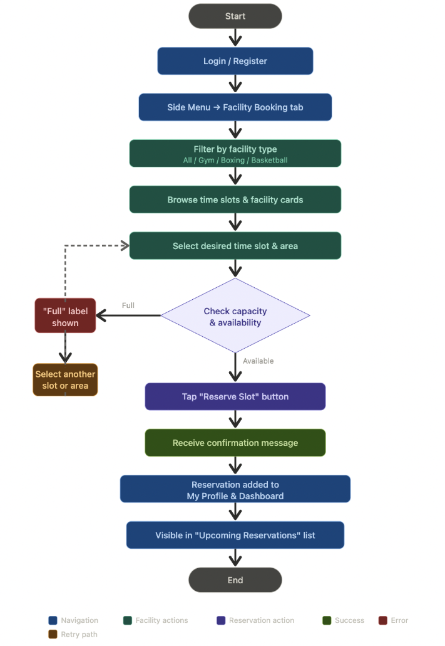
Figure 2. Task flow for the main scenario — reserving a facility — including the capacity check, the full-capacity branch, and the final confirmation outcome.

Labeling System
To prevent confusion, labels are consistent and user-friendly: Reserve Slot (not “Create record”); Join Session (not “Insert participant”); Book Session (not “Initiate request”); My Profile / My Reservations. Status labels: Available, Full, Active, Pending, Cancelled, Unavailable. Facility types: Gym, Boxing, Basketball. Session levels: Beginner, Intermediate, Advanced, All Levels.

Page Content Inventory
Page | Purpose | Main content | User actions
Dashboard | Overview | Next reservation, bookings-this-week, gym occupancy, open courts, upcoming-reservations table, quick actions | Navigate, cancel reservation
Facility Booking | Reserve slots | Filter tabs, facility cards (name, time, capacity bar, status badge) | Filter, reserve, view full state
Group Sessions | Join classes | Session cards (name, instructor, schedule, level badge, participant count) | Join session
Personal Trainers | Book PT | Trainer cards (avatar, specialty, rating, session count, availability) | Book session
My Profile | Manage account | Editable name/email/phone/address, membership card | Edit & save profile

Instructor Panel
Page | Purpose | Content | Actions
Create Session | Add group sessions | Session form (name, schedule, capacity, level) | Submit session
Manage Sessions | Manage own sessions | List of created sessions, participant counts | Edit / review

Admin Dashboard
Page | Purpose | Content | Actions
Facility Usage | Monitor system | Occupancy KPIs, capacity compliance | Navigate / review
Reservation Monitoring | Oversee bookings | Reservation list, statuses | Review / export

Wireframes

Low Fidelity Screens
Early digital low-fidelity sketches established layout structure, content blocks, button placement, and navigation relationships before visual styling: the homepage (clear search + categories), the facility list (card design + filters), and the detail/booking page (hierarchy + primary CTA button).

High Fidelity Screens
The Figma file contains eight connected high-fidelity screens demonstrating consistent visual hierarchy, real components (cards, badges, capacity bars), and clickable navigation that simulates a real reservation flow. The seven desktop screens are shown below; the implemented HTML/CSS/JS screens match these designs.
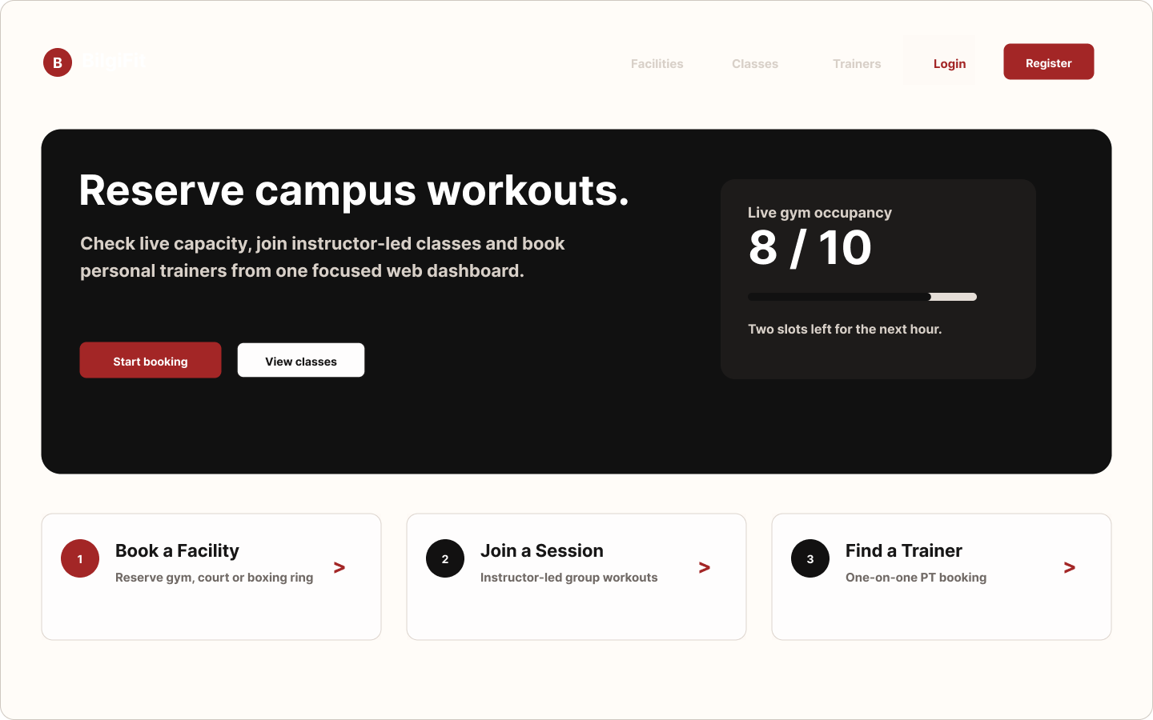
Figure 3. Homepage — value proposition, live gym occupancy, and three entry points (Book a Facility, Join a Session, Find a Trainer).
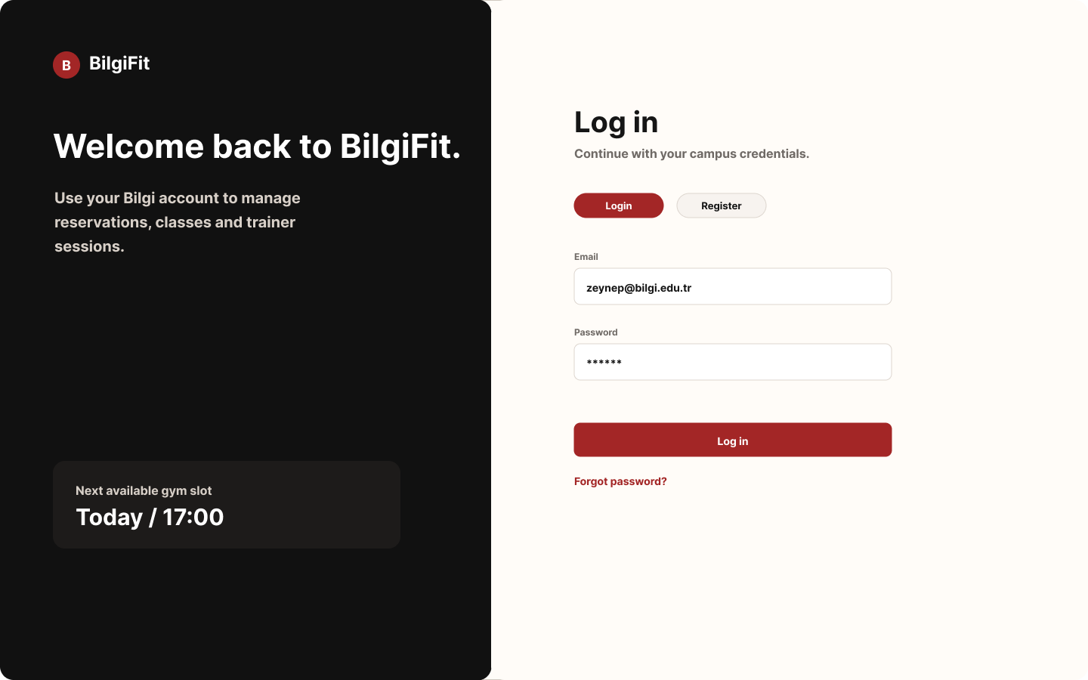
Figure 4. Login / Register — split layout with a dark brand panel and a form using Bilgi-email validation.
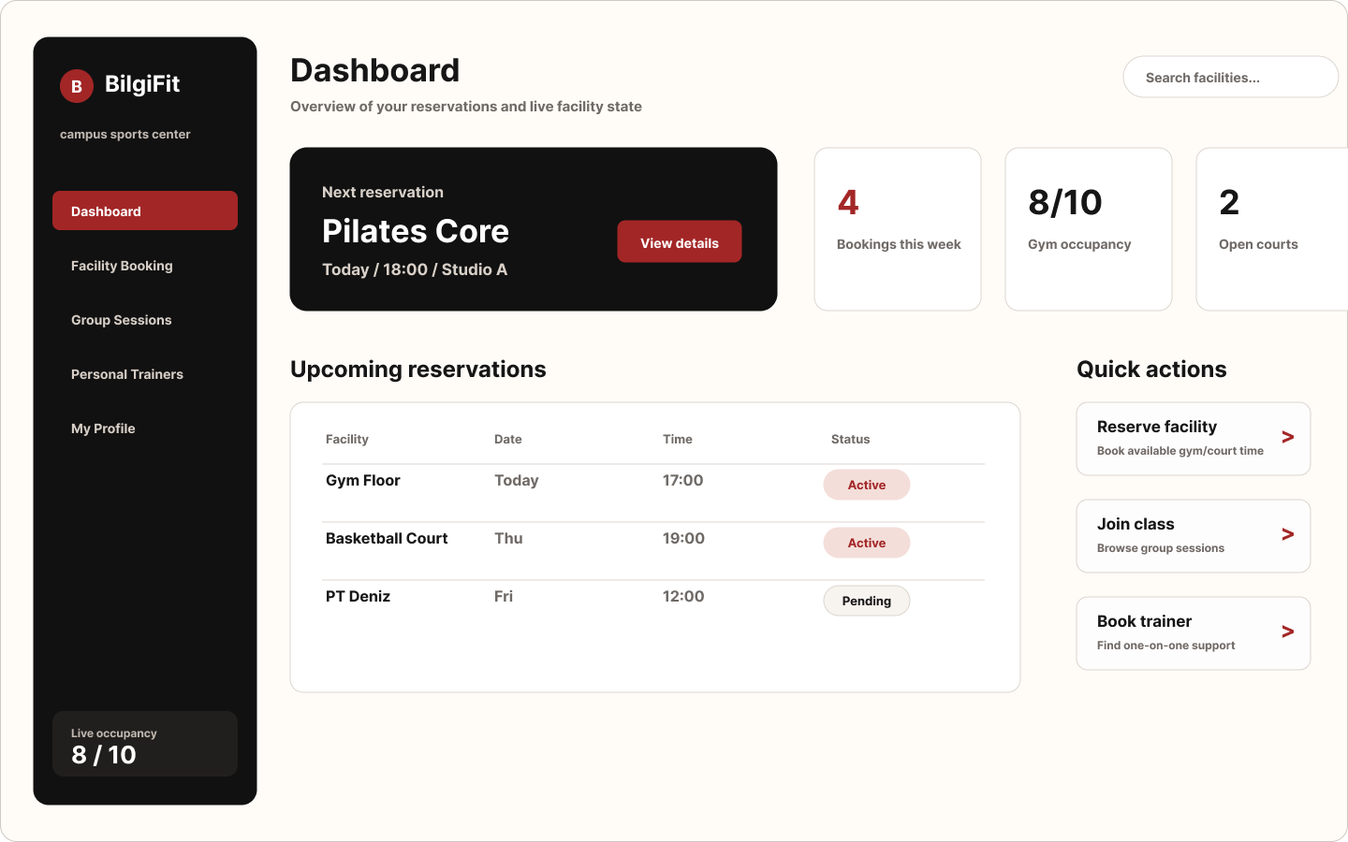
Figure 5. Dashboard — next reservation, weekly bookings, live gym occupancy, quick actions, and the upcoming-reservations table.
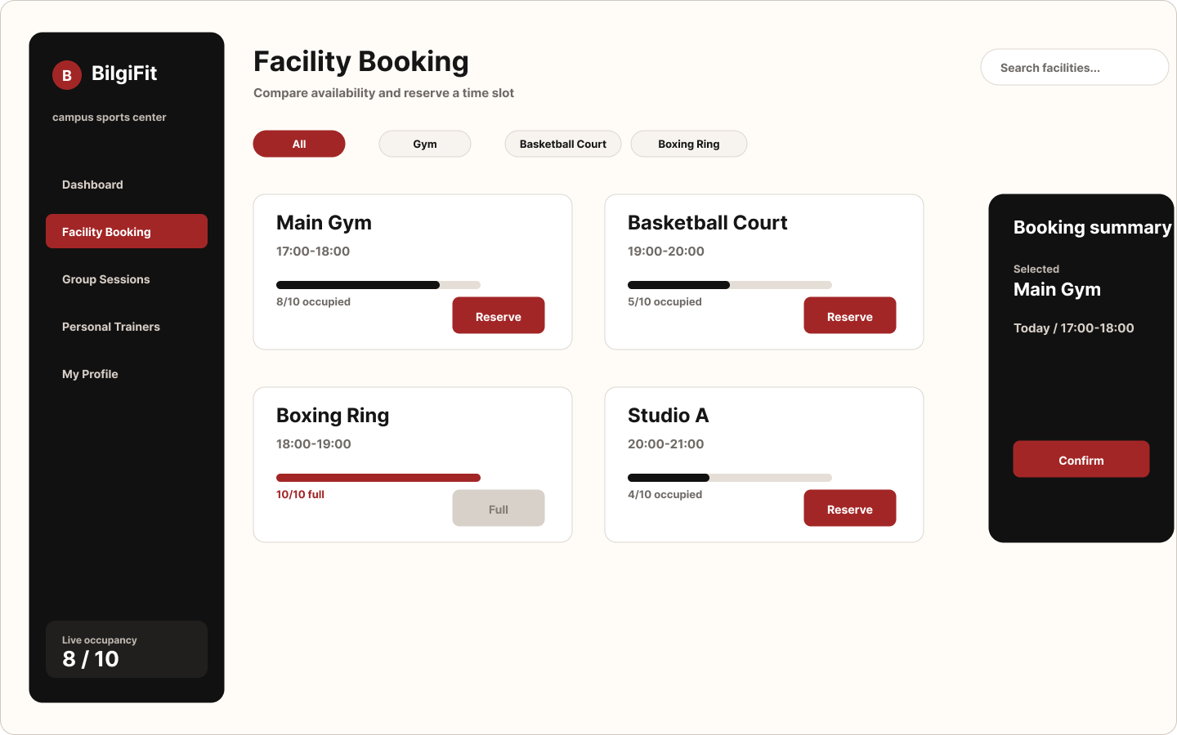
Figure 6. Facility Booking — facility-type filters, per-slot capacity bars, and Reserve / Full button states.
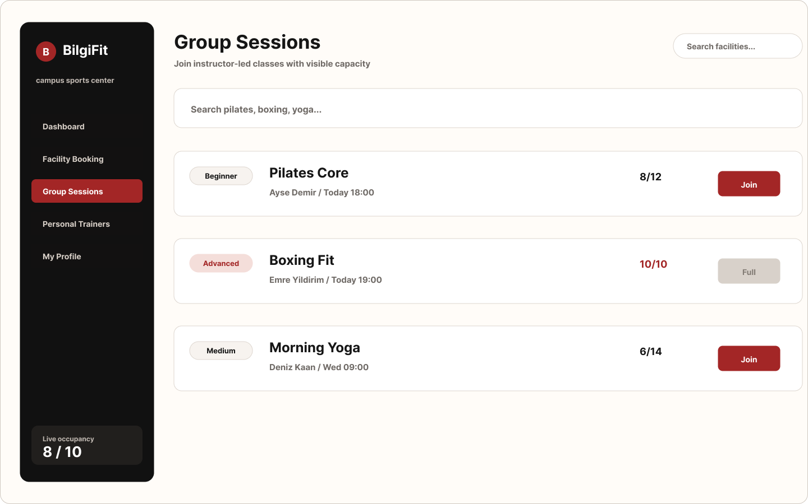
Figure 7. Group Sessions — session cards with level badges, participant counts, and Join / Full states.
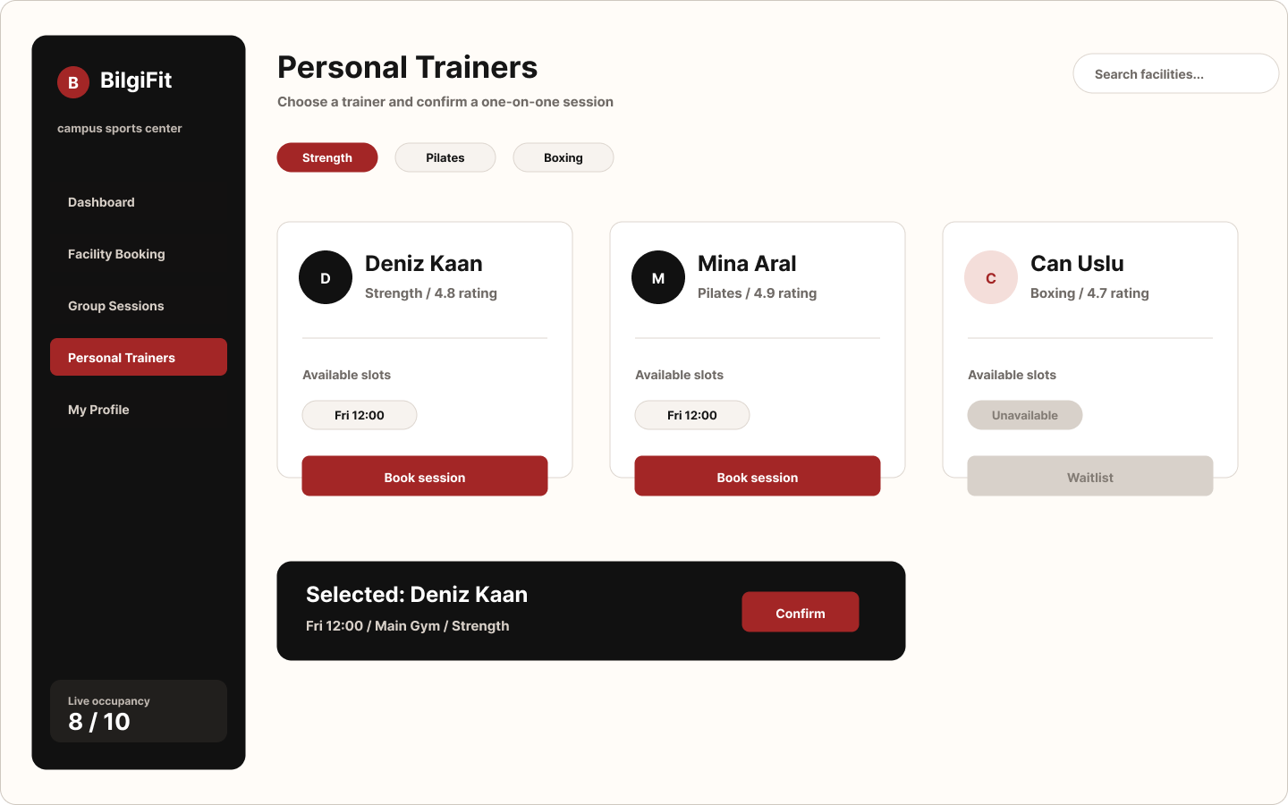
Figure 8. Personal Trainers — trainer cards with specialties, ratings, session counts, and Book / Unavailable states.
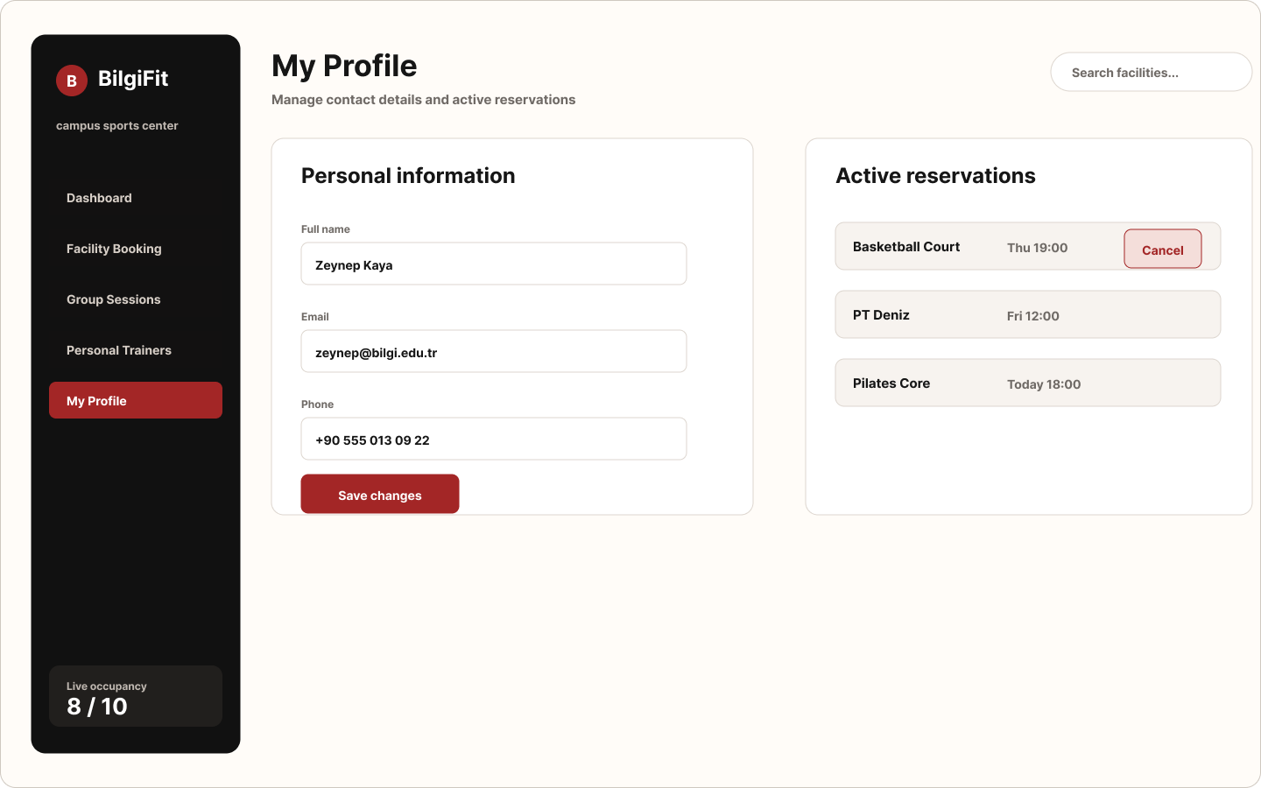
Figure 9. My Profile — personal information, editable fields, and membership status.

Design System
This section documents the unified design system created for the BilgiFit web application. The design system ensures visual consistency, usability, accessibility, and scalability across all screens. The interface uses a red, charcoal-black, and warm-white identity that signals energy and action while keeping core workflow screens calm and readable.

Color System
Purpose | Color | Usage
Primary action | Red | Log in, Reserve, Join, Book session, Confirm; active sidebar item
Surface (dark) | Charcoal / black | Sidebar, brand area, hero panels, primary text
Background | Warm white / light gray | Page background and cards
Success | Green | Confirmation toasts and “Active” badges
Warning / pending | Amber | “Pending” badges and full-capacity indication
Error | Red border + soft red fill | Invalid inputs and form-level alerts
Colors were selected to provide sufficient contrast ratios to meet WCAG 2.1 AA accessibility requirements.

Typography
Usage | Font | Size
Headings (H1) | Inter / sans-serif | 34–58 px, bold
Section / card title | Inter / sans-serif | 22–34 px, bold
Body text | Inter / sans-serif | 14–17 px, medium
Labels & badges | Inter / sans-serif | 12–14 px, bold
Typography supports clear hierarchy, mobile readability, and accessibility compliance.

Spacing & Grid System
Desktop frame 1440 × 900 px; frame inner padding 36–52 px; sidebar width ~238 px (consistent across screens); card gaps 24–32 px; button height 44 px and input height 48 px; card radius 8–18 px; base spacing rhythm 8 px.

Core UI Components
Component | Description
Buttons | Primary (red), Secondary (outline), Disabled, Danger
Input fields | Text, email, tel, dropdown
Cards | Facility / session / trainer preview and result display
Badges | Status indicators (Available, Full, Active, Pending, Unavailable)
Modal | Reservation confirmation
Navigation bar | Persistent sidebar (global navigation)
Capacity bar | Visual progress indicator of slot/session occupancy
Toast | Transient success/error feedback

States & Microinteractions
State | Behavior
Hover | Highlight border & shadow
Focus | Visible outline (keyboard accessibility)
Loading | Temporary state during async calls
Error | Red border & helper text
Success | Green confirmation toast
Capacity is communicated three ways at once — progress bar, count text, and a Full/Available badge — so meaning never depends on color alone. Microinteractions provide immediate system feedback and improve perceived usability.

ER Data Model
The system is built on seven core entities (the model deployed in the live PostgreSQL database).
Entity 1: users — all registered members/students. Key attributes: id (PK), fullname, email (unique), password (hash).
Entity 2: facility_slots — bookable facility time slots. Key attributes: id (PK), facility_name, facility_type (gym/boxing/basketball), slot_time, capacity, booked.
Entity 3: group_sessions — instructor-led classes. Key attributes: id (PK), session_name, instructor, schedule, participant_count, max_capacity, level.
Entity 4: personal_trainers — trainer profiles. Key attributes: id (PK), trainer_name, specialty, rating, session_count, available.
Entity 5: reservations — unified booking log (facility / session / trainer). Key attributes: id (PK), user_id (FK → users), reservation_title, reservation_date, reservation_time, status.
Entity 6: session_participants — junction entity resolving the many-to-many relationship between users and group sessions. Key attributes: id (PK), user_id (FK → users), session_id (FK → group_sessions).
Entity 7: pt_bookings — one-on-one trainer bookings. Key attributes: id (PK), user_id (FK → users), trainer_id (FK → personal_trainers), booking_date, booking_time, status.
The conceptual ER model (Assignment 2) is shown in Figure 10. It names the same seven entities using domain terms (User, Facility, Reservation, GroupSession, PersonalTrainer, PTBooking, SessionParticipant); the deployed implementation keeps these entities and relationships but uses database-friendly names and a single unified reservations log for the dashboard view. The SQL Tables section documents the implemented schema in database/schema.sql.
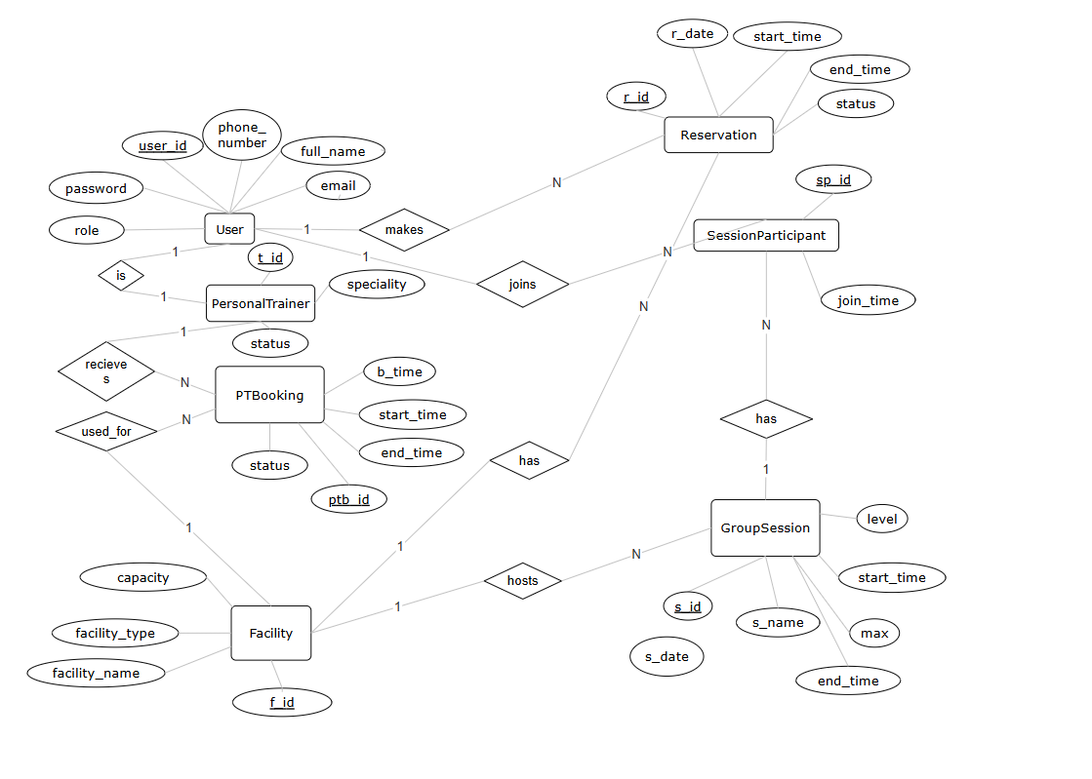
Figure 10. Conceptual Entity–Relationship diagram (Chen notation) showing the seven entities, their attributes, relationships, and cardinalities.

Relational Schema
The ER model maps to seven relational tables. Figure 11 shows the conceptual relational schema with primary keys and foreign-key relationships.
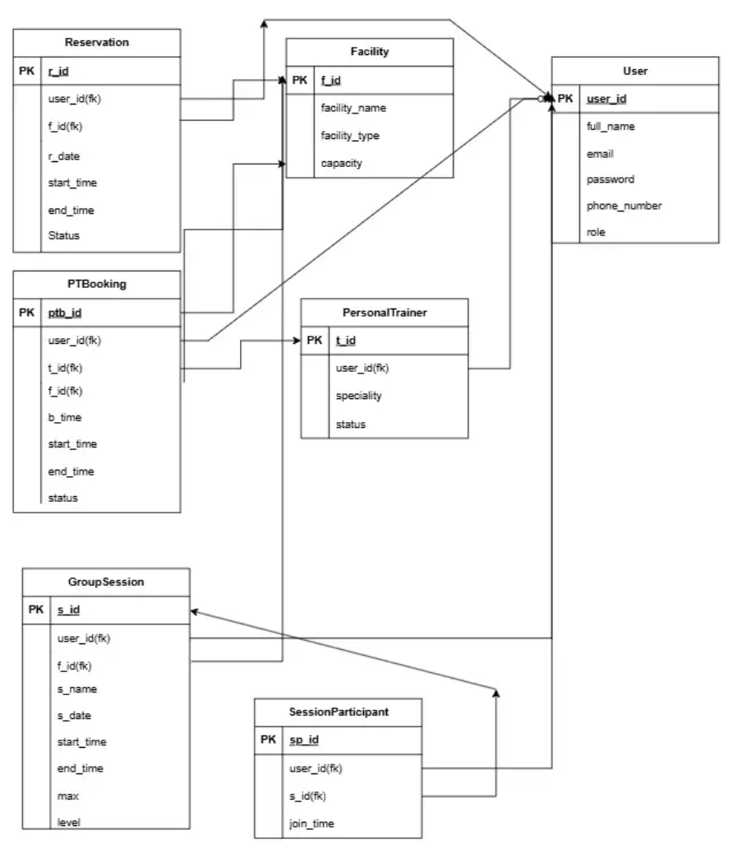
Figure 11. Relational schema — tables with primary keys (PK) and foreign-key (FK) relationships derived from the ER model.

Business Rules (ER Constraints)
- Only @bilgi.edu.tr and @bilgiedu.net email domains are accepted.
- Each email is unique — one account per address.
- The gym area cannot exceed its capacity (10) per time slot; booked ≤ capacity always holds.
- A facility cannot be reserved when booked ≥ capacity (“Full”).
- A user cannot join the same group session twice.
- A user cannot create duplicate bookings for the same trainer.
- A full facility/session remains visible but disabled rather than hidden.
- Cancellation is a soft delete (status = 'Cancelled') to preserve reservation history.
- Passwords are stored only as Werkzeug hashes, never plaintext.

Relationships & Cardinality
- R1: users — create — reservations. User (1) → Reservation (N).
- R2: facility_slots — appear in — reservations. Facility (1) → Reservation (N).
- R3: users — join — group_sessions (via session_participants). User (N) ↔ GroupSession (M).
- R4: users — make — pt_bookings. User (1) → PTBooking (N).
- R5: personal_trainers — receive — pt_bookings. Trainer (1) → PTBooking (N).
- R6: users (instructor) — create — group_sessions. User (1) → GroupSession (N).

CRUD Matrix
UI screen / action | users | facility_slots | group_sessions | personal_trainers | reservations | session_participants | pt_bookings
Register | C | – | – | – | – | – | –
Login | R | – | – | – | – | – | –
Dashboard (load) | – | R | R | R | R | – | –
Facility Booking (browse) | – | R | – | – | – | – | –
Reserve facility | – | U | – | – | C | – | –
Group Sessions (browse) | – | – | R | – | – | – | –
Join session | – | – | U | – | C | C | –
Personal Trainers (browse) | – | – | – | R | – | – | –
Book trainer | – | – | – | U | C | – | C
Cancel reservation | – | – | – | – | U (soft delete) | – | –
My Profile (save) | U | – | – | – | – | – | –
Admin monitoring | – | R | R | R | R | R | R

SQL Tables

Relational Schema Design: Tables + Primary Key / Foreign Key + Normalization
The full DDL is provided in database/schema.sql. Each table is in Third Normal Form.
users
Column | Type | Constraints
id | SERIAL | PK
fullname | VARCHAR(120) | NOT NULL
email | VARCHAR(160) | NOT NULL, UNIQUE, CHECK (Bilgi domain)
password | VARCHAR(255) | NOT NULL (Werkzeug hash)
facility_slots
Column | Type | Constraints
id | SERIAL | PK
facility_name | VARCHAR(120) | NOT NULL
facility_type | VARCHAR(40) | NOT NULL, CHECK IN (‘gym’,‘boxing’,‘basketball’)
slot_time | VARCHAR(40) | NOT NULL
capacity | INTEGER | NOT NULL, CHECK (capacity > 0)
booked | INTEGER | NOT NULL DEFAULT 0, CHECK (booked ≤ capacity)
group_sessions
Column | Type | Constraints
id | SERIAL | PK
session_name | VARCHAR(120) | NOT NULL
instructor | VARCHAR(120) | NOT NULL
schedule | VARCHAR(80) | NOT NULL
participant_count | INTEGER | NOT NULL DEFAULT 0
max_capacity | INTEGER | NOT NULL, CHECK (> 0)
level | VARCHAR(40) | NOT NULL, CHECK IN (‘Beginner’,‘Intermediate’,‘Advanced’,‘All Levels’)
personal_trainers
Column | Type | Constraints
id | SERIAL | PK
trainer_name | VARCHAR(120) | NOT NULL
specialty | VARCHAR(120) | NOT NULL
rating | NUMERIC(2,1) | CHECK (0–5)
session_count | INTEGER | NOT NULL DEFAULT 0
available | BOOLEAN | NOT NULL DEFAULT TRUE
reservations
Column | Type | Constraints
id | SERIAL | PK
user_id | INTEGER | FK → users(id), NOT NULL, ON DELETE CASCADE
reservation_title | VARCHAR(160) | NOT NULL
reservation_date | VARCHAR(40) | NOT NULL
reservation_time | VARCHAR(40) | NOT NULL
status | VARCHAR(20) | NOT NULL DEFAULT ‘Active’, CHECK IN (‘Active’,‘Pending’,‘Cancelled’)
session_participants
Column | Type | Constraints
id | SERIAL | PK
user_id | INTEGER | FK → users(id), NOT NULL, ON DELETE CASCADE
session_id | INTEGER | FK → group_sessions(id), NOT NULL, ON DELETE CASCADE
(composite) | – | UNIQUE (user_id, session_id)
pt_bookings
Column | Type | Constraints
id | SERIAL | PK
user_id | INTEGER | FK → users(id), NOT NULL, ON DELETE CASCADE
trainer_id | INTEGER | FK → personal_trainers(id), NOT NULL, ON DELETE RESTRICT
booking_date | VARCHAR(40) | NOT NULL
booking_time | VARCHAR(40) | NOT NULL
status | VARCHAR(20) | NOT NULL DEFAULT ‘Pending’, CHECK IN (‘Pending’,‘Confirmed’,‘Cancelled’)
(composite) | – | UNIQUE (user_id, trainer_id)
Normalization. 1NF — every attribute is atomic and every table has a primary key; there are no repeating groups. 2NF — all tables use single-column primary keys, so there are no partial dependencies. 3NF — no transitive dependencies: trainer details live only in personal_trainers, facility details only in facility_slots, and reservations reference users by user_id instead of duplicating member data.

Relationships in Relational Form (PK/FK Summary)
- reservations.user_id → users.id (mandatory)
- session_participants.user_id → users.id (mandatory)
- session_participants.session_id → group_sessions.id (mandatory)
- pt_bookings.user_id → users.id (mandatory)
- pt_bookings.trainer_id → personal_trainers.id (mandatory)

Integrity Constraints (Must-have)
- users.email UNIQUE + Bilgi-domain CHECK
- facility_slots: facility_type CHECK; capacity > 0; booked ≤ capacity
- group_sessions: participant_count ≤ max_capacity; level CHECK
- reservations.status CHECK (‘Active’,‘Pending’,‘Cancelled’)
- pt_bookings.status CHECK (‘Pending’,‘Confirmed’,‘Cancelled’)
- UNIQUE (user_id, session_id) on session_participants (no duplicate joins)
- UNIQUE (user_id, trainer_id) on pt_bookings (no duplicate bookings)
- Delete behavior: reservations / session_participants / pt_bookings → CASCADE on user; pt_bookings.trainer_id → RESTRICT

Sample SQL Logic
Representative queries (full set in database/crud_queries.sql):
-- READ: authenticate a user (POST /login)
SELECT id, fullname, email, password FROM users WHERE email = $1;
-- READ: facility slots for the booking screen (GET /api/facilities)
SELECT id, facility_name, facility_type, slot_time, capacity, booked
FROM facility_slots ORDER BY id;
-- CREATE + UPDATE: reserve a facility (POST /api/reserve-facility)
UPDATE facility_slots SET booked = booked + 1 WHERE id = $1;
INSERT INTO reservations (user_id, reservation_title, reservation_date, reservation_time, status)
VALUES ($1, $2, 'Today', $3, 'Active');
-- UPDATE: soft-delete cancellation (POST /api/cancel-reservation)
UPDATE reservations SET status = 'Cancelled' WHERE id = $1;
-- JOIN: trainer booking volume (admin report)
SELECT pt.trainer_name, COUNT(b.id) AS total_bookings
FROM personal_trainers pt
LEFT JOIN pt_bookings b ON b.trainer_id = pt.id
GROUP BY pt.id, pt.trainer_name ORDER BY total_bookings DESC;

API Endpoints
The Flask backend exposes a REST API consumed by the frontend via fetch.
Method | Endpoint | Purpose
POST | /register | Create account (Bilgi-email + hashed password)
POST | /login | Authenticate, return user object
GET | /api/facilities | List facility slots
POST | /api/reserve-facility | Reserve a slot (capacity-checked)
GET | /api/sessions | List group sessions
POST | /api/join-session | Join a session (capacity + duplicate checked)
GET | /api/trainers | List personal trainers
POST | /api/book-trainer | Request a trainer booking
GET | /api/reservations | List reservations (optional ?user_id=)
POST | /api/cancel-reservation | Soft-cancel a reservation
GET | /api/stats | Dashboard KPIs (gym occupancy, open courts, weekly bookings)
Responses are JSON with a success flag and a human-readable message, using correct HTTP status codes (201, 400, 401, 404, 409, 500).

Async Fetch Flow
This section describes how the BilgiFit web application retrieves, updates, and synchronizes data between the user interface and the database using asynchronous communication. Pages do not reload while data is loading; users get immediate feedback; multiple users can interact simultaneously; and the UI stays responsive during network delays.
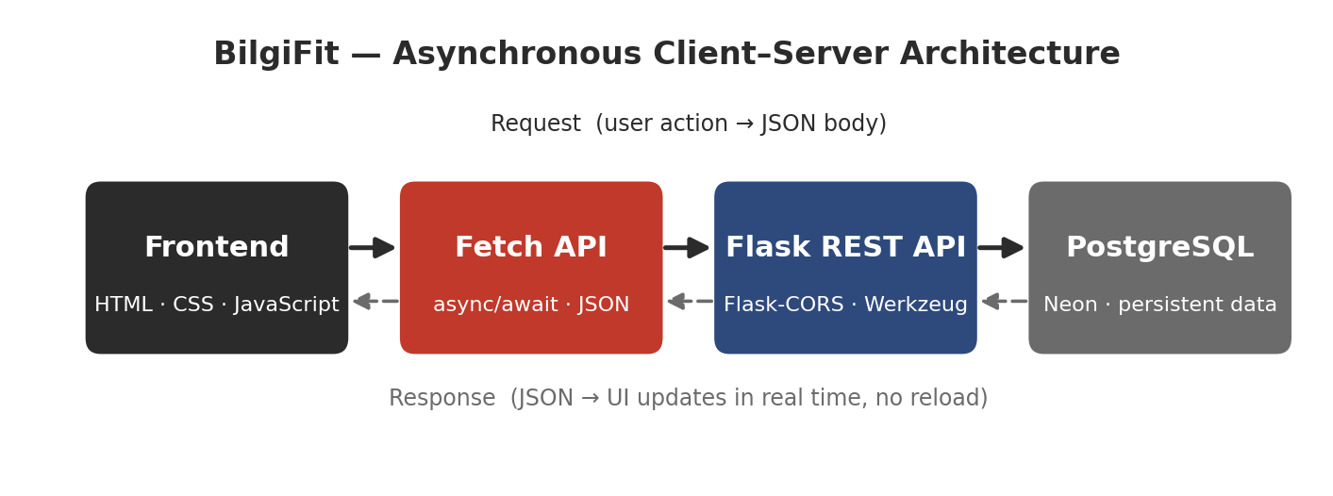
Figure 12. System architecture — the asynchronous client–server data flow between the frontend, the Fetch API layer, the Flask REST API, and the PostgreSQL database.
Core fetch architecture:
Layer | Technology | Responsibility
Frontend | HTML / CSS / JavaScript | UI rendering & user interactions
Communication | Fetch API (async/await) | Sends & receives JSON
Backend | Flask (Flask-CORS, Werkzeug) | Processes logic, validation, hashing
Database | PostgreSQL (Neon) | Stores permanent data
Deployment | Render + Gunicorn | Hosts the live application
Example async flow — reserving a facility (static/dashboard.js):
const response = await fetch("/api/reserve-facility", {
method: "POST",
headers: { "Content-Type": "application/json" },
body: JSON.stringify({ user_id: user.id, facility_id: pendingFacilityId })
});
const data = await response.json();
if (!response.ok) { showToast(data.message); return; }
showToast("Reservation confirmed.");
closeModal();
await loadDashboardData(); // re-fetch + re-render without a page reload
On the server, the corresponding endpoint validates capacity, then updates and inserts atomically:
UPDATE facility_slots SET booked = booked + 1 WHERE id = $1;
INSERT INTO reservations (user_id, reservation_title, reservation_date, reservation_time, status)
VALUES ($1, $2, 'Today', $3, 'Active');
Dynamic content & validation. The dashboard loads facilities, sessions, trainers, and reservations concurrently with Promise.all([...]), then renders capacity bars, participant counts, and Full/Available/Joined/Booked button states from live data. Client-side validation runs before every request: required fields, a Bilgi-email regex, a minimum password length, and password confirmation, each surfaced as an inline error near the relevant input.
Error handling (async safety). Every call is wrapped in try/catch; a failed response surfaces a friendly toast (“Server error.” / “Database connection failed.”) instead of breaking the UI:
try {
const res = await fetch(url);
if (!res.ok) throw new Error("Server Error");
} catch (e) {
showToast("Network issue. Try again.");
}

Accessibility Review
Accessibility was treated as a core design requirement rather than an optional enhancement. The application targets WCAG 2.1 Level AA and supports inclusive use across diverse user groups.
WCAG principle | Implementation
Perceivable | High-contrast charcoal/white/red palette; readable type scale; status shown by text and color (Full / Available / Active / Pending / Unavailable) — never color alone
Operable | Full keyboard navigation; visible focus outlines; click targets at/above 44 px; persistent sidebar reduces memory load
Understandable | Clear labels, short corrective error messages near inputs, consistent layout across screens
Robust | Semantic HTML + ARIA: aria-live="polite" content/toast regions, role="dialog" + aria-modal on the confirmation modal, role="tablist"/role="tab" on facility filters, <label> on all fields
Additional measures: minimum 4.5:1 contrast target; text resizing support; logical focus order; error feedback announced to assistive technologies via live regions; inputs preserve user values on error; simple, step-by-step task flows that minimize cognitive load.

Final Reflection
The biggest challenge of this project was connecting the visual interface to system thinking. BilgiFit began as a set of static screens and grew into a working reservation system backed by a real database and an asynchronous API. Building the data model forced us to think about capacity rules, duplicate prevention, and what “cancel” really means (a status change, not a deletion), and those decisions then shaped the UI — disabled buttons, capacity bars, and confirmation modals all exist because the data model and business rules required them.
Designing the information architecture taught us to organize content by user goal so members can reserve a facility in a few predictable steps. We became more aware of cognitive load, consistency, and recognition-over-recall: small choices in labeling, button placement, and grouping made a large difference in how easy the system felt to use. The accessibility and validation work showed that good UI is not only visual polish — clear labels, keyboard support, and corrective error messages directly affect whether the system is usable for everyone.
On the technical side, mapping each UI action to a CRUD operation, a relational schema, and an asynchronous API made the connection between interface design and system architecture concrete. We now understand how front-end decisions directly affect data integrity, validation logic, and backend implementation.
Overall, this project taught us to approach interface design as a structured engineering and design process rather than a purely visual task — from personas and journeys through data modeling to a deployed, working application. We feel more confident designing user-centered systems, documenting design decisions, and communicating requirements between design and implementation, and we understand how thoughtful UI/UX design directly improves system effectiveness and user satisfaction.

