BilgiFit: Gym Reservation System
CMPE 372 - Final Project Report
Group 3: Ece Doga Gul, Berkay Ozdelice, Baki Kerem Artan, Selim Sengil, Cem Akcicek
Figma Prototype: https://www.figma.com/design/rs4aRJcavArfGf8ne2doTo/BilgiFit-Assignment-3---High-Fidelity-UI?node-id=8-3
Source Code: https://github.com/Becho-png/CMPE372-Bilgifit

1. Project Overview
BilgiFit is a campus gym reservation system for Istanbul Bilgi University sports facilities. The project solves a common campus problem: students, instructors, and staff need a fair and clear way to reserve gym spaces, join group sessions, and manage trainer bookings without confusion or overcrowding.
The value proposition is simple: users can see availability before arriving, reserve a time slot, and receive clear feedback when an action is completed or blocked. For instructors, the system supports organized class creation. For administrators, it provides better visibility into facility usage and capacity.
The system purpose is to connect interface actions with real data structures. The final design includes a dashboard, facility booking, group sessions, personal trainers, profile management, and admin/instructor support areas. The implementation currently contains a Flask backend for authentication and a dynamic HTML/CSS/JavaScript dashboard prototype for the main booking flows.

Problem Definition
Campus sports facilities are shared by many people. Without a structured system, users may arrive when a facility is full or already reserved. This wastes time and creates frustration. The problem matters because sports center access should be predictable, fair, and easy to manage.

Target Users
- Students and gym members who reserve facilities, join group sessions, and book personal trainers.
- Instructors who create classes and reserve facilities for teaching.
- Administrators who monitor usage, occupancy, reservations, and system rules.

Project Scope
- In scope: login/register, facility availability, reservations, gym capacity limit, group sessions, trainer booking, profile editing, dashboard summaries, admin monitoring logic.
- Out of scope: payment processing, nutrition tracking, in-app chat, wearable integration, video training, and multi-branch gym support.

2. Personas

Zeynep Kaya
Field | Description
Age | 21
Role | Active gym user
Goals | Reserve facilities quickly and check live occupancy before arriving at the sports center.
Frustrations | Overcrowded gym spaces, unclear time slots, and losing available slots before booking.
Digital Behavior | Uses mobile and web apps every day and expects fast feedback after each action.
Typical Tasks | Log in, check occupancy, reserve a court, join a group session, and cancel a booking.
System Needs | Simple dashboard, clear capacity data, fast reservation flow, and visible confirmation messages.

Emre Yildirim
Field | Description
Age | 29
Role | Fitness instructor
Goals | Create sessions, reserve teaching spaces, and avoid schedule conflicts.
Frustrations | Manual coordination, last-minute facility conflicts, and unclear participant counts.
Digital Behavior | Uses scheduling tools but prefers a simple class management interface.
Typical Tasks | Reserve the boxing ring, create a class, check participants, and update session details.
System Needs | Instructor panel, conflict checks, participant counts, and session edit controls.

Derya Acar
Field | Description
Age | 35
Role | Sports center administrator
Goals | Monitor usage, keep capacity under control, and understand peak times.
Frustrations | Low visibility into daily usage, overlapping bookings, and manual monitoring work.
Digital Behavior | Comfortable with dashboards, tables, and operational reports.
Typical Tasks | Review reservations, check capacity, resolve conflicts, and monitor facility demand.
System Needs | Admin dashboard, usage data, audit-friendly records, and clear status information.

3. User Stories
- As a student, I want to reserve a gym time slot, so that I can work out without overcrowding.
- As a student, I want to reserve the basketball court, so that I can play at a scheduled time.
- As a student, I want to see facility availability, so that I can choose the best time.
- As a student, I want to join a group training session, so that I can train with others.
- As a student, I want to book a personal trainer, so that I can receive one-on-one support.
- As an instructor, I want to create group classes, so that users can join my sessions.
- As an instructor, I want to see participant counts, so that I can manage capacity.
- As an administrator, I want to monitor reservations, so that I can manage facility usage.
- As a user, I want confirmation after booking, so that I know the action succeeded.
- As a user, I want cancellation support, so that I can free my slot when plans change.

4. User Journey Map
Stage | Actions | Emotions | Pain Points | Opportunities
Login | Opens the app and logs in. | Neutral | Forgotten password may slow the user. | Clear login and error feedback.
Browse Sessions | Opens Group Sessions and scans class cards. | Curious | Long lists can be hard to scan. | Filters and clear metadata.
View Details | Checks instructor, time, level, and available spots. | Interested | Missing capacity information creates uncertainty. | Visible participant count.
Join | Clicks Join Session. | Motivated | Session may become full. | Disable full sessions and update count instantly.
Confirmation | Receives success feedback. | Reassured | User may forget the time. | Show reservation in dashboard.
Pre-Session Check | Checks upcoming reservations. | Prepared | Dashboard can feel crowded. | Clean reservation table.
Attend | Arrives at the correct facility. | Ready | Overcrowding anxiety. | Live occupancy information.
After Session | Plans another session or cancels a booking. | Satisfied | Cancel action can be hidden. | Visible cancel button.

5. Information Architecture
The information architecture groups tasks by user goal. This reduces cognitive load because users do not need to search through unrelated functions.
Module | Main Purpose | Role-Based Access
Dashboard | Shows next reservation, weekly count, occupancy, and quick actions. | All users
Facility Booking | Shows facility slots, filters, capacity bars, and reservation action. | Students, instructors
Group Sessions | Shows instructor-led classes and join/full states. | Students, instructors
Personal Trainers | Shows trainer profiles and booking availability. | Students
My Profile | Shows editable user information and membership status. | All users
Instructor Panel | Creates and manages group sessions. | Instructors
Admin Panel | Monitors usage, reservations, and capacity compliance. | Administrators

Primary Navigation
- Dashboard
- Facility Booking
- Group Sessions
- Personal Trainers
- My Profile

Secondary Navigation
- Dashboard quick actions link to Facility Booking, Group Sessions, and Personal Trainers.
- Facility filters separate Gym, Boxing, and Basketball slots.
- Booking cards use modal confirmation for reservation decisions.

Site Map
- Home/Login -> Dashboard
- Dashboard -> Facility Booking -> Confirmation Modal
- Dashboard -> Group Sessions -> Joined State
- Dashboard -> Personal Trainers -> Booked State
- Dashboard -> My Profile -> Save Feedback
- Dashboard -> Instructor Panel -> Manage Sessions
- Dashboard -> Admin Panel -> Facility Usage and Reservation Monitoring

6. Page Content Inventory
Page | Purpose | Main Content | User Actions
Login/Register | Authenticate campus users. | Email/password fields, tab switch, inline errors. | Submit, switch mode.
Dashboard | Personal overview. | Next reservation, stats, occupancy, quick actions, table. | Search, navigate, cancel.
Facility Booking | Reserve physical spaces. | Filter tabs, facility cards, capacity bars. | Filter, reserve, confirm.
Group Sessions | Join classes. | Session cards, instructor, level, participant count. | Join available session.
Personal Trainers | Book trainer support. | Trainer cards, rating, specialty, availability. | Book trainer.
My Profile | Manage account data. | Editable contact fields and membership card. | Validate and save.
Admin Panel | Monitor system usage. | Reservation log and facility usage summaries. | Read and review.

7. High-Fidelity Prototype
The Figma file contains eight connected high-fidelity screens. The prototype demonstrates consistent visual hierarchy, realistic dashboard components, interactive navigation, and booking state changes.
Accessible Figma link: https://www.figma.com/design/rs4aRJcavArfGf8ne2doTo/BilgiFit-Assignment-3---High-Fidelity-UI?node-id=8-3
Screen | Key Design Decisions
Homepage | Dark hero area, brand introduction, Get Started and Login CTAs.
Login/Register | Centered form, tab switch, inline validation states.
Dashboard | Stat cards, quick actions, occupancy, and reservation table.
Facility Booking | Facility filters, slot cards, capacity bars, disabled Full state.
Group Sessions | Session cards with instructor, schedule, level badge, participant count.
Personal Trainers | Trainer cards with specialty, rating, session count, availability.
My Profile | Editable contact fields and active membership card.
Admin Panel | Usage summaries and reservation monitoring table.

8. Accessibility Review
- Typography uses readable sizes and clear heading hierarchy.
- Color is supported with text labels such as Full, Available, Active, Pending, and Unavailable.
- Buttons and form inputs use large click targets near or above 44 px in the prototype.
- Form errors are placed close to the related input and do not rely only on red color.
- Navigation is grouped in a persistent sidebar to reduce memory load.
- The HTML implementation uses labels, aria-live feedback, role dialog, and role tablist for key UI states.
- The visual system keeps strong contrast between dark surfaces, white cards, and red action states.

9. Dynamic UI and Interaction Logic
Screen | Dynamic Content | Async or State Logic | UI Feedback
Login/Register | Validation messages and auth result. | POST request to Flask route. | Inline errors or success banner.
Dashboard | Reservation list and occupancy numbers. | State refresh after booking/cancel. | Updated table and toast message.
Facility Booking | Filtered slots and capacity bars. | Capacity check before reservation. | Modal confirmation and disabled Full button.
Group Sessions | Participant counts. | Join action updates count. | Joined disabled state.
Personal Trainers | Trainer availability. | Book action changes local state. | Booked or Unavailable state.
My Profile | Editable fields. | Client validation before save. | Inline error or success toast.

10. Database and Data Model
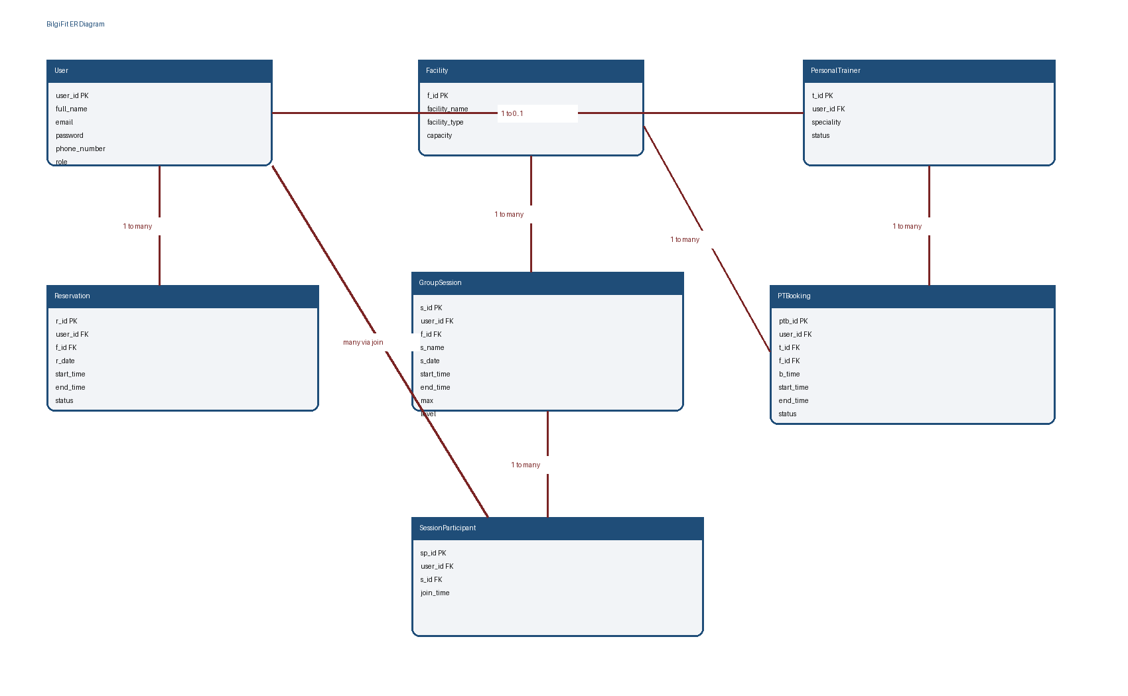
Figure 1. ER diagram for the BilgiFit database model.
Entity | Key Attributes | Purpose
User | user_id PK, full_name, email, password, phone_number, role | Stores students, instructors, trainers, and admins.
Facility | f_id PK, facility_name, facility_type, capacity | Stores gym areas, courts, and boxing rings.
Reservation | r_id PK, user_id FK, f_id FK, r_date, start_time, end_time, status | Stores facility reservations.
GroupSession | s_id PK, user_id FK, f_id FK, s_name, s_date, start_time, end_time, max, level | Stores instructor-led sessions.
PersonalTrainer | t_id PK, user_id FK, speciality, status | Stores trainer-specific data.
PTBooking | ptb_id PK, user_id FK, t_id FK, f_id FK, b_time, start_time, end_time, status | Stores one-on-one trainer bookings.
SessionParticipant | sp_id PK, user_id FK, s_id FK, join_time | Resolves many-to-many relation between User and GroupSession.

Normalization Explanation
The schema satisfies 1NF because each field stores atomic values and each table has a primary key. It satisfies 2NF because tables use single-column primary keys, so partial dependency does not occur. It satisfies 3NF because descriptive data is not duplicated across tables. For example, facility names stay in Facility, while Reservation stores only f_id as a foreign key.

Relationship Logic and Cardinality
- One User can create many Reservations; one Facility can have many Reservations.
- One instructor User can create many GroupSessions; one Facility can host many GroupSessions.
- One User can make many PTBookings; one PersonalTrainer can receive many PTBookings.
- One User can join many GroupSessions and one GroupSession can include many Users through SessionParticipant.

Constraints and Business Rules
- Only @bilgi.edu.tr and @bilgiedu.net email domains are accepted.
- The main gym area cannot exceed 10 active users per time slot.
- A user cannot reserve the same facility and time slot twice.
- Full facility slots and full group sessions must be visible but disabled.
- Cancellation uses status = cancelled instead of deleting reservation history.
- Only instructor-role users can create or edit group sessions.

11. UI-Database Mapping
Screen | Entity | CRUD Action | HTTP | Explanation
Register | User | Create | POST /register | Creates a new user after campus email validation.
Login | User | Read | POST /login | Checks credentials and returns user data.
Dashboard | Reservation | Read | GET /reservations | Lists upcoming active bookings.
Dashboard Cancel | Reservation | Update | PATCH /reservations/:id/cancel | Changes status to cancelled.
Facility Booking | Facility, Reservation | Read | GET /facilities | Loads slots and capacity data.
Reserve Slot | Reservation | Create | POST /reservations | Creates a booking if capacity allows.
Group Sessions | GroupSession, SessionParticipant | Read | GET /group-sessions | Shows session cards and counts.
Join Session | SessionParticipant | Create | POST /group-sessions/:id/join | Adds user to session if not full.
Personal Trainers | PersonalTrainer | Read | GET /trainers | Shows trainer availability.
Book Trainer | PTBooking | Create | POST /trainer-bookings | Creates trainer booking request.
My Profile | User | Update | PATCH /users/me | Updates profile fields after validation.
Instructor Panel | GroupSession | Create/Update/Delete | POST/PATCH/DELETE | Instructor manages class sessions.
Admin Panel | Reservation, Facility, User | Read | GET /admin/reservations | Admin monitors system-wide reservations.

12. Sample SQL Logic

SELECT examples
SELECT r.r_id, f.facility_name, r.r_date, r.start_time FROM Reservation r JOIN Facility f ON r.f_id = f.f_id WHERE r.user_id = 12 AND r.status = 'active' ORDER BY r.r_date, r.start_time;
SELECT f.facility_type, COUNT(r.r_id) AS active_reservations FROM Facility f LEFT JOIN Reservation r ON f.f_id = r.f_id AND r.status = 'active' GROUP BY f.facility_type ORDER BY active_reservations DESC;
SELECT facility_name, capacity FROM Facility WHERE facility_type = 'basketball' ORDER BY facility_name;

INSERT examples
INSERT INTO User (full_name, email, password, phone_number, role) VALUES ('Zeynep Kaya', 'zeynep@bilgi.edu.tr', '<hashed_password>', '+905550103720', 'student');
INSERT INTO Reservation (user_id, f_id, r_date, start_time, end_time, status) VALUES (12, 3, '2026-06-04', '17:00', '18:00', 'active');
INSERT INTO SessionParticipant (user_id, s_id, join_time) VALUES (12, 5, NOW());

UPDATE examples
UPDATE User SET phone_number = '+905551112233' WHERE user_id = 12;
UPDATE Reservation SET status = 'cancelled' WHERE r_id = 44 AND user_id = 12;
UPDATE GroupSession SET max = 15, level = 'Intermediate' WHERE s_id = 5 AND user_id = 21;

DELETE examples
DELETE FROM SessionParticipant WHERE user_id = 12 AND s_id = 5;
DELETE FROM PTBooking WHERE ptb_id = 18 AND status = 'pending';
DELETE FROM GroupSession WHERE s_id = 7 AND user_id = 21;

JOIN examples
SELECT gs.s_name, u.full_name AS instructor, f.facility_name FROM GroupSession gs JOIN User u ON gs.user_id = u.user_id JOIN Facility f ON gs.f_id = f.f_id;
SELECT pt.t_id, u.full_name, pt.speciality, COUNT(pb.ptb_id) AS booking_count FROM PersonalTrainer pt JOIN User u ON pt.user_id = u.user_id LEFT JOIN PTBooking pb ON pt.t_id = pb.t_id GROUP BY pt.t_id, u.full_name, pt.speciality;
SELECT r.r_id, u.full_name, f.facility_name, r.r_date, r.status FROM Reservation r JOIN User u ON r.user_id = u.user_id JOIN Facility f ON r.f_id = f.f_id WHERE r.status = 'active' ORDER BY r.r_date DESC;

13. Basic Front-End Implementation
The GitHub project contains a Flask app with separate HTML templates and static JavaScript/CSS files. The current implementation includes:
- Login/Register screen with Bilgi email validation and asynchronous form submission.
- Flask /register and /login routes with hashed password support.
- Demo in-memory auth fallback when DATABASE_URL is not configured, while still supporting PostgreSQL when it is configured.
- Dynamic dashboard with Facility Booking, Group Sessions, Personal Trainers, and My Profile sections.
- Facility filters, capacity bars, disabled Full state, modal confirmation, toast feedback, and profile validation.
- Responsive layout checked on desktop and mobile viewport.
Repository: https://github.com/Becho-png/CMPE372-Bilgifit

14. Final Reflection
The biggest challenge was connecting the visual interface with system thinking. At first, BilgiFit was mostly a screen design project. During the final stage, the project became more complete because each UI action was connected to an entity, CRUD operation, validation rule, or SQL example.
The project changed from simple static screens into a more realistic reservation system. The final implementation now shows how capacity, disabled states, confirmation messages, and profile validation can work in the browser. The report also combines the previous assignments into one clearer structure.
We learned that UI/UX design is not only about making screens look good. A strong interface must also explain system rules, prevent errors, and guide users with clear feedback. Database design also affects the interface because the screen can only show useful information if the data model is clear.

