**Smart Home System.**



**Name: Abduraufov Bekhzod.**

**Student Number: 201739082.**

**Course: IoT Programming.**

**Professor**: **LEE Kang Yoon**



I used Python Tkinter library in order to make the GUI if Smart Home System. It consists of 6 buttons:

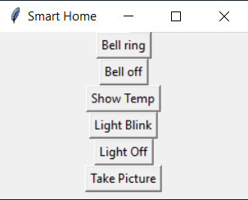

1. Bell ring button is the button which triggers the buzzer to make the sound. When this button is clicked, it calls the bell Ring function:

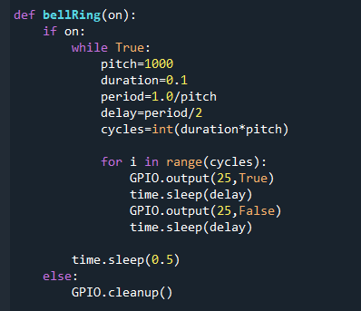

This function gets a single Boolean value as an input to check if the current state of the buzzer is on. If it is on makes the sound. I used the buzzer function that we have studied during the lecture.

if the inputs is false the calls the GPIO.cleanup() that shuts the buzzer down.

1. The second button is Bell of and it uses the same function but when button is clicked, it calls the bell Ring function with the false value:

3. The third button is Show Temp button which demonstrates current temperature in LCD. However, because of unknown reason I could not configure my LCD, but still I implemented the function:

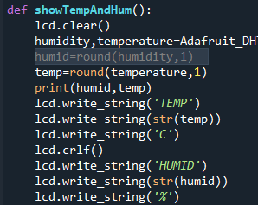 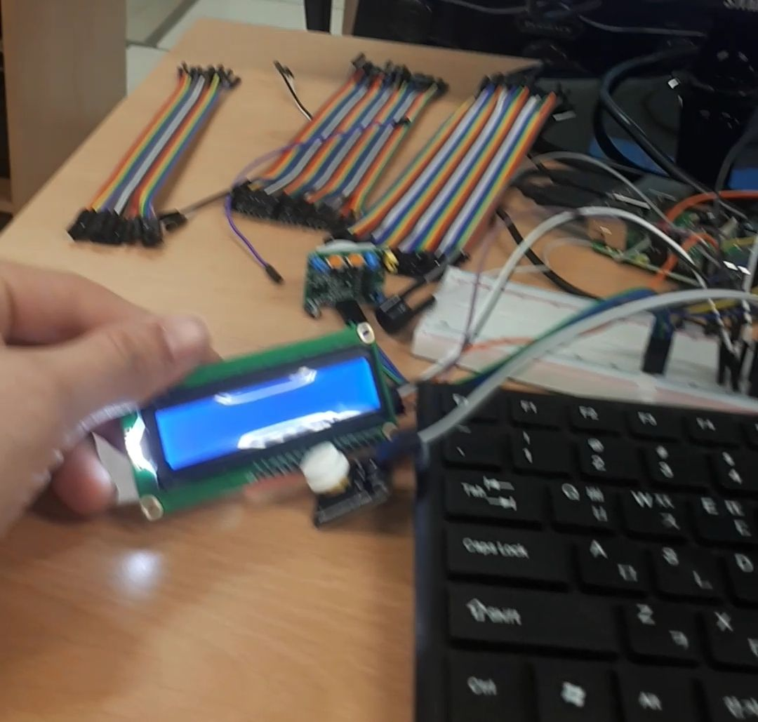

1. Next buttons are light blink of light off buttons which triggers the emergency light on or off respectively:

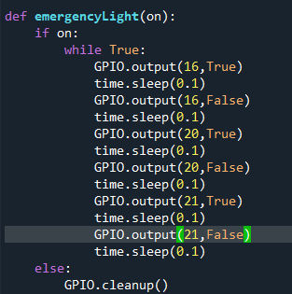

this function has the same logic as the bell ring function which check the same of light depending of the value of input parameter which could be either true or false value.

The last Button is take picture button which calls the camera function:

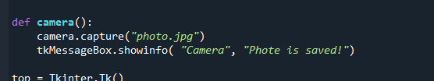

As can be seen from the above picture the capture the photo and shows up a message in the GUI use show info function of Tkinter library.

To sum up, this the general view of my code:

