IRP: ACS Access Control System (ACS)

# Introduction

Advantech Ltd., a company for manufacturing and delivery of sensitive and high value bottled liquids, have decided to build a new manufacturing facility that will automate the manufacturing process within the existing facility, provide advanced system for monitoring and controlling environmental conditions and access and security control.

This project is to develop this solution leveraging IoT concepts, synchronous programming and system-level designing. This is a milestone report documenting the progress and decisions made for this project. This document is to give the details to a single component, the Access Control System.

# Brief

*3.4. Safety and Access Control System – ACS Access Control System (ACS) controls movement of the personnel in the space. First, it authorises entry/exit from the Facility by the use of access cards and biometric information, the latter being only an option. Also, all personnel and visitors are issued a carry-on badge that enables identification and location of the personnel by using RF-based localisation system. Different access rights are assigned for Office section and Manufacturing section. Presence of personnel in the Manufacturing section is strictly controlled. Also, presence of personnel in the zones that directly associated with the manufacturing (ABS and around ABS) is detected and bottling process suspended as there must be no humans in the vicinity of the machines and the bottling process. Virtual boundaries, implemented using laser beams, are enforced around the ABS.*

# Overall Design

Below is a diagram of the overall design with the ACS highlighted. As can be seen the ACS will run independent of other subsystems that handle other aspects of the facilities. Communication is achieved by establishing channels to talk internally and externally, with the aid of links to help with timing and interfacing

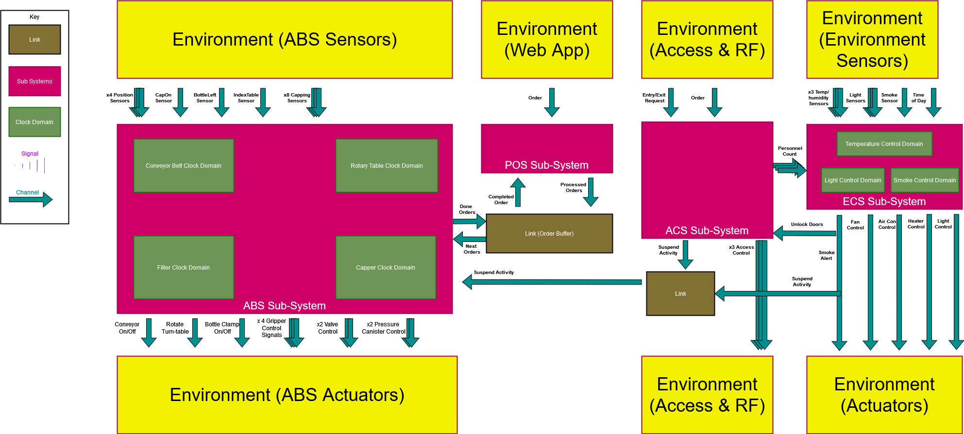

# Clock Domains

Below is a brief explanation of some of the main clock domains that are planning to be implemented to ensure the operation of the ACS.

## Facility Access Domain

**Input Signals**

* onOff (pure signal) – While signal high, operates.
* facReq (Integer) – Facility Request. When high, shows access has been requested, ID of request must be passed into domain

**Variables**

* FacAccessList : array of Integer – Will hold all the possible ID values that are approved to access facilities through the front door

**Output Signals**

* facApprov(pure signal) – High when access has been allowed. While sustained facility door is unlocked

**Operation**

1. While onOff signal low, no operation. When high operation enabled
2. Wait for request to be passed in with ID value
3. ID value is referenced in data structure holding eligible IDs
4. If match found among eligible IDs, output signal sent to unlock door. Door is left unlock for a few moments and then locked again. If no match no action
5. Loop back to 1.

## Main Office Access Domain

**Input Signals**

* onOff (pure signal) – While signal high, operates.
* officeReq (Integer) – Main Office Request. When high, shows access has bee requested, ID of request must be passed into domain

**Variables**

* OfficeAccessList : array of Integer – Will hold all the possible ID values that are approved to access facilities through the front door

**Output Signals**

* officeApprov(pure signal) – High when access has been allowed. While sustained facility door is unlocked

**Operation**

1. While onOff signal low, no operation. When high operation enabled
2. Wait for request to be passed in with ID value
3. ID value is referenced in data structure holding eligible IDs
4. If match found among eligible IDs, output signal sent to unlock door. Door is left unlock for a few moments and then locked again. If no match no action
5. Loop back to 1.

## Manufacturing Access Domain ABS

**Input Signals**

* onOff (pure signal) – While signal high, operates.
* manReq (Integer) – Manufacturing Zone Request. When high, shows access has been requested, ID of request must be passed into domain

**Variables**

* ManAccessList : array of Integer – Will hold all the possible ID values that are approved to access facilities through the front door

**Output Signals**

* manApprov(pure signal) – High when access has been allowed. While sustained facility door is unlocked

**Operation**

1. While onOff signal low, no operation. When high operation enabled
2. Wait for request to be passed in with ID value
3. ID value is referenced in data structure holding eligible IDs
4. If match found among eligible IDs, output signal sent to unlock door. Door is left unlock for a few moments and then locked again. If no match no action
5. Loop back to 1.

## Restriction Domain

**Input Signals**

* onOff(pure signal) – While signal high, operates.
* boundDetect(pure signal) – High while laser is undisturbed. Someone crossing the laser will drive signal low

**Output Signals**

* suspend(pure signal) - Will be outputted so that it can be sent to ABS to pause.

**Operation**

1. While onOff signal low, no operation. Otherwise operate whilst signal is high
2. Await for boundDetect to go low, this will signal that someone has entered the restricted area.
3. While boundDetect low, sustain the suspend signal so no ABS is notified to not operate
4. Once boundDetect high again, halt emitting suspend signal.

## Localization Domain

**Input Signals**

* onOff(pure signal)
* ping(valued signal, Integer)
* appendOrRemove(valued

**Variables**

* PersonList : array of Integer – Will hold all theID values (and thus people) who are currently within facilities and are detected. 2 dimensional with the data stored including the unique IDs, and the zone they were last scanned for.

**Output Signals**

* trackingList (valued signal, array of Integer) - Will output the current PersonList

**Operation**

1. While onOff signal low (0), no operation otherwise will cycle through operation
2. When ping single present, take the values and store them temporarily
3. Use ID from ping signal to find related elements in the PersonList
4. If required update the elements, changing the zone of which is stored for an entry
5. If appendOrRemove signal high, take values and depending on values, add or remove an entry to PersonList.