# IRP 1: Final Report

COMPSYS 704: Advanced Embedded Systems

Project 1

Group 7

Rufaro Manjala (rman429)

# 1. Introduction ­

Advantech Ltd., a company for manufacturing and delivery of sensitive and high value bottled liquids, have decided to build a new manufacturing facility that will automate the manufacturing process within the existing facility, provide advanced system for monitoring and controlling environmental conditions and access and security control.

This project is to develop this solution leveraging IoT concepts, synchronous programming and system-level designing. The chosen language and environment to create this is System J and Java. This is a final report documenting the final design of Access Control System (ACS). This report includes details on the ACS-specific brief and an overview of the design.

# 2. Brief

## Overall Brief

The solution is facility wide. Incorporated in multiple parts of the physical facility as well as in the purpose of the facility, it has the following requirements:

* A developed Automated Bottling System (ABS), as this is facility’s purpose, to output orders of bottled goods
* Be able to monitor who is within the facility as well as specifically where they are
* Be able to provide security in the form of only allowing selected personnel in general and specific areas of the facility (e.g. restricted access to the main office)
* Continuously monitor and adjust the facility's climate factors such as humidity and heat to desired conditions. Even able to adjust the climate of specific areas differently within the facility
* Receive and process orders from registered customers for bottling

These are the high-level requirements from which more detailed and specific requirements stem from.

## ACS Brief

Specifically for the ACS it was required to satisfy the following criteria

* Authorise the entry/exit into facility with access cards.
* Identifies and locates personnel by using RF-based localisation system.
* Different access rights assigned for Office section and Manufacturing section.
* Presence of personnel in the Manufacturing Section controlled, detection in this zone and near ABS will issue a suspend command to ABS using virtual boundaries

# 3.Design

The following section explores the design the ABS. The entire ABS system was made with two sides to it. One side being the System J side where all the logic and computation was done. The other side was Java, using libraries such as Java Swing to provide a graphical user interface (GUI) to portray the workings of the system. The following section goes into detail of the overall design on both sides, and how it connected with the wider system of systems.

It must be noted that description of clock domain signals, variables and in depth operation steps will not be found within this document. For those details, refer to the related compendium that should have come included with this report.

## Overall Design

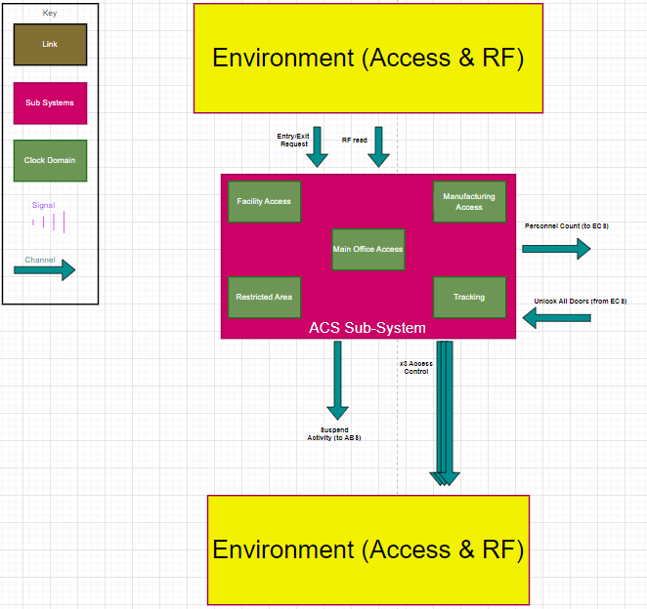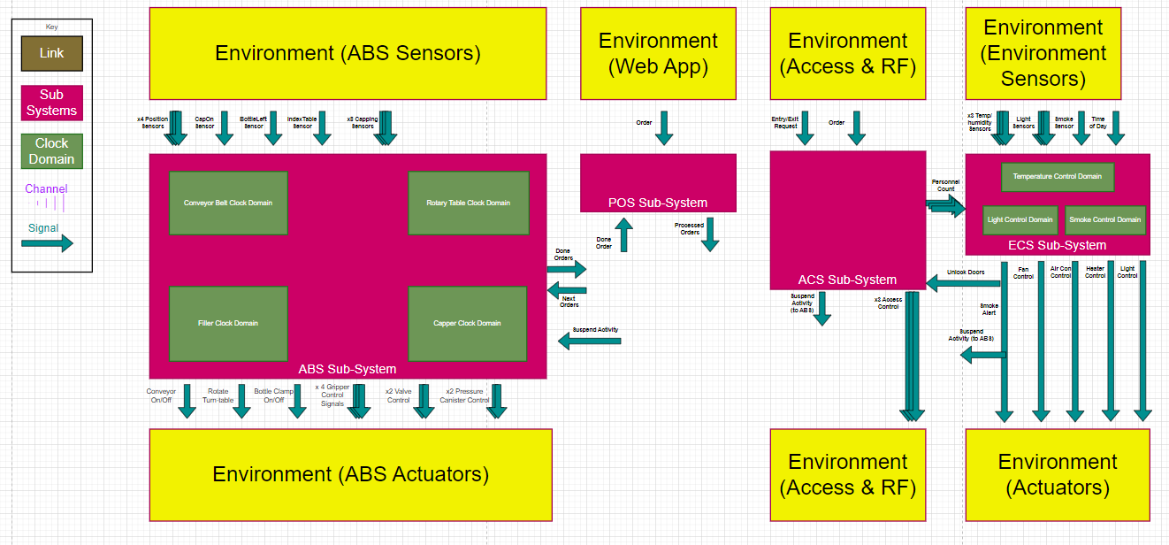As shows by the below <<Figure 1>>, the overall design is a collection of sub-systems running independently yet working with each other to fulfill the entire brief. A decentralized approach was chosen to allow for sake of modularity, ease of task allocation, and to reduce the chances of harmful coupling. While this report focuses on the ABS, seeing the entire solution at a high level assists in providing understanding where the ABS fits with everything.

Figure 2 - ACS design

Figure 1 - Overall design

The above figure Figure 2 shows the specific design of the ACS.

Figure - ACS diagram

## ACS System J

## ACS GUI

## Interfacing with the ABS

# 4.Conclusion