Parking Structure Management System
(PSMS)

Software Requirements Specification

SRS Version 2.0

Team T01
12 February 2026

Beckett Dunlavy (manager)
Aditya Chauhan
Christian Maestas
Oscar McCoy
Isaac Tapia

CS 460 Software Engineering
Table of Contents

1 Introduction 3
2 General Description 3
2.1 Description 4
3 Specific Requirements 4
3.1 External Interfaces 5
3.1.1 Input Events 5
3.1.2 Output Events 6
3.2 Control Logic 7
3.2.2 Entry Gate Dynamic Diagram 9
4 System Constraints 9
5 Definition of Terms 11
6 Conclusion……………………………………………………………………………………………. 12
7 References 13

1 Introduction
Parking structures provide concentrated parking capacity for high-demand areas such as campuses and urban centers. For such facilities to operate effectively, the system responsible for admission control and availability reporting must maintain a consistent and accurate representation of occupancy across multiple floors. In practice, availability is affected not only by vehicles occupying parking spots, but also by vehicles that have entered the structure and are traveling to locate a spot. If these intermediate conditions are not represented in the system state, the structure may admit vehicles beyond practical capacity or display incorrect availability, leading to congestion and a degraded driver experience.
The purpose of this Software Requirements Specification (SRS) is to define the functional and non-functional requirements for the Parking Structure Management System (PSMS). PSMS is a software-controlled parking management system intended to support the operation of a multistory parking facility by processing sensor and gate inputs to maintain accurate floor-level and structure-level availability. The system supports controlled entry based on capacity, real-time availability reporting through displays and stall indicators, and safe operation under abnormal conditions such as emergencies or power loss.
This document is organized as follows. Section 2 provides a general description of PSMS and its operating context. Section 3 specifies the system’s requirements, including external interfaces, use cases, and control logic. Section 4 lists design constraints. Section 5 defines terminology used throughout the SRS. Section 6 concludes the document.

2 General Description
The Parking Structure Management System (PSMS) manages vehicle flow and occupancy information for a multistory parking structure. The system maintains a consistent internal view of parking availability across floors by processing input signals from the environment and producing outputs that communicate status to drivers and control facility behavior.
PSMS operates using a set of external inputs, such as gate detection/passage signals and parking stall occupancy sensing. Based on these inputs and the current system state, PSMS updates its internal counts (including vehicles currently In Transit versus Parked) and generates outputs such as entry/exit gate commands, per-spot indicator light status (red/green/blue), and floor-level/entrance availability displays. The system is designed so that entry is only permitted when capacity allows, while exit remains available under normal operation.
PSMS also supports safe operation during abnormal conditions. When an emergency signal or power fault is detected, PSMS shifts to a safe operating behavior that prevents new admissions while allowing vehicles already inside the structure to exit safely. The specific behaviors and interfaces that support these functions are detailed in Section 3.

2.1 Description
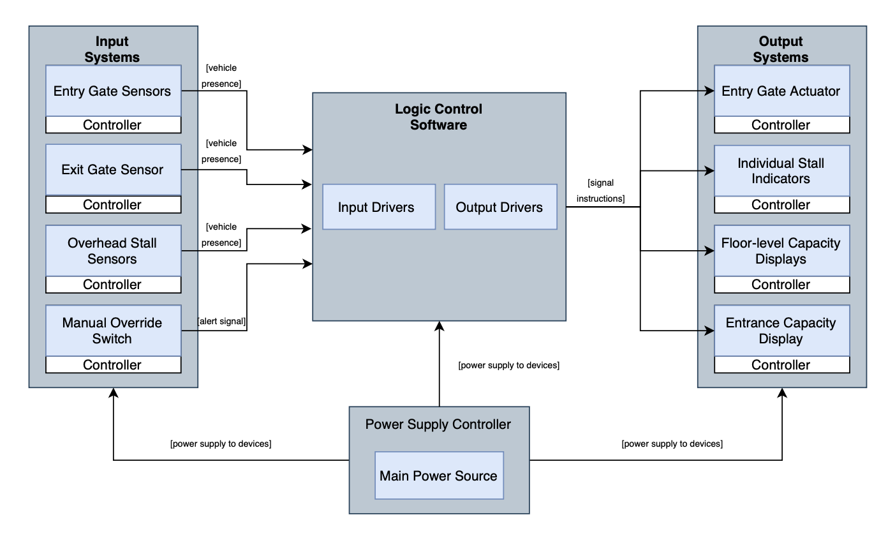
Figure 1: PSMS Physical Systems Block Diagram [4]

Figure 1 illustrates the operational relationships between the input and output systems. The Power Supply Controller provides the necessary electrical feed to the input systems, the output systems, and the Logic Control Software to ensure continuous functionality. Data flows from the input systems, including the Entry Gate Sensor, Exit Gate Sensor, Overhead Stall Sensors, and a Manual Override Switch, to the Logic Control Software for processing. Based on the system logic, instructions are then sent to the output systems to operate the Entry Gate Actuator and update visual feedback through the Individual Stall Indicators, floor level capacity displays, and entrance capacity displays.

3 Specific Requirements

The PSMS must process a variety of input and output signals in order to manage vehicle flow, track occupancy, and ensure safe operation of the parking structure. This section specifies the external interfaces that the PSMS interacts with and the signals exchanged between the system and its environment. The Black Box Figure provides a logical diagram of all system input and output signals.

The PSMS receives input signals from gate sensors, parking spot sensors, the power monitoring unit, and an authorized override control panel. Based on its internal logic and the current system state, the PSMS produces output signals that control gate actuators, overhead spot indicators, digital availability displays, emergency systems, and operator notifications. Each interface is described in terms of its source or destination device, the signal it carries, and its role in maintaining the system state.

3.1 External Interfaces
In order to manage vehicle entry and exit, track real-time occupancy, and respond to emergency conditions, the PSMS must interact with a set of external interfaces. The external devices inform the PSMS about the current state of the parking structure in terms of vehicle presence, spot occupancy, and power status. The PSMS processes the information it receives and reacts by controlling gate actuators, updating visual indicators, refreshing availability displays, and activating emergency protocols as needed. The interfaces are organized below into input events (Section 3.1.1) and output events (Section 3.1.2).

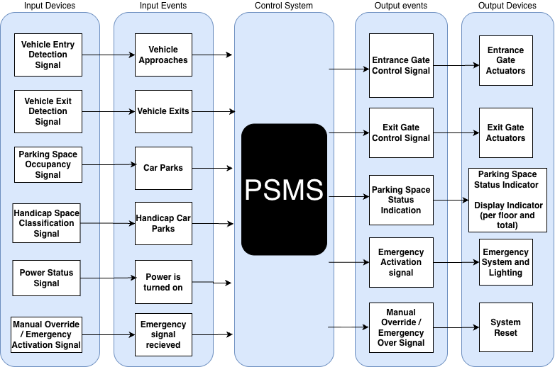
Figure 2: Logical Diagram

3.1.1 Input Events
Input events represent signals from external devices that inform the PSMS about changes in the parking structure's physical state. These events drive the system's internal state transitions and determine the appropriate output actions.

Vehicle Entry Detection Signal
Source Device: Entry Gate Sensor
Produced when a vehicle is detected at the entrance of the parking structure. This signal notifies the PSMS that a vehicle has arrived and is requesting access. Upon admission, the vehicle is registered to the In-Transit state.
Vehicle Exit Detection Signal
Source Device: Exit Gate Sensor
Produced when a vehicle is detected leaving the parking structure. This signal informs the PSMS that a vehicle has departed, allowing the system to decrement the appropriate internal counts of In-Transit vehicles.
Parking Space Occupancy Signal
Source Device: Binary Spot Sensor
Indicates the current state of an individual parking space as either Occupied or Available. Each sensor is mapped to a specific floor and spot identifier. This signal is used to determine parking availability, update accurate counts per floor, and control the overhead parking space status indicators.
Handicap Space Classification Signal
Source Device: Binary Spot Sensor (ADA-designated)
Identifies which parking spaces are designated as ADA-accessible. This signal allows the PSMS to apply the blue status indicator to the corresponding overhead light and to maintain accurate reporting of handicap space availability on a per-spot basis.
Power Status Signal
Source Device: Power Monitoring Unit
Reports the operational status of the parking structure's power supply. If a power failure or abnormal condition is detected, this signal triggers the PSMS to initiate emergency protocols and maintain safety.
Manual Override / Emergency Activation Signal
Source Device: Control Panel (Authorized Personnel)
Allows authorized personnel to place the parking structure into an emergency or maintenance mode. This signal may override normal system behavior to ensure safety and accessibility.

3.1.2 Output Events
Output actions are performed by the PSMS in order to control devices within the parking structure. These actions are produced after processing the input events the system has received and evaluating the current internal state. Output actions control physical gate mechanisms, visual indicators, digital displays, emergency systems, and operator notification channels.
Entrance Gate Control Signal
Destination Device: Entrance Gate Actuators
Determines if vehicles are permitted to enter the parking structure. This output signal is based on the current structure's capacity, parked vehicle count, and vehicles in transit. The gate opens when space is available and remains closed when the structure is at capacity.

Exit Gate Control Signal
Destination Device: Exit Gate Actuators
Controls the exit gate sensor. This output signal operates without capacity restrictions and ensures smooth and efficient vehicle departure from the parking structure. This signal also allows overall counts to be updated accurately.
Parking Space Status Indication
Destination Device: Parking Space Status Indicator
Communicates the current state of each parking spot, which includes available, occupied, and handicap status. This output signal enables the visual representation of parking availability throughout each floor of the parking structure using color-coded overhead lights: red for occupied, green for available, and blue for ADA-accessible available.
Emergency Activation Signal
Destination Device: Emergency System and Lighting
Initiates emergency behavior within the system during occurrences of power outages or unsafe conditions. This includes activating emergency lighting behavior and restricting normal system operation by not allowing any new vehicles into the structure.
Manual Override / Emergency Over Signal
Destination Device: System Reset Device
Signals the end of emergency mode. Once the emergency situation has been resolved and authorized personnel confirm safe conditions, this signal restores the PSMS to normal operation and re-enables standard admission logic.

3.2 Control Logic
In this section, we use OMT dynamic models to demonstrate our technical approach. There are two diagrams for the entry gate and the emergency mode. The global dynamic diagram demonstrates the interaction between the diagrams/modes.

3.2.1 Global Dynamic Diagram
The global dynamic diagram, Figure 3, shows the logical flow of the PSMS’s top-level. The system initializes and activates its entry gate, which operates normally unless the emergency protocol is
triggered. If the emergency protocol is triggered, then the system must be reinitialized manually.
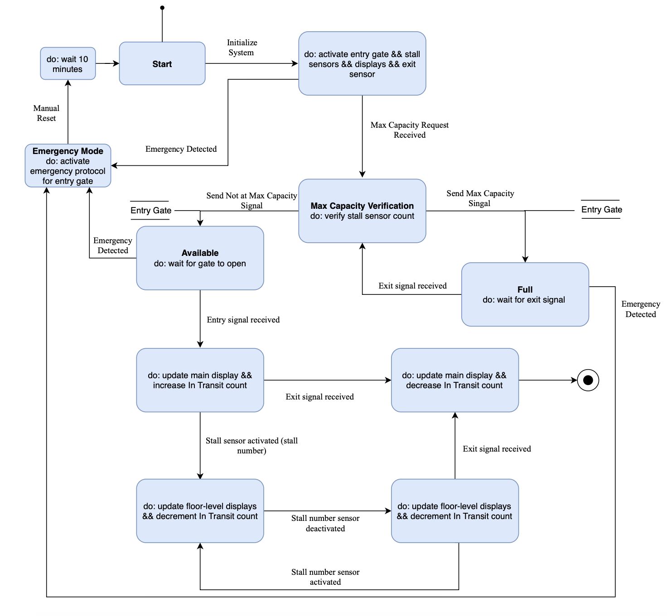
Figure 3: Global Dynamic Diagram

3.2.2 Entry Gate Dynamic Diagram
The Entry Gate Dynamic Diagram, Figure 4, shows the logical flow of the normal operation mode of the entry gate. The diagram describes the conditions and events that trigger when a vehicle approaches and enters the parking structure.
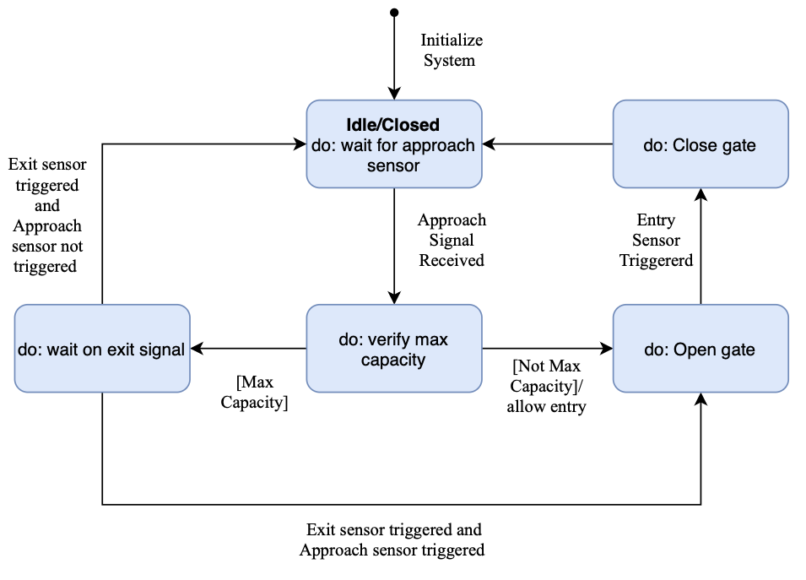
Figure 4: Entry Gate Dynamic Diagram

4 System Constraints
The design and implementation of the Parking Structure Management System are governed by a set of legal mandates, physical hardware limitations, and environmental safety protocols in order to follow federal and local requirements. These constraints define the operational envelope within which the software must maintain a consistent and reliable state.

Legal and Regulatory Constraints
The PSMS must comply with federal, state, and local regulations for public parking facilities in Albuquerque, New Mexico.

- ADA Accessibility Standards (Federal/State)
  - The structure must provide a minimum of eight designated disabled parking spaces for a facility with 101–300 total spaces [1].
  - At least one of every six accessible parking spaces (or fraction thereof) must be "Van Accessible" [2].
  - Accessible spaces must be a minimum of 12 feet wide, or 8.5 feet wide with an adjacent 3.5-foot access aisle. Van access aisles must be a minimum of 8 feet wide [1][3].
  - Surface slopes for disabled parking spaces and access aisles shall not exceed 1:20 (5% slope) in any direction [1].
- Signage Regulations (State/Local)
  - Each disabled parking space must be identified by a conspicuously posted upright sign (at least 12 by 18 inches) showing the international symbol of accessibility [1].
  - Signs must explicitly state: “Violators are subject to a fine and/or towing” [2]
- Parking Stall and Aisle Dimensions (Local)
  - Standard parking stalls must meet a minimum dimension of 8.5 feet in width and 18 feet in length [3].
  - Small car/compact spaces are permitted for up to 25% of the total spaces if the premises contain more than 20 spaces, with minimum dimensions of 7.5 feet by 15 feet [3].
  - Two-way traffic drive aisles must maintain a minimum width of 22 feet [3].
Operational and Physical Constraints
The PSMS is constrained by the physical characteristics of the structure and the limitations of the deployed sensing technology.
- Fixed Structural Capacity: The software must not "over-admit" vehicles beyond the fixed number of physical parking spots per floor defined in the system initialization.
- Binary Sensor Limitations
  - Each spot is equipped with a binary sensor (occupied/free).
  - The "Motorcycle Problem": Inductive or ultrasonic binary sensors may fail to detect small vehicles or metal masses, potentially resulting in an incorrect "green" (available) light for an occupied spot.
  - Positioning: Sensors only report occupancy if a vehicle is parked directly within the sensor's field of detection. Vehicles parked across two spots may incorrectly trigger two "occupied" states or fail to trigger either accurately.
- Signage Visibility and Height: All internal level displays and overhead spotlights must be mounted to maintain a minimum vertical clearance (typically 7 to 8 feet) and must be positioned to remain visible to drivers while in motion within the 22-foot-wide drive aisles.
- Maximum Drive Aisle Length: Internal drive aisles are constrained to a maximum length of 400 feet without a circulation break to discourage unsafe vehicular speeds [3].

Environmental Constraints
The PSMS must operate within the following environmental boundaries:
- Operating Environment: Sensors and displays must be rated for the Albuquerque climate, including high thermal ranges and potential dust interference, which may degrade ultrasonic sensor accuracy over time.

5 Definition of Terms
- ADA (Americans with Disabilities Act): Federal legislation that mandates specific design standards for accessible parking, including stall width and signage.
- Aisle: The driving path within the parking structure used for vehicle circulation between parking stalls.
- Binary Sensor: A hardware device installed in a parking spot that reports one of two states: occupied or free.
- DPM (Development Process Manual): The City of Albuquerque’s regulatory document that defines standard dimensions for parking infrastructure.
- Egress: The action of leaving the parking structure, specifically prioritized during emergency scenarios.
- Fail-Safe: A design feature that ensures the system defaults to a safe state (e.g., closing entrance gates) in the event of a power or software failure.
- Floor-Level Capacity: The maximum number of vehicles permitted on a specific level of the structure, determined by the total number of physical parking stalls available on that floor.
- Input Events: Signals from external devices that inform the PSMS about changes in the parking structure's physical state and drive the system's internal state transitions.
- Internal State: The software’s real-time "memory" or count of occupied spots and admitted vehicles.
- In-Transit: A core vehicle state representing a vehicle that has passed through an entry gate but has not yet been detected by a parking sensor. This is a software-calculated value derived from the difference between the gate transactions and occupied spots.
- Output Actions: Actions performed by the PSMS to control devices within the parking structure (e.g., gates, visual indicators, displays) after processing the input events.
- Parked: A core vehicle state representing a vehicle that has been detected by an individual parking spot sensor as Occupied.
- PSMS (Parking Structure Management System): The complete software and hardware control system responsible for tracking capacity and vehicle flow.
- Stall: An individual designated area within the parking structure intended for the parking of a single vehicle.
- Structure-Level Capacity: The total maximum occupancy of the entire facility. This value is used to trigger “Full” status at entry gates and is the sum of all Floor-Level Capacities.
- Van Accessible: A specific type of ADA parking space that includes a wider access aisle to accommodate wheelchair lifts.
6 Conclusion

This SRS defines the requirements for the Parking Structure Management System (PSMS) and serves as the baseline for design, implementation, and testing. Because parking availability depends on both parked vehicles and vehicles moving within the structure, PSMS must maintain a consistent multi-floor occupancy state to prevent incorrect displays and over-admission. Accordingly, this document specifies the required external interfaces, use cases, and control logic that govern gate behavior, occupancy tracking, real-time availability outputs, and safe operation during emergency or power-failure conditions. Future project work should use this SRS as the source of truth when validating system behavior and resolving requirement ambiguities.

7 References
[1] New Mexico Administrative Code, Title 14, Chapter 16, Part 3: Albuquerque Uniform Administrative Code and Technical Codes.
[2] New Mexico Administrative Code, Title 14, Chapter 7, Part 2: 2021 New Mexico Commercial Building Code.
[3] City of Albuquerque, Development Process Manual (DPM), 2020 Revision.
[4] Team T11, "Physical Systems Block Diagram," T11_BlockDiagram11.pdf, CS 460 Software Engineering, University of New Mexico, Fall 2026.

