**SETUP**

1. Unzip the Project in the path of your choose. In my case I will do it in /opt
2. Cd to the folder path of the unzipped project (where the docker-compose.yml file is).
3. Lets deploy the Project now with:

docker-compose up -d

1. Giving permissions to storage/logs and storage/framework

chmod 777 -R storage/logs  
chmod 777 -R storage/framework

1. Installing composer dependencies:

docker exec -it -u 0 laravel **php composer install**

1. Installing migrations

docker exec -it -u 0 laravel **php artisan migrate:install**

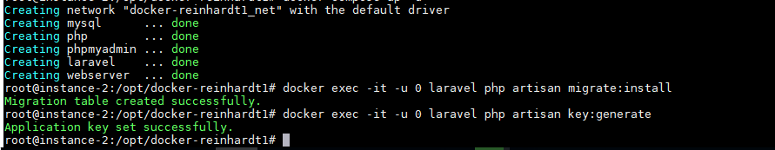

docker exec -it -u 0 laravel **php artisan migrate:refresh**

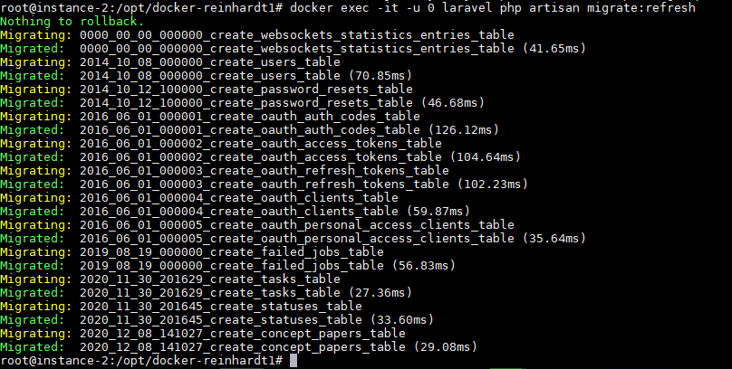

1. Installing Passport

docker exec -it -u 0 laravel **php artisan passport:install**

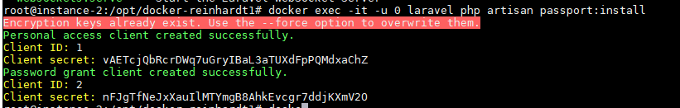

After this we can open the browser:

Go to: <http://localhost> or http://PUBIC_SERVER_IP_ADDRESS

