From metawebs to dynamics: How food webs are built shapes how they behave
2026-10-19
Abstract
Dynamic food web models provide a mechanistic framework for understanding ecological stability, extinction cascades, and responses to environmental change, but their predictions depend on the network supplied as model input. Empirical metawebs provide rich information on potential species interactions yet contain interactions that may not occur simultaneously within a community. Converting these interaction pools into realised networks therefore requires assumptions about which interactions are likely to co-occur, potentially introducing uncertainty before population dynamics are simulated. Here, we investigate how alternative approaches to network realisation influence network structure and subsequent ecological dynamics. Using empirical metawebs, we generated realised food webs using four ecologically motivated downsampling approaches, alongside networks generated using Niche and allometric trophic network models as reference approaches. We then compared network topology, structural change during dynamical burn-in, and inferred robustness under topological and dynamic extinction simulations. Downsampling approach altered network topology, with differences becoming increasingly pronounced as greater proportions of interactions were removed. Dynamical burn-in further reorganised network structure but did not erase the signatures introduced during network construction; instead, downsampled networks underwent structural changes that were often more like the niche model than the original metaweb. Despite these differences, the broad tendency for topological extinction simulations to infer greater robustness than dynamic simulations were consistent across network reconstruction approaches. However, dynamic simulations revealed differences in network behaviour that were not apparent from topology alone, including convergence of niche-based downsampling towards the behaviour of the synthetic niche model. These results demonstrate that network realisation is not simply a preprocessing step, but an additional source of ecological model uncertainty. Dynamic food web predictions are therefore shaped by successive assumptions about which interactions are realised and which of those realised networks can persist dynamically, highlighting the importance of explicitly considering network reconstruction when using empirical interaction data to make mechanistic predictions about ecological change.

1. Introduction
Ecological networks provide a powerful framework for understanding how biodiversity is organised and how ecological communities respond to environmental change. Early food web research focused largely on describing structural properties such as connectance, trophic organisation, and degree distributions, revealing recurring patterns across ecosystems (Williams & Martinez, 2000). Increasingly, however, attention has shifted from describing network architecture to predicting ecological processes. Mechanistic dynamic food web models enable researchers to investigate community stability, biomass dynamics, extinction cascades, and responses to perturbation by explicitly simulating energy transfer among interacting species (Brose et al., 2006; Curtsdotter et al., 2011; Delmas et al., 2017; Yodzis & Innes, 1992). By incorporating resource limitation, interaction strengths, and feedback, these models provide a means of linking network structure to ecological dynamics. Their predictions, however, depend not only on the equations governing population dynamics, but also on the network supplied as model input.
Constructing appropriate networks for dynamic modelling presents a fundamental challenge. Synthetic food web models, such as the niche model, provide tractable representations of trophic structure and can be readily coupled to population dynamics (Williams & Martinez, 2000). Other approaches incorporate biological information, including consumer–resource body-size relationships, to generate mechanistically informed networks, as in allometric models (Brose et al., 2006; Petchey et al., 2008). However, these approaches make assumptions about how trophic interactions are organised and do not necessarily recover the specific interactions occurring within a given community, limiting their applicability to species-specific, real-world tangibility. Empirical metawebs offer an alternative by compiling potential trophic interactions among species from observations, literature, or trait-based inference (Dunne, 2006). Because these interactions may have been observed or inferred across different locations, seasons, or environmental conditions, however, a metaweb does not necessarily represent a set of interactions that can occur simultaneously within a single community. Using empirical interaction pools in dynamic models therefore requires an additional step: selecting which potential interactions are realised together to construct a plausible community-level food web.
This process of network realisation introduces assumptions about how ecological processes filter potential interactions into realised communities. Different approaches may favour interactions near the centre of a consumer’s trophic niche, assign retention probabilities according to consumer trophic breadth, favour links involving specific combinations of highly connected species, or remove interactions without reference to their ecological characteristics. Although these approaches can operate on the same empirical metaweb, they may produce networks with different structural properties. Such differences may become particularly important when substantial reductions in connectance are required, because the choice of which interactions to retain increasingly determines the architecture of the resulting network. Network reconstruction is therefore not simply a technical step for reducing network size or connectance, but an ecological modelling decision that can influence subsequent inference. More broadly, concerns about the comparability and reuse of interaction networks highlight the potential for methodological choices to propagate into ecological conclusions (Brimacombe et al., 2023). Yet how reconstruction assumptions influence both the subsequent structural reorganisation and the dynamical behaviour of food webs remains insufficiently understood.
Network construction is followed by a second filtering process when the resulting food web is subjected to population dynamics. Dynamic models typically undergo a burn-in period during which biomass changes and species unable to persist under the specified model conditions are lost. This process transforms the initial network into a dynamically viable community, potentially altering its structure before any perturbation is imposed. Network realisation thus occurs in two stages: the initial selection of potential interactions and the subsequent filtering of the constructed network through dynamical persistence. These stages may have different consequences for ecological inference. Initial reconstruction may determine much of the network architecture inherited by subsequent simulations, whereas dynamical filtering may introduce additional differences through biomass-dependent and rate-dependent processes. It is therefore important to establish whether structural differences introduced during network construction persist through burn-in, and whether networks that differ in their initial topology also differ in their responses to extinction.
This distinction is particularly relevant when comparing topological and dynamic approaches to extinction robustness. Topological extinction simulations infer secondary extinctions from network structure, whereas dynamic simulations additionally account for changes in biomass and the ecological processes governing species persistence. Previous work has shown that these approaches can yield different estimates of food web robustness (Curtsdotter et al., 2011), but the extent to which this difference generalises across alternative network reconstruction approaches remains unclear. Moreover, similarities in topological extinction responses need not imply similarities in dynamic behaviour, because networks with comparable structural properties may interact differently with their functional parameterisation. Comparing network types across both approaches can therefore distinguish conclusions that are relatively insensitive to reconstruction choices from those that depend on how networks are constructed and dynamically parameterised.
Understanding these dependencies is particularly important for ecological systems in which empirical interaction data are incomplete, including palaeoecological communities. Fossil records provide opportunities to investigate ecological change across major extinction events, but reconstructed assemblages rarely provide a complete observation of a single realised food web (Dunhill et al., 2024; Fricke et al., 2022; Karapunar et al., 2026; Roopnarine, 2017; Roopnarine, 2006). Instead, they may be more appropriately represented as empirically constrained pools of potential interactions from which plausible community networks must be inferred. Translating these interaction pools into dynamically viable food webs could provide a route towards testing mechanistic explanations of ecological change, including through comparisons across extinction events and hindcasting exercises (Strydom, Catchen, et al., 2021). Such applications, however, require an understanding of how assumptions made during network reconstruction influence the ecological behaviour subsequently inferred from dynamic models.
Here, we investigate how alternative approaches to network realisation influence food web structure, burn-in, and inferred extinction robustness. Using empirical metawebs, we generate networks with four ecologically motivated downsampling approaches and compare them with networks constructed using the niche and allometric trophic network models. Specifically, we ask three questions. First, how does downsampling approach influence network topology, and to what extent do these differences persist following burn-in? Second, does the difference between topological and dynamic estimates of extinction robustness generalise across network reconstruction approaches and extinction scenarios? Third, do alternative network types retain similar relationships in inferred robustness under topological and dynamic extinction simulations, or does incorporating population dynamics reveal differences that are not apparent from topology alone? Rather than identifying a single optimal reconstruction method, we use these comparisons to investigate how assumptions introduced during network construction propagate through subsequent dynamical modelling. We show that reconstruction approaches produce increasingly distinct topologies as greater proportions of interactions are removed, that burn-in acts as an additional structural filter, and that the relationship between topological and dynamic robustness is broadly consistent across network types despite differences in their inferred behaviour. Together, these results demonstrate that network realisation is an important source of ecological model uncertainty, while also identifying conclusions that remain comparatively robust across alternative representations of food web structure.

2. Methods

2.1 Fossil data
We used community data from seven locations spanning the Permian-Triassic mass extinction (PTME) event compiled by Karapunar et al. (2026). This dataset comprises community-level trophic data representing potentially interacting taxa across seven locations across the Permian-Triassic mass extinction (PTME; ~250 Ma) event. Here we used the guild-level assemblages from the pre-extinction (Permian) time point along with the plankton and zooplankton data from the outputs of the EcoGEnIE models (Ward et al., 2018) also used in Karapunar et al. (2026). These represent distinct communities of potentially interacting guilds. We excluded the community from Russia because it contained no intermediate species and was therefore unsuitable for the subsequent extinction analyses as it would produce distinct results. The seven locations act as replicates to better determine if observed extinction patterns are driven by specific network structures (location) or if results are more generalisable. Detailed descriptions of the underlying community data, including trait assignment, their composition and spatial structure, are provided in Karapunar et al. (2026).

2.2 Network construction
Metawebs were constructed using the Paleo Food Web Inference Model (PFWIM; Shaw et al. (2024)). The PFWIM applies a set of mechanistic feasibility rules to consumer–resource pairs based on different trait classes. An interaction is deemed as being feasible only when all trait combinations satisfy the specified rules. These metawebs were subsequently downsampled to the specified target connectance (see Section 2.3 for details on downsampling). Using the community data we also constructed networks using the allometric trophic network (ATN) model (Brose et al., 2006), which represents a realised but empirically grounded network. For the ATN species body masses were sampled independently from a truncated log-normal distribution constrained by species categorical body-size classifications. Interaction probabilities were generated by varying the feeding threshold between 0.01 and 0.12 and selecting the network whose connectance most closely matched a target connectance. Finally for each community we also constructed a niche model network (Williams & Martinez, 2000) using the guild richness and target connectance as input parameters (see Section 2.4 for details on parametrisation)

2.3 Downsampling approaches
We treat downsampling as an assumption on the process of ecological realisation rather than observation. Starting from a metaweb containing all potential trophic interactions, each downsampling approach represents an alternative ecological hypothesis describing how local ecological processes may filter these potential interactions into the subset that is realised within a particular community. The different approaches therefore differ not only in their implementation, but also in the ecological assumptions they embed about how realised food webs emerge from a common regional interaction pool.

2.3.1 Niche
The original niche model from Williams & Martinez (2000) assumes that realised interactions represent the core of a consumer’s trophic niche, and that these diets can be arranged along a single niche axis. In order to create a downsampling approach that mimics this we infer a latent trophic axis directly from the metaweb using Singular Value Decomposition (SVD). It has been shown that the latent spaces described by the left and right singular vectors are closely aligned with the generality and vulnerability of species (Strydom et al., 2022) and so the SVD composition should retain the dietary signal of the species. This is done as follows:
Let $A$ denote the $S×S$ adjacency matrix of the metaweb, where $A_{ij}=1$ if consumer $i$ feeds on resource $j$. We compute its singular value decomposition,
$$A=UΣV^{⊤}$$
where $U$ and $V$ are the left and right singular vectors, respectively, and $Σ$ is the diagonal matrix of singular values. Using the leading singular value, $σ_{1}$, and corresponding singular vectors, $u_{1}$ and $v_{1}$, each species is assigned latent consumer and resource coordinates,
$$c_{i}=\sqrt{σ_{1}} u_{i1}, r_{i}=\sqrt{σ_{1}} v_{i1}$$
Because species can act both as consumers and as resources, these coordinates are combined to obtain a single niche position,
$$x_{i}=\frac{c_{i}+r_{i}}{2}$$
which is subsequently rescaled to lie between 0 and 1. Species with similar values of $x_{i}$ therefore occupy similar positions along the dominant trophic gradient of the metaweb.
For each consumer $i$, the centroid of its realised niche is
μi=1kij∈Ri​xj
where $R_{i}$ is the set of resources consumed by species $i$, and $k_{i}$ is its trophic breadth (generality). Niche breadth is estimated as the standard deviation of prey positions,
$$σ_{i}=max\left(sd(x_{j}), 0.1\right)$$
where the lower bound prevents unrealistically narrow niches for specialists. Niche breadth can optionally be scaled to further constrain realised diets,
$$σ_{i}^{′}=ασ_{i}$$
where $α$ is acts as a scaling parameter.
The probability of retaining an interaction between consumer $i$ and resource $j$ is then
$$P_{ij}∝exp\left[−{\left(\frac{x_{j}−μ_{i}}{σ_{i}^{′}}\right)}^{2}\right]$$
Interactions closest to the consumer’s niche centre are therefore most likely to be realised (retained), whereas interactions towards the margins of the niche are preferentially removed. Ecologically, this assumes that local communities realise the central portion of a consumer’s potential trophic niche, with peripheral or opportunistic interactions occurring less consistently.

2.3.2 Power-law
The power-law approach assumes that interaction realisation depends primarily on consumer trophic breadth. Following Roopnarine (2006), the retention probability for consumer $i$ is
$$P_{i}∝exp\left(\frac{k_{i}}{E}\right)$$
where $k_{i}$ is consumer generality and
$$E=S^{(y−1)/y}$$
with $S$ denoting network size and $y$ the scaling exponent. Probabilities are subsequently normalised to lie between 0 and 1. Every interaction belonging to consumer $i$ inherits the same retention probability,
$$P_{ij}=P_{i}$$
Ecologically, this represents the hypothesis that generalist consumers realise a larger fraction of their potential trophic niche than specialist consumers, irrespective of the identity of individual resources.

2.3.3 Degree-product
The degree-product approach assumes that interaction realisation depends on the centrality of both interacting species. Here each interaction is assigned a weight
$$w_{ij}=k_{i}^{out}k_{j}^{in}$$
where $k_{i}^{out}$ is the consumer’s out-degree (generality) and $k_{j}^{in}$ is the resource’s in-degree (vulnerability). Retention probabilities are then calculated as
$$P_{ij}=1−\frac{w_{ij}}{max(w)}$$
before being constrained to the interval $[0,1]$. Under iterative downsampling, degrees are recalculated following each interaction removal, allowing probabilities to evolve as the realised network changes. Ecologically, this assumes that highly connected species possess many potential interactions that are not simultaneously realised within any local community, whereas interactions involving more specialised species are more likely to represent essential realised links.

2.3.4 Random
Random downsampling provides the ecological null model. Every interaction has an equal probability of being retained,
$$P_{ij}=c$$
where $c$ is constant for all existing interactions. Interactions are removed uniformly at random until the target connectance is reached, subject to the constraint that species cannot become isolated. This assumes that no ecological process preferentially favours the realisation of one potential interaction over another, such that realised food webs constitute an unbiased subset of the regional metaweb that is ultimately only constrained by the number of links.

2.4 Simulations
For each empirical community, we generated 30 network replicates ($n$ = 30 replicates $×$ 7 network types $×$ 6 locations). For each replicate a target connectance was independently sampled from a truncated normal distribution bounded between 0.05 and 0.15. This target connectance was used to determine the ‘degree of downsampling’ of the metaweb for each downsampling approach as well as constraining the ATN and Niche networks. These represent the ‘creation’ networks
For the dynamic simulations body masses were assigned using the predator-prey body mass distribution where body mass ($M_{i}$) is assigned deterministically from the trophic level ($TL$) as follows $M_{i}=Z^{TL_{i}−1}$, where $Z$ represents the assumed constant predator–prey body-mass ratio, here set to 10. Note that even for the ATN networks we used this theoretical body size specification despite the network itself being constructed with empirical bodysizes. This is because we found that for networks which had empirically specified body sizes the community would almost completely collapse (see Supplementary Materials), which suggests the dynamic model itself is sensitive to this specification. Initial biomasses were drawn from a uniform distribution. These trait values were used to construct a series of alternative networks.
Each creation network was then parameterised using the default parameters (Delmas et al., 2017) and ran the model until we had stable biomass fluctuation or up to 5000 time steps. Species whose biomass declined below the survival threshold (${10}^{−12}$) during this burn-in period were considered extinct and removed from the network. The surviving species and their interactions constituted the corresponding ‘realised’ networks.
For each ‘creation’ and ‘realised’ network we measured 32 network structural metrics (described in Table S1). These span a different components of network structure from macro-scale to node-level properties.

2.4.1 Extinction simulations
For extinctions we followed the framework of Curtsdotter et al. (2011) and simulated both topological and dynamic extinctions. Topological extinctions were done on both the ‘creation’ as well as ‘realised’ networks. For each type of extinction simulation we used the same ten extinction scenarios from Curtsdotter et al. (2011) to determine the order of species to be removed for primary extinctions. For topological extinctions secondary extinctions occurred when species lost all prey, these secondary extinctions were allowed to cascade before the next primary extinction occurred. For dynamic extinctions primary extinctions were imposed by setting the biomass of the focal species to the survival threshold (${10}^{−12}$), after which the community was simulated for a further 5000 time steps to allow for the downstream effects of the primary extinction to propagate through the system. Species whose biomass subsequently declined below the survival threshold were recorded as secondary extinctions and removed at the end of the 5000 time steps. This procedure was repeated until the entire community collapsed.
For each extinction scenario, robustness was quantified from the resulting extinction curves as the proportion of primary extinctions required to produce a 50% reduction in total species richness ($R_{50}$ (Jonsson et al., 2015)). In instances when a primary extinction would ‘overshoot’ the 50% robustness was estimated by linear interpolation between extinction events.

2.5 Software
Network construction and extinction simulations were run in Julia v1.12.6 (Bezanson et al., 2017), we used EcologicalNetworksDynamics.jl (Lajaaiti et al., 2025) for dynamic simulations, PFIM.jl [REF] for construction of metawebs, FoodWebTools.jl [REF] for network downsampling, and Extinctions.jl [REF] for extinctions and robustness calculations. Statistical analyses were run in R v4.5.2 (R Core Team, 2024). All code can be found at TODO

3. Downsampling and burn-in alter network topology in method-dependent ways
Redundancy analysis (RDA), using permutation-based significance testing while accounting for community-level variation, revealed that downsampling approach significantly affected network topology, but that this effect depended on the magnitude of connectance reduction required to reach the target connectance (999 permutations; $F_{7,707}$ = 112.8, $p$ = 0.001; Figure 1, panel A). The type of network (i.e., downsampling approach) explained 31.8% of total topology variation (adjusted $R^{2}$ = 0.318), with community identity accounting for an additional 39.7% of variation. The significant interaction between downsampling approach and connectance change (marginal test; $F_{3,707}$ = 18.90, $p$ = 0.001) demonstrated that topology trajectories differed among downsampling methods depending on the degree of downsampling required. Thus, the extent to which network structure diverged from the original topology depended on both the severity of downsampling and the mechanism by which interactions were removed.
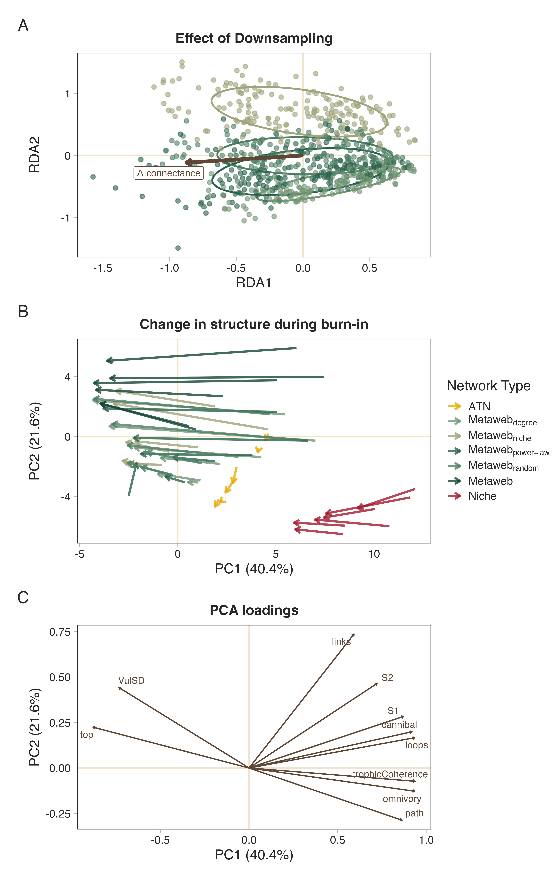
Figure 1: Downsampling approach influences both network topology and subsequent structural reorganisation during burn-in. (A) Redundancy analysis (RDA) ordination showing differences in network topology among downsampling approaches across the downsamping ($ΔCo$) gradient after accounting for community-level variation. (B) Principal component trajectories illustrating structural change between network creation and burn-in for each downsampling approach. (C) Loadings of the top ten contributing structure metrics.
We next asked whether these structurally distinct networks responded differently during the burn-in phase (Figure 1, panel B). Structural reorganisation was quantified as the Euclidean displacement between network positions before and after burn-in in the first three principal component dimensions, with location included as a random effect to account for the substantial variation among location. Burn-in displacement differed significantly among network types ($F$ = 62.0, $p$ < 0.001). Metawebs underwent the greatest structural reorganisation, whereas ATN networks exhibited the smallest displacement. Among the downsampled networks, all but the randomly downsampled networks had a displacement similar to that of the Niche model (Figure S2), while all downsampled networks showed displacement distinct from the original metaweb. When looking at the loadings of the first two PC axes (Figure 1, panel C), the primary changes in structure were related to node-level measures and, unsurprisingly, the number of links. This is to be expected since there is no rewiring of links permitted in this system, and as such any changes should be driven by the loss of nodes rather than a major reorganisation of network structure.
Together, these analyses demonstrate that downsampling approach influences network topology both during the initial downsampling step and during the subsequent burn-in phase. Differences among downsampling methods become increasingly pronounced as greater proportions of interactions are removed, consistent with the expectation that the ecological assumptions underlying each removal strategy would become more embedded as more links are removed. Importantly, despite generating distinct initial topologies, the different downsampling approaches underwent remarkably similar structural reorganisation during burn-in, changing in ways more similar to the niche model than the original metaweb. This suggests that ecologically informed downsampling of metawebs allows us to produce networks whose subsequent structure more closely resembles that of realised networks, while also suggesting that the burn-in phase is, in and of itself, an additional network realisation step. Notably, the two realised models (Niche and ATN) do not behave similarly and still end up at different ‘end points’ following burn-in compared with the empirical webs, highlighting that the choice of network reconstruction approach will still have a strong effect on the structure and behaviour of the system (Strydom et al., 2026).

4. Differences in inferred robustness of topological and dynamic extinctions are unaffected by network type
To determine whether the qualitative differences between topological and dynamic extinction simulations previously demonstrated by Curtsdotter et al. (2011) generalise across alternative network reconstructions, we compared the difference in robustness ($ΔR_{50}$) among network types for each extinction scenario while accounting for community-level variation. Network type significantly affected $ΔR_{50}$ across extinction scenarios (model summaries in Table S2), indicating that the magnitude of the difference between topological and dynamic robustness depended on network reconstruction.
Despite these quantitative differences, the qualitative pattern identified by Curtsdotter et al. (2011) was largely maintained. Under all but random basal removal, topological extinction inferred greater robustness than dynamic extinction for every network type, although the magnitude of this discrepancy varied among reconstruction methods (Figure 2). Random basal extinction represented the only notable departure from this general pattern (Figure S3). Here, the discrepancy between topological and dynamic robustness was substantially reduced, with power-law and degree-product downsampled networks exhibiting a slightly higher $ΔR_{50}$ and random downsampled networks showing little difference between the two approaches. Thus, the conclusion that topological analyses provide more conservative estimates of robustness, although not universal, remains remarkably robust across reconstruction methods and extinction scenarios.
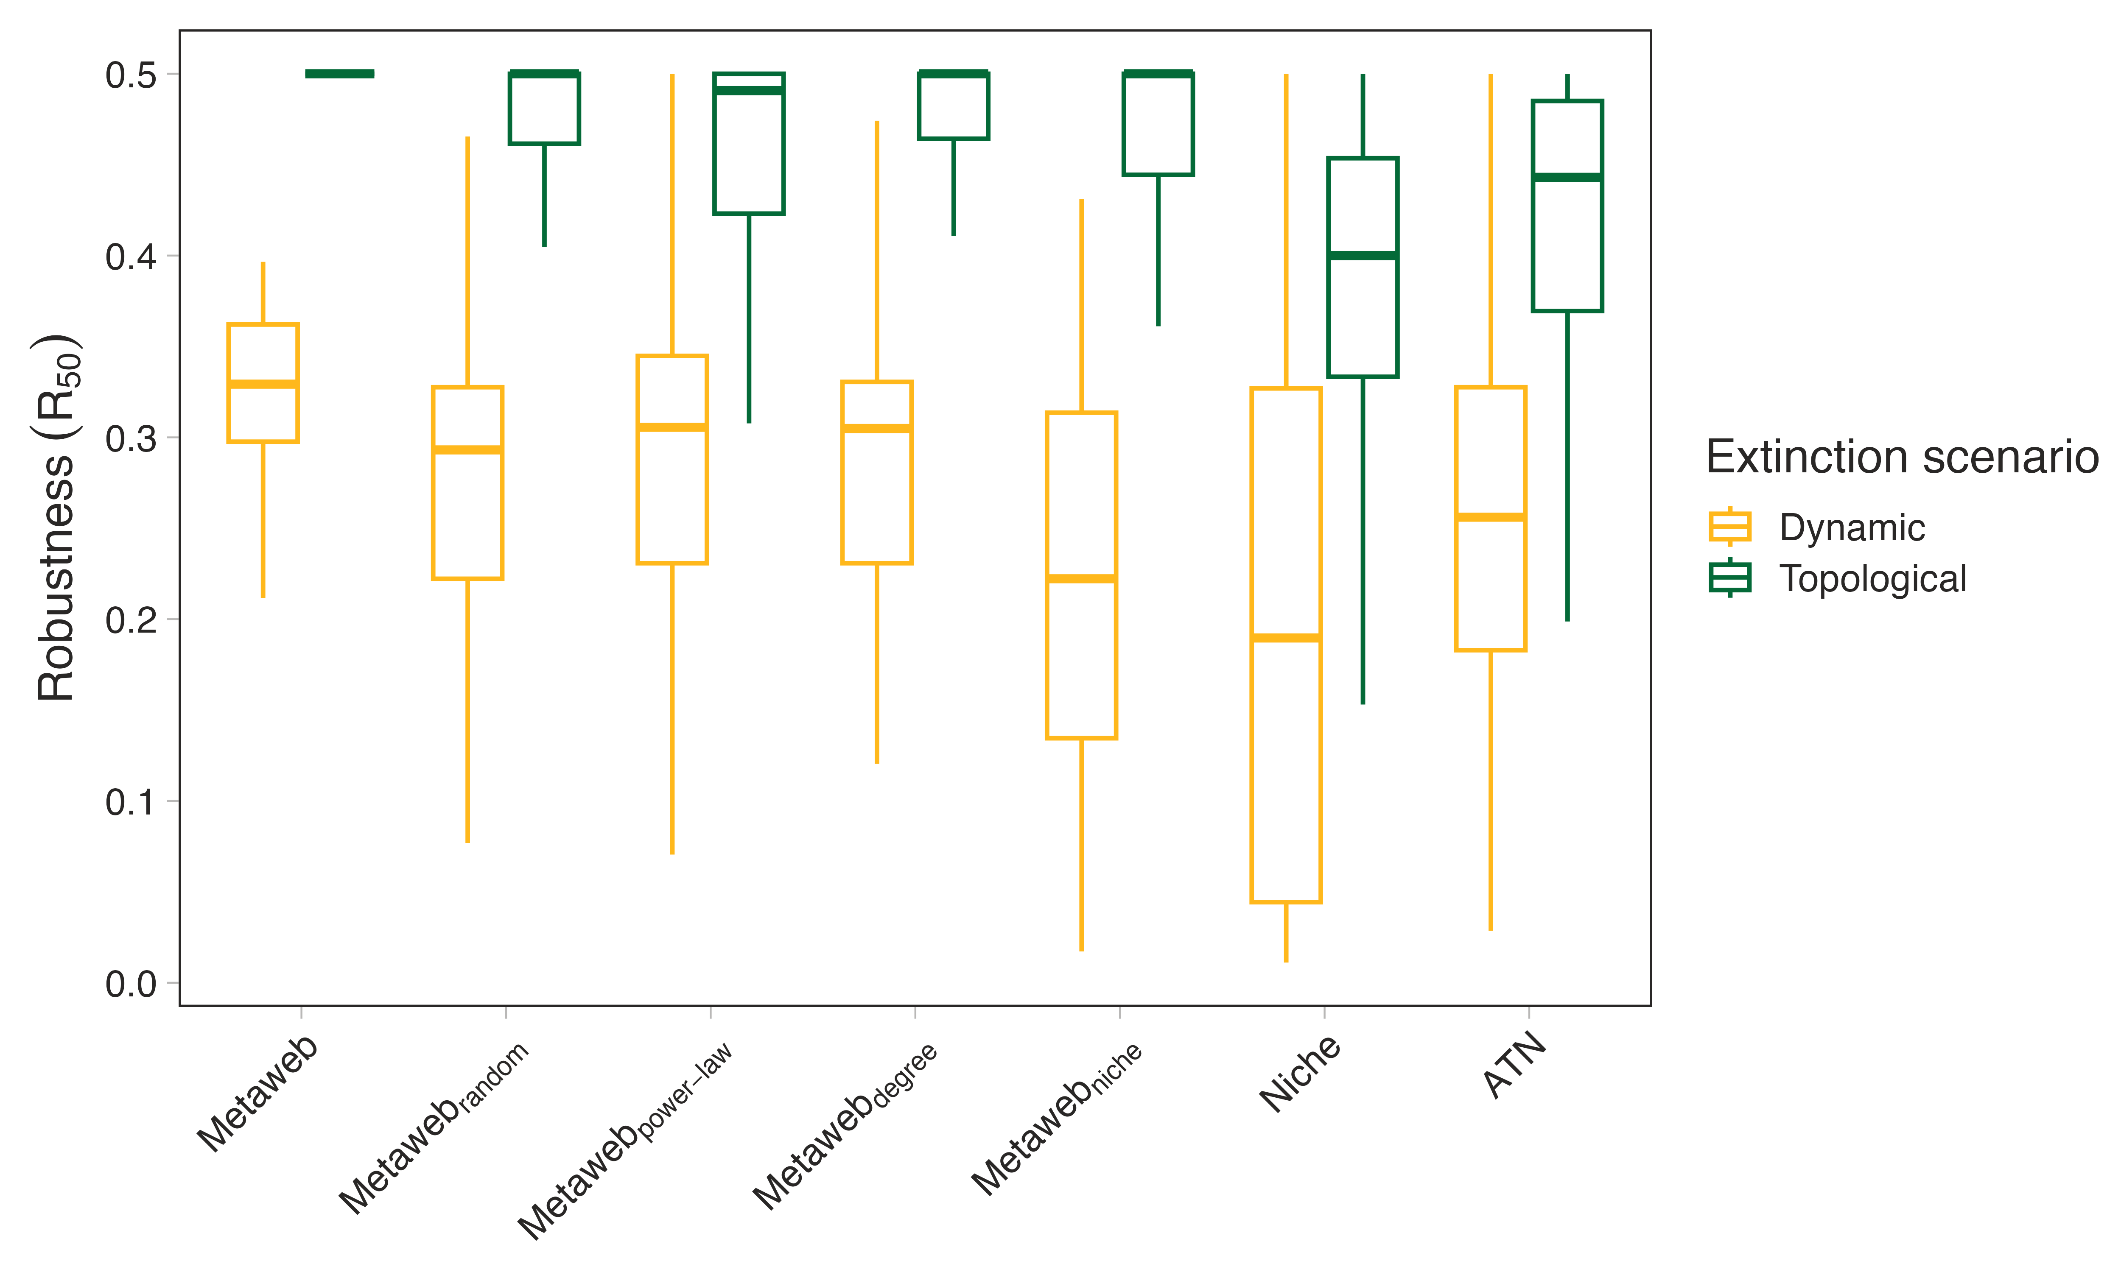
Figure 2: Differences between topological and dynamic estimates of network robustness. Boxplot showing aggregated realised topological and dynamic robustness across the different communities and extinction scenarios for the different network types.
Together, these analyses demonstrate that the principal conclusion of Curtsdotter et al. (2011) extends well beyond the niche model. While the precise magnitude of the discrepancy between topological and dynamic robustness depends on both network reconstruction and extinction mechanism, the qualitative tendency for topological extinction simulations to infer greater robustness than dynamic simulations were recovered across most reconstructed food webs examined here.

5. Dynamic extinctions re-enforce ecological assumptions
For each community $×$ extinction scenario $×$ time point, $R_{50}$ was modelled as a function of network type, and estimated marginal means were compared using Tukey-adjusted pairwise contrasts (Figure S4-6). Network-type pairs with adjusted $p≥$ 0.05 were considered indistinguishable, and the frequency of indistinguishable comparisons was summarised across scenarios (Figure S7). To identify broader groupings of network types, estimated marginal means were standardised, Euclidean distances among network types were calculated, and hierarchical clustering was performed using Ward’s $D^{2}$ method (Figure 3).
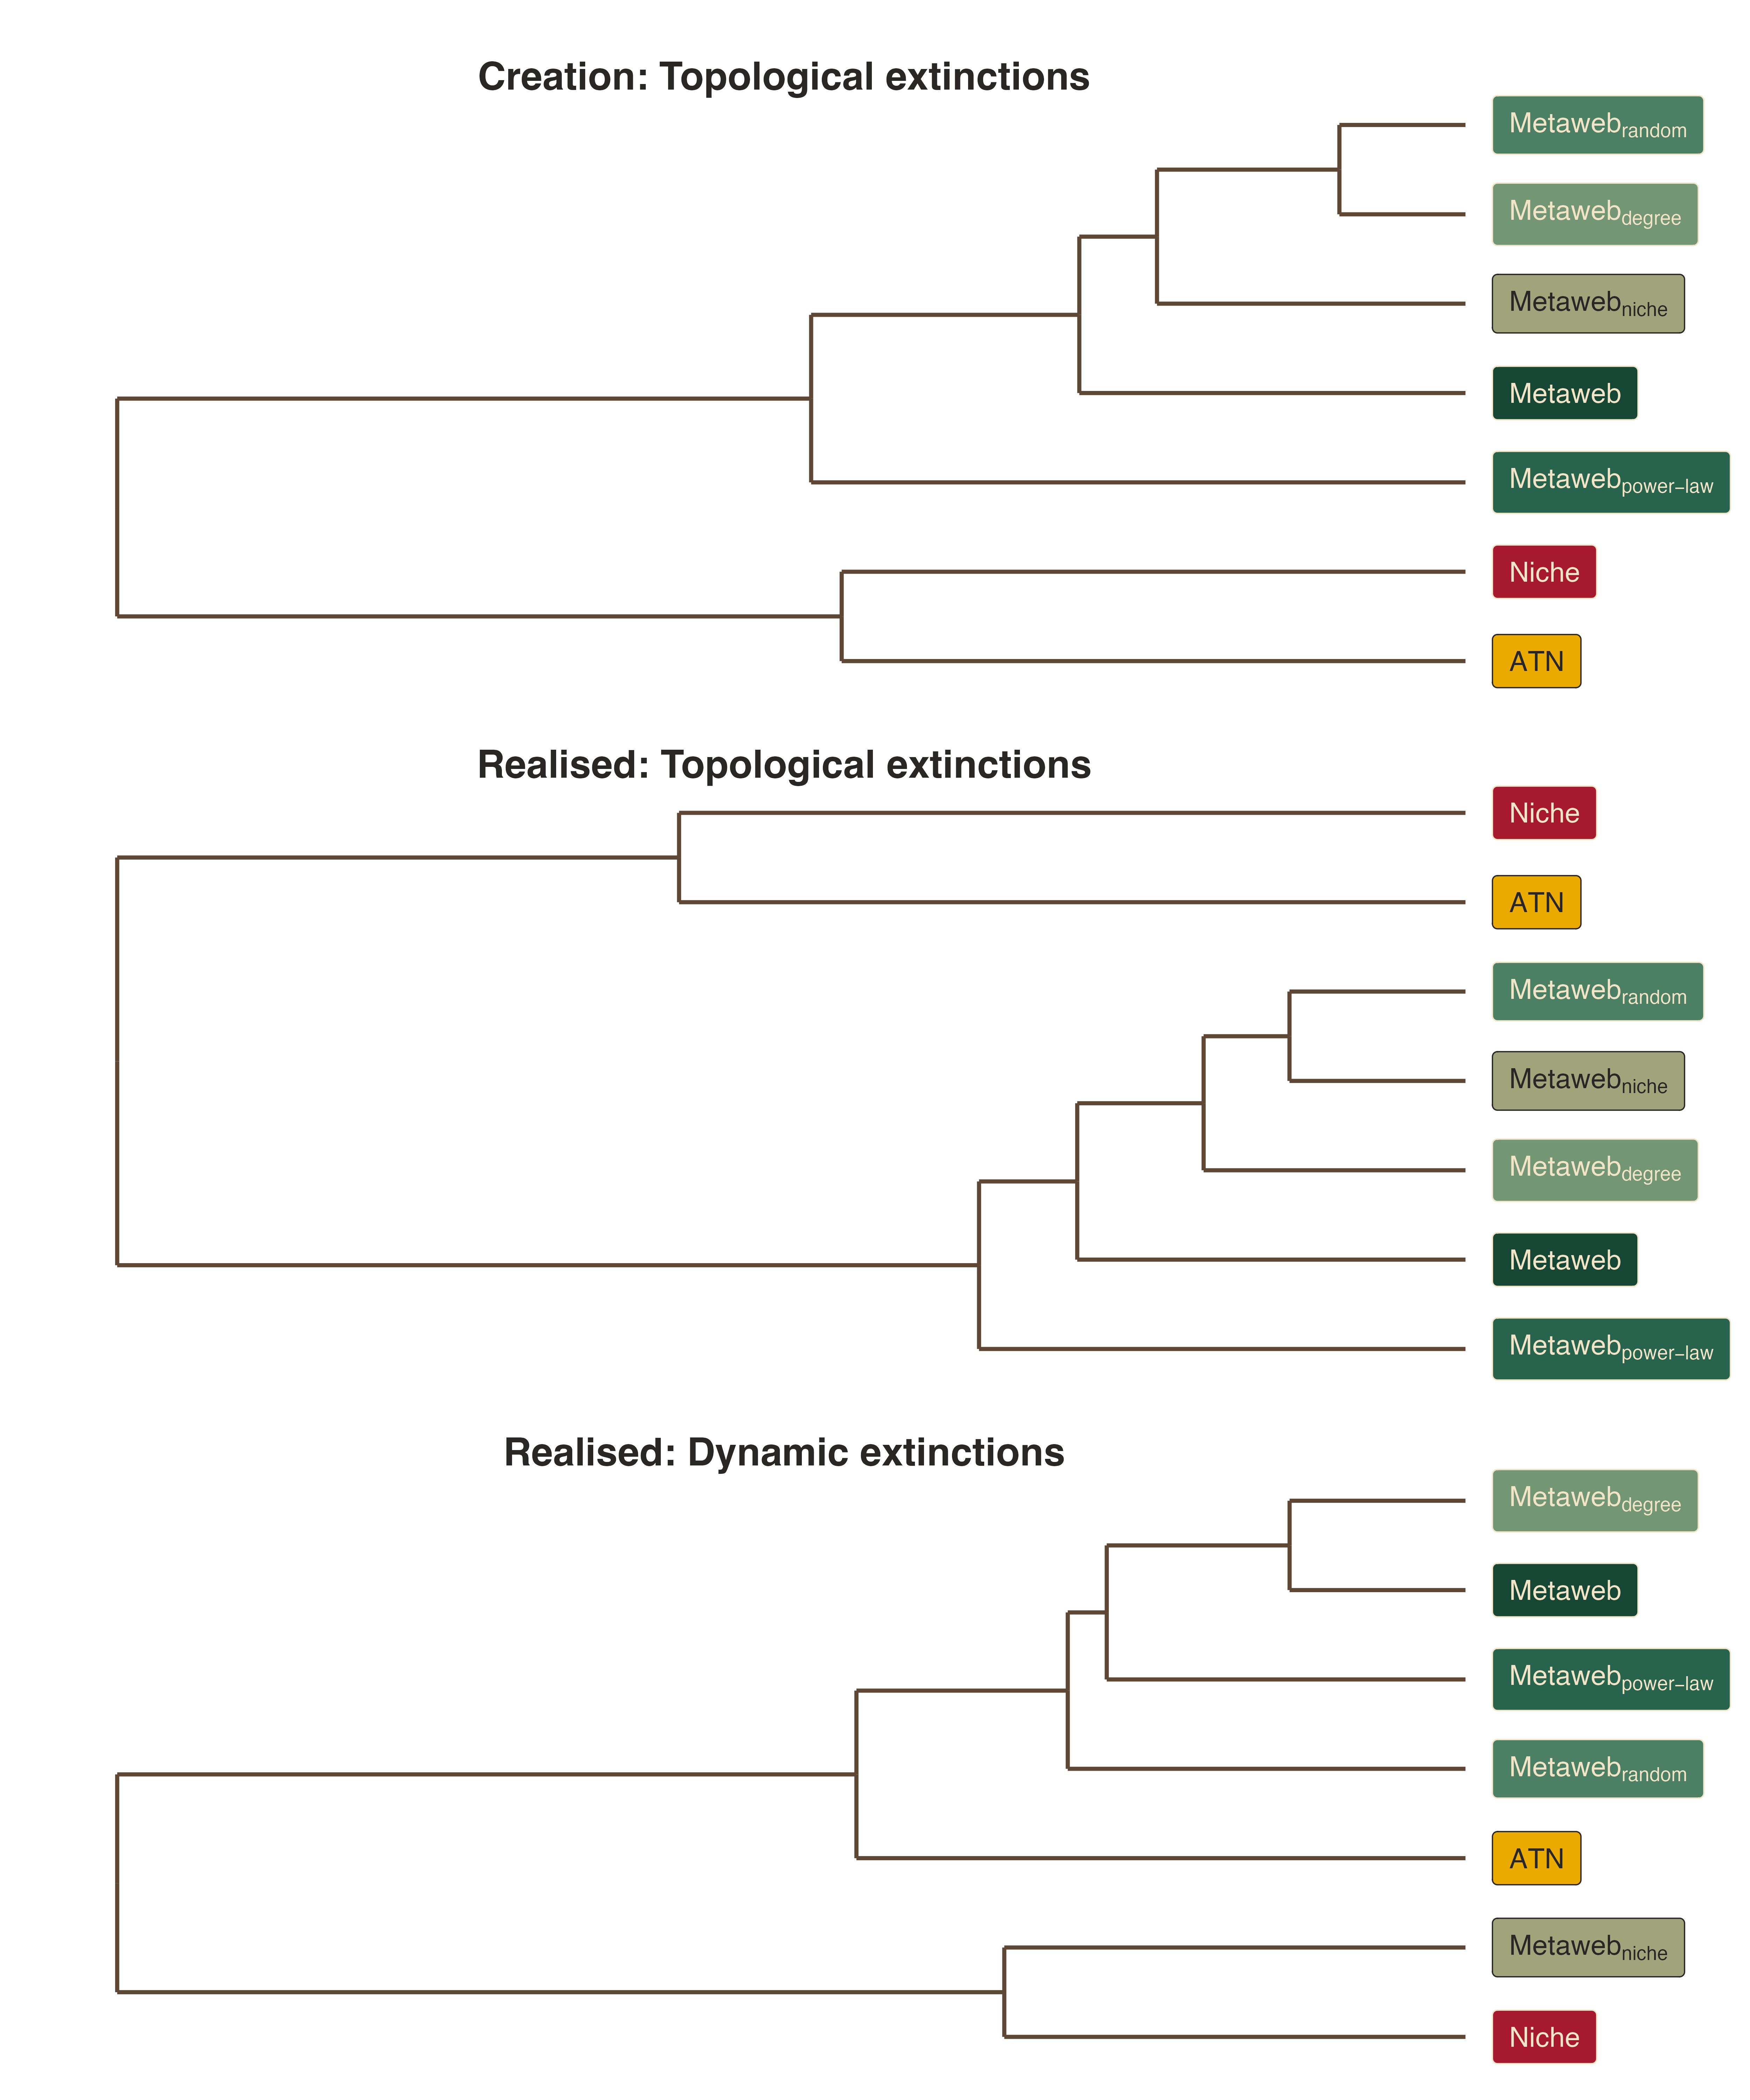
Figure 3: Clustering of network types based on similarity in inferred robustness ($R_{50}$). Dendrograms show hierarchical clustering of network types based on their estimated marginal mean ($R_{50}$) values across community () extinction scenario combinations. Clustering was performed separately for each extinction time point after standardising estimated marginal means across network types, using Euclidean distances and Ward’s ($D^{2}$) method. Branch colours indicate three clusters of network types
In terms of topological robustness, metaweb derived networks consistently formed a distinct cluster separate from the two realised networks (niche model and ATN; Figure 3, top two rows). However, under dynamic extinction simulations, this grouping broke down, with a reshuffling of the relative similarity among network types (Figure 3, bottom row). Most notably, the niche downsampled networks converged with those of the Niche model, whereas the remaining empirically derived networks maintained their mutual similarity.
Topological extinction simulations primarily interrogate network architecture and therefore retain the common structural signature inherited from the metaweb. Dynamic simulations introduce biomass- and rate-dependent interactions, revealing differences among networks that are not apparent from topology alone. When examining topological extinctions, it is clear why empirically derived networks behave similarly to one another: they share a common baseline architecture inherited from the regional metaweb (Figure 1, panel B), and topological cascades depend strictly on network topology. For dynamic extinctions, however, network behaviour is not determined solely by initial structure. Instead, higher-order differences emerge from how model parameterisation interacts with network topology. Thus, network structure appears sufficient to explain much of the similarity in responses to topological extinctions, but is insufficient to predict responses to dynamic extinctions, where functional parameterisation introduces additional sources of variation. Although the clustering pattern was not universal across communities (Figures S8-10), suggesting that initial network structure still exerts an influence.
This raises an important question about the role of network connectance – to what extent does specifying connectance constrain the structural and dynamical properties of generated networks? Work from Poisot & Gravel (2014) and Strydom, Dalla Riva, et al. (2021) shows that less-connected networks can exhibit greater structural complexity, because there are many ways to arrange a small number of links but progressively fewer ways to arrange links as a network becomes fully connected. At low connectance, we therefore expect a much larger number of possible network configurations, meaning that in specifying connectance we place constraints on the precise structure of the resulting network. This provides one possible explanation for why increasingly aggressive downsampling can amplify differences among reconstruction approaches: as fewer interactions are retained, the ecological assumptions used to determine which interactions remain have greater scope to shape the resulting network.

6. Conclusions
Reconstructing realised food webs from regional interaction pools requires assumptions about which potential interactions are likely to occur together. Here, we demonstrate that alternative downsampling approaches can produce dynamically viable food webs from the same empirical metaweb, but that the resulting networks retain detectable signatures of the assumptions underlying their construction. These differences become increasingly pronounced as greater proportions of interactions are removed, indicating that downsampling is not a neutral step between empirical data collection and dynamical modelling.
Our results further suggest that dynamical burn-in represents a second form of network realisation. Although burn-in altered the structure of all networks, it did not erase the differences introduced during initial network construction. Instead, the dynamical model acted as an additional filter, determining which structurally feasible networks could persist under its assumptions about biomass, interaction strengths, and species persistence. The ecological behaviour of a simulated community is therefore shaped by successive filters. First, how potential interactions are realised within a network, and second, how that network is filtered into a dynamically viable community.
Despite these differences in network structure and dynamical behaviour, the broad relationship between topological and dynamic robustness was consistent across network reconstruction approaches. Topological extinction simulations generally indicated greater robustness than dynamic simulations, consistent with previous work (Curtsdotter et al., 2011). This suggests that some conclusions drawn from network topology may be relatively robust to uncertainty in network reconstruction (Strydom et al., 2026). However, dynamic simulations also revealed differences among networks that were not apparent from topology alone, demonstrating that networks generated from the same empirical interaction pool can exhibit different dynamical behaviour depending on the assumptions used to realise that pool.
These findings highlight an important challenge for the growing use of dynamic food web models to move beyond describing network structure towards predicting ecological change. Increasingly sophisticated approaches can reconstruct networks from empirical observations or biological traits, while regional metawebs provide a means of retaining broad empirical information about potential interactions. Yet neither empirical provenance nor mechanistic parameterisation necessarily produces a realised community as both require assumptions about which interactions occur together and (in dynamic models) which of those interactions can persist. Network realisation therefore represents a necessary but currently underappreciated bridge between empirical interaction data and mechanistic dynamic modelling.
Developing a clear framework for explicitly incorporating empirical metawebs into dynamic models is an important step towards bridging theoretical work on network stability with real-world communities and ecological scenarios. Our case study reinforces the findings of Curtsdotter et al. (2011), suggesting that topological extinction simulations alone may underestimate the importance of top-down effects in determining secondary extinctions and community robustness. Intentional downsampling provides a means of approximating the structure of realised communities (Roopnarine, 2006), helping to integrate ecological realism with theoretical predictions. If palaeoecological communities can be reconstructed as plausible, dynamically viable food webs, dynamic modelling could provide a route to testing mechanistic explanations of observed ecological change rather than relying solely on topological reconstructions. Our results represent a first step towards this goal, while demonstrating that the assumptions underlying network construction can remain detectable throughout the modelling process.
Rather than identifying a single correct method for constructing realised networks, we argue that network realisation should be recognised as a methodological choice that can influence model outcomes. We therefore recommend that researchers who use downsampling explicitly test the sensitivity of their results to alternative downsampling approaches. As food web modelling increasingly combines empirical interaction data with dynamic approaches, predictions will depend not only on the equations governing population dynamics, but also on how empirical knowledge is translated into the networks on which those equations operate. Understanding and quantifying this additional source of uncertainty will be essential if dynamic food web models are to provide increasingly empirically grounded predictions of how ecological communities respond to environmental change.

References
Bezanson, J., Edelman, A., Karpinski, S., & Shah, V. (2017). Julia: A Fresh Approach to Numerical Computing. SIAM Review, 59(1), 65–98. https://doi.org/10.1137/141000671
Brimacombe, C., Bodner, K., Michalska-Smith, M., Poisot, T., & Fortin, M.-J. (2023). Shortcomings of reusing species interaction networks created by different sets of researchers. PLOS Biology, 21(4), e3002068. https://doi.org/10.1371/journal.pbio.3002068
Brose, U., Jonsson, T., Berlow, E. L., Warren, P., Banasek-Richter, C., Bersier, L.-F., Blanchard, J. L., Brey, T., Carpenter, S. R., Blandenier, M.-F. C., Cushing, L., Dawah, H. A., Dell, T., Edwards, F., Harper-Smith, S., Jacob, U., Ledger, M. E., Martinez, N. D., Memmott, J., … Cohen, J. E. (2006). Consumer–Resource Body-Size Relationships in Natural Food Webs. Ecology, 87(10), 2411–2417. https://doi.org/10.1890/0012-9658(2006)87[2411:CBRINF]2.0.CO;2
Curtsdotter, A., Binzer, A., Brose, U., De Castro, F., Ebenman, B., Eklöf, A., Riede, J. O., Thierry, A., & Rall, B. C. (2011). Robustness to secondary extinctions: Comparing trait-based sequential deletions in static and dynamic food webs. Basic and Applied Ecology, 12(7), 571–580. https://doi.org/10.1016/j.baae.2011.09.008
Delmas, E., Brose, U., Gravel, D., Stouffer, D. B., & Poisot, T. (2017). Simulations of biomass dynamics in community food webs. Methods in Ecology and Evolution, 8(7), 881–886. https://doi.org/10.1111/2041-210X.12713
Dunhill, A. M., Zarzyczny, K., Shaw, J. O., Atkinson, J. W., Little, C. T. S., & Beckerman, A. P. (2024). Extinction cascades, community collapse, and recovery across a Mesozoic hyperthermal event. Nature Communications, 15(1), 8599. https://doi.org/10.1038/s41467-024-53000-2
Dunne, J. (2006). The network structure of food webs. In Ecological Networks: Linking Structure to Dynamics in Food Webs (pp. 27–86).
Fricke, E. C., Hsieh, C., Middleton, O., Gorczynski, D., Cappello, C. D., Sanisidro, O., Rowan, J., Svenning, J.-C., & Beaudrot, L. (2022). Collapse of terrestrial mammal food webs since the Late Pleistocene. Science, 377(6609), 1008–1011. https://doi.org/10.1126/science.abn4012
Jonsson, T., Berg, S., Pimenov, A., Palmer, C., & Emmerson, M. (2015). The reliability of R50 as a measure of vulnerability of food webs to sequential species deletions. Oikos, 124(4), 446–457. https://doi.org/10.1111/oik.01588
Karapunar, B., Strydom, T., Beckerman, A. P., Ridgwell, A., Wignall, P. B., Dunne, J. A., Little, C. T. S., Hull, P., Pimiento, C., & Dunhill, A. (2026, February 25). No global collapse of food webs across the Permian-Triassic Mass Extinction. https://doi.org/10.64898/2026.02.24.707709 (Pre-published)
Lajaaiti, I., Bonnici, I., Kéfi, S., Mayall, H., Danet, A., Beckerman, A. P., Malpas, T., & Delmas, E. (2025). EcologicalNetworksDynamics.jl: A Julia package to simulate the temporal dynamics of complex ecological networks. Methods in Ecology and Evolution, 16(3), 520–529. https://doi.org/10.1111/2041-210X.14497
Petchey, O. L., Eklöf, A., Borrvall, C., & Ebenman, B. (2008). Trophically Unique Species Are Vulnerable to Cascading Extinction. The American Naturalist, 171(5), 568–579. https://doi.org/10.1086/587068
Poisot, T., & Gravel, D. (2014). When is an ecological network complex? Connectance drives degree distribution and emerging network properties. PeerJ, 2, e251. https://doi.org/10.7717/peerj.251
R Core Team. (2024). R: A Language and Environment for Statistical Computing [Computer software]. R Foundation for Statistical Computing. https://www.r-project.org/
Roopnarine, P. D. (2017). Ecological Modelling of Paleocommunity Food Webs. In Conservation Paleobiology: Using the Past to Manage for the Future (pp. 201–226). University of Chicago Press.
Roopnarine, P. D. (2006). Extinction Cascades and Catastrophe in Ancient Food Webs. Paleobiology, 32(1), 1–19. https://www.jstor.org/stable/4096814
Shaw, J. O., Dunhill, A. M., Beckerman, A. P., Dunne, J. A., & Hull, P. M. (2024, January 30). A framework for reconstructing ancient food webs using functional trait data. https://doi.org/10.1101/2024.01.30.578036 (Pre-published)
Strydom, T., Bouskila, S., Banville, F., Barros, C., Caron, D., Farrell, M. J., Fortin, M.-J., Hemming, V., Mercier, B., Pollock, L. J., Runghen, R., Dalla Riva, G. V., & Poisot, T. (2022). Food web reconstruction through phylogenetic transfer of low-rank network representation. Methods in Ecology and Evolution, 13(12). https://doi.org/10.1111/2041-210X.13835
Strydom, T., Catchen, M. D., Banville, F., Caron, D., Dansereau, G., Desjardins-Proulx, P., Forero-Muñoz, N. R., Higino, G., Mercier, B., Gonzalez, A., Gravel, D., Pollock, L., & Poisot, T. (2021). A roadmap towards predicting species interaction networks (across space and time). Philosophical Transactions of the Royal Society B: Biological Sciences, 376(1837), 20210063. https://doi.org/10.1098/rstb.2021.0063
Strydom, T., Dalla Riva, G. V., & Poisot, T. (2021). SVD Entropy Reveals the High Complexity of Ecological Networks. Frontiers in Ecology and Evolution, 9. https://doi.org/10.3389/fevo.2021.623141
Strydom, T., Karapunar, B., Dunne, J. A., Hull, P., Little, C. T. S., Pimiento, C., Ridgwell, A., Beckerman, A. P., & Dunhill, A. M. (2026). Are We Mapping Ecosystems or Models? Framework Choices Dominate Food Web Topology and Extinction Inferences. https://ecoevorxiv.org/repository/view/13495/
Ward, B. A., Wilson, J. D., Death, R. M., Monteiro, F. M., Yool, A., & Ridgwell, A. (2018). EcoGEnIE 1.0: Plankton ecology in the cGEnIE Earth system model. Geoscientific Model Development, 11(10), 4241–4267. https://doi.org/10.5194/gmd-11-4241-2018
Williams, R. J., & Martinez, N. D. (2000). Simple rules yield complex food webs. Nature, 404(6774), 180–183. https://doi.org/10.1038/35004572
Yodzis, P., & Innes, S. (1992). Body Size and Consumer-Resource Dynamics. The American Naturalist, 139(6), 1151–1175. https://doi.org/10.1086/285380

