Finding the mjor descriptors of species networks

Tanya Strydom

Andrew P. Beckerman

2025-06-02

Abstract

TODO

Blah blah blah [1]

*“It is incumbent on network ecologists to establish clearly the independence and uniqueness of the descriptive metrics used.”* - [2]

|  |  |  |  |  |  |  |  |  |  |  |  |  |  |  |  |  |  |  |  |  |  |  |  |  |  |  |  |  |  |  |  |  |  |  |  |  |  |  |  |  |  |  |  |  |  |  |  |  |  |  |  |  |  |  |  |  |  |  |  |  |  |  |  |  |  |  |  |  |  |  |  |  |  |  |  |  |  |  |  |  |  |  |  |  |  |  |  |  |  |  |  |  |  |  |  |  |  |  |  |  |  |  |  |  |  |  |  |  |  |  |  |  |  |  |  |  |  |  |  |  |  |  |  |  |
| --- | --- | --- | --- | --- | --- | --- | --- | --- | --- | --- | --- | --- | --- | --- | --- | --- | --- | --- | --- | --- | --- | --- | --- | --- | --- | --- | --- | --- | --- | --- | --- | --- | --- | --- | --- | --- | --- | --- | --- | --- | --- | --- | --- | --- | --- | --- | --- | --- | --- | --- | --- | --- | --- | --- | --- | --- | --- | --- | --- | --- | --- | --- | --- | --- | --- | --- | --- | --- | --- | --- | --- | --- | --- | --- | --- | --- | --- | --- | --- | --- | --- | --- | --- | --- | --- | --- | --- | --- | --- | --- | --- | --- | --- | --- | --- | --- | --- | --- | --- | --- | --- | --- | --- | --- | --- | --- | --- | --- | --- | --- | --- | --- | --- | --- | --- | --- | --- | --- | --- | --- | --- | --- | --- | --- |
| Table 1: An informative caption about the different network properties   | Label | Definition | “Function” | Reference (for maths), can make footnotes probs | | --- | --- | --- | --- | | Basal | Percentage of basal taxa, defined as species who have a vulnerability of zero |  |  | | Connectance | , where is the number of species and the number of links |  |  | | Cannibal | Percentage of species that are cannibals |  |  | | ChLen | Mean food chain length, averaged over all species (where a food chain is defined as a continuous path from a ‘basal’ to a ‘top’ species) |  |  | | ChSD | Standard deviation of ChLen |  |  | | ChNum | log number of food chains |  |  | | Clust | mean clustering coefficient (probability that two taxa linked to the same taxon are also linked) |  | **TODO** | | GenSD | Normalized standard deviation of generality of a species standardized by |  | [3] | | Herbivore | Percentage of herbivores plus detritivores (taxa that feed only on basal taxa) |  |  | | Intermediate | Percentage of intermediate taxa (with both consumers and resources) |  |  | | LinkSD | Normalized standard deviation of links (number of consumers plus resources per taxon) |  |  | | Loop | Percentage of taxa in loops (food chains in which a taxon occurs twice) |  |  | | L/S | links per species |  |  | | MaxSim | Mean of the maximum trophic similarity of each taxon to other taxa, the number of predators and prey shared by a pair of species divided by their total number of predators and prey |  | **TODO** | | Omnivory | Percentage of omnivores (taxa that feed on 2 taxa with different trophic levels) |  |  | | Path | characteristic path length, the mean shortest food chain length between species pairs |  |  | | Richness | Number of nodes in the network |  |  | | TL | Prey-weighted trophic level averaged across taxa |  | [4] | | Top | Percentage of top taxa (taxa without consumers) |  |  | | VulSD | Normalized standard deviation of vulnerability of a species standardized by |  |  | | Links | The number of links in the network |  |  | | Diameter | Diameter can also be measured as the average of the distances between each pair of nodes in the network |  | [5] | |  | Spectral radius is a a conceptual analog to nestedness (and more appropriate for unipartite networks). It is defined as the absolute value of the largest real part of the eigenvalues of the *undirected* adjacency matrix |  | [6] | | Complexity | SVD complexity of a network, defined as the Pielou entropy of its singular values | Something about structural v behavioural complexity being captured | [7] | | Centrality | Centrality is a measure of how ‘influential’ a species is, under various definitions of ‘influence’… | Centrality can help in quantifying the importance of species in a network |  | | S1 | Number of linear chains |  | [8] [9] | | S2 | Number of omnivory motifs |  | [8] [9] | | S4 | Number of apparent competition motifs |  | [8] [9] | | S5 | Number of direct competition motifs |  | [8] [9] | | Intervality |  |  | **TODO** [10] | |

|  |  |  |  |  |  |  |  |  |  |  |  |  |  |  |  |  |  |  |  |  |  |  |  |  |  |  |  |  |  |  |  |  |  |  |  |  |  |  |  |  |  |  |  |  |  |  |  |  |  |  |  |  |  |  |  |  |  |  |  |  |  |  |  |  |  |  |  |  |  |  |  |  |  |  |  |  |  |  |  |  |  |  |  |  |  |  |  |  |  |  |  |  |  |  |  |  |  |  |  |  |  |  |  |  |  |  |  |  |  |  |  |  |  |  |  |  |
| --- | --- | --- | --- | --- | --- | --- | --- | --- | --- | --- | --- | --- | --- | --- | --- | --- | --- | --- | --- | --- | --- | --- | --- | --- | --- | --- | --- | --- | --- | --- | --- | --- | --- | --- | --- | --- | --- | --- | --- | --- | --- | --- | --- | --- | --- | --- | --- | --- | --- | --- | --- | --- | --- | --- | --- | --- | --- | --- | --- | --- | --- | --- | --- | --- | --- | --- | --- | --- | --- | --- | --- | --- | --- | --- | --- | --- | --- | --- | --- | --- | --- | --- | --- | --- | --- | --- | --- | --- | --- | --- | --- | --- | --- | --- | --- | --- | --- | --- | --- | --- | --- | --- | --- | --- | --- | --- | --- | --- | --- | --- | --- | --- | --- | --- | --- | --- |
| Table 2: Here is a table showing the correlation of the different network properties with the first three dimensions of the PCA   | Property | PCA 1 (27%) | PCA 2 (24%) | PCA 3 (11%) | | --- | --- | --- | --- | | richness | **0.8** | 0.46 | -0.11 | | links | **0.89** | 0.14 | -0.16 | | connectance | 0.05 | -0.9 | 0.02 | | diameter | **0.81** | -0.06 | 0.14 | | complexity | -0.28 | 0.48 | 0.41 | | distance | 0.41 | 0.13 | -0.03 | | basal | -0.29 | 0.38 | -0.73 | | top | -0.24 | 0.59 | 0.55 | | intermediate | 0.4 | -0.68 | 0.32 | | herbivory | -0.29 | 0.51 | 0.13 | | omnivory | 0.52 | -0.71 | 0.18 | | cannibal | 0.29 | -0.72 | -0.19 | | l_S | **0.78** | -0.33 | -0.18 | | GenSD | -0.1 | 0.42 | -0.80 | | VulSD | -0.05 | **0.76** | 0.31 | | TL | 0.59 | -0.13 | 0.39 | | ChLen | 0.17 | 0.45 | 0.30 | | ChSD | 0.42 | 0.05 | 0.15 | | ChNum | 0.19 | **0.69** | 0.42 | | path | 0.66 | 0.09 | 0.17 | | LinkSD | 0.04 | 0.63 | -0.54 | | S1 | **0.82** | 0.29 | 0.00 | | S2 | **0.84** | 0.12 | -0.06 | | S4 | **0.74** | 0.43 | -0.13 | | S5 | **0.76** | 0.39 | -0.22 | | ρ | 0.14 | -0.82 | -0.24 | | centrality | -0.49 | -0.29 | 0.21 | | loops | 0.45 | 0.12 | 0.07 | |

Source: [Article Notebook](https://BecksLab.github.io/ms_feature_selection/index.qmd.html)

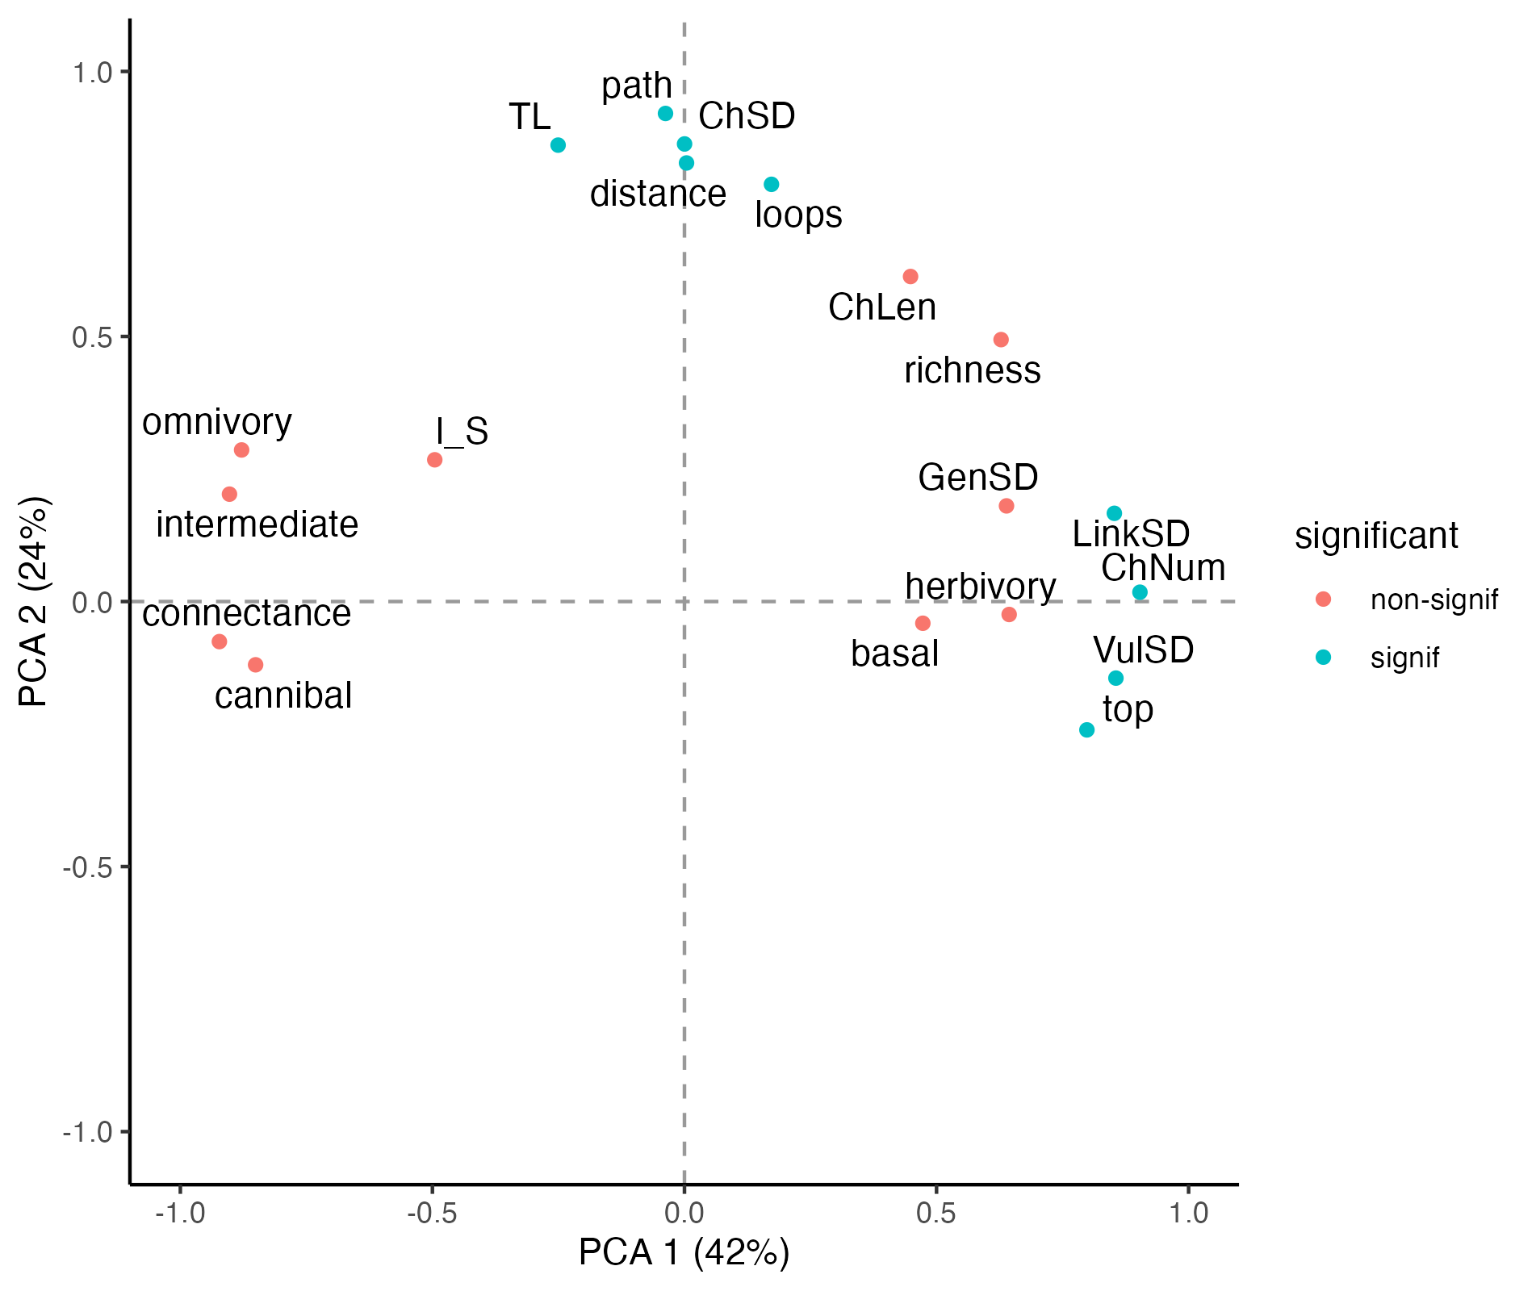

VERMAAT networks only

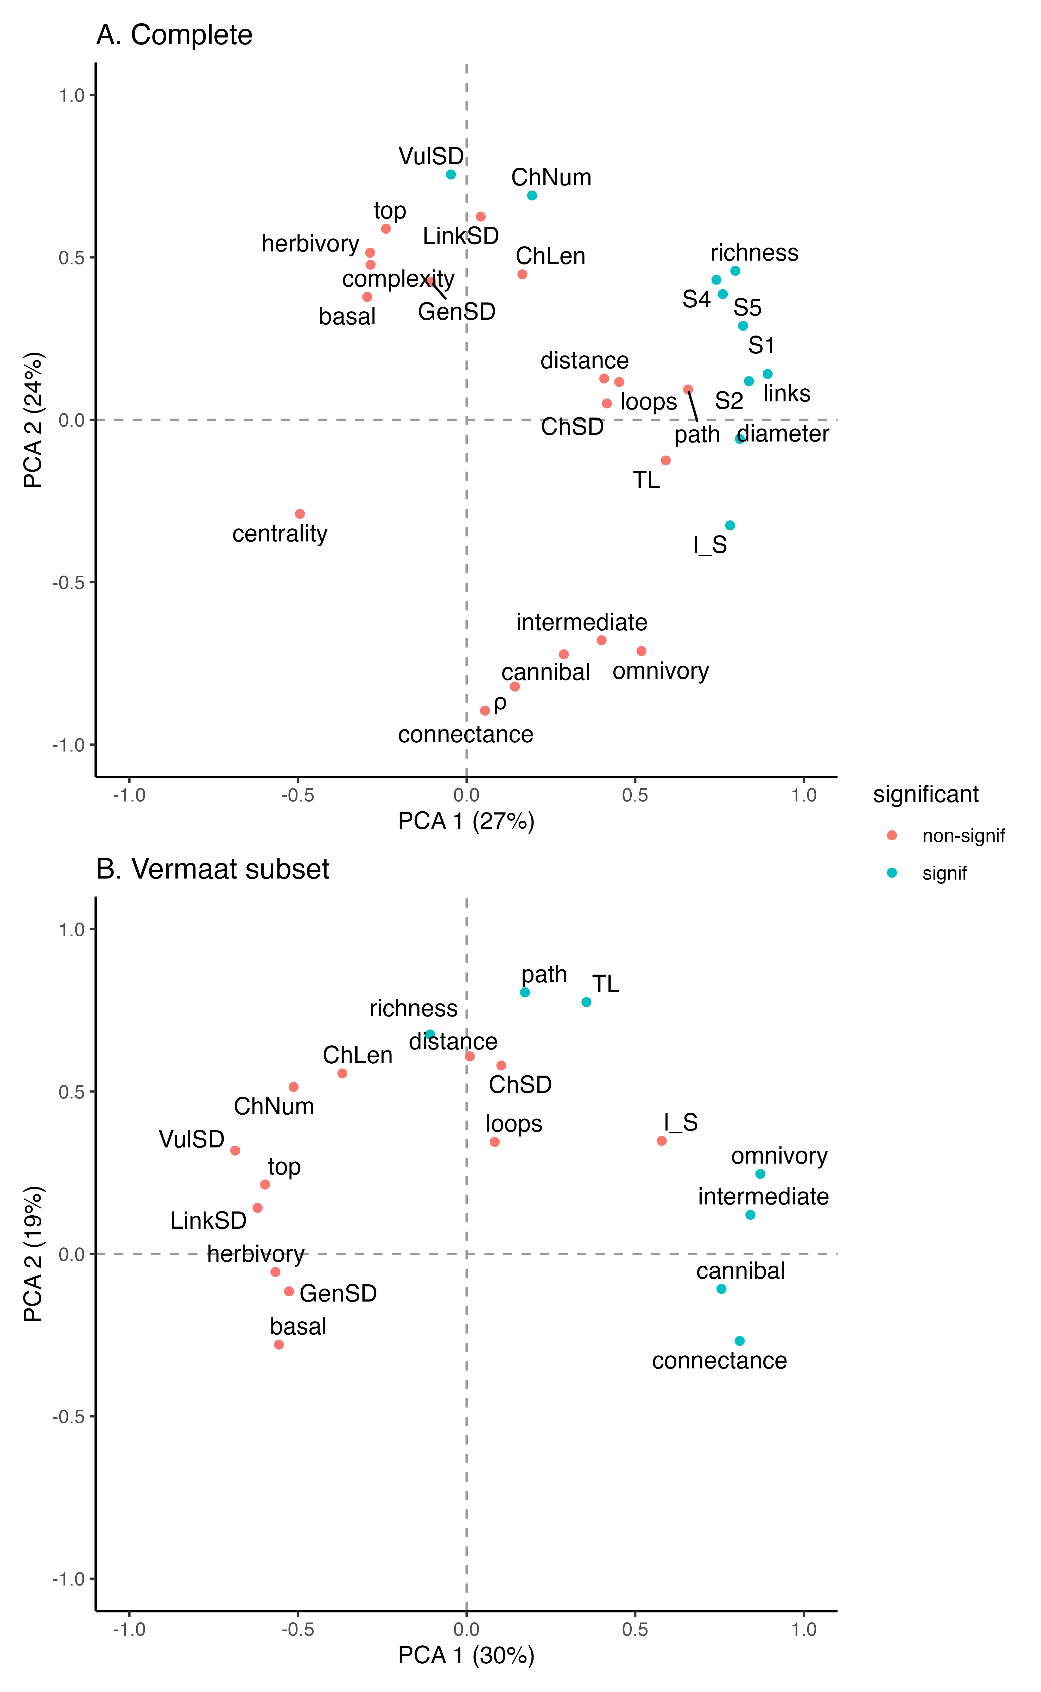

All networks. Vermaat subset = using only the structural measures from Vermaat

# References

1. Vermaat, J.E. *et al.* (2009) [Major dimensions in food-web structure properties](https://doi.org/10.1890/07-0978.1). *Ecology* 90, 278–282

2. Lau, M.K. *et al.* (2017) [Ecological network metrics: Opportunities for synthesis](https://doi.org/10.1002/ecs2.1900). *Ecosphere* 8, e01900

3. Williams, R.J. and Martinez, N.D. (2008) [Success and its limits among structural models of complex food webs](https://doi.org/10.1111/j.1365-2656.2008.01362.x). *The Journal of Animal Ecology* 77, 512–519

4. Williams, R.J. and Martinez, N.D. (2004) [Limits to Trophic Levels and Omnivory in Complex Food Webs: Theory and Data](https://doi.org/10.1086/381964). *The American Naturalist* 163, 458–468

5. Delmas, E. *et al.* (2019) [Analysing ecological networks of species interactions](https://doi.org/10.1111/brv.12433). *Biological Reviews* 94, 16–36

6. Staniczenko, P.P.A. *et al.* (2013) [The ghost of nestedness in ecological networks](https://doi.org/10.1038/ncomms2422). *Nature Communications* 4, 1391

7. Strydom, T. *et al.* (2021) [SVD Entropy Reveals the High Complexity of Ecological Networks](https://doi.org/10.3389/fevo.2021.623141). *Frontiers in Ecology and Evolution* 9

8. Stouffer, D.B. *et al.* (2007) [Evidence for the existence of a robust pattern of prey selection in food webs](https://doi.org/10.1098/rspb.2007.0571). *Proceedings of the Royal Society B: Biological Sciences* 274, 1931–1940

9. Milo, R. *et al.* (2002) [Network Motifs: Simple Building Blocks of Complex Networks](https://doi.org/10.1126/science.298.5594.824). *Science* 298, 824–827

10. Stouffer, D.B. *et al.* (2006) [A robust measure of food web intervality](https://doi.org/10.1073/pnas.0603844103). *Proceedings of the National Academy of Sciences* 103, 19015–19020