Is everything a Niche model? Food Web Reconstruction Frameworks Converge in Structure but Diverge in [something]
Tanya Strydom
Xiaoxiao Li
Alain Danet
Laura Sophia Landon Blake
Andrew P. Beckerman
Dylan Z. Childs
2026-09-24
Abstract
Food web ecology relies heavily on generative models to reconstruct trophic interactions, yet these models embody fundamentally different assumptions about how ecological communities are assembled. Whether these alternative reconstruction frameworks provide interchangeable baselines for studying ecosystem dynamics remains largely unknown. Here, we compared seven food web generative models spanning structural, statistical, and trait-based approaches by embedding each within an identical bioenergetic simulation framework while controlling species pools and dynamical rules. Initial networks generated by different frameworks occupied distinct regions of multivariate topology space, demonstrating that reconstruction framework alone produces substantially different food web architectures. Following bioenergetic simulations, however, realised networks converged towards a shared region of topology space through extinction-driven pruning of species and interactions, indicating that ecological dynamics impose strong constraints on viable network structure. Despite this structural convergence, predictions of biomass equilibrium did not converge. Local stability metrics, including resilience and reactivity, remained strongly dependent on the original generative model, whereas broader network-level properties were explained primarily by realised species richness rather than reconstruction framework. Our results reveal a decoupling between structural and dynamical convergence. Ecological dynamics filter diverse initial architectures towards persistent network structures, but they retain the historical signature of the assumptions used to reconstruct trophic interactions. This suggests that generative models are not interchangeable starting points for ecological inference. Structural models provide useful approximations for broad topological and diversity patterns, whereas trait-based models are required to capture transient dynamics and local stability. Rather than treating food web reconstruction as a universal modelling baseline, reconstruction frameworks should be chosen according to the ecological questions they are intended to answer.

1. Introduction
For over two decades, community ecology has relied heavily on generative models to understand and reconstruct the structure of trophic networks. At the centre of this framework is the niche model. Introduced by Williams & Martinez (2000) as a major advance over the strictly hierarchical Cascade model (Cohen et al., 1990), the Niche model demonstrated that relatively simple assembly rules could reproduce many emergent properties of empirical food webs, including realistic degree distributions, trophic guild proportions, and path lengths. This success has established the niche model as the default structural baseline for investigating macroecological patterns, robustness to primary extinctions, and the stability of ecological communities (Allesina & Tang, 2012; Curtsdotter et al., 2011).
The widespread use of the Niche model has also encouraged a broader assumption that different food web reconstruction methods provide interchangeable representations of ecological communities. However, generative models embody fundamentally different assumptions about how trophic interactions arise (Strydom, Dunhill, et al., 2026). Structural models operate from the network down, generating interactions according to statistical or topological rules. The Niche and Cascade models impose ordered feeding hierarchies along a latent niche axis, while maximum entropy (MaxEnt) models generate networks that satisfy macroscopic constraints while remaining maximally unstructured beyond those constraints (Banville et al., 2023). In contrast, mechanistic approaches operate from the species up, constructing networks from organismal traits and ecological processes. The Allometric Diet Breadth Model (ADBM) derives realised diets from optimal foraging and energetic profitability (Petchey et al., 2008), whereas the Allometric Trophic Network (ATN) framework constrains interactions through body-size scaling and metabolic theory (Brose et al., 2006; Schneider et al., 2016). Latent trait models occupy an intermediate position, inferring interactions statistically from underlying species traits without prescribing explicit feeding rules (Rohr et al., 2010).
These contrasting modelling philosophies raise a fundamental question. Are they simply different routes to the same ecological inference, or do they encode different assumptions about network architecture that persist into predictions of ecosystem dynamics? Recent work has shown that applying different reconstruction frameworks to identical species pools produces markedly different food web topologies and inference about species extinctions (Strydom, Karapunar, et al., 2026). Because network architecture governs the pathways through which energy, biomass, and indirect effects propagate through communities (Delmas et al., n.d.), differences in reconstruction may have important consequences for ecological dynamics rather than representing alternative but equivalent descriptions of the same system.
At the same time, empirical food webs exhibit surprisingly consistent local structural organisation despite large differences in species composition and ecosystem type, suggesting that ecological communities occupy a constrained region of possible network architectures rather than arbitrary combinations of interactions. This has motivated the idea that ecological dynamics selectively retain interaction structures that are compatible with persistence while filtering those that are not (Stouffer et al., 2007; Stouffer & Bascompte, 2010). Whether this filtering is sufficiently strong to erase the structural differences introduced by alternative reconstruction frameworks remains unknown.
Here, we test whether food web reconstruction frameworks function as benign structural templates or whether they fundamentally shape ecological inference. We generated food webs using seven models spanning structural, statistical, and trait-based philosophies and embedded each within an identical bioenergetic simulation framework while controlling species pools and dynamical rules. This design allows us to separate the effects of network construction from the effects of ecological dynamics and ask two questions: (i) do different reconstruction frameworks converge towards a common realised network structure under bioenergetic dynamics, and (ii) if structural convergence occurs, do predictions of biomass equilibrium also converge, or do they retain a signature of the original generative model?

2. Methods

2.1 Network generation
We generated food webs using six established generative models, spanning structural (Niche, Cascade, Random, MaxEnt) and trait-based approaches (Latent Trait Model, Allometric Trophic Network, Allometric Diet Breadth Model), see Table 1 for more details. All simulations were implemented in Julia (Bezanson et al., 2017) and analyses in R (R Core Team, 2024).
Table 1: Summary of food web models used in this study. Structural models (Niche, Cascade, MaxEnt) generate network topology based on abstract or statistical rules, while realised/dynamic models (ADBM, ATN, Latent trait) incorporate species-specific traits and biological mechanisms to predict interactions. For each model, we list the main inputs and the key assumptions that govern link formation.
Model | Type | Main Inputs | Key Assumptions
Niche model (Williams & Martinez, 2000) | Structural | Species niche values | Trophic interactions structured by a one-dimensional feeding niche; species consume all prey within a contiguous range; allows cannibalism.
Cascade model (Cohen et al., 1990) | Structural | Species rank | Consumers feed only on species with lower ranks; strictly hierarchical; no loops or omnivory.
MaxEnt model (Banville et al., 2023) | Structural | Species richness, connectance | Links assigned to maximise entropy; captures global network properties without species-specific mechanisms.
Allometric Diet Breadth Model (ADBM) (Petchey et al., 2008) | Realised | Body mass, prey energy content | Consumers maximize energy intake; diet breadth determined by profitability and handling time; allometric scaling governs parameters.
Allometric Trophic Network (ATN) (Brose et al., 2006) | Realised | Body mass | Interactions constrained by body mass ratios; mechanical size limits structure networks; probability of interaction follows Ricker function.
Latent trait model (Rohr et al., 2010) | Realised | Species traits (e.g., body mass) | Interactions inferred statistically based on hidden trait correlations; can incorporate probabilistic constraints on links.

To isolate model effects from input variation, all trait-based models were parameterised using an identical species pool at each replicate. Species richness was set to 10, 20, 40, and for each iteration we sampled (i) a target basal fraction (U(0.1,0.3)), (ii) metabolic classes consistent with this fraction, and (iii) body masses from class-specific log-uniform distributions. These inputs were shared across the Latent Trait, ATN, and ADBM models. Structural models were instead parameterised by a target connectance drawn from U(0.05, 0.3) where relevant. This allows one to isolate the effect of network-generating assumptions by holding constant (i) species richness, (ii) trait distributions (within trait-based models), and (iii) dynamical rules. Differences in structure and dynamics can therefore be attributed directly to the generative model used to reconstruct trophic interactions.
Networks were generated using a rejection-sampling procedure to enforce comparable emergent properties. A network was retained only if its realised basal fraction and connectance fell within the target ranges (0.1–0.3 and 0.05–0.3, respectively). For trait-based models, networks were accepted only when all three models successfully generated valid networks from the same species pool. We obtained 100 valid replicates per model, with an upper bound on sampling attempts to prevent non-termination. MaxEnt networks were constructed by sampling joint in- and out-degree distributions consistent with a target number of links, followed by entropy-maximising rewiring under degree constraints. The Niche and Cascade networks were constructed using the target connectance and species richness.

2.2 Network structure
All networks were converted to directed interaction networks and analysed using a standardised pipeline. We quantified structural properties across multiple scales, including connectance, trophic level, generality, vulnerability, clustering, centrality, trophic coherence, and path length. These metrics were used to characterise the structural signature of each model.
I can do a supp matt that breaks all the structural metrics down - I don’t think we need it here in the main text.

2.3 Dynamic simulations
To evaluate the dynamical consequences of different generative models, we simulated each network using the bio-energetic food web dynamic model implemented in EcologicalNetworksDynamics.jl (Lajaaiti et al., 2025). A key feature of the bio-energetic model is the allometric scaling of metabolism, growth and foraging rates with body mass. For trait-based models (ATN, ADBM, LTN), species body masses were taken from the generative networks and rescaled relative to the producer with the lowest body mass. For structural models (Niche, Cascade, MaxEnt, Random), which did not include body mass information, body masses were assigned from species trophic levels assuming apredator–prey body mass ratio of 100.
For a consumer species $i$, biomass dynamics were determined by gains from feeding, losses to predators, and metabolic maintenance, which is expressed as:
dBidt=j∈prey(i)​eijBiFij−j∈predators(i)​BjFji−xiBi
where $B_{i}$ is the biomass of consumer $i$, $e_{ij}$ is its assimilation efficiency when feeding on prey j, $x_{i}$ is its metabolic rate scaled with body mass, and $F_{ij}$ is the functional response of consumer i feeding on prey j, defined as
Fij=ωiaijBjhMi1+k∈prey(i)​ωiaikhikBkh
where $w_{i}$ is the equal preference of the consumer i feeding on its prey, $w_{i}$ = 1/number of prey species. $a_{ij}$ is the attack rate, $h_{ij}$ is the handling time, and $M_{i}$ is the body mass of consumer i. Attack rates and handling times scaled with both consumer and prey body masses. The Hill exponent was set to $h=2$ as a Type III functional response.
For a basal species $j$, biomass dynamics were determined by its logistic growth and losses to consumers, expressed as:
dBjdt=rjGjBj−i∈predators(j)​BiFij
where $r_{j}$ is the intrinsic growth rate and $G_{j}=1−\frac{B_{j}}{K_{j}}$ is the logistic growth modifier , with $K_{j}$ is the carrying capacity. Both $r_{j}$ and $K_{j}$ scaled with species body mass.
All allometric constants used to parametrise $x_{i}$, $a_{ij}$, $h_{ij}$, $r_{j}$, and $K_{j}$ were set to the default values provided by (Lajaaiti et al., 2025).
Each network was simulated until it reached a steady state. Species were considered extinct when their biomass fell below ${10}^{−6}$. At equilibrium, both extinct species and disconnected species were removed, yielding the realised post-simulation network.

2.4 Post-simulation analyses

2.4.1 Phenotypic trajectory analysis
To quantify how ecological dynamics reshaped network topology, all structural metrics were recalculated following the dynamic simulations using the realised (post-extinction) network. These post-dynamics metrics were compared with those of the initial network using a phenotypic trajectory analysis (PTA) framework (Adams & Collyer, 2009), where each network was represented as a point in a multivariate topology space defined by the suite of structural network metrics [TABLE in SI]. Prior to analysis, all metrics were standardised (mean = 0, SD = 1) to remove differences in scale before constructing a common topology space using principal component analysis (PCA). Both pre- and post-dynamics networks were projected into this shared ordination, allowing each network to be represented by a trajectory from its initial to realised topology.
Trajectory vectors were calculated as the displacement between pre- and post-dynamics positions in the five-dimensional PCA space. Trajectory length was calculated as the Euclidean distance between the two states, providing a measure of the magnitude of topological change. Mean trajectories were calculated for each network reconstruction model centroid to summarise their overall direction of change. Finally, convergence among network topologies was assessed by calculating each network’s Euclidean distance to the global post-dynamics centroid before and after simulation, with positive reductions in distance indicating convergence towards a common realised network topology.

2.4.2 Community stability
At equilibrium, we calculated two sets of stability metrics to compare realised networks across generative models. First, network-level stability was characterised by species persistence, Shannon diversity of biomasses, the Gini coefficient of consumption fluxes, and the skewness of interspecific interaction strengths. Second, local stability was characterised by resilience and reactivity. Resilience was measured by the real part of the dominant eigenvalue of the Jacobian matrix, with more negative values indicating faster return to equilibrium following a small perturbation (Ruiter et al., 1995). Reactivity quantified the maximum instantaneous amplification of perturbations, with more positive values indicating a stronger tendency for some perturbations to initially move the system further away from equilibrium (Neubert & Caswell, 1997).
For each stability metric, we fitted a linear model including food web model and equilibrium species richness as additive predictors:
$\text{Stability metric}∼\text{Food web model}+\text{Equilibrium richness}$.
We used Type II ANOVA to assess the contribution of each predictor while controlling for the other. The magnitude of each association was quantified using partial eta-squared, which represents the proportion of effect-plus-residual variation attributable to a predictor after accounting for the other predictor.

3. Results

3.1 Networks Converge in Structure
Projection of all networks into a common topology space revealed that initial and realised food web topologies occupied distinct regions of multivariate space (Figure 1 A). The first two principal components explained 50.7% of the total variation in network structure, with variation primarily associated with linkage density, chain length, and direct competition (S4) (Figure 1 B). While considerable separation among reconstruction models was evident in the initial topology space, post-dynamics networks exhibited greater overlap, suggesting that ecological dynamics altered structural differences among models.
Figure 1: Ecological dynamics reshape food web topology within a shared multivariate topology space. Network structural metrics were standardised and summarised using principal component analysis, with each network represented by its position before and after dynamic simulations. (A) PCA of networks before and after dynamic simulations. Ellipses cover 90% of points (B) Principal component loadings showing the contribution of the top ten individual network metrics to topology space (C) Centroid trajectories for each reconstruction model, illustrating the direction and magnitude of topological change between initial and realised networks. (D) Displacement of model centroids as trajectory lengths over the first five principal component axes, points represent mean length (E) Mean Euclidean distance of networks to the centroid before and after simulations, providing a measure of convergence in network topology.
All reconstruction models underwent measurable shifts in topology following dynamic simulations, although both the magnitude and direction of change differed among models (Figure 1 C). Centroid trajectories showed that all models moved broadly in the same direction, indicating that ecological dynamics reshaped network topology in a consistent manner. This can be seen when looking at the displacement of models along the various PC axes (Figure 1 D), where all models showed the greatest displacement along PC1.
Finally, realised networks showed evidence of convergence within topology space (Figure 1 E). The mean Euclidean distance to the global realised-network centroid decreased following dynamic simulations for all models, suggesting that ecological dynamics drove networks towards a common structural endpoint despite differences in initial topology.

3.2 Structure does not confer stability
With the exception of the Niche and Cascade models not all networks reached an equilibrium biomass (Figure 2). The Random networks had the lowest percentage of networks that reached an equilibrium state, with most of the networks collapsing i.e., species went extinct. With the two structural networks (Random and MaxEnt) we see that the larger the initial network is the more of them fail to reach an equilibrium state. Conversely the three body size models (ADBM, ATN, and LTM) show the opposite relationship (smaller networks tend to fail). Interestingly we primarily see that networks fail due to extinction of the community as opposed to the network not being able to reach an equilibrium state.
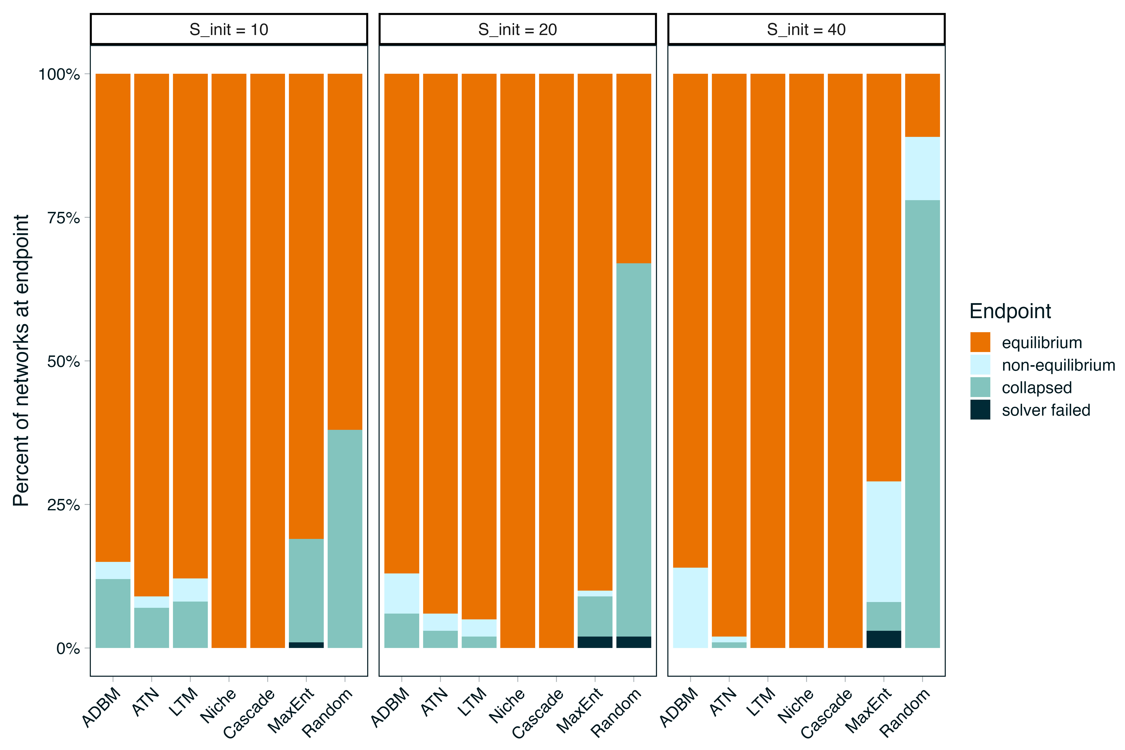
Figure 2: End points of networks indicating the percentage of networks that reached an equilibrium biomass (orange) and if they did not (shades of blue) why not. These are faceted by the initial starting richness for each network
Interestingly if we plot the ‘failed’ networks into the PCA space (Figure 3, darker points) these networks do not differ obviously in structure with the ‘successful’ networks. What is perhaps notable though is that we do begin to see some deviation in this observation for the larger networks (right column, Figure 3), with these networks typically being on the ‘end range’ of the pre structural space.
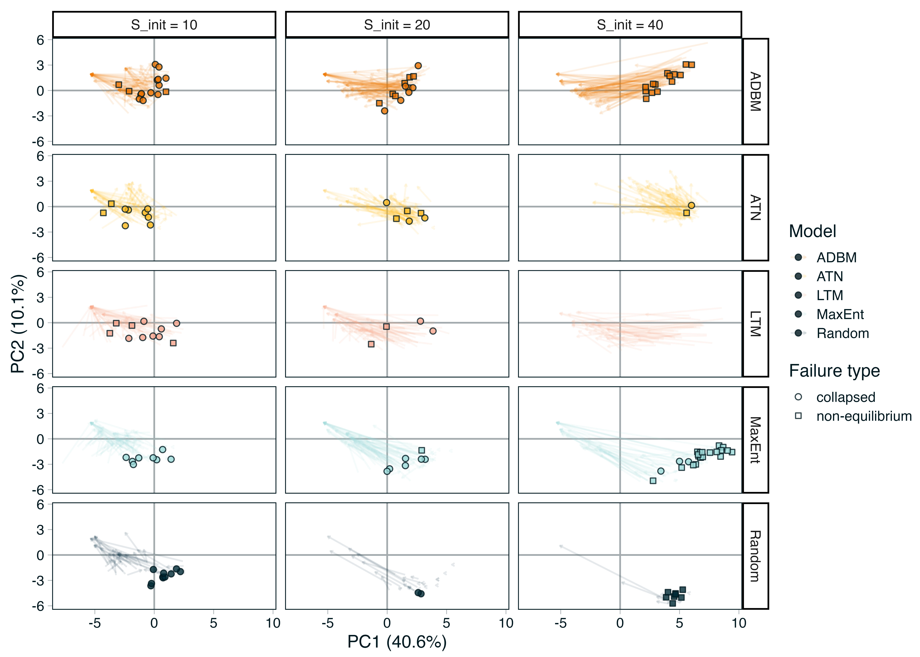
Figure 3: Arrows indicate trajectory of individual networks. Points are networks that failed to reach an equilibrium state that have been predicted into the PCA space. Pale arrows show the trajectory of each individual network, dark arrows the mean trajectory. Note we do not plot networks that failed due to solver issues, additionally we omit the Niche and Cascade models as they have no failed networks

3.3 Network stability inferences
Equilibrium richness explained substantially more variation than generative food web models in network-level stability metrics, with the strongest contribution observed for Shannon diversity of biomasses, followed by the skewness of interaction strengths, species persistence and the Gini coefficient of consumption fluxes (Figure 4). In contrast, variation in resilience was influenced by both richness and model, with a larger contribution from model. Reactivity was explained primarily by generative food web models, with very little contribution from equilibrium richness.
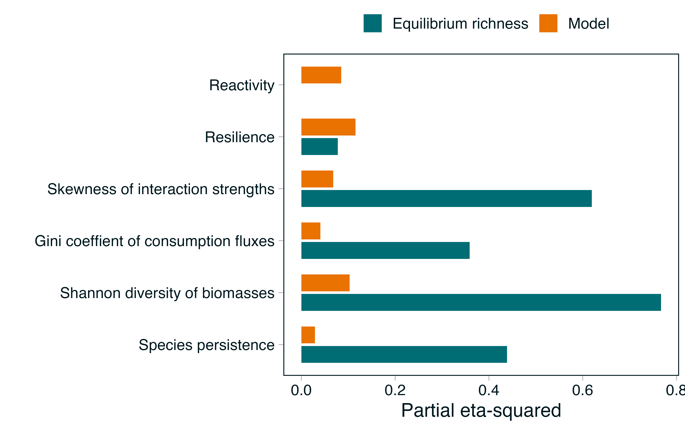
Figure 4: Relative contributions of equilibrium species richness and generative food web models to variation in network and local stability metrics
After accounting for equilibrium richness, Niche, Cascade, ATN and MaxEnt generally supported higher species persistence than ADBM, LTM and Random generated food webs (Figure 5). Biomass diversity was highest in Cascade and Niche webs, but comparatively low in LTM and MaxEnt. Random model had the most uneven consumption fluxes, while MaxEnt and Random webs showed the strongest skewness in interaction strengths. ADBM and LTM generated food webs showed the highest resilience, i.e.,fastest asymptotic recovery, whereas LTM food webs were also the most reactive, i.e., strongest initial amplification of perturbations.
Figure 5: Network and local stability metrics across generative food web models. Points are estimated marginal means adjusted to the mean equilibrium species richness. Bars show 95% confidence intervals.

4. Discussion

4.1 Ecological dynamics constrain food web structure
One of the clearest results of this study is that ecological dynamics consistently reduced structural differences among food web reconstruction frameworks. Networks generated from fundamentally different structural, statistical, and trait-based assumptions began in distinct regions of multivariate topology space, yet their realised counterparts occupied a much narrower region following bioenergetic simulations. This convergence indicates that ecological dynamics impose strong constraints on viable food web architecture, regardless of how the initial network is assembled.
Importantly, this convergence emerged without any opportunity for networks to rewire. Species interactions remained fixed throughout the simulations, meaning that all structural change resulted from species extinctions and the subsequent removal of trophic interactions. The realised networks therefore represent a filtered subset of the original architectures rather than newly assembled communities. In this sense, bioenergetic dynamics act as a selection process on network structure. Interactions that cannot be maintained under energetic and demographic constraints are systematically removed, while those compatible with persistence remain. This interpretation aligns closely with previous work demonstrating that secondary extinctions reshape food web structure through dynamic processes that cannot be captured by static robustness analyses alone (Curtsdotter et al., 2011).
The dominant axis of structural change was associated with reductions in metrics describing indirect competitive interactions, particularly exploitative competition (S4). Rather than highlighting these motifs as special cases, we interpret them as evidence that ecological dynamics simplify portions of the network where indirect effects are concentrated. This interpretation is consistent with empirical studies showing that food webs exhibit conserved local interaction structure across ecosystems despite substantial differences in species composition, suggesting that persistent communities occupy a constrained distribution of these smaller motifs (Stouffer et al., 2007; Stouffer & Bascompte, 2010). Our simulations extend this idea by demonstrating that similar structural organisation can emerge through extinction-driven filtering, even when networks originate from contrasting generative assumptions. Moreover, this extinction-driven pruning agrees with the observation that stable food webs are enriched for interaction configurations that persist under ecological dynamics, whereas structurally unstable configurations are selectively removed (Borrelli, 2015).
The behaviour of the Random networks further illustrates the existence of a constrained structural domain for persistence. Randomly assembled networks were the least likely to reach equilibrium, particularly as species richness increased, yet those that did survive underwent relatively little structural reorganisation. Rather than converging through extensive pruning, these surviving networks appear to have been generated close to a dynamically feasible region of topology space by chance. This result echoes classic stability theory, which predicts that unconstrained random interaction matrices are overwhelmingly unstable unless they possess particular structural properties (Allesina & Tang, 2012; May, 1974). Ecologically informed reconstruction models do not guarantee persistence, but they substantially increase the probability of generating networks within this feasible region because their assembly rules embed ecological constraints absent from purely random topology (Dunne et al., 2002).
Together, these results suggest that convergence in topology is not evidence that generative models are interchangeable. Instead, ecological dynamics compress a diverse set of initial architectures into a narrower subset of structures compatible with persistence. The important question therefore becomes whether this shared realised topology also produces shared ecological dynamics, or whether the assumptions embedded in the reconstruction framework continue to influence stability despite structural convergence.

4.2 Structural convergence does not imply dynamical equivalence
Although ecological dynamics drove networks towards a shared region of topology space, this convergence did not produce equivalent predictions of community stability. Instead, we observed a clear separation between coarse dynamic properties, which were largely explained by realised species richness, and local dynamical properties, which remained strongly dependent on the original reconstruction framework. Structural convergence therefore represents only one dimension of ecological similarity; the dynamical consequences of those structures retain a signature of how the network was assembled.
This distinction is most apparent when comparing network-level and local stability metrics. Shannon diversity of biomasses, interaction strength skewness, species persistence, and the Gini coefficient of consumption fluxes were explained predominantly by equilibrium richness rather than model identity. This agrees with longstanding ecological theory showing that many aggregate properties of communities emerge from biodiversity itself through biomass partitioning, portfolio effects, and the distribution of energy across trophic levels (Loreau & Mazancourt, 2013; Yodzis, 1981). Once ecological dynamics had removed species and reduced networks to similar realised sizes, these macroscopic properties became remarkably insensitive to the initial reconstruction framework.
Local stability, however, behaves differently. Reactivity was explained almost entirely by the generative model, while resilience remained strongly influenced by model identity even after accounting for realised richness. These metrics quantify how perturbations propagate through communities rather than simply whether communities persist, making them inherently sensitive to the organisation of interaction strengths within the Jacobian matrix (Neubert & Caswell, 1997; Tang et al., 2014). Two networks with similar connectance, trophic structure, and species richness can therefore exhibit fundamentally different transient responses if the underlying energetic constraints that generated their interactions differ.
The contrast between structural and trait-based models illustrates this point. Niche and Cascade networks consistently reached equilibrium, but this should not be interpreted as evidence that they provide the most biologically realistic representation of ecological persistence. Rather, these models inherit body masses only after network construction through a fixed predator-prey mass ratio, meaning that energetic structure is imposed post hoc to satisfy the assumptions of the bioenergetic model (Delmas et al., 2017). In contrast, ADBM, ATN, and latent trait networks propagate body mass distributions directly from the reconstruction process into the dynamical model. The resulting interaction strengths, attack rates, handling times, and metabolic rates remain coupled through the biological assumptions embedded in each framework (Brose et al., 2006; Petchey et al., 2008; Schneider et al., 2016).
This difference helps explain the apparent paradox in our results. Trait-based models often supported fewer persistent species than structural models, yet they generated markedly different resilience and reactivity profiles. In particular, latent trait networks combined relatively high resilience with the strongest transient amplification of perturbations, while ADBM networks recovered rapidly despite lower overall persistence. This decoupling of asymptotic stability from transient dynamics has been recognised as a defining property of complex ecological communities where interaction strengths are structured rather than random (Neubert & Caswell, 1997; Tang et al., 2014). Consequently, reproducing global food web topology is not sufficient for reproducing ecological dynamics.
Our results suggest that structural convergence should not be interpreted as evidence that reconstruction frameworks become interchangeable after ecological dynamics. Instead, extinction-driven filtering removes many topological differences while preserving historically contingent differences in how energy flows through the community. The realised network may look similar, but its response to perturbation still reflects the assumptions embedded in the model used to generate it.

4.3 What makes a good food web model?
The Niche model transformed food web ecology by demonstrating that simple assembly rules can reproduce the large-scale architecture of empirical trophic networks (Williams & Martinez, 2000). Since then, structural generative models have become the default starting point for studies of robustness, extinction cascades, and ecosystem stability (Allesina & Tang, 2012; Curtsdotter et al., 2011). Our results do not challenge the value of these models for describing food web topology. Instead, they demonstrate that reproducing network structure is not equivalent to reproducing ecological dynamics.
The central implication of this study is that food web reconstruction frameworks should be viewed as an embedding of assumptions rather than interchangeable Null models. Each reconstruction framework encodes assumptions about the processes that generate trophic interactions, whether these assumptions arise from niche ordering, statistical constraints, body size scaling, or optimal foraging. Those assumptions influence the interaction strengths, energetic organisation, and transient dynamics that emerge once networks are embedded within a common dynamical framework. Ecological dynamics subsequently filter these initial structures towards a shared region of viable topology, but they do not erase the signature of how those networks were constructed.
This distinction helps reconcile an apparent tension in the food web literature. Structural models have proven remarkably successful at reproducing global network statistics across ecosystems, while mechanistic models have been developed to explain the biological processes that generate those same interactions (Banville et al., 2023; Brose et al., 2006; Petchey et al., 2008). Our results suggest that these approaches answer different ecological questions rather than competing to identify a single ‘best’ food web model. For questions concerning broad topological organisation, biodiversity patterns, or realised species richness, structural and statistical models may provide appropriate and computationally efficient approximations. In contrast, questions concerning transient dynamics, perturbation responses, resilience, or extinction cascades require reconstruction frameworks that preserve the biological constraints governing interaction strengths and energy flow (Delmas et al., 2017; Poisot et al., 2016; Schneider et al., 2016).
More broadly, these findings support a shift in how food web reconstruction is interpreted. Rather than asking whether one generative model best represents ecological communities, we should ask whether the assumptions embedded within a reconstruction framework are appropriate for the ecological inference being made. As ecological networks are increasingly reconstructed across space, time, and future environmental scenarios (Strydom et al., 2021; Strydom, Dunhill, et al., 2026), explicitly matching reconstruction models to inferential goals will become as important as matching dynamical models to ecological processes.
Ultimately, not everything is a niche model. Different reconstruction frameworks can converge on similar realised network architectures while retaining fundamentally different predictions about how ecological communities respond to perturbation. The choice of generative model is therefore not simply a technical decision about network construction. It is an ecological hypothesis about how communities are assembled and how they persist.

References
Adams, D. C., & Collyer, M. L. (2009). A GENERAL FRAMEWORK FOR THE ANALYSIS OF PHENOTYPIC TRAJECTORIES IN EVOLUTIONARY STUDIES. Evolution, 63(5), 1143–1154. https://doi.org/10.1111/j.1558-5646.2009.00649.x
Allesina, S., & Tang, S. (2012). Stability criteria for complex ecosystems. Nature, 483(7388), 205–208. https://doi.org/10.1038/nature10832
Banville, F., Gravel, D., & Poisot, T. (2023). What constrains food webs? A maximum entropy framework for predicting their structure with minimal biases. PLOS Computational Biology, 19(9), e1011458. https://doi.org/10.1371/journal.pcbi.1011458
Bezanson, J., Edelman, A., Karpinski, S., & Shah, V. (2017). Julia: A fresh approach to numerical computing. SIAM Review, 59(1), 65–98. https://doi.org/10.1137/141000671
Borrelli, J. J. (2015). Selection against instability: Stable subgraphs are most frequent in empirical food webs. Oikos, 124(12), 1583–1588. https://doi.org/10.1111/oik.02176
Brose, U., Jonsson, T., Berlow, E. L., Warren, P., Banasek-Richter, C., Bersier, L.-F., Blanchard, J. L., Brey, T., Carpenter, S. R., Blandenier, M.-F. C., Cushing, L., Dawah, H. A., Dell, T., Edwards, F., Harper-Smith, S., Jacob, U., Ledger, M. E., Martinez, N. D., Memmott, J., … Cohen, J. E. (2006). Consumerresource body-size relationships in natural food webs. Ecology, 87(10), 2411–2417. https://doi.org/https://doi.org/10.1890/0012-9658(2006)87[2411:CBRINF]2.0.CO;2
Cohen, J. E., Briand, F., & Newman, C. (1990). Community food webs: Data and theory. Springer-Verlag. https://www.springer.com/gp/book/9783642837869
Curtsdotter, A., Binzer, A., Brose, U., De Castro, F., Ebenman, B., Eklöf, A., Riede, J. O., Thierry, A., & Rall, B. C. (2011). Robustness to secondary extinctions: Comparing trait-based sequential deletions in static and dynamic food webs. Basic and Applied Ecology, 12(7), 571–580. https://doi.org/10.1016/j.baae.2011.09.008
Delmas, E., Brose, U., Gravel, D., Stouffer, D. B., & Poisot, T. (2017). Simulations of biomass dynamics in community food webs. Methods in Ecology and Evolution, 8(7), 881–886. https://doi.org/10.1111/2041-210X.12713
Delmas, E., Stouffer, D. B., & Poisot, T. (n.d.). Food web structure alters ecological communities top-heaviness with little effect on the biodiversity-functioning relationship. https://doi.org/10.1101/2020.06.10.144949
Dunne, J., Williams, R. J., & Martinez, N. D. (2002). Network structure and biodiversity loss in food webs: Robustness increases with connectance. Ecol. Lett., 5(4), 558–567.
Lajaaiti, I., Bonnici, I., Kéfi, S., Mayall, H., Danet, A., Beckerman, A. P., Malpas, T., & Delmas, E. (2025). EcologicalNetworksDynamics.jl: A julia package to simulate the temporal dynamics of complex ecological networks. Methods in Ecology and Evolution, 16(3), 520–529. https://doi.org/10.1111/2041-210X.14497
Loreau, M., & Mazancourt, C. de. (2013). Biodiversity and ecosystem stability: A synthesis of underlying mechanisms. Ecology Letters, 16(s1), 106–115. https://doi.org/10.1111/ele.12073
May, R. M. (1974). Stability and complexity in model ecosystems (Vol. 1). Princeton University Press. https://doi.org/10.2307/j.ctvs32rq4
Neubert, M. G., & Caswell, H. (1997). Alternatives to resilience for measuring the responses of ecological systems to perturbations. Ecology, 78(3), 653–665. https://doi.org/10.1890/0012-9658(1997)078[0653:ATRFMT]2.0.CO;2
Petchey, O. L., Beckerman, A. P., Riede, J. O., & Warren, P. H. (2008). Size, foraging, and food web structure. Proceedings of the National Academy of Sciences, 105(11), 4191–4196. https://doi.org/10.1073/pnas.0710672105
Poisot, T., Stouffer, D. B., & Kéfi, S. (2016). Describe, understand and predict: Why do we need networks in ecology? Functional Ecology, 30(12), 1878–1882. https://doi.org/10.1111/1365-2435.12799
R Core Team. (2024). R: A language and environment for statistical computing. R Foundation for Statistical Computing. https://www.R-project.org/
Rohr, R., Scherer, H., Kehrli, P., Mazza, C., & Bersier, L.-F. (2010). Modeling food webs: Exploring unexplained structure using latent traits. The American Naturalist, 176(2), 170–177. https://doi.org/10.1086/653667
Ruiter, P. C. de, Neutel, A.-M., & Moore, J. C. (1995). Energetics, patterns of interaction strengths, and stability in real ecosystems. Science, 269(5228), 1257–1260. https://doi.org/10.1126/science.269.5228.1257
Schneider, F. D., Brose, U., Rall, B. C., & Guill, C. (2016). Animal diversity and ecosystem functioning in dynamic food webs. Nature Communications, 7(1), 12718. https://doi.org/10.1038/ncomms12718
Stouffer, D. B., & Bascompte, J. (2010). Understanding food-web persistence from local to global scales. Ecology Letters, 13(2), 154–161. https://doi.org/10.1111/j.1461-0248.2009.01407.x
Stouffer, D. B., Camacho, J., Jiang, W., & Nunes Amaral, L. A. (2007). Evidence for the existence of a robust pattern of prey selection in food webs. Proceedings of the Royal Society B: Biological Sciences, 274(1621), 1931–1940. https://doi.org/10.1098/rspb.2007.0571
Strydom, T., Catchen, M. D., Banville, F., Caron, D., Dansereau, G., Desjardins-Proulx, P., Forero-Muñoz, N. R., Higino, G., Mercier, B., Gonzalez, A., Gravel, D., Pollock, L., & Poisot, T. (2021). A roadmap towards predicting species interaction networks (across space and time). Philosophical Transactions of the Royal Society B, 376(1837). https://doi.org/10.1098/rstb.2021.0063
Strydom, T., Dunhill, A. M., Dunne, J. A., Poisot, T., & Beckerman, A. P. (2026). From metawebs to realised webs: A framework for ecological network representation under global change. EcoEvoRxiv. https://doi.org/10.32942/X2JW8K
Strydom, T., Karapunar, B., Dunne, J. A., Hull, P., Little, C. T. S., Pimiento, C., Ridgwell, A., Beckerman, A. P., & Dunhill, A. M. (2026). Are we mapping ecosystems or models? Framework choices dominate food web topology and extinction inferences. https://ecoevorxiv.org/repository/view/13495/
Tang, S., Pawar, S., & Allesina, S. (2014). Correlation between interaction strengths drives stability in large ecological networks. Ecology Letters, 17(9), 1094–1100. https://doi.org/https://doi.org/10.1111/ele.12312
Williams, R. J., & Martinez, N. D. (2000). Simple rules yield complex food webs. Nature, 404(6774), 180–183. https://doi.org/10.1038/35004572
Yodzis, P. (1981). The stability of real ecosystems. Nature, 289(5799), 674–676. https://doi.org/10.1038/289674a0

