Methods for Reconstructing Paleo Food Webs

Tanya Strydom

Andrew P. Beckerman

2025-04-14

Abstract

Food webs represent the feeding relationships between species and can help infer ecosystem-level processes. Alongside the development of food web theory, methods for constructing food webs have been developed to infer species interactions when empirical data is lacking. Food web construction methods are diverse, each utilising different approaches to infer species interactions —such as the use of traits to infer mechanistic relationships vs using gut content as a proxy for species diets. These methods have distinct theories, mechanisms, and data requirements. In paleoecology, where direct evidence of feeding interactions are rare, food web construction methods are especially valuable and affords us the opportunity to make inferences about paleo communities beyond simply a record of species composition. However, the limitations of paleontological data (e.g., information of species traits is limited to that which can be preserved) restrict which methods can reliably be used. By considering both ecological theory and the constraints of what can be derived from the fossil record, we identify the methods best suited for the construction of paleo food webs. Specifically, we focus on how these methods differ in the networks they produce and what these networks can reveal about species interactions. In doing so we hope to clarify the ecological nuances of network prediction and help prevent the accidental misuse or misinterpretation of paleo food webs.

# 1. Why build paleo food webs?

* Because its interesting?
* Value in using hindcasting to aid in forecasting. *e.g.,* the Toarcian ms [1] shows how we can use these paleo communities to understand trophic-level responses to extinctions.

# 2. How do we do it?

* There is an evolving body of work that focuses on developing tools specifically for the task of predicting food webs.
* There are a handful that have been developed specifically in the context of paleo settings *e.g.,* TODO but we can also talk about those that might have been developed/tested in contemporary settings but still have applicability in paleo ones.
* Different underlying theory though
  + Focus here on the idea of different ‘currencies’ but also aggregations - energy vs compatibility.
* Insert brief overview of the different methods as they pertain to approach (so the T4T triangle)
* Challenges we face (even in contemporary settings)?
  + keep high level - I think the argument here should fall more in the data trade offs…

# 3. Understanding how networks are different

It is important to be aware that networks can be configured in different ways depending on how the interactions are defined (Strydom, in prep). Basically we have metawebs, which represent *potential* interactions, and realised networks, which represent the subset of potential that are realised as a result of community and environmental context.

# 4. Challenges specific to paleo communities/networks

Although there are a suite of tools and methods that have been developed to predict species interactions and networks they will not all be suitable for the prediction of paleo communities. Some of these include the fact that the fossil record is incomplete/preservation is biased [REF] which means that we have an incomplete picture of the entire community. Fossils are 2D and only represent specific ‘parts’ of an individual (hard and bone-y bits), this means we don’t have a complete picture of the physical traits of species *e.g.,* no body mass (but yes size), behaviours, or ability to construct well resolved phylogenetic trees the deeper we go back in time. Also owing to the patchy nature of fossils one often has to aggregate over large spatial scales, and also fossils are preserved in 2D so no *real* idea of spatial arrangements, compounded that fossils aren’t necessarily conserved/found ‘in situ’ but can be moved (*e.g.,* alluvial deposits). Methodologically speaking some tools that ‘learn’ from contemporary communities (*e.g.,* [2], [3]) will become ‘worse’ the further one goes back in time since species then look very different from now but can still be useful for ‘recent’ communities (*e.g.,* [4]). Something about the intersectionality of the data we don’t have for paleo communities and the data we need for some of the different modelling approaches.

# 5. Dataset Overview

## 5.1 Species occurence

Here we use the fossil occurrence data over an interval extends from the upper Pliensbachian (~185 Ma) to the upper Toarcian (~175 Ma) of the Cleveland Basin [see 1 for a more comprehensive overview]. The data set consists of a subset of four broad time periods, or assemblages, which are treated as communities of interacting organisms; pre-extinction, post-extinction, early recovery, and late recovery.

## 5.2 Defining modes of life (traits)

We used the modes of life (traits) as identified in [1], who defined the motility (fast, slow, facultative, non-motile), tiering (pelagic, erect, surficial, semi-infaunal, shallow infaunal, deep infaunal), feeding (predator, suspension feeder, deposit feeder, mining, grazer), and size: gigantic (>500 mm), very large (>300–500 mm), large (>100–300 mm), medium (>50–100 mm), small (>10–50 mm), tiny (≤10 mm), for each fossil species based on the ecological traits defined in the Bambach ecospace model [5].It would be very sexy if we could get a figure that looks something like this together…

# 6. Methods

## 6.1 Models

|  |  |  |  |  |  |  |  |  |  |  |  |  |  |  |  |  |  |  |  |  |  |
| --- | --- | --- | --- | --- | --- | --- | --- | --- | --- | --- | --- | --- | --- | --- | --- | --- | --- | --- | --- | --- | --- |
| Table 1: A summary of the different families of tools that can be used to generate paleo food webs.   | Model | Predicts | Notes | | --- | --- | --- | | Allometric diet breadth model | Realised network |  | | Body size ratio model | Metaweb |  | | Niche model | Structural network | Is not species specific - cannot apply species metadata | | Paleo food web inference model | Metaweb |  | | Random model | Structural network |  | | l-matrix | Realised network |  | |

### 6.1.1 Paleo food web inference model

The Paleo food web inference model (PFIM; [6]) uses a series of rules for a set of trait categories (such as habitat and body size) to determine if an interaction can feasibly occur between a species pair. If all conditions are met for the different rule classes then an interaction is deemed to be feasible. The original work put forward in [6] also includes a ‘downsampling’ step developed by [7] that uses a power law, defined by the link distribution, to ‘prune’ down some of the links. It is worth mentioning that this approach is similar to that developed by [8] with the exception that Shaw does not specifically bin species into guilds, and so we choose to use the method developed by Shaw since both methods should produce extremely similar networks as they are built on the same underlying philosophy.

### 6.1.2 Allometric diet breadth model

The Allometric diet breadth model (ADBM; [9]) is rooted in feeding theory and allocates the links between species based on energetics, which predicts the diet of a consumer based on energy intake. This means that the model is focused on predicting not only the number of links in a network but also the arrangement of these links based on the diet breadth of a species, where the diet ($K$) is defined as follows:

$$K=\frac{\sum_{i=1}^{k}{λ_{ij}}E_{i}}{1+\sum_{i=1}^{k}{λ_{ij}}H_{ij}} \left(1\right)$$

where $λ_{ij}$ is the handling time, which is the product of the attack rate $A_{i}$ and resource density $N_{i}$, $E_{i}$ is the energy content of the resource and $H_{ij}$ is the ratio handling time, with the relationship being dependent on the ratio of predator and prey bodymass as follows:

$$H_{ij}=\frac{h}{b−\frac{M_{i}}{M_{j}}}if\frac{M_{i}}{M_{j}}<b$$

or

$$H_{ij}=∞≥b$$

Refer to [9] for more details as to how these different terms are parametrised.

### 6.1.3 Body size ratio model

The body size ratio model [10] determines feeding interactions using the ratio between consumer () and resource () body sizes - which supposedly stems from niche theory (still trying to reconcile that). The probability of a link existing between a consumer and resource (in its most basic form) is defined as follows:

$$P_{ij}=\frac{p}{1+p}$$

where

$$p=exp\left[α+βlog\left(\frac{M_{i}}{M_{j}}\right)+γlog^{2}\left(\frac{M_{i}}{M_{j}}\right)\right] \left(2\right)$$

The original latent-trait model developed by [10] also included an additional latent trait term $v_{i}δf_{j}$ however for simplicity we will use Equation 2 as per [11] Based on [10] it is possible to estimate the parameters $α$, $δ$, and $γ$ using a GLM but we will use the parameters from [11], which was ‘trained’ on the Serengeti food web data and are as follows: = 1.41, = 3.75, and = 1.87.

### 6.1.4 L matrix

For now we can link to thATNr package [12] until I can find a more suitable manuscript that breaks down this construction method. [13] Interactions are determined by allometric rules (ratio of consumer () and resource () body sizes) and a Ricker function as defined by and and returns The probability of a link () existing between a consumer and resource, and is defined as follows:

where

It is also possible to apply a threshold value to , whereby any probabilities below that threshold are set to zero.

### 6.1.5 Niche model

The niche model [14] introduces the idea that species interactions are based on the ‘feeding niche’ of a species. Broadly, all species are randomly assigned a ‘feeding niche’ range and all species that fall in this range can be consumed by that species (thereby allowing for cannibalism). The niche of each species is randomly assigned and the range of each species’ niche is (in part) constrained by the specified connectance of the network. The niche model has also been modified, although it appears that adding to the ‘complexity’ of the niche model does not improve on its ability to generate a more ecologically ‘correct’ network [15].

## 6.2 Assessing model performance

In terms of wanting to asses and compare across the different models it is beneficial to approach this task by thinking about the different aspects of the network as well as interactions that are being predicted by the different models. It is perhaps beneficial to think of these across different ‘scales’ of organisation within the network, namely macro (the entire network), meso (smaller interacting units within the network), and micro (species-level attributes). Although there are a myriad of possible ways to ‘measure’ and analyse ecological networks [16] we do still lack a clear set of guidelines for assessing how well models recover network structure [17] and it is beneficial to use a small subset of metrics that can clearly be tied to broader aspects of network function or capturing a ecological process.

### 6.2.1 Macro network properties

**Connectance** [18] has been shown to be the feature of networks that underpin a series of other properties and function [19] and so it is perhaps the most important structural attribute for a model to be able to retrieve correctly. Additionally we consider the **complexity** of networks by calculating their SVD entropy (this gives us an estimate of the physical as opposed to behavioural complexity of networks; [20]), we could also look at the rank/rank deficiency of networks which (theoretically) represents the number fo unique interaction strategies in the network [20], which may be specifically interesting in terms of looking at pre and post extinction but also as a way to unpack ‘functional redundancy’ that some models may introduce.

### 6.2.2 Meso network properties

Motifs represent smaller subset of interactions between three species, and are argued to capture dynamics that are likely to be ecologically relevant [21,22]. Here we specifically look at the number of **linear chains**, **omnivory**, **apparent competition**, and **direct competition** motifs. In the broader context the ability of a model in being able to capture these smaller motifs will inform as to its suitability of use understanding the more dynamic component of network ecology.

### 6.2.3 Micro network properties

The number of interactions established (**generality**) or received (**vulnerability**) by each species [23], are (broadly) indicative of consumer-resource relationships and diet breadth of species [ref]. Although this is usually determined at the species level the standard deviation of the generality and vulnerability of species is often used when benchmarking predicted networks [9,*e.g.,* 15].

The **specificity** of species in a network is measured as a function of the proportion of resources they effectively use [24]

**Shape:** to determine if the ‘shape’ of the network is correct we are looking at the ratio of ‘top’:‘basal’ species (where ‘top’ species are those that have a vulnerability of 0 and ‘basal’ species have a generality of 0) as well as the distance to base from one of the top species (this will represent the shortest path but a large discrepancy between the real and predicted network would be indicative that the model is not predicting a similar ‘shape’). This will allow is to see if the models construct tall ‘pencil’ vs flat ‘pancake’ networks (Beckerman 2024, pers comms). A small (< 1) number will thus be indicative of a ‘bottom-heavy’ network and the opposite for larger numbers

### 6.2.4 Interactions

**Interaction turnover** [24] tells us which interactions are ‘conserved’ (shared) across the networks from the same period but constructed using different models.

### 6.2.5 Robustness

see [25]

# 7. Results

## 7.1 Comparing predicted networks

|  |
| --- |
| Figure 1: stuff… For display purposes the counts for the different motifs are log transformed |

## 7.2 Comparing inference

## 7.3 Extinctions

|  |
| --- |
| Figure 2: Dashed line indicates the (mean) extinction simulation results (post value, start values are those estimated by the relevant model). For display purposes the counts for the different motifs are log transformed |

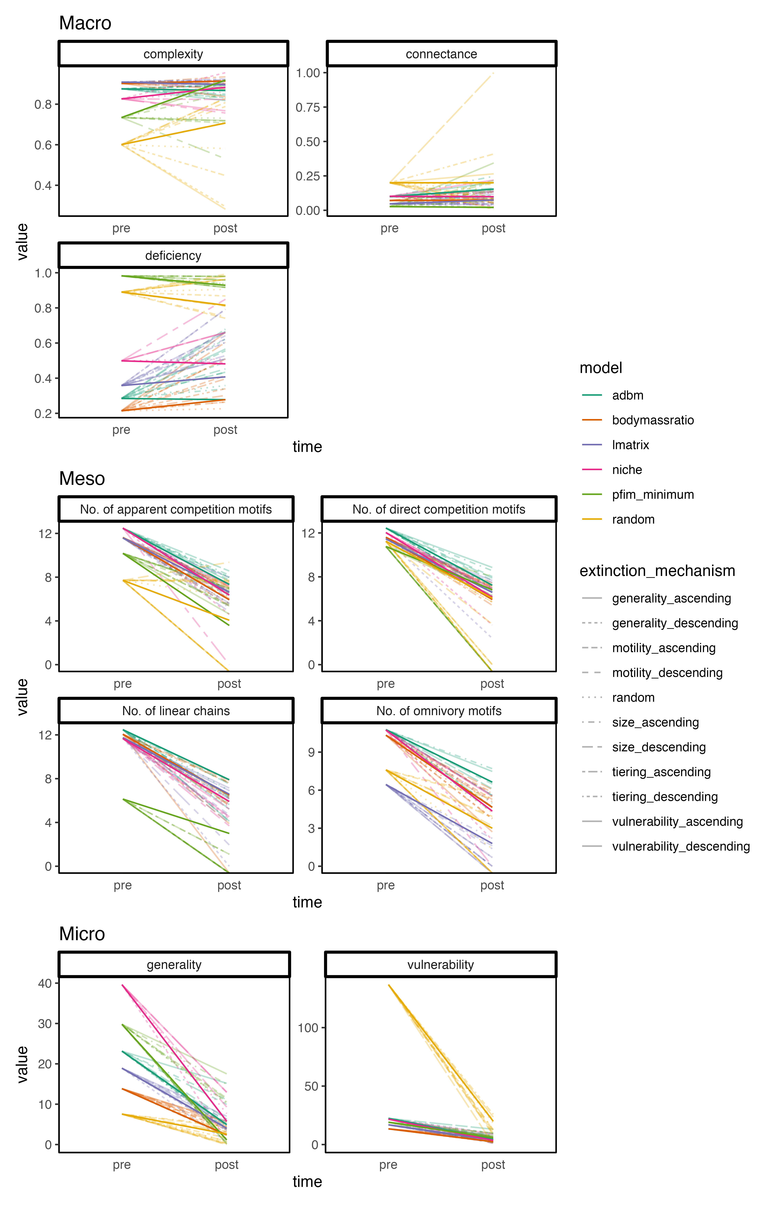

Dark line indicates ‘real’ extinction simulation results the lighter lines show each model individually, which is also denoted by the linetype. For display purposes the counts for the different motifs are log transformed

# References

1. Dunhill, A.M. *et al.* (2024) [Extinction cascades, community collapse, and recovery across a Mesozoic hyperthermal event](https://doi.org/10.1038/s41467-024-53000-2). *Nature Communications* 15, 8599

2. Strydom, T. *et al.* (2023) [Graph embedding and transfer learning can help predict potential species interaction networks despite data limitations](https://doi.org/10.1111/2041-210X.14228). *Methods in Ecology and Evolution* 14, 2917–2930

3. Caron, D. *et al.* (2022) [Addressing the Eltonian shortfall with trait-based interaction models](https://doi.org/10.1111/ele.13966). *Ecology Letters* 25, 889–899

4. Fricke, E.C. *et al.* (2022) [Collapse of terrestrial mammal food webs since the Late Pleistocene](https://doi.org/10.1126/science.abn4012). *Science* 377, 1008–1011

5. Bambach, R.K. *et al.* (2007) [Autecology and the Filling of Ecospace: Key Metazoan Radiations](https://doi.org/10.1111/j.1475-4983.2006.00611.x). *Palaeontology* 50, 1–22

6. Shaw, J.O. *et al.* (2024) [A framework for reconstructing ancient food webs using functional trait data](https://doi.org/10.1101/2024.01.30.578036)bioRxiv, 2024.01.30.578036

7. Roopnarine, P.D. (2006) [Extinction cascades and catastrophe in ancient food webs](https://www.jstor.org/stable/4096814). *Paleobiology* 32, 1–19

8. Roopnarine, P.D. (2017) Ecological Modelling of Paleocommunity Food Webspp. 201–226, University of Chicago Press

9. Petchey, O.L. *et al.* (2008) [Size, foraging, and food web structure](https://doi.org/10.1073/pnas.0710672105). *Proceedings of the National Academy of Sciences* 105, 4191–4196

10. Rohr, R. *et al.* (2010) [Modeling food webs: Exploring unexplained structure using latent traits.](https://doi.org/10.1086/653667) *The American Naturalist* 176, 170–177

11. Yeakel, J.D. *et al.* (2014) [Collapse of an ecological network in ancient egypt](https://doi.org/10.1073/pnas.1408471111). *PNAS* 111, 14472–14477

12. Gauzens, B. *et al.* (2023) [ATNr: Allometric Trophic Network models in R](https://doi.org/10.1111/2041-210X.14212). *Methods in Ecology and Evolution* 14, 2766–2773

13. Schneider, F.D. *et al.* (2016) [Animal diversity and ecosystem functioning in dynamic food webs](https://doi.org/10.1038/ncomms12718). *Nature Communications* 7, 12718

14. Williams, R.J. and Martinez, N.D. (2000) [Simple rules yield complex food webs](https://doi.org/10.1038/35004572). *Nature* 404, 180–183

15. Williams, R.J. and Martinez, N.D. (2008) [Success and its limits among structural models of complex food webs](https://doi.org/10.1111/j.1365-2656.2008.01362.x). *The Journal of Animal Ecology* 77, 512–519

16. Delmas, E. *et al.* (2018) Analysing ecological networks of species interactions. *Biological Reviews* DOI: [10.1111/brv.12433](https://doi.org/10.1111/brv.12433)

17. Allesina, S. *et al.* (2008) [A general model for food web structure](https://doi.org/10.1126/science.1156269). *Science* 320, 658–661

18. Martinez, N.D. (1992) [Constant connectance in community food webs](http://www.jstor.org/stable/2462337). *The American Naturalist* 139, 1208–1218

19. Strydom, T. *et al.* (2021) [A roadmap towards predicting species interaction networks (across space and time)](https://doi.org/10.1098/rstb.2021.0063). *Philosophical Transactions of the Royal Society B: Biological Sciences* 376, 20210063

20. Strydom, T. *et al.* (2021) [SVD entropy reveals the high complexity of ecological networks](https://doi.org/10.3389/fevo.2021.623141). *Frontiers in Ecology and Evolution* 9

21. Milo, R. *et al.* (2002) [Network motifs: Simple building blocks of complex networks](https://doi.org/10.1126/science.298.5594.824). *Science* 298, 824–827

22. Stouffer, D.B. *et al.* (2007) [Evidence for the existence of a robust pattern of prey selection in food webs](https://doi.org/10.1098/rspb.2007.0571). *Proceedings of the Royal Society B: Biological Sciences* 274, 1931–1940

23. Schoener, T.W. (1989) [Food Webs From the Small to the Large: The Robert H. MacArthur Award Lecture](https://doi.org/10.2307/1938088). *Ecology* 70, 1559–1589

24. Poisot, T. *et al.* (2012) [A comparative study of ecological specialization estimators](https://doi.org/10.1111/j.2041-210x.2011.00174.x). *Methods in Ecology and Evolution* 3, 537–544

25. Jonsson, T. *et al.* (2015) [The reliability of R50 as a measure of vulnerability of food webs to sequential species deletions](https://doi.org/10.1111/oik.01588). *Oikos* 124, 446–457