Live Full Audit Report: 2026-02-17T19:12:05.590Zwait per action: 7000 ms

Summary: 6 | Passed: 5 | Failed: 1

Failed scenarios
entity-initial: Action 12 (Role continue to Entity) failed: Could not click "Role continue to Entity". Patterns: /continue to the Entity/i OR /Continue/i. Visible buttons: . Matcher debug first try: (empty) [disabled]. Matcher debug retry: (empty) [disabled]. Prompt: Write one sentence that describes the Role as position and contribution, not tasks or services. Use: 'Mindd connects/aligns/translates ... so that ...'. Keep it true even if tactics change.. CardDesc: Let's sharpen the Role statement so it guides clear choices and sets boundaries. Think about the effect Mindd consistently creates and what becomes non-negotiable because of this Role.

step0-initial: Step 0 open state: PASSprompt: To get started, could you tell me what type of business you are starting or running, and what the name is (or if it's still TBD)?card text: Just to set the context, we'll start with the basics.buttons: (none)

1. Start: click: Start the proces with Validation & Business Name: yes
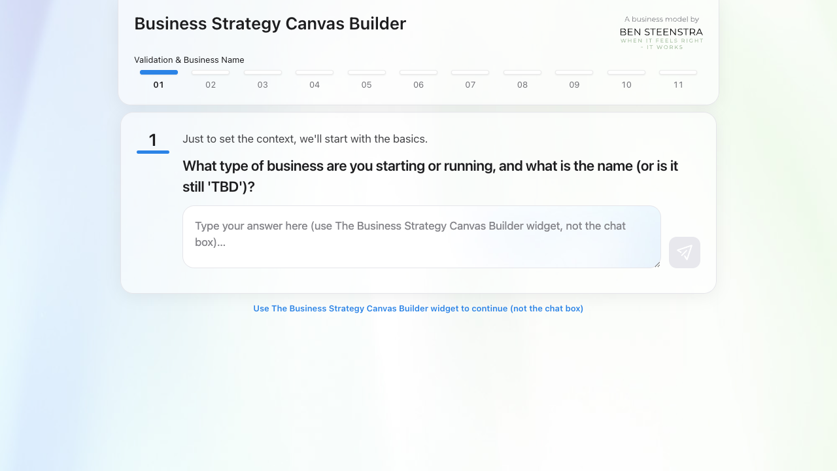

dream-initial: Reach Dream: PASSprompt: Define the Dream of Mindd or choose an option.card text: Vision comes from the Greek visio, meaning to see. A real visionary dreams of a future image before it is obvious. That is why this step is called Dream. A Dream is a desired future image.
This is not a revenue goal, not a tactic, and not a disguised product or service pitch. It is a human future image that creates emotional resonance. It must be effect-first, not tool-first or execution-first. Please share your first draft, even if rough. For example: "Mindd dreams of a world in which creativity in advertising brings people and brands closer together."buttons: Tell me more about why a dream matters | Do a small exercise that helps to define your dream.

1. Start: click: Start the proces with Validation & Business Name: yes

2. Step0 business input-try-1: fill: Venture: advertising agency | Name: Mindd | Status: existing: yes
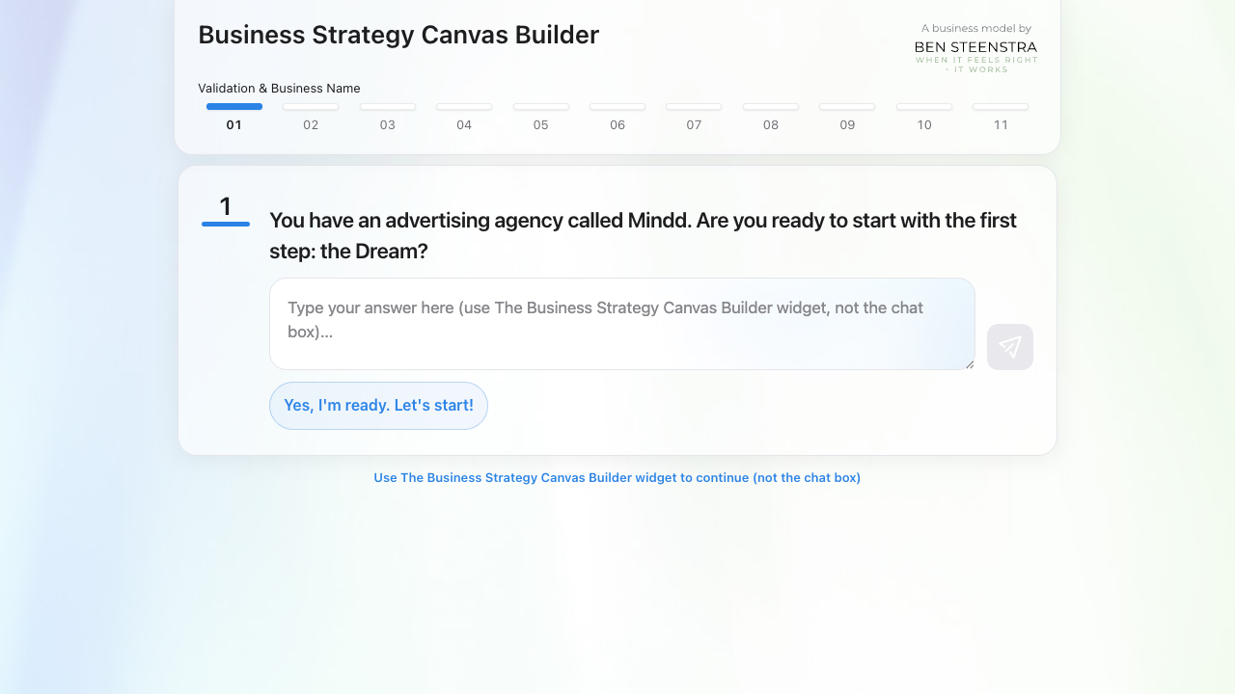

3. Step0 fallback business input-try-1: fill: I run an advertising agency called Mindd: yes
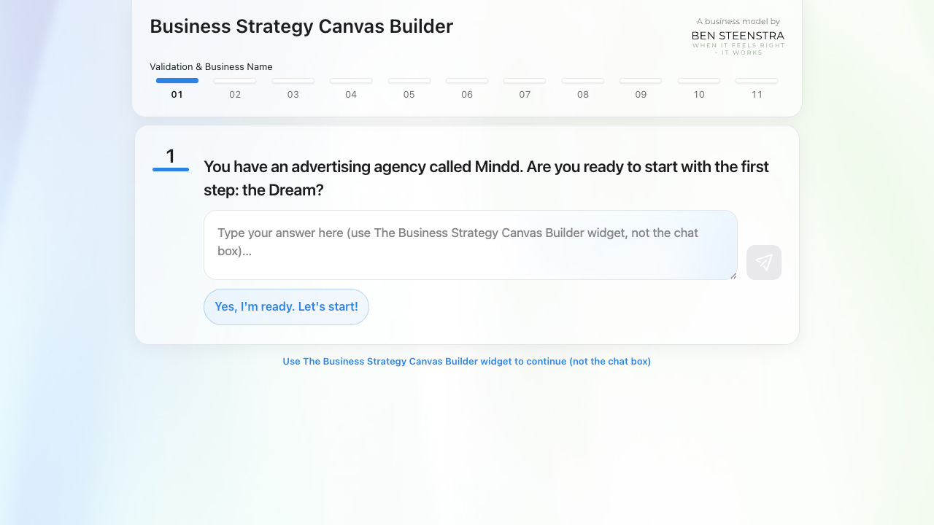

4. Step0 continue to Dream: click: Yes, I'm ready. Let's start!: yes
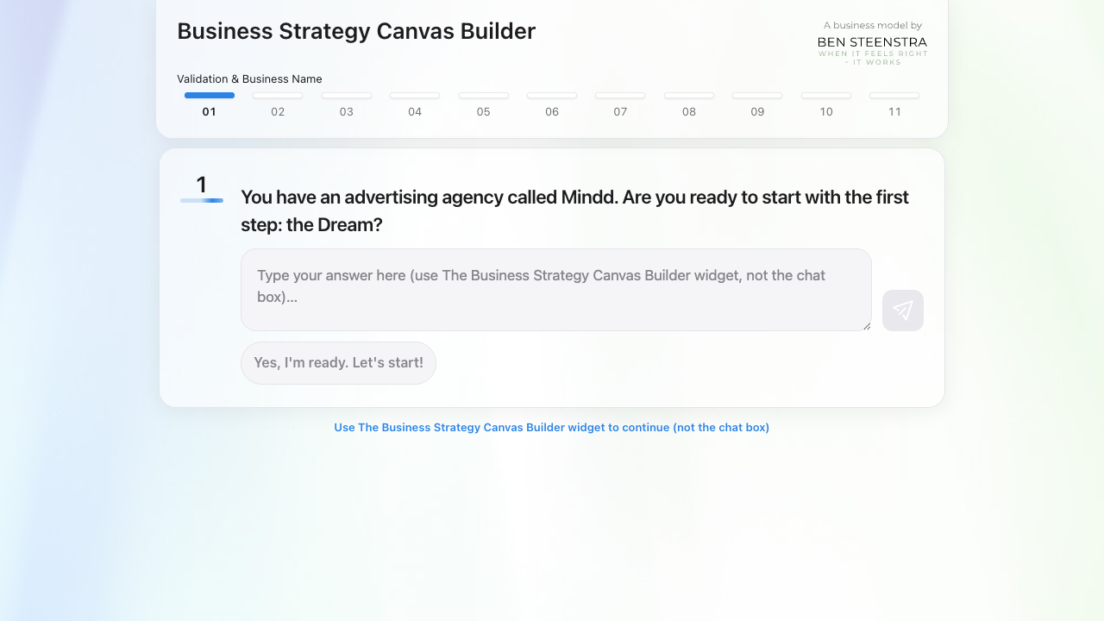

purpose-initial: Reach Purpose: PASSprompt: Refine the Dream of Mindd or choose an option.card text: Your current Dream for Mindd is:
Mindd dreams of a world in which businesses flourish by creating meaningful connections that empower people to grow, collaborate, and feel valued.buttons: I'm happy with this wording, please continue to step 3 Purpose | Do a small exercise that helps to define your dream.

1. Start: click: Start the proces with Validation & Business Name: yes

2. Step0 business input-try-1: fill: Venture: advertising agency | Name: Mindd | Status: existing: yes

3. Step0 fallback business input-try-1: fill: I run an advertising agency called Mindd: yes

4. Step0 continue to Dream: click: Yes, I'm ready. Let's start!: yes

5. Dream answer-after-fill-wording-suggestion: click: #wordingChoicePickSuggestion: yes
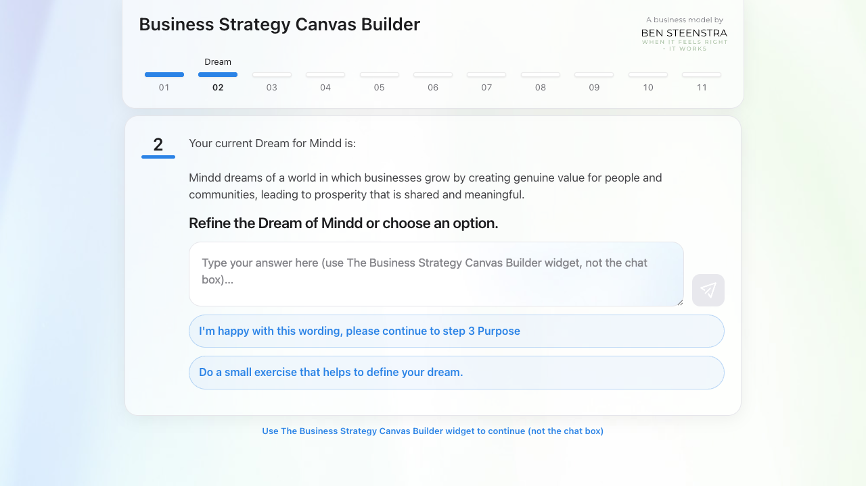

6. Dream answer-try-1: fill: A world where businesses thrive.: yes

7. Dream continue to Purpose: click: I'm happy with this wording, please continue to step 3 Purpose: yes
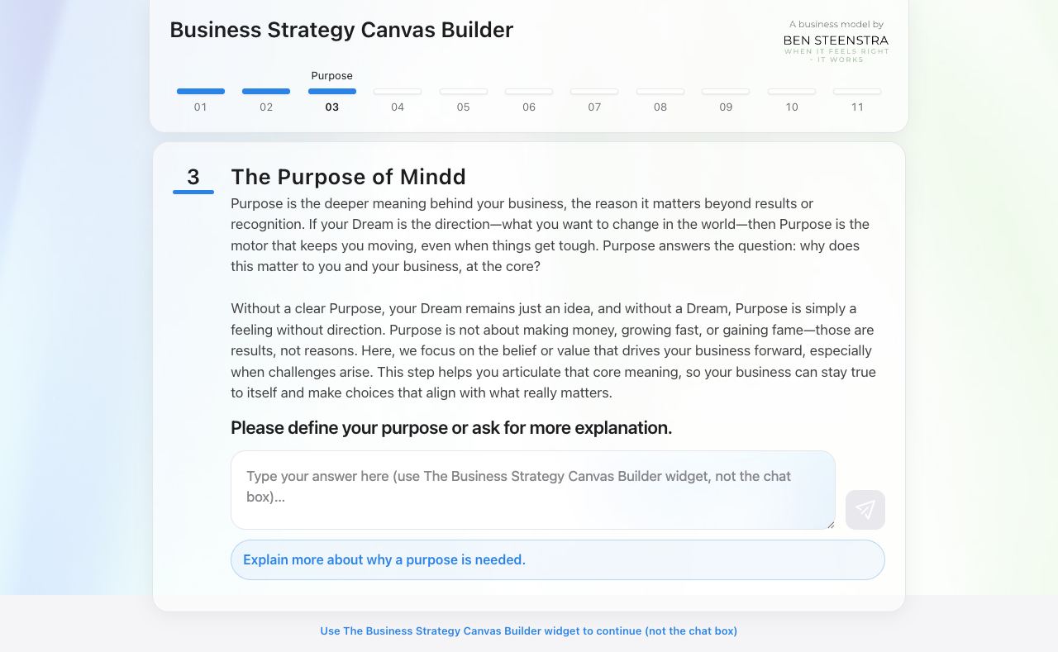

bigwhy-initial: Reach Big Why: PASSprompt: Is this an accurate formulation of the Purpose of Mindd, or do you want to refine it?card text: Your current Purpose for Mindd is:
Mindd exists to help companies grow by fostering genuine connections that strengthen and inspire communities.buttons: I'm happy with this wording, please continue to next step Big Why.

1. Start: click: Start the proces with Validation & Business Name: yes

2. Step0 business input-try-1: fill: Venture: advertising agency | Name: Mindd | Status: existing: yes

3. Step0 fallback business input-try-1: fill: I run an advertising agency called Mindd: yes

4. Step0 continue to Dream: click: Yes, I'm ready. Let's start!: yes

5. Dream answer-after-fill-wording-suggestion: click: #wordingChoicePickSuggestion: yes

6. Dream answer-try-1: fill: A world where businesses thrive.: yes

7. Dream continue to Purpose: click: I'm happy with this wording, please continue to step 3 Purpose: yes

8. Purpose answer-after-fill-wording-suggestion: click: #wordingChoicePickSuggestion: yes
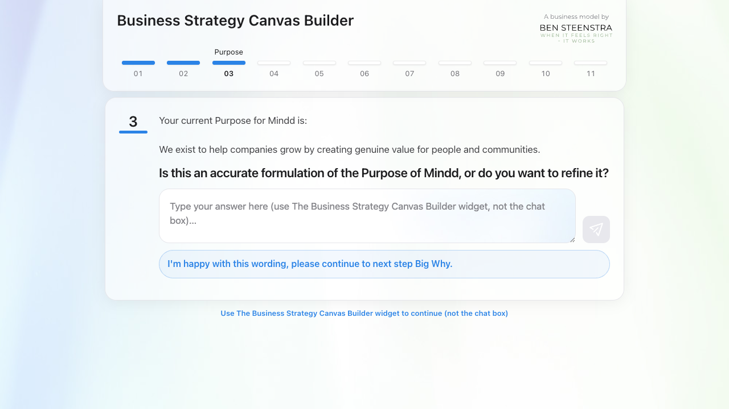

9. Purpose answer-try-1: fill: We help companies grow.: yes

10. Purpose continue to Big Why: click: I'm happy with this wording, please continue to next step Big Why.: yes
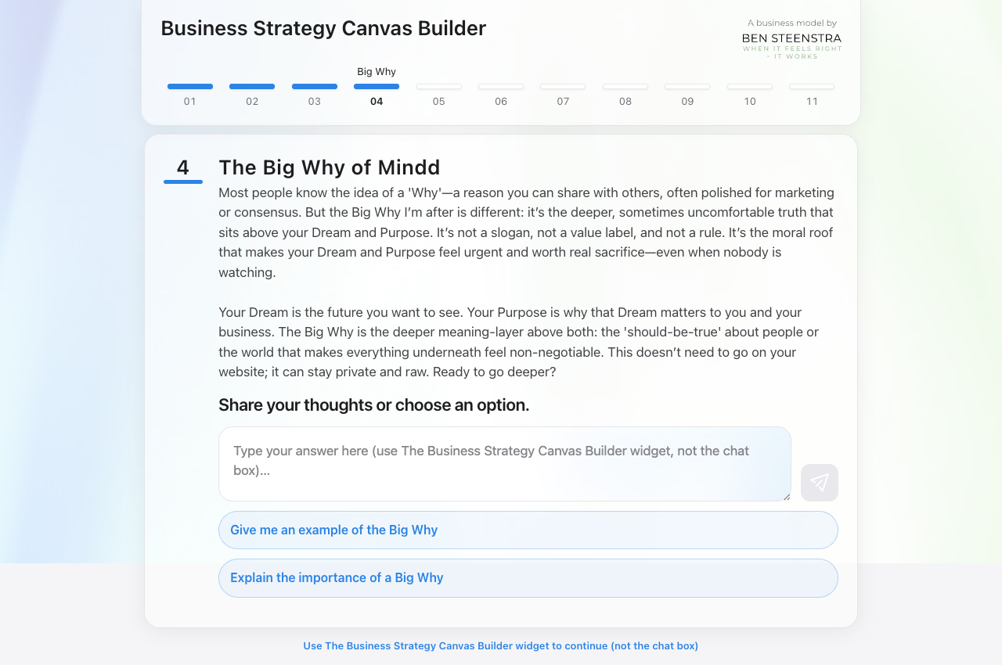

role-initial: Reach Role: PASSprompt: Refine your Big Why for Mindd or choose an option.card text: Your current Big Why for Mindd is:
People deserve opportunities to grow, because growth enables individuals and communities to reach their potential and inspire positive change in the world.buttons: I'm happy with this wording, continue to step 5 Role | Redefine the Big Why for me please

1. Start: click: Start the proces with Validation & Business Name: yes

2. Step0 business input-try-1: fill: Venture: advertising agency | Name: Mindd | Status: existing: yes

3. Step0 fallback business input-try-1: fill: I run an advertising agency called Mindd: yes

4. Step0 continue to Dream: click: Yes, I'm ready. Let's start!: yes

5. Dream answer-after-fill-wording-suggestion: click: #wordingChoicePickSuggestion: yes

6. Dream answer-try-1: fill: A world where businesses thrive.: yes

7. Dream continue to Purpose: click: I'm happy with this wording, please continue to step 3 Purpose: yes

8. Purpose answer-after-fill-wording-suggestion: click: #wordingChoicePickSuggestion: yes

9. Purpose answer-try-1: fill: We help companies grow.: yes

10. Purpose continue to Big Why: click: I'm happy with this wording, please continue to next step Big Why.: yes

11. Big Why answer-after-fill-wording-suggestion: click: #wordingChoicePickSuggestion: yes
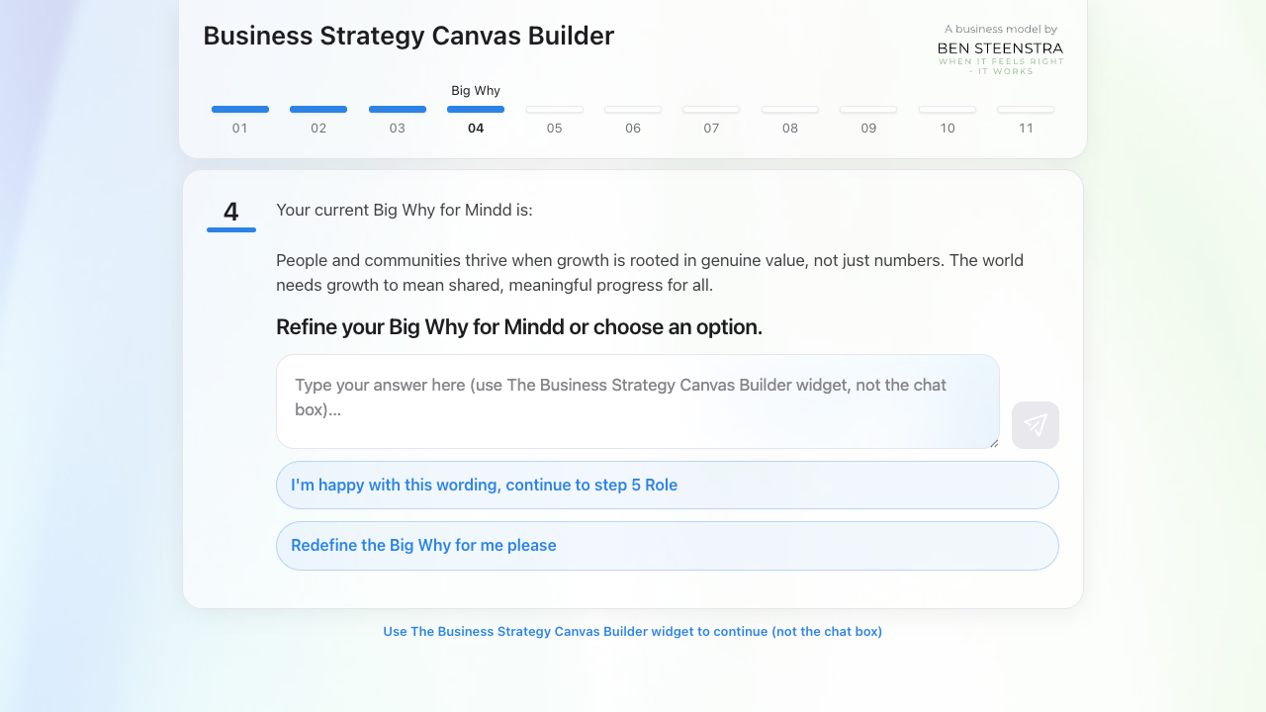

12. Big Why answer-try-1: fill: Because growth matters.: yes

13. Big Why continue to Role: click: I'm happy with this wording, continue to step 5 Role: yes
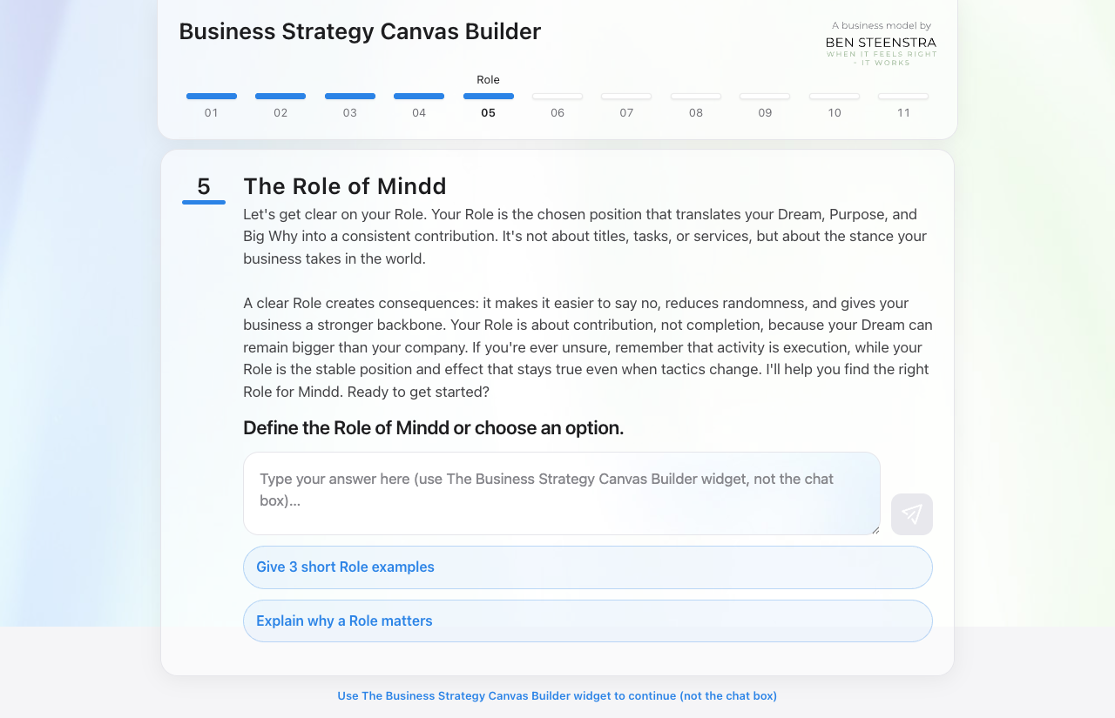

entity-initial: Reach Entity: FAILprompt: Write one sentence that describes the Role as position and contribution, not tasks or services. Use: 'Mindd connects/aligns/translates ... so that ...'. Keep it true even if tactics change.card text: Let's sharpen the Role statement so it guides clear choices and sets boundaries. Think about the effect Mindd consistently creates and what becomes non-negotiable because of this Role.buttons: (none): Action 12 (Role continue to Entity) failed: Could not click "Role continue to Entity". Patterns: /continue to the Entity/i OR /Continue/i. Visible buttons: . Matcher debug first try: (empty) [disabled]. Matcher debug retry: (empty) [disabled]. Prompt: Write one sentence that describes the Role as position and contribution, not tasks or services. Use: 'Mindd connects/aligns/translates ... so that ...'. Keep it true even if tactics change.. CardDesc: Let's sharpen the Role statement so it guides clear choices and sets boundaries. Think about the effect Mindd consistently creates and what becomes non-negotiable because of this Role.

1. Start: click: Start the proces with Validation & Business Name: yes

2. Step0 business input-try-1: fill: Venture: advertising agency | Name: Mindd | Status: existing: yes

3. Step0 fallback business input-try-1: fill: I run an advertising agency called Mindd: yes

4. Step0 continue to Dream: click: Yes, I'm ready. Let's start!: yes

5. Dream answer-after-fill-wording-suggestion: click: #wordingChoicePickSuggestion: yes

6. Dream answer-try-1: fill: A world where businesses thrive.: yes

7. Dream continue to Purpose: click: I'm happy with this wording, please continue to step 3 Purpose: yes

8. Purpose answer-after-fill-wording-suggestion: click: #wordingChoicePickSuggestion: yes

9. Purpose answer-try-1: fill: We help companies grow.: yes

10. Purpose continue to Big Why: click: I'm happy with this wording, please continue to next step Big Why.: yes

11. Big Why answer-after-fill-wording-suggestion: click: #wordingChoicePickSuggestion: yes

12. Big Why answer-try-1: fill: Because growth matters.: yes

13. Big Why continue to Role: click: I'm happy with this wording, continue to step 5 Role: yes

14. Role answer-after-fill-click-adjust: click: Adjust it: yes
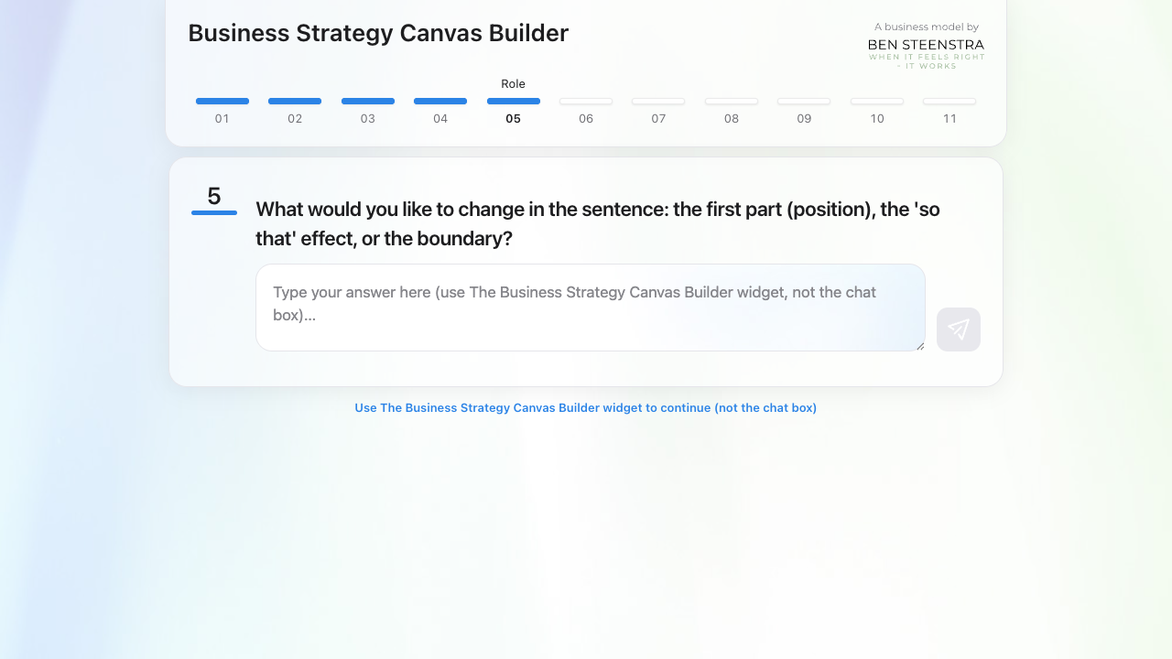

15. Role answer-after-fill-fill-adjust: fill: Please refine this to a stronger, clearer, and more concrete formulation.: yes
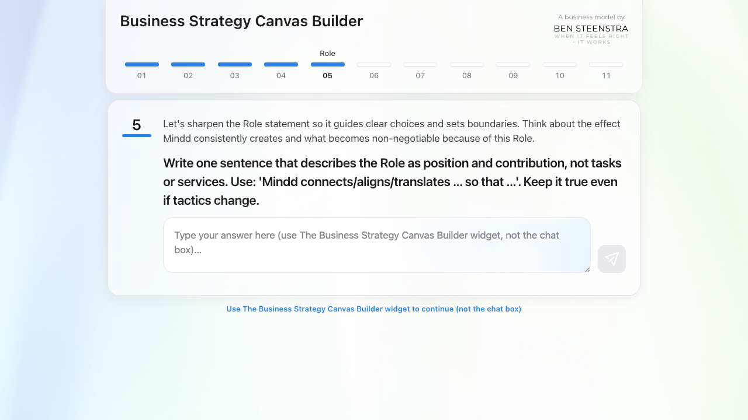

16. Role answer-try-1: fill: Strategic advisor: yes

17. Role continue to Entity-recover-open-question-answer: fill: Please refine this into a stronger and more concrete formulation.: yes
