***~~这是标题~~***

***~~段落添加到这里粗体普通斜体~~***

***~~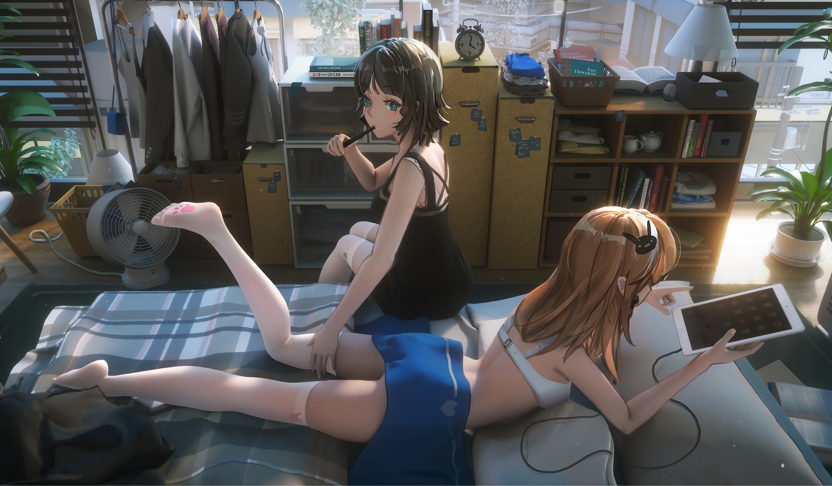~~***

|  |  |  |  |  |
| --- | --- | --- | --- | --- |
|  |  |  |  |  |
|  |  |  |  |  |
|  |  |  |  |  |
|  |  |  |  |  |
|  |  |  |  |  |

|  |  |  |  |  |
| --- | --- | --- | --- | --- |
| 1 | 2 | 3 | 4 | 5 |
| 1 | 2 | 3 | 4 | 5 |
| 1 | 2 | 3 | 4 | 5 |
| 1 | 2 | 3 | 4 | 5 |
| 1 | 2 | 3 | 4 | 5 |