- Why New Framework
The JCI Action Framework has played an important role in guiding JCI members and organisations in developing projects that address community needs and contribute to positive change.
Over time, it helped establish a common understanding of how JCI initiatives should move from identifying a problem to delivering solutions with measurable impact.
However, as the organisation and the environment in which we operate have evolved, the need for an updated approach has become increasingly clear.
The JCI Action Framework 2.0 is the result of a comprehensive effort to modernize and strengthen this methodology so it better supports today’s project realities and the future direction of JCI.

Why an Update Was Needed
Several factors motivated the development of a revised framework.
Changing Project Environment
Projects today often operate in more complex environments, involving multiple stakeholders, partnerships, and funding sources. To navigate this complexity, project teams benefit from clearer structures for analysis, planning, implementation, and evaluation.
Stronger Focus on Impact
JCI initiatives aim to create meaningful and measurable change in communities. This requires stronger tools for identifying real needs, defining expected outcomes, and evaluating results.
Practical Implementation
Feedback from members across the organisation has highlighted the need for a framework that is easier to apply in practice, supported by practical templates and clearer step-by-step guidance.
Consistency Across Projects
JCI organisations around the world deliver a wide range of initiatives. An updated framework helps provide a shared structure that improves consistency in how projects are developed, documented, and evaluated.
Learning and Replication
Projects generate valuable experience and knowledge. The revised framework places greater emphasis on capturing lessons learned, enabling successful initiatives to be improved, replicated, or scaled.

What the New Framework Aims to Achieve
The JCI Action Framework 2.0 is designed to provide a modern, practical, and impact-oriented structure for developing initiatives.
It aims to:
- Support JCI organisations in moving from ideas to measurable impact
- Strengthen needs analysis and project design
- Provide clearer guidance for implementation and monitoring
- Improve evaluation and organisational learning
- Offer practical templates and tools to support project teams
- Ensure the framework is adaptable to projects of different sizes and contexts

A Framework Designed for Practical Use
The updated framework introduces a clear six-step project cycle, supported by guidelines and templates that help project teams move through the process in a structured and manageable way.
The design focuses on:
- simplicity and clarity
- practical implementation
- flexibility for different types of projects
- stronger connection between activities and impact
Rather than adding complexity, the goal is to make it easier for organisations to plan, implement, and evaluate high-quality projects.

Testing Before Global Rollout
Before being introduced across the global JCI network, the new framework will be tested through a structured pilot phase with selected organisations.
The pilot will help validate whether the framework is:
- clear and easy to understand
- practical to apply in real projects
- supported by useful tools and templates
Feedback from pilot organisations will guide further refinement before the framework is finalized and introduced globally.

- Overview of the New Framework
IMPORTANT NOTE:
The JCI Action Framework 2.0 presented here is currently in a pilot (test) phase and has not yet been officially launched.
The information on this platform is shared for testing and feedback purposes and may be updated during the pilot phase based on feedback from participating organisations and/or other stakeholders involved.
To avoid confusion before the official launch, we kindly ask not to share these materials publicly at this stage.
The JCI Action Framework 2.0 provides a structured yet practical approach for developing initiatives that respond to real needs and create measurable positive impact.
It guides project teams through a six-step cycle, supporting the journey from an initial idea to implementation, evaluation, and learning.
Each step builds on the previous one, helping organisations move systematically from understanding a challenge to delivering and assessing solutions.
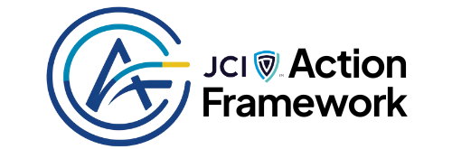
GuidelinesFeedback
The framework aims to help project teams:
- transform ideas into structured initiatives
- understand real community needs
- design realistic and well-planned projects
- manage implementation effectively
- measure results and capture learning

The Six-Step Project Cycle
The framework is structured around the following six steps:
Step 1: VALIDATE
At this stage, organisations explore potential project ideas and ensure they align with JCI priorities, community needs, and organisational capacities.
The goal is to identify opportunities where a project could create meaningful value.
Step 2: ANALIZE
Once an idea has been identified, the next step is to better understand the problem, its causes, and the context in which it exists.
This includes analysing target groups, stakeholders, and existing conditions to ensure the project addresses real needs rather than assumptions.
Step 3: DESIGN
During this step, the project concept is transformed into a structured plan.
The project team defines objectives, activities, timelines, resources, and expected outcomes, ensuring that the proposed initiative is realistic, well-designed, and aligned with the identified needs.
Step 4: ENGAGE
Before implementation begins, the project must receive the necessary internal approvals and external support.
This step ensures that roles, partnerships, and resources are clearly defined and confirmed, providing the foundation for successful execution.
Step 5: EXECUTE
The project plan is now implemented.
Activities are carried out while progress is monitored to ensure that the project remains aligned with its objectives, timeline, and available resources. Monitoring also allows the team to respond to emerging challenges and make adjustments when necessary.
Step 6: EVALUATE
Once the project activities are completed, the final step focuses on evaluating results, documenting lessons learned, and closing the project properly.
Evaluation helps determine whether the initiative achieved its intended outcomes and provides insights that can improve future projects.

How the Steps Work Together
Although presented as sequential steps, the framework should be seen as a learning cycle rather than a rigid process.
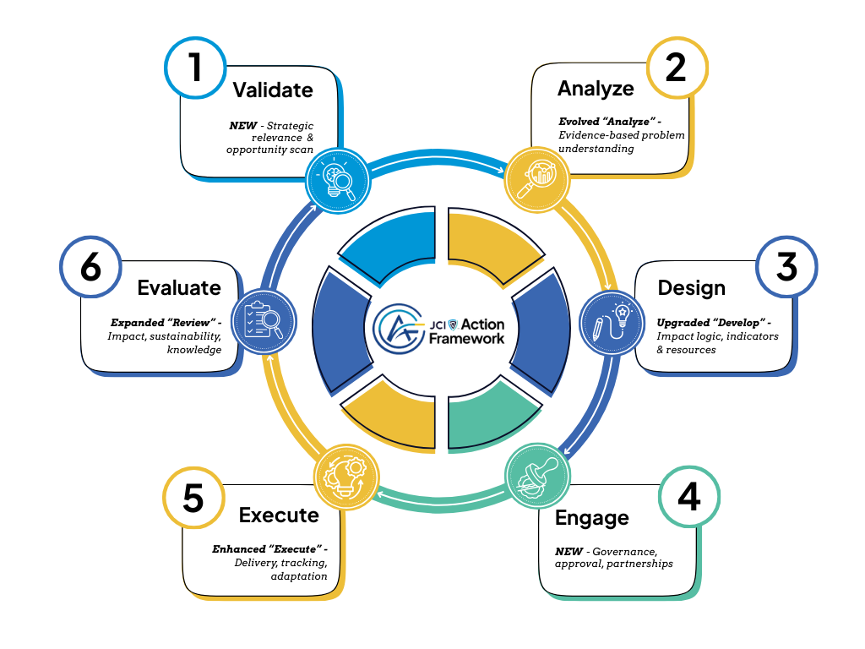
Each stage contributes important information that supports the next one:
- Exploration leads to better analysis
- Analysis informs stronger project design
- Good planning supports effective implementation
- Monitoring enables adaptive management
- Evaluation strengthens future initiatives
This cycle allows organisations not only to deliver projects but also to continuously improve the quality and impact of their initiatives.
Below is the framework lifecycle map showing the purpose of each step, what question the step answers, and what happens conceptually.
STEP
CORE QUESTION
PURPOSE
KEY OUTPUT
1. Validate
Is this project worth doing?
Validate the idea, confirm alignment with JCI and impact intention
Clear project concept and decision to proceed
2. Analyze
Do we truly understand the problem?
Reconfirm the need with evidence and understand causes, context, and risks
Evidence-based understanding of the problem
3. Design
What exactly will we do?
Translate analysis into objectives, outcomes, activities, and resources
Complete project design package
4. Engage
Who must support and authorize the project?
Secure approval, partners, sponsors, and communication readiness
Project authorized and partnerships defined
5. Execute
Are we delivering the project effectively?
Implement activities, monitor progress, and adjust as needed
Activities delivered and data collected
6. Evaluate
What did we achieve and what do we learn?
Measure impact, capture lessons, and formally close the project
Final evaluation and learning for future projects

A Practical Approach to Project Development
The framework is designed to be simple, flexible, and practical.
To support implementation, each step is accompanied by:
- Guidelines explaining what should happen during the step
- Templates that help structure project documentation
- Tools that support project teams in applying the framework effectively
These resources help ensure that projects are not only well-intentioned but also well-structured, well-executed, and able to demonstrate their impact.

Understanding Project Levels
Not all projects require the same level of documentation or complexity.
To keep the framework practical and adaptable, it introduces project levels, allowing organisations to apply the framework proportionally depending on the scale of the initiative.

- Project Levels
The JCI Action Framework 2.0 is designed to be scalable.
Not all projects require the same level of complexity, documentation, or control. JCI organisations deliver a wide range of initiatives - from small local activities to large projects involving external partners and funding.
To keep the framework practical while maintaining quality, the framework introduces three project levels, each with a proportional set of requirements, tools, and expectations.
This model ensures that every project uses the appropriate level of structure to deliver meaningful impact without unnecessary administrative burden.

Overview of Project Levels
The framework distinguishes between three types of projects:
Level
Project Type
Typical Use
Level 1
Light Project
Small, local, member-led initiatives
Level 2
Standard Project
Structured LO or NO projects with partners
Level 3
Advanced Project
Large, funded, multi-partner initiatives
This structure allows organisations to start simple while maintaining a clear pathway toward more advanced and strategic initiatives.

Level 1 – Light Project
“Start simple. Learn by doing.”
Light Projects are designed to help Local Organizations quickly implement simple community initiatives with minimal administrative requirements.
Typical Characteristics
- Local scope
- Short duration (from a few days to a few months)
- Limited or no budget
- Volunteer-driven
- Few partners or none
- No external grant funding
Focus
For these projects, the framework prioritizes clarity and practical implementation rather than detailed documentation.
Teams focus on:
- identifying a real community need
- planning simple activities
- delivering the initiative
- reflecting on the results and lessons learned
Example Projects
- Local awareness campaigns
- Skills workshops
- One-off community events
- Pilot initiatives

Level 2 – Standard Project
“Plan better. Deliver stronger impact.”
Standard Projects involve more structured planning and coordination, often including multiple partners and longer implementation periods.
They represent the core type of strategic initiatives implemented by Local and National Organizations.
Typical Characteristics
- Local, national, or cross-LO scope
- Medium duration (approximately 3-12 months)
- Defined budget
- Multiple partners or stakeholders
- Strategic alignment with organizational priorities
- Potential for future funding or scaling
Focus
These projects require stronger planning and monitoring, including:
- structured project proposals
- defined objectives and outcomes
- clearer roles and responsibilities
- monitoring of outputs and outcomes
Example Projects
- National leadership programs
- Multi-month community initiatives
- Strategic partnerships with companies or institutions
- Flagship LO or NO initiatives

Level 3 – Advanced Project
“Fundable. Accountable. Scalable.”
Advanced Projects are complex initiatives designed to meet external funding and partnership standards.
They typically involve multiple partners, formal agreements, and stronger governance requirements.
Typical Characteristics
- National, regional, or international scope
- Longer duration (6-36 months)
- External funding (grants, foundations, CSR programs)
- Formal partnerships and contracts
- Higher financial and reputational risk
Focus
These projects require full application of the framework, including:
- comprehensive planning and documentation
- formal governance structures
- structured monitoring and evaluation
- financial and donor-compliant reporting
Example Projects
- Foundation-funded programs
- EU or international grant projects
- Multi-country initiatives
- Long-term social or environmental programs

Selecting the Appropriate Project Level
The appropriate project level should normally be determined during the Design & Plan step.
Project teams should consider:
- project scope and duration
- expected impact
- budget size
- number of partners involved
- funding sources
- project risks
Projects may move to a higher level during implementation if their complexity increases. For example, a project initially designed as a Level 2 initiative may later become a Level 3 project if it receives external grant funding.

Why This Model Works for JCI
The scalable project model provides several advantages for JCI organisations:
- It protects smaller Local Organizations from unnecessary bureaucracy
- It creates a clear pathway for project growth and maturity
- It supports grant readiness and partnership development
- It ensures consistent reporting and quality across different regions
- It keeps the framework accessible for all members while enabling advanced initiatives

