Public Events Calendaring

Planning your Bedework public events system
Bedework's public events system allows different units within an organization to publish events to a central pool where they can be disseminated to the largest appropriate audience. Public events can be delivered via web interfaces, feeds & subscriptions, and direct downloads. External calendar subscriptions can be aggregated with the central event pool, and users can pull filtered feeds of events (e.g. ical feeds, rss, caldav, json).
Each group in your organization that needs to publish events is represented by an administrative group. Members within the same group can see and edit each other's events in the administrative web client. The first step in establishing a Bedework public events system is to identify which groups within your organization should be represented by administrative groups and how fine grained the groups should be.
Calendar suites control how events are tagged and filtered. Each administrative group works within the context of a calendar suite, and the second step in establishing a Bedework public events system is building your calendar suites.

Definitions
- Calendar suite: a web application with its own context, theme, subscriptions, and views. Calendar suites are attached to Bedework's group hierarchy, and event administrators work within the context of the calendar suite under which their group is placed. Calendar suites control how events are tagged and filtered.
- Calendar collection: a container for events (or other calendaring items such as tasks and journal entries). When we use the term "Calendar" we mean calendar collection.
- Folder: a container for calendar collections (only).
- Category: an iCalendar (RFC-2445) property used to tag events. Categories are maintained by superusers and calendar suite owners.
- Subscription: an alias to a calendar collection. Subscriptions may point to calendar collections, to other subscriptions in Bedework, or to external icalendar feeds. Subscriptions provide structure to Bedework's global calendar tree and to calendar suites. Likewise, they provide a structure and hierarchy for tagging events by category.
- Topical Area: a topical area is a subscription that will appear in a calendar suite's add/edit event form and provides fine-grained control over how events are tagged.
- Filter: an expression used to match events from the global pool. Bedework makes particular use of category filtering in public events calendaring.
- Event administrator: a user who is a member of a public events administrative group. Event administrators can add and edit events using the administrative web client.
- Calendar suite owner: a user who is a member of public events administrative group to which a calendar suite is attached. Calendar suite owners can modify calendar suite preferences, subscriptions, and views. Calendar suite owners, like superusers, can also add and edit categories.

Managing Users and Admin Groups
Administrative groups are hierarchical and inherit access rules down the group tree. In the public events system, all admin groups are children of a default root group named “campusAdminGroups” and inheritance of access control rights starts from there.
Calendar suites are attached to groups. An event administrator will add and edit events in the context of the calendar suite that is found first when traversing back up the tree.
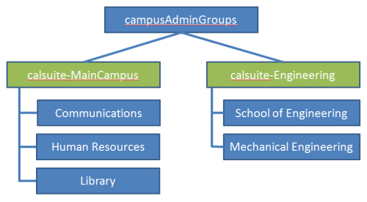
Public events are administered centrally through the administrative web client. Every administrator is a member of a group, and events are owned not by administrative users directly, but by a special “events owner” associated with the group. Each group also has a group owner that is a specific administrative user; this role does not currently provide any functionality, but allows you to specify the lead event admin for a group.
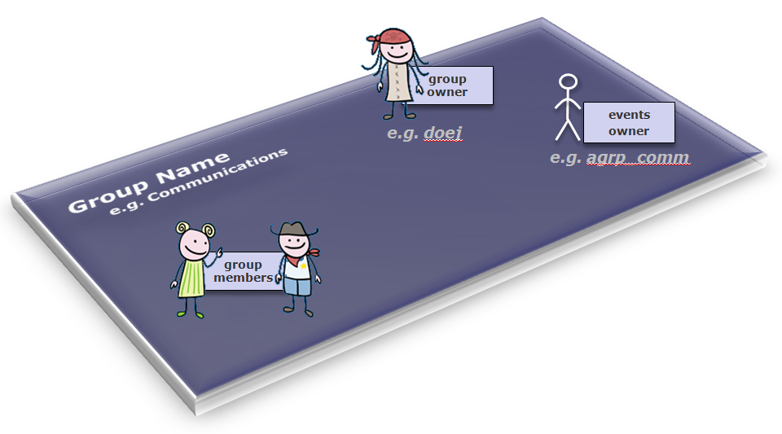
The events owner is a system user, not found in the organization's user space, that owns all the events for a group. Having such an owner allows all group members to see and edit events within the group. Also, the event owner is the “user” whose preferences define the behavior of a calendar suite. The system ensures that the events owners are distinct from real users by prefixing them with a string, by default “agrp_”.
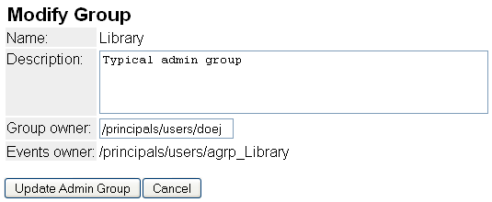
Within the administrative client, events are filtered by the current events owner so that administrators can only see and edit events for their current group. A super user can switch to any group. By searching for events in the admin client, event administrators can also tag events created by other groups.
If the system is configured to do so in the configuration properties files, locations, contacts and categories can be filtered to make them editable only by the group. They are however, always readable. Creating contacts and locations that cannot be edited by typical admins can be achieved by creating them in a special group.

Group structure and access control
Access control is inherited from the top down the group tree. Therefore, it is best to create a single, top-level group for access to /public and then add all other administrative groups to it. By default, Bedework comes with a top-level group named “campusAdminGroups”. All other groups should be made members of this group to inherit write-content access on /public. Groups should represent the departments within your organization who will be responsible for adding and maintaining public events, e.g. “Arts”, “SOE” (school of engineering), or “Athletics”.
The first children of campusAdminGroups should be groups associated with calendar suites. By convention, we name these groups calsuite-SomeName to distinguish them from typical admin groups.
While it is possible to close branches of the /public calendar tree from access to all administrators by creating a different group hierarchy, we discourage doing this. If public calendars are kept topical, an administrator from any group can add events to any calendar in the tree. However, an administrator can only see events created by his or her group.
It is important to remember that group calendaring (e.g. scheduling meetings within a department) should be kept away from the /public tree – which is only intended for public events. Events that must not be seen by any but a subset of your community are not public (such events are to be distinguished from those intended for a subset of your community that are still okay for others to see). These should be kept in the personal and group space, or if your need dictates it, in a top-level /dept branch of the tree which you will need to create. We believe in actual practice, most group calendaring will best be managed within the personal and group space.

Event administrators and superusers
To add an event administrator to the system, simply add the user to a group. When a user is removed from all groups, the user will be removed from the system. Because the public event space is distinct from the personal calendaring space, administrative users are managed in Bedework's database by default (though they need not be).
A superuser may be added to the system by selecting System (tab) → Manage system preferences, and adding a user id to the “Super Users” field. The field accepts a list of comma separated user ids.

Understanding and architecting your calendar hierarchy

Introduction
Bedework uses a single calendar model for publishing public events. This model provides flexibility and power for Bedework deployers while simplifying the user interface for event administrators.
Filtered output: In the single calendar model, categories are the primary means of organizing events. Calendar suites can subscribe to the single calendar collection with a category filter or to predefined calendar aliases in the global calendar tree with filters already defined. This approach provides fine-grained control over what events are returned to the views. As chains of subscriptions get created, events are filtered by the union of all filters on output.
Tagged input: Subscriptions in a calendar suite may be marked as “Topical Areas” and assigned categories. Topical Areas appear in the add event form for the calendar suite and provide a means for event administrators to tag events by one or many categories. Topical Areas allow superusers and calendar suite owners to control which categories an event administrator may apply to an event. A subscription that is not tagged as a topical area won't appear in the add event form for tagging and is, in essence, read-only; a subscription to an external holiday feed is a good example.
Event administrators add events within the context of a calendar suite, and can tag events with the "Topical Areas" defined for that suite. Each topical area may apply one or many categories to an event. All details of this are hidden from the typical adminstrative user. This approach simplifies the event admin's user interface substantially: the user doesn't need to know what categories to select to make an event appear in a particular view or data feed; nor does the user need to know anything about the underlying calendar structure. Each suite defines its aggregate "topical areas", and the admin user needs only understand these. For example, a topical area named “Front Page Highlights” may be available only to event administrators working within the context of the “Communications” calendar suite and could be used to set several categories on an event that cause it to appear on the front of the organization's website via a json feed.
To summarize: subscriptions marked as topical areas are used to tag events on input, and subscriptions filter events on output based on the category filters applied to them. When a subscription points to an alias in the public tree, events are filtered by the union of all filters in the subscription and the public tree alias. Likewise, events are tagged by a union of all categories in the subscription and public tree alias. It is possible to create tagging and filtering chains by creating a chain of subscriptions.

The Structure
The top-level structure of the /public calendar tree, as shipped with the Bedework quickstart, is divided into calendars, aliases, and an unbrowsable branch:
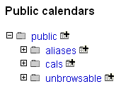
In /public/cals we have only one calendar collection:
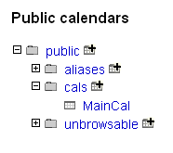
All events added to Bedework using the public events administration client are placed within the MainCal calendar collection.
Opening up the tree, we find calendar aliases that can be used by calendar suites for building subscriptions. The calendar aliases are centrally curated, pre-filtered subscriptions. The /public/aliases branch is also used to generate the listing of “suggested topical areas” for the public submissions web client. Event administrators refine these when they pick up the event for publication. The branch is likewise exposed to personal calendar users as a subscription source within the personal client. Calendar aliases / subscriptions appear in CalDAV clients as if they were calendars.
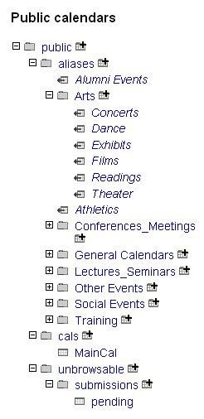
The unbrowsable branch of the tree contains the calendar collection used to hold pending events from the submissions web client and can be used for other special purpose calendar collections.

Categories
Because categories play such an important role in public event retrieval, only superusers and calendar suite owners are allowed to manage them. (In future releases, we expect to allow admin groups to create their own categories with which they can filter events – but this is not available in Bedework 3.6.)
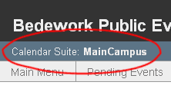
Bedework 3.6 suggests a naming convention for categories, and this convention is used by the URL Builder (see section 6.9 in this chapter): categories used to represent organizations should be prefixed by “org/”; categories used to represent special system categories (and can be hidden from the URL Builder) should be prefixed by “sys/”. See the “sys/ongoing” category and the “org/Engineering” categories in the Bedework quickstart initial data for examples.

Managing Calendar Suites
Bedework's web views of public event information are called "Calendar Suites". Calendar Suites provide a custom web context, custom look and feel, custom subscriptions, and custom views of event data. The quickstart comes with two suites, named MainCampus and SoEDepartmental. Calendar Suites are best used for large or significant groups within an organization. For example, a school may warrant a Calendar Suite, while a department within that school may only need a filtered view on the school's suite and an event data feed for embedding in its departmental website. All calendar suites for a single Bedework instance pull event data from the same central pool of events (plus any subscriptions to external calendars).
Calendar suite owners (or superusers) build a calendar suite structure by adding subscriptions to collections in the public calendar tree or to external calendars. The calendar suite owner may subscribe directly to /public/cals/MainCal or to any of the calendar aliases in the tree making filtering easier. Subscriptions marked as “topical areas” will be exposed to event administrators for tagging in the add event form.
Note: while it is necessary to have at least one calendar suite for public events, you can pull data feeds of events for sub-organizations without creating a new suite. See section 4.6 “Managing Events” → “Getting events out.”
The public calendar tree is not directly visible in the add event form. Rather, the event admin sees only the "Topical Areas" defined by the calendar suite owner.

Managing a calendar suite

Calendar Suites and Administrative Groups
A calendar suite is associated with an administrative group. Members of this group (calendar suite owners) can administer the calendar suite's preferences, subscriptions, and views. Event admins in groups that are children of the calendar suite group tag events with topical areas defined in the suite. When an event is added, categories are applied to the event based on the topical areas chosen.
The calendar suite you are working within is displayed in the upper left of the admin client user interface:

Administering a Calendar Suite
To administer a calendar suite, log in to the admin client as a member of the calendar suite group, or login as superuser and change groups once logged in. When logged in as a member of a calendar suite group, you will see a "Calendar Suite" tab:
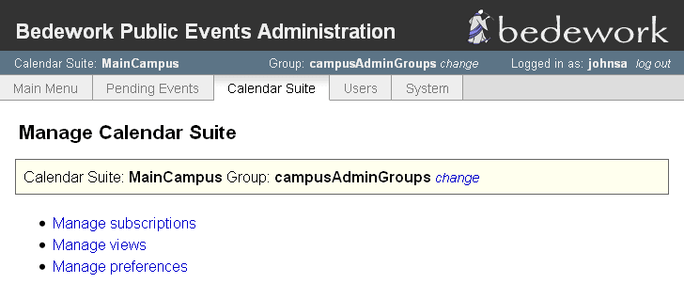
It is here that you may mange subscriptions, views, and preferences for the suite.

Managing Calendar Suite Preferences:
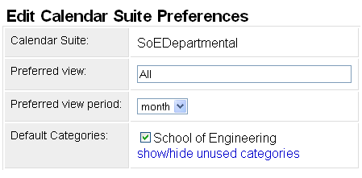
The calendar suite preferences let you set the default view, default view period (day, week, month), and any default categories for the suite. When default categories are assigned, every event created in the context of the suite will be tagged with those categories.

Managing Calendar Suite Subscriptions:
Subscriptions define what events are pulled into the suite to be viewed. When assigned as a topical area, subscriptions are used to tag events with one or many categories.

Managing Calendar Suite Views:
Subscriptions are aggregated into views for display in the public web client. The “preferred view” defined in the calendar suite preferences provides the default display of events when a user first visits the public web client for the calendar suite. The following screenshot shows an example view called “All” that contains most of the subscriptions available in the suite. When a user selects this view, they will see all events revealed through the subscriptions contained in the view.
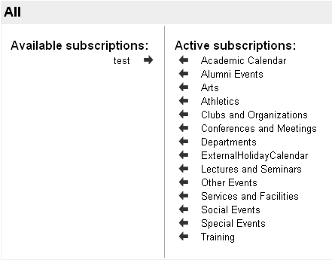

Adding a New Calendar Suite
A Calendar Suite that is to have its own web context (e.g. http://localhost:8080/mydept ) must be built, and the resulting .war will be packaged up and deployed alongside the other suites. If you wish to use calendar suites solely for limiting access to topical areas, you do not need to build it and may skip directly to “Configuring a Bedework Calendar Suite”.

Building a Bedework Calendar Suite
- Follow the instructions in chapter 3.2 for setting up your build environment.
- Add calendar suites to your cal.properties and cal.options.xml files, using the quickstart's example of "SoEDept" (the demo departmental public web client). Also add the suite to the list of applications to be built in the cal.properties file for the property: org.bedework.install.app.names (line 19).
- Copy a template directory for use with the new calendar suite from an existing one, and name it with the name given the calendar suite. E.g. copy bedework/deployment/webpublic/webapp/resources/demoskins/MainCampus as ....demoskins/MyDept
- Build Bedework

Configuring a Bedework Calendar Suite
You must now define the Calendar Suite in the admin client and associate it with an administrative group.
- Create an admin group from which to hang the Calendar Suite:
  - Log into the Bedework Admin Client as a superuser.
  - Select the "Users" tab.
  - Select "Manage admin groups"
  - Click the button "Add a new group"
  - Set the group's properties:
    - Name: calsuite-MyDept (note: it is recommended practice to name Calendar Suite groups in this way, prepending them with "calsuite-" or a similar signifier so that they are easy to distinguish from other groups. Furthermore, you should only add users to this topmost group who should be granted Calendar Suite Owner access. Such users can manipulate the calendar suite itself.)
    - Description: provide a reasonable description for the group, e.g. "calendar suite for MyDept"
    - Group owner: a userid, probably of the main contact point for the group; this field is only informational
    - Events owner: agrp_CalSuite-MyDept (note: it is recommended practice to make the events owner the same as the Name prepended with "agrp_" or a similar signifier to associate the owner with the group. The "events owner" is a system user: the "agrp_" prefix distinguishes this user from a real user - one associated with an actual person. The calendar suite's preferences will be attached to this user.)
- Add the new group to “campusAdminGroups” so that proper access rights are inherited down the group hierarchy.
  - Select the "Users" tab.
  - Select "Manage admin groups"
  - Select “membership” for campusAdminGroups and add the new group to it.
- Add the calendar suite
  - Select the "System" tab.
  - Select "Manage Calendar Suites"
  - Click the button "Add Calendar Suite"
  - Set the Calendar Suite's properties:
    - Name: this is the calendar suite name you defined in myconfig.properties, e.g. if you defined org.bedework.app.MyDept.cal.suite=MyDept, use "MyDept".
    - Group: this is the name of the group you defined in step 1, e.g. "CalSuite-MyDept".
    - Root calendar: this will almost always be "/public", the root of the public calendar tree.

Managing Events: Getting Events In

Administrative web client
The administrative web client is the control center for managing public events. When logged in you are presented with the main menu tab view that will look like this:
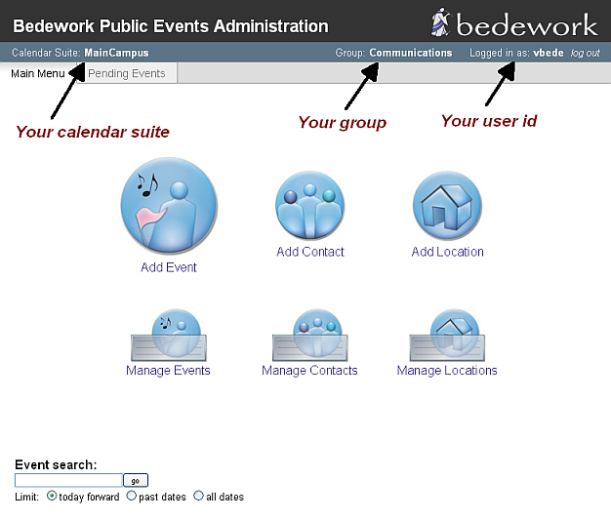
for a typical event administrator, and like this:
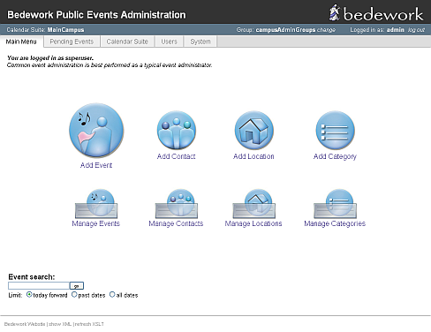
for a super user.
Creating events
- Select the “Add Event” link under the “main menu” tab.
- Type in a title for the event.
- If you are working with a single public calendar for publishing (the default) you will not be presented with a calendar to select. However, if you are working with more than a single publishing calendar or are logged in as a superuser, you must select a calendar. Typically this would be the default “cals/mainCal”, or you can select your own.
- Select “all day” if this is an all day event. Select floating if you don’t want to be restricted by time zones. Or if you want to enter a specific start and end time for your event follow step 5.
- Select the icon and select a start date for the event.
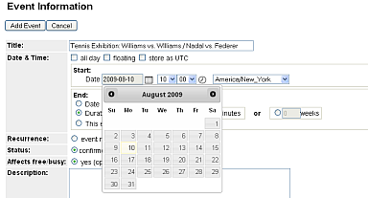

- Select a start time
- Select the icon and select an end date for the event
- Select an end time or duration. Or select the “this event has no duration or end date” radio button if the event has none.
- Under recurrence leave at “this event does not recur”. See the next section for recurring events.
- Leave the event status as “confirmed”. Or if the event will change, select “tentative”. If an event has been cancelled, select “cancelled” - this will display a cancellation notice in the event title in calendar suites and data feeds.
- Enter more details about the event in the description.
- Enter a cost for the event (optional).
- Enter a URL for the event, if you have a website with more information about it (optional).
- You can add an image to the event (optional).
- Select a location for the event. For a more comprehensive list of locations, select the “all” radio button. The preferred listing will display the locations you've already used.
- Select a contact for the event. For a more comprehensive list of contacts, select the “all” radio button. The preferred listing will display the contacts you've already used.
- Select the topical area(s) with which you want to tag the events

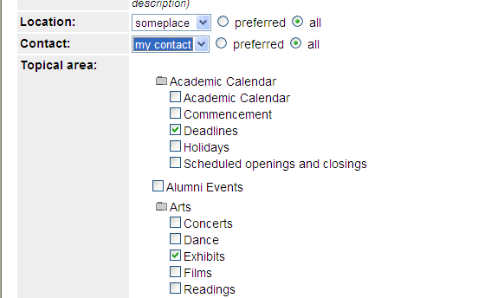
- Select the “add event” button

To create a recurring event
- Follow steps 1-8 above
- Select “event recurs”
- Select how often the event recurs under frequency... for example if the event recurs every month, select the “monthly” radio button
- Leave at forever if you want the event to repeat forever. If not specify how many times you want the event to recur by selecting the “times” radio button and typing the number times to repeat the event. Or alternatively select the “until” radio button and specify an end date. Note: the end date you specify here is different from the end date you specified earlier for the event. The end date here is the date you want the recurrence to stop and not the end date for the event.
- For more advanced options select the “show advanced rules” check box. You might need to select the “monthly” (or frequency of your choice) radio button again to see the advanced rules.
- If you want the event recurring every other month type in 2 under the “interval” label or any interval of your choice.
- You can specify how you would like the event to recur. For example, if you want the event to recur on the first Monday and Tuesday of the month and also on the last Monday and Tuesday,
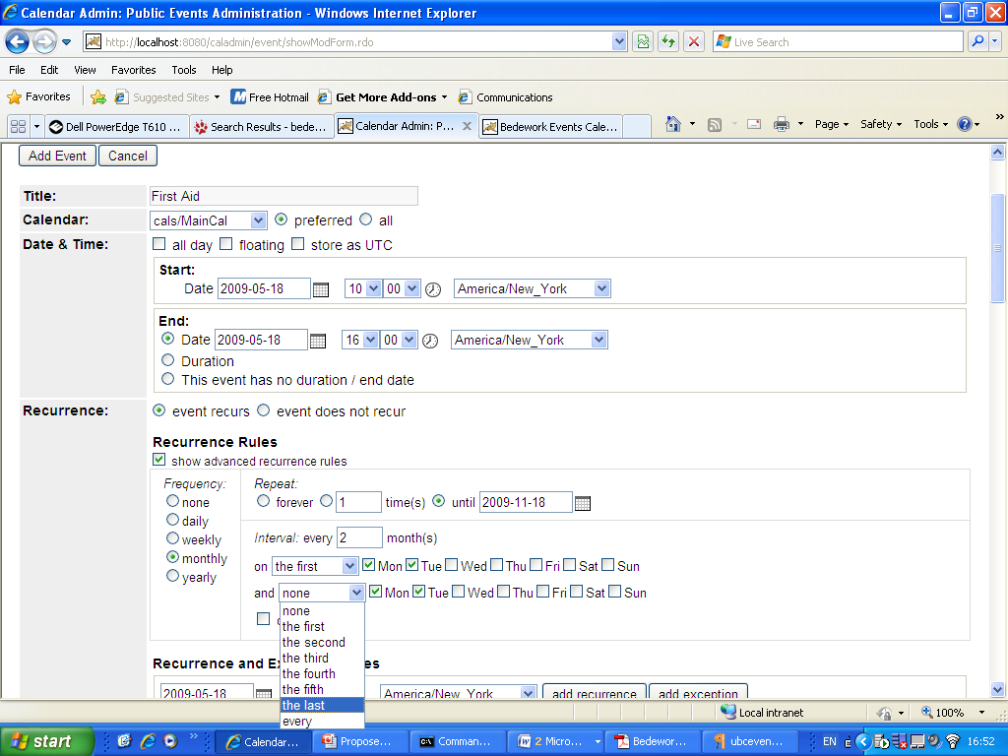
select as shown in the diagram.
- You can also create exceptions for your recurring events. For example, if there is a public holiday on a Monday you have designated your event to recur. Create an exception by deleting the recurrence instance of the event after it is created.
- You can also create one-off recurrences for the event. Select a date under the “recurrence and exception dates” field and select the “add recurrence” button.
- Follow steps 10-18 above to add the event.

To Edit/delete an event
- Select the “manage events” link under main menu. Alternatively you can search for the event by typing the event name under the “event search” label in the main menu.

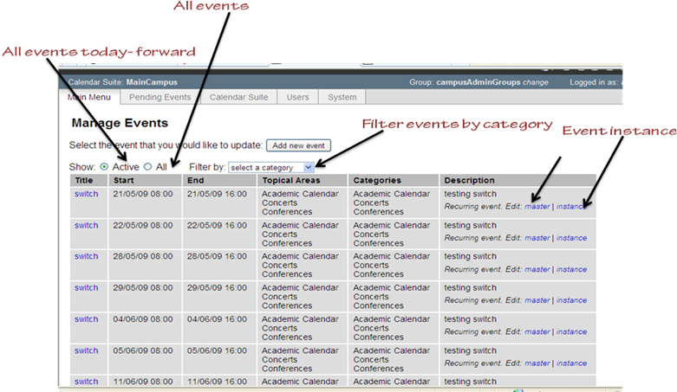
- You can show all events or active events or you can filter events by selecting a category.
- To edit an event select the event under the “Title” column or if the event recurs select “master” under the “Description” column. Changes you make to the master affect all instances of the event. To edit/ delete a single instance of an event, select the “instance” link under description.
- When you are done with your changes select the “update event” button.

Importing events
Superusers can import events in the admin client by going to the system tab and selecting “Upload ical file”. The currently active group will own the events. At the moment you may only import events into true calendars (not calendar aliases), e.g. public/cals/mainCal. Because of this, it is a good idea to set categories on the event in the ical file prior to import. We will allow import of events with topical area tagging in upcoming releases. You may also wish to consider subscribing to the ical file instead of direct import.

Community submissions client
The community submissions web client allows authenticated members of your community to suggest public events. Using the quickstart, you can log into the client from the Bedework quickstart jump page: http://localhost:8080/bedework/
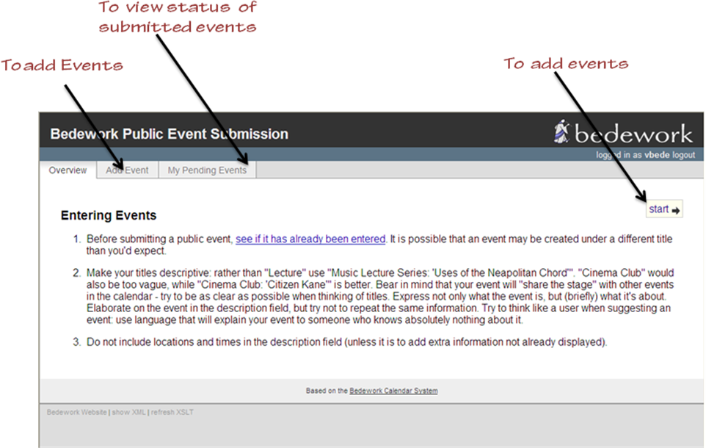

Submitted events do not automatically go into the public calendar. They are viewed by an event administrator in the admin client for approval. The event administrator can approve, reject or edit the event. If the event is approved, it is displayed in the public calendar for the administrator's calendar suite. You can view the status of the event by clicking the “My Pending Events” tab. You can create an event for submission by selecting the “Start” link or the “Add Event” tab.

To add an event
- Type in a title for the event
- Select “all day” if this is an all day event. Or if you want to enter a specific start and end time for your event follow step 3.
- Select the icon and select a start date for the event
- Select a start time
- Select the icon and select an end date for the event
- Select an end time or duration. Or select the “this event has no duration or end date” radio button if the event has none. Note: the format of the dates, times, and duration presented to the user will be the user's preferences as set in the personal client. If you are not using the personal client, the user will be presented with the default preferences for all users as configured at build time.
- Leave the event status as “confirmed”. Or if the event will change, select “tentative”.
- Enter more details about the event in the description.
- Enter a cost for the event (optional).
- Enter a URL for the event, if you have a website with more information about the event (optional).
- You can add an image to the event (optional).
- Select the “Next “ link

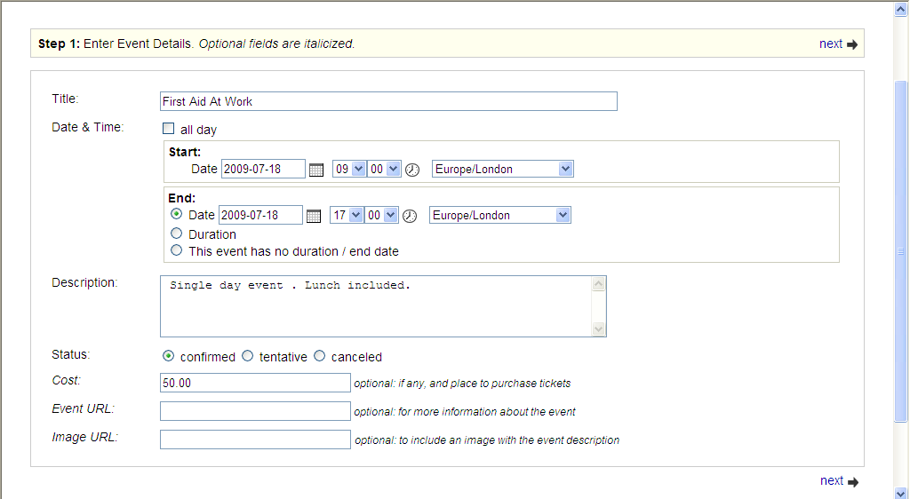

Note: You cannot submit a recurring event. However, recurrence information can be described on the last page of the add event wizard in the box for user comments or instructions.

- Select a location by clicking on the down arrow button. Or you can suggest a new location by entering the information in the “Address” “Sub-Address” and “URL” fields. New locations you enter here needs to be approved by a user with administrative rights for the calendar suite.
- Select the “next” link. You can select the “previous” link to edit the information on the previous page
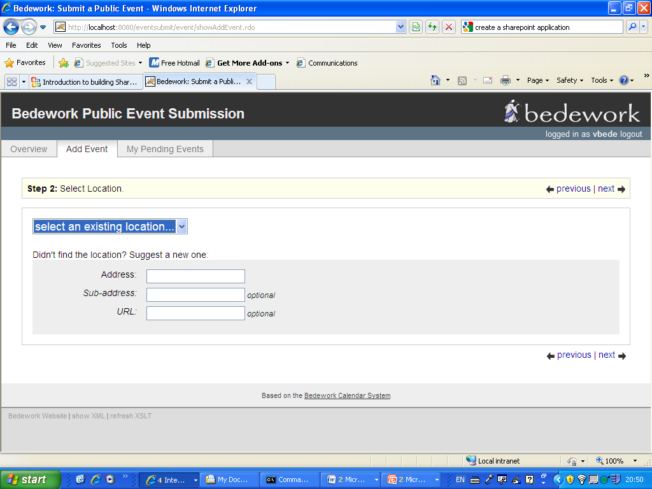

- Select a contact. Or you can suggest a new contact by entering the information in the “Organisation Name” field, you can also fill out the optional fields. New contacts you enter here needs to be approved by a user with administrative rights for the calendar suite.
- Select the “next” link

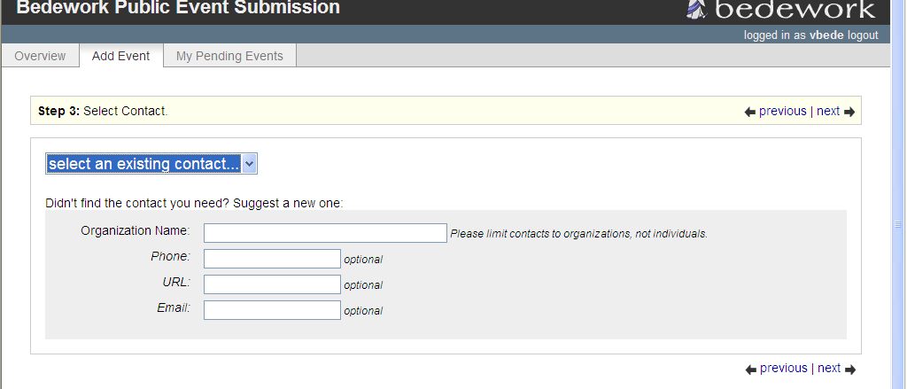

- Select the topical areas for the event
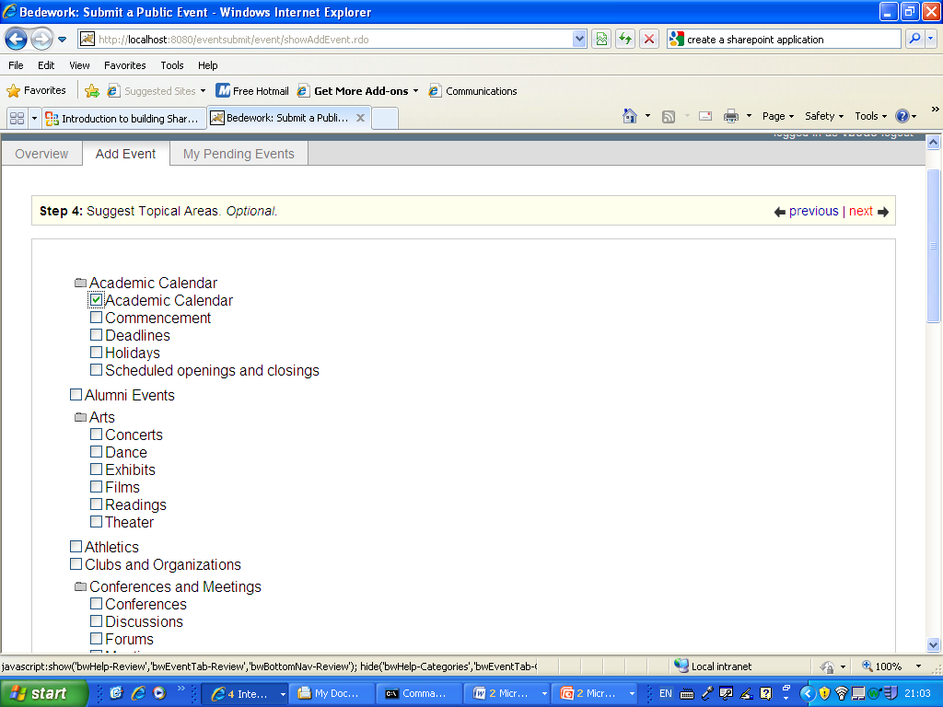

- Alternatively you can enter the event type if none of the topical areas fit the type of event you are submitting
- Select the “ next” link
- Enter your email address
- Enter additional notes or instructions for the event. For example, you can request that the administrator book a room for the event.
- Select the “Submit for Approval” button to submit the event or select the “cancel” button to cancel the event.
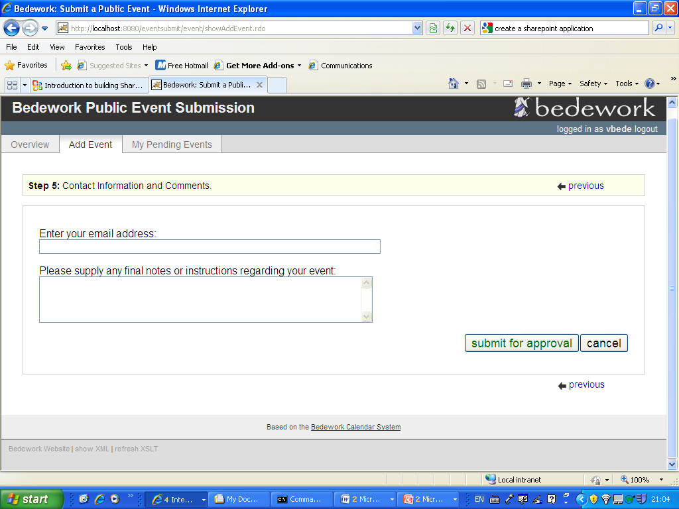

You can view the status of the events you submit for approval.

To view the status of an event
- Select the “My Pending Events” tab

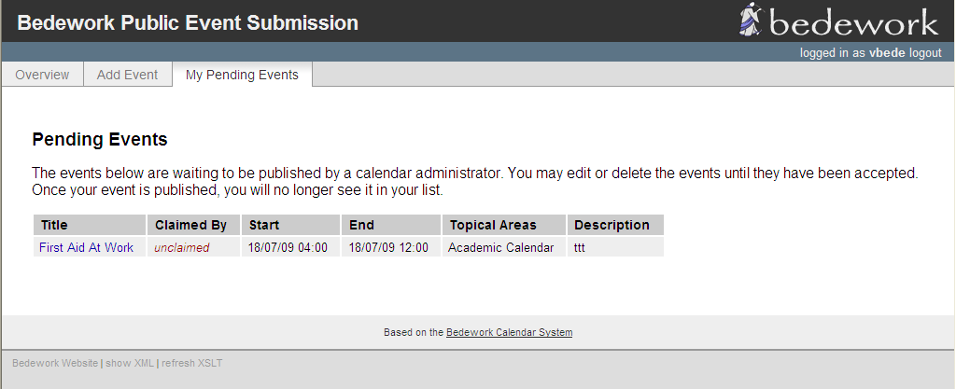

Here you can find information regarding the status of your event. The “Claimed By” column lets you know which administrator is handling your request. You can also select the event title link in the “Title” column to edit or delete the event. An administrator for the calendar suite can claim the event by login to the administrative client.

To administer a submitted event
- Login the administrative client
- Select the “Pending Events” tab

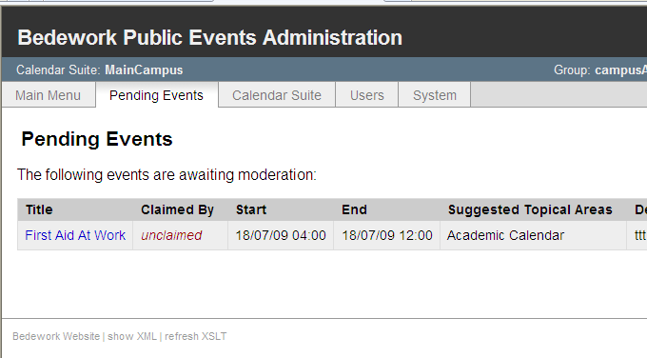
- Select the event title link under the “title” column

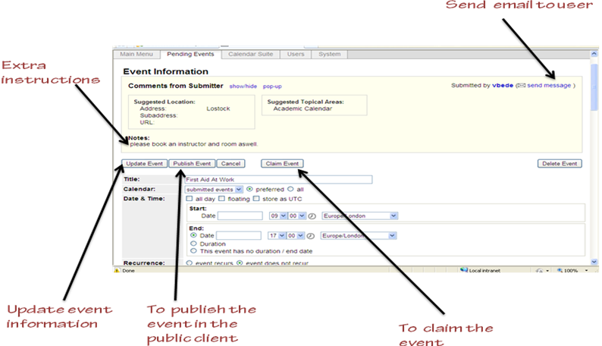

Under “Event Information” you can see details about the event. If the user who submitted the event has suggested a location for the event; you can create the new location under “Add Location” in the “Main Menu” tab. You can hide the event comments by selecting the “show /hide” link. You can also edit the other fields on the form such as entering a topical area.

- To claim the event, select the “Claim Event” button.
- To publish the event, select the “Publish Event” button. When you select this, the event can be viewed by users in the public client. If your system uses the single calendar model (this is the default set up in Bedework 3.6) you are done.
- If your set up includes more than one calendar or your are logged in as a super-user, you will need to select a calendar to publish the event. If you follow the single calendar model, this would typically be the “cals/MainCal”

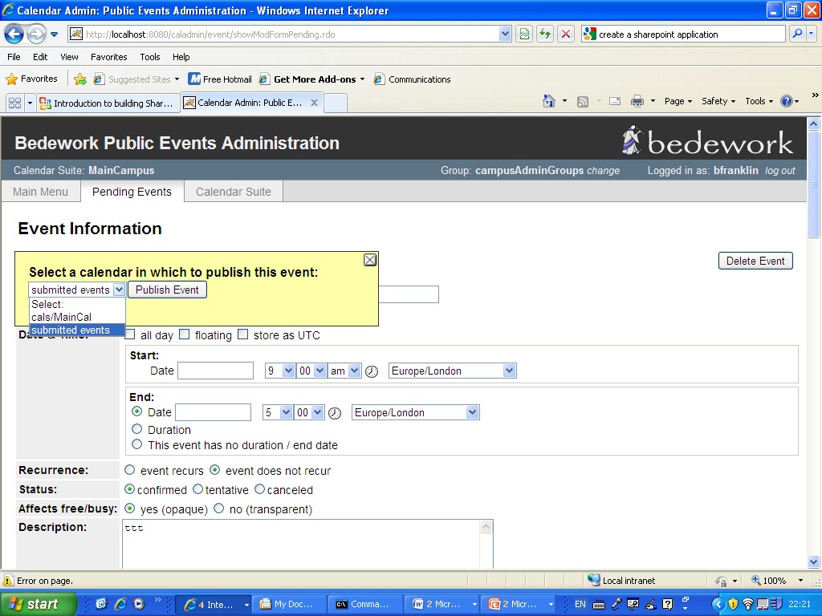

Managing Events: Getting Events Out

Calendar suites
Each calendar suite in your Bedework implementation can produce a custom web site, and you will need at least one calendar suite to display public events or to produce data feeds. For more information, see the topics already covered in this chapter (section 4.5).

Downloads
Events and whole calendars can be downloaded in iCalendar format from Bedework's web interfaces. The downloads are suitable for any desktop calendar client such as MS Outlook and Apple's iCal. They can be imported into other calendar systems as well.
To download an event, look for the download icon on the event details page or in a list view. To download a calendar, visit the “All Topical Areas” section of a public calendar suite and select the icon to download the calendar. Calendars can be downloaded from today into the future, for past dates, or for a date range.

Subscriptions
Subscriptions to Bedework's public events can be pulled for use in Bedework's user client, where there is built in integration for subscribing to public calendars, and from any ical capable calendar client. RSS and javascript feeds are also available (see “Data feeds” below).

Data feeds - ical, raw xml, rss, json, js, etc.
Bedework 3.6 ships with a specialized application for serving data feeds: the “feeder” web app found at http://localhost:8080/feeder. The feeder app comes with a number of skins, the default being clean XML.
Bedework has a special action for generating a discreet list of events most useful to data feeds: the listEvents action. If you want to produce feeds from other Bedework actions, see the stylesheet examples in the feeder app's “default” directory.
Data feeds rely on XSL stylesheets to transform Bedework XML into a proper output format, except for the case of iCalendar feeds which are converted by the system directly.
Be aware: data feeds can potentially request large amounts of data which can be further compounded by a high request rate. The core Bedework system should be protected by a front end caching system, and Bedework 3.6 ships with an example cache and URL builder packaged in Tomcat (see: http://localhost:9090/urlbuilder ). For more information about the URL builder and web cache, see the section 6.9 in this chapter, “Cached Feed and URL Builder”.
Several caching systems have been recently developed for use with Bedework. Please visit the Bedework webite, wiki, and mailing lists for information about caching if you anticipate using the feed API directly against your system.

Action: listEvents
"listEvents.do" generates a listing of discrete events optionally filtered by categories or creator in a range of time. This listing is useful for RSS, javascript, and ical feeds and for producing the traditional event list such as a printed Academic Calendar or agenda.
It is the view established in the "List" tab of the public and personal clients.
The request returns XML output which can be transformed into RSS, Javascript, HTML, etc. using Bedework's XSLT filter. The quickstart comes with a number of XSL templates that handle conversion to various outputs. For example, rss-list.xsl and json-list-src.xsl are default transforms for RSS and JSON feeds. Look for these files in the application root for the public client (<quickstart>/bedework/deployment/webpublic/webapp/resources/). Further instructions can be found at the top of the files.
The listEvents action can be used in two ways:
- Default: return a list of events from today through a specified number of days (e.g. RSS or agenda view); if no duration is supplied, return the next seven days.
- Return a list of events within a specified date range; if no start date is supplied, begin today. The maximum number of days returned is limited to 31. Requesting a range larger than this limit will return an error.
The action’s simplest form looks like:
http://localhost:8080/cal/listEvents.do
and returns the discrete events for the next seven days.

Parameters:
Time parameters:
- days=n (number of days to display forward from "today"; default is seven days.)
or
- start=yyyy-mm-dd (start date)
- end=yyyy-mm-dd (end date - exclusive. Optional - if unspecified, the default duration of seven days from the start date will be displayed.)
Calendar path:
- calPath=/public/cals/MainCal
- calPath=/public/cals/SomeOtherCal
- calPath=/public/cals/ (should return events from both MainCal and SomeOtherCal)

The calPath parameter constrains the query. If you are building a link to a data feed, best practice is to always send it.
Filters:
- catuid=categoryid (filter by a category)
- catuid=categoryid&catuid=othercategoryid (filter by more than one category)
- cat=catname (filter by a category name (less exact))
- cat=catname&cat=othercatname (filter by more than one category name)
- creator=creatorid (filter by creator, e.g. /principals/users/agrp_Somegroup)
Format:
- format=text/calendar (forces the output into iCalendar format)
If no time parameter is included, the list will display "today" plus seven days. Time and filter parameters can be combined. An arbitrary number of category filters may be added to the query string.
A number of Bedework skins provide a means for arbitrary filtering, and are easily extended. For example, the list-json.xsl skin found in the feeder app allows for the a key/value pair to be sent with a filter name as an application variable. By extending this file you could, for example, send the parameter: “setappvar=filter(location:Jefferson Hall)” and then use this to filter events in the stylesheet.

Examples:
(note: these exclude the calPath parameter. In most cases, you should append the calPath to the query string shown. e.g. “&calPath=/public/cals/MainCal”).
/listEvents.do?days=4
returns the next four days' events
/listEvents.do?start=2007-01-01
returns all events from Jan 1, 2007 forward (seven days)
/listEvents.do?start=2007-09-01&end=2007-10-01
returns discreet events from Sept 1, 2007 through Sept 31, 2007 (end date is exclusive)
/listEvents.do?catuid=ff808181-1fd7389e-011f-d7389eff-00000004
returns the next seven days worth of events filtered by the category "Exhibits" (as found in the quickstart). Note: this is the preferred method of selecting by exact category.
/listEvents.do?cat=Ballroom%20Dance
returns the next seven days worth of events filtered by the category "Ballroom Dance"
/listEvents.do?creator=/principals/users/agrp_SomeGroupId
returns the next seven days worth of events created by the group "agrp_SomeGroupId", where the group id is the "event owner" for the group.
/listEvents.do?days=3&catuid=ff808181-1fd7389e-011f-d7389eff-00000004
returns the next three days worth of events filtered by the category "Exhibits" (as found in the quickstart).
http://localhost:8080/cal/main/listEvents.do?start=2009-06-07&format=text/calendar
returns events in icalendar format for seven days starting June 7, 2009

Output:
Events are represented as follows:
:
:
<page>eventList</page>

<events>
<event>
:
:
</event>
</events>
:
:
To output the data in RSS, append the query string with “&skinName=rss-list”, e.g.
/listEvents.do?days=4&skinName=rss-list
To output the data in json, append the query string with “&skinName=json-list-src”, e.g.
/listEvents.do?days=4&skinName=json-list-src
Starting with the rss-list.xsl or json-list-src.xsl files it is easy to build your own output types and data feeds. For more information on these topics, see the chapter 6 “Bedework Theming” and the Bedework wiki: “Using json Feeds in Static Web Pages”.
http://www.bedework.org/trac/bedework/wiki/BedeworkManual/v3.6/DesignGuide/jsonFeeds

Cached Feed and URL/Widget Builder
The Cached Feed and URL Builder are packaged in the Tomcat server found in the Bedework quickstart and provide a way for users to produce cached data feeds and widgets for public events.

URL/Widget Builder
From the user's perspective it all starts here. The user fills out a web form where she dictates which events she wants (lectures and seminars hosted by the School of Architecture, for example), over what timeframe (the next 21 days, the current month, etc.) and in what form (rss feed, iframe widget, etc.). For those looking for a feed, the form generates a URL that when clicked initiates a download (icalendar) or perhaps an invocation of their feed aggregators (rss). For those looking for a widget, the form writes some paste-able code into a text box.

CachedFeeder
CachedFeeder is written in Ruby and uses Ruby's page cache. Results that Bedework generates are mapped to a unique URL; each URL corresponds to a physical location in the cache's filestore. The filestore is hierarchical and follows the path components in the URL. As you'd expect, when a URL is requested, CachedFeeder first looks for the corresponding cache file. If the file exists, then it returns it. If it doesn't exist, the caching app calls Bedework's feeder application and caches the resulting file in the cache's file system store.

CachedFeeder uses jruby, an implementation of Ruby that generates JVM code, to compile the program into a war file for deployment. The cache appears by default in <tomcat>/webapps/webcache/v1.0. Currently, cache pages aren't expired by the system. See http://www.bedework.org/trac/bedework/wiki/CachedFeeder/ExpiringEvents for some advice on expiring pages.

Feeder Application
The feeder application is a simplified version of the webclient application. It doesn't need nearly as much functionality, since the app only needs to worry about public event feeds.

Further documentation for the Cached Feed and URL Builder is maintained in the Bedework Wiki at http://www.bedework.org/trac/bedework/wiki/CachedFeeder

Adding custom properties (X-Properties) to events
X-Properties are a means of extending ical to define custom fields. They are useful for site-specific data and for extending Bedework for site specific functionality, but be aware that while other calendar clients will preserve them, they will not display them. For example, if a user downloads an event into outlook, your locally defined x-properties will not be seen.
All Bedework X-Properties take the following form:
X-BEDEWORK-PROPERTYNAME;param1;param2;param3:value
Bedework X-Property names are declared at the top of bedeworkXProperties.js. If you would like an X-Property to be considered for inclusion in Bedework, we suggest beginning the name with "X-BEDEWORK-".
Local properties can be named appropriately, e.g. X-MYUNIVERSITY-PROPNAME.

Bedework X-Properties
The following table lists two of the x-properties used by Bedework. For more information about Bedework's x-properties, see the Bedework wiki.
X-Property Name | Property Value | Parameters | Description
X-BEDEWORK-SUBMITTEDBY | Identity of event submitter | none | Assembles the userId of the event submitter, the group name, and the group userId
X-BEDEWORK-IMAGE | URL of image resource | X-BEDEWORK-PARAM-WIDTH  X-BEDEWORK-PARAM-HEIGHT  X-BEDEWORK-PARAM-DESCRIPTION | URL of image to be included with event description in web views

Adding Custom X-Properties
Add custom X-Property handling to the setBedeworkXProperties() function of bedeworkEventForm.js. This function takes the event form object as a parameter; you can convert a custom form field to an x-property using the update() method of the x-property javascript object (declared in bedeworkXProperties.js in admin, submission, and user clients):
bwXProps.update(name,params,value,isUnique);
The update method takes the following parameters:
- name - name of the x-property, e.g. X-MYUNIVERSITY-GPSCOORDS
- params - series of key value pairs expressed in a 2-D array
- value - value of the x-property
- isUnique - true or false; if true, Bedework will only allow one x-property with this name.
Example:
function setBedeworkXProperties(formObj,submitter) {
// set up specific Bedework X-Properties on event form submission
// Depends on bedeworkXProperties.js
// Set application local x-properties here.

// X-BEDEWORK-IMAGE and its parameters:
if (formObj["xBwImageHolder"] && formObj["xBwImageHolder"].value != '') {
bwXProps.update(bwXPropertyImage,
[[bwXParamDescription,'An Orca!'],
[bwXParamWidth,'400'],
[bwXParamHeight,'300']],
formObj["xBwImageHolder"].value,true);
}
// X-BEDEWORK-SUBMITTEDBY
bwXProps.update(bwXPropertySubmittedBy,[],submitter,true);

// commit all xproperties back to the form
bwXProps.generate(formObj);
}
Note: in this example, the image parameters are hard coded. The value of formObj["xBwImageHolder"] will be a url reference to an image.

X-Property Output
X-Properties are output within the event XML like so:
<event>
:
:
<xproperties>

<X-BEDEWORK-SUBMITTEDBY>
<values>
<text>caladmin for Communications (agrp_admGrp2)</text>
</values>
</X-BEDEWORK-SUBMITTEDBY>

<X-BEDEWORK-IMAGE>
<parameters>
<X-BEDEWORK-PARAM-DESCRIPTION>An Orca!</X-BEDEWORK-PARAM-DESCRIPTION>
<X-BEDEWORK-PARAM-WIDTH>400</X-BEDEWORK-PARAM-WIDTH>
<X-BEDEWORK-PARAM-HEIGHT>300</X-BEDEWORK-PARAM-HEIGHT>
</parameters>
<values>
<text>http://photography.naturestocklibrary.com/orca-stock-photo.jpg</text>
</values>
</X-BEDEWORK-IMAGE>

</xproperties>
:
:
</event>
note: if no parameters are present, they will not be output

