Public Events Calendaring

Planning your Bedework system

Understanding and architecting your calendar hierarchy

Introduction
Bedework 3.5 adopts a single calendar model for publishing public events. This model provides flexibility and power for Bedework deployers while simplifying the user interface for event administrators. The 3.5 release represents a major architectural change from previous releases and is intended to meet the demands of the community running Bedework's public events system. Bedework 3.5 provides the features of Bedework 3.4.1.1 with the addition of filters, greatly enhanced subscriptions, and tighter control over categories and calendar suites. Much of what was done in the 3.4.1.1 stylesheets can now be accommodated in the 3.5 administrative client.
In the single calendar model, categories are the primary means of organizing events. Calendar suites can subscribe to the single calendar collection with a filter, providing fine-grained control over what events are returned to their views. Topical Areas (known as subscriptions in 3.4.1.1) can filter by category or by other attributes directly in the administrative client.
Event administrators add events within the context of a calendar suite, tagging events with "Topical Areas" within the suite. Categories are applied to the events automatically to match the underlying topical area filters. All details of this are hidden from the end user. As you will see, this approach simplifies the event admin's user interface substantially: the user doesn't need to know what categories to select to make an event appear in a particular view or data feed; nor does the user need to know anything about the underlying calendar structure. Each suite defines its aggregate "topical areas", and the admin user needs only understand these.

Definitions
- Calendar collection: a container for events (or other calendaring items such as tasks and journal entries). When we use the term "Calendar" we mean calendar collection.
- Calendar alias: an alias to a calendar collection. Calendar aliases are used in the context of the public calendar tree.
- Folder: a container for calendar collections (only).
- Category: an iCalendar (RFC-2445) property used to tag events. Categories are maintained by superusers calendar suite owners.
- Calendar suite: a web application with its own context, stylesheets, topical areas, and views. Calendar suites are attached to Bedework's group hierarchy, and event administrators work within the context of the calendar suite under which their group is placed.
- Topical area: a calendar alias used in the context of a calendar suite. Topical areas typically “subscribe” to the public tree, but can also be subscriptions to external ical feeds.
Calendar Aliases and Topical Areas can automatically tag events on input and filter events on output based on the categories and category filters applied to them. When a topical area points to an alias in the public tree, events are filtered by union of all filters in the topical area and the public tree alias. Likewise, events are tagged by a union of all categories in the topical area and public tree alias.

The Structure
The top-level structure of the /public calendar tree, as shipped with the Bedework quickstart, is divided into calendars, aliases, and an unbrowsable branch:
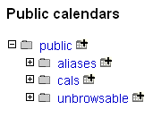
In /public/cals we have only one calendar collection:
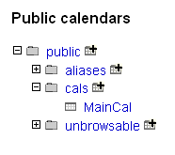
All events added to Bedework using the public events administration client are placed within the MainCal calendar collection.
Opening up the tree, we find calendar aliases gathered together as pre-filtered collections which calendar suites can use when building topical areas. The unbrowsable branch of the tree contains the calendar collection used to hold pending events from the submissions web client and can be used for other special purpose calendar collections.
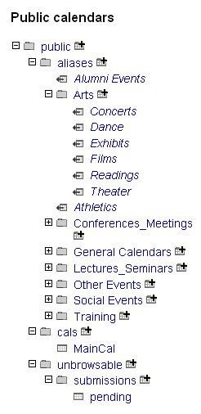
The /public/aliases branch is exposed in the submissions client to allow the submitter to suggest topical areas for their event. Event administrators refine these when they pick up the event for publication. (Note: work on the submissions client is not complete in the current preview release.) It is likewise exposed to personal calendar users as a subscription source within the personal client. Calendar aliases will appear in CalDAV clients as if they were calendars.

Calendar Suites
Calendar suite owners (or superusers) build the calendar suite structure by adding topical areas pointing to collections in the public calendar tree or to external calendars. The calendar suite owner has the option of pointing to any of the calendar alias in the tree making filtering easier.
The public calendar tree is not directly visible in the add event form. Rather, the event admin sees only the "Topical Areas" defined by the calendar suite owner. The 3.5 preview release assumes one public calendar under /public/cals - however, we will test for multiple calendars in this branch and expose them for selection prior to final release. In most cases, we encourage a single calendar model for public events publishing.

managing users

managing calendars

managing calendar suites

managing events

Getting events in

Administrative web client

Community submissions client

Getting events out

Calendar suites

data feeds - ical, raw xml, rss, json, js, etc.

Filtering

Adding custom properties (X-Properties)

backups

