Introducing Bedework 3.6

Bedework System Overview
Bedework is an open-source enterprise calendar system that supports public, personal, and group calendaring. It is designed to conform to current calendaring standards with a goal of attaining strong interoperability between other calendaring systems and clients. Bedework is built with an emphasis on higher education, though it is used by many commercial enterprises.
You may choose to deploy Bedework for public events calendaring, personal calendaring and scheduling, or both. Bedework is suitable for embedding in other applications or in portals and has been deployed across a wide range of environments.

Bedework System Architecture
Bedework 3.6 has a central server architecture and is modular and extensible. It consists of the following components:
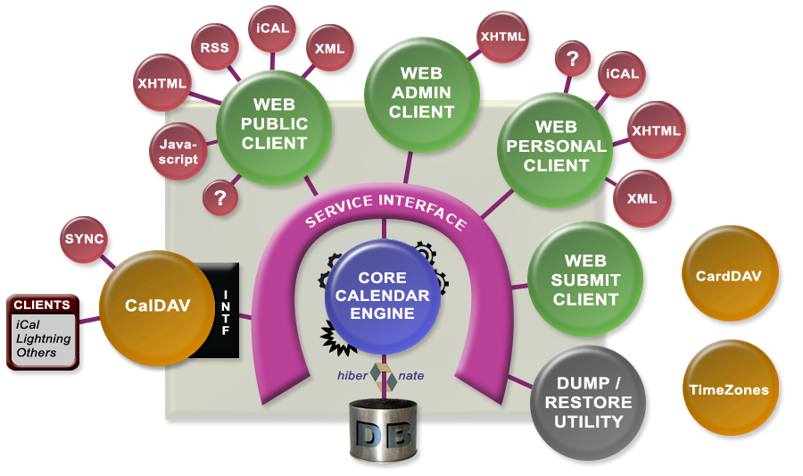Illustration 1: Bedework System Architecture

- Bedework core calendar engine
- Public events web client, called a “Calendar Suite”, for display of public events
- Public events administration web client for entering public events, moderating pending events from the submissions client, and configuring calendar suites
- Public events submission web client for authenticated members of your community to suggest public events – these become pending events in the admin client
- Personal and group calendaring web client with a subscription model to Bedework public calendars, user calendars, and external calendar feeds
- CalDAV server for integration with CalDAV capable desktop (and web) clients such as Apple's iCal or Mozilla Lightning
- CardDAV server supporting contacts for scheduling in the personal client. This server will become more heavily used in future versions of Bedework for contacts, locations, and other resources.
- TimeZone server for support of timezone information
- Dump/Restore command-line utilities for database backup, initialization, and upgrades.
The Bedework system is divided into two main spaces: the public events space, and the personal and group calendaring space which are kept separate by design. Public events are stored below a public calendar root folder and personal calendars are below a user calendar root folder.
PUBLIC
EVENTS

calendars & events are
publicly viewable unless
hidden or access is changed

root is /public
PERSONAL & GROUP
EVENTS

calendars & events are
private unless shared

root is /user
Personal calendar users (and other clients) can subscribe to public events, but users may only add public events using the Administrative and Community Submissions web clients. For more information about Bedework's public and personal event calendaring models, see chapters 4 and 5.

Features of Bedework
- Java : Written completely in Java, Bedework is system independent. Currently it will compile and run in Java 1.5 or later.
- Standards based and interoperable : Interoperability with other calendar systems and clients by way of standards compliance is a fundamental design goal of the Bedework system. The following standards are supported:
iCalendar support (rfc2445)
iTIP (rfc2446)
CalDAV (rfc4791)
CalDAV scheduling (draft)
VVenue (draft)
- CalDAV server : a full CalDAV server is a core feature of Bedework. It can be used with any CalDAV capable client and has been shown to work with Mozilla Lightning, Apple's iCal, Evolution, and others.
- Web clients : The Bedework web clients provide access to public events in guest mode and to public and personal events in authenticated mode. All web clients are easily skinned allowing a high degree of customization.
- Public calendar suites : Public events are displayed using "calendar suites" allowing multiple organizations to maintain their own public views of events with whatever degree of visibility is appropriate. A Bedework public calendaring installation may have one or many calendar suites. A calendar suite provides a customized view of events, custom theming, and control over how events are tagged by event administrators.
- Personal calendars : Bedework provides a web client for personal and group calendaring including scheduling. Using CalDAV desktop clients, users can see a fully synchronized view of their personal and subscribed events between their desktop client and the web client.
- Administrative client for public events : Public event entry and maintenance is carried out through the administrative web client. The system supports three roles: Super Users control global system settings including user and calendar maintenance and the setup of calendar suites. Calendar Suite Owners can modify the settings of their calendar suite, and Event Administrators can add and edit events for the administrative groups to which they belong.
- Public event submission : Bedework provides a web client for submitting events to a public queue allowing members of your community who are not event administrators to suggest public events.
- Highly customizable look and feel - XML & XSLT : The web clients are XML and XSLT based allowing Bedework to be "skinned" for multiple clients and uses. For example, the quickstart comes with skins for producing production RSS, Javascript, and video feeds as well as HTML displays suitable for handheld devices.
- Database independence - Hibernate : The core of the calendar uses Hibernate for all database transactions giving support of many database systems and enterprise level performance and reliability. A number of caching schemes are implemented for Hibernate including clustered systems giving further options for improving availability.
- Sharing : Full CalDAV access control is available allowing the sharing of calendars and calendar entities based on authentication status and identity.
- Scheduling : Bedework supports scheduling of meetings including invitations and their responses. Caldav scheduling (still in draft) is supported. Freebusy is supported and the busy time is displayed as attendee lists are built. Access control allows users to determine who may attempt to schedule meetings with them.
- Import and export : Events can be imported and exported in iCalendar (RFC2445) format. This provides an option for populating the calendar from external sources. A dump/restore utility provides a means to backup and restore xml data files.
- Calendar subscriptions : Users may subscribe to calendars to which they have access, including public and personal calendars. iCalendar data feeds are available from the public web client.
- Multiple calendars : The core system supports multiple calendars for users and for public events.
- Tagging & Filtering : Events and folders can be tagged by any number of categories and event views and feeds can be filtered by these.
- Internationalization : Internationalization is carried out by creating a new skin. The skin selected is based upon skin name and locale allowing a significant degree of multilanguage support in the client. Work is currently taking place to strengthen support for internationalization independent of Bedework skins.
- RSS, Javascript, iCalendar Feeds : Feeds can be filtered by category or creator.
- Portal support : Bedework has been shown to work as a JSR168 portlet in Jetspeed, uPortal and Liferay using the portal-struts bridge.
- Timezone support : Full timezone support is implemented. There is a set of system defined timezones based upon externally available sets of timezone definitions. In addition users are able to store their own timezone definitions.
- Recurring events : Extensive recurring event support is available via CalDAV and the web clients.
- Event references : Users may add public event references to their personal calendars. Event references can be annotated by the user.
- Pluggable group support : Bedework uses a pluggable class implementation to determine group membership for authenticated users allowing organizations to implement a class which uses an external directory. The default class uses internal tables to maintain group membership. Different implementations can be used for administrative and personal use allowing the separation of any given users roles.
- Container authentication : There is no authentication code in Bedework. Rather, Bedework behaves as a standard servlet, and all authentication is carried out through external mechanisms. Standard container authentication (via Tomcat or Jboss) and filter based Yale CAS authentication are used in production. The quickstart comes packaged with the Apache DS server against which the quickstart deployment of Bedework authenticates. This server can be used in production, though many deployers opt to authenticate against their organization's existing directory.
- Support for other calendar systems and clients : It is possible to access an entire calendar with a single url. This can be used to subscribe to a Bedework calendar from Google or Outlook. Bedework can also take advantage of the richness of CalDAV capable desktop clients such as Apple's iCal and Mozilla Lightning.

Bedework History / Background
Bedework was established in March 2005 in succession to UW Calendar. In December 2006 Bedework received the Andrew W. Mellon Foundation's Technology Collaboration (MATC) Award. Since then the project has prospered, and in early 2009, Bedework became an incubator project of the Java Architecture Special Interest Group (JA-SIG).
Bedework is named after the Venerable Bede, a highly influential monk and scholar from the area of Northumbria in Britain who in 725AD wrote the treatise, "On the Reckoning of Time". Like Bede is pronounced “bead”, Bedework is pronounced “bead work”.

Calendaring Standards & Interoperability
Interoperability with other calendar systems and clients is a core design principal of Bedework. Bedework's lead developers participate extensively (as members of Rensselaer Polytechnic Institute) in CalConnect, The Calendaring and Scheduling Consortium. For more information about calendaring and calendaring standards, please see http://www.calconnect.org/

