Chapter 5 - Pattern-Oriented Validation
This notebook runs seven validation tests on the labour-market ABM. Each test asks the same kind of question: if we change one knob in the model, does the outcome move in the direction that economic theory predicts?
At the end there is a summary table.
# | Pattern | Quick description
1 | Profitability gate | Loss-making firms should stop proactive automation
2 | AI cost | Expensive AI is adopted less often
3 | Severance | Higher firing cost should slow AI adoption
4 | Demand decline | Job losses should drop aggregate demand
5 | Minimum wage | Higher wage floor pushes firms to automate
6 | Polarisation | AI hitting routine tasks hurts low-skilled workers most

Setup
Imports, find the repo root, load the model, and define a tiny run_sims helper that runs the model N_REPS times and gives us back a list of dataframes (one per replication).
import os, sys, warnings
from pathlib import Path
import numpy as np
import pandas as pd
import matplotlib.pyplot as plt
from scipy import stats, optimize
warnings.filterwarnings('ignore', category=RuntimeWarning)
# --- find the repo so we can import the model -------------------------
def find_repo_root(start):
for p in [start, *start.parents]:
if (p / 'model' / 'labour_market_model.py').exists():
return p
raise FileNotFoundError('Cannot find repo root')
REPO_ROOT = find_repo_root(Path.cwd().resolve())
sys.path.insert(0, str(REPO_ROOT / 'model'))
from labour_market_model import LabourMarketModel
from base_parameters import BASE_PARAMS
FIG_DIR = REPO_ROOT / 'notebooks' / 'validation' / 'validation_figures'
FIG_DIR.mkdir(exist_ok=True)
# --- compute budget --------------------------------------------------
N_REPS = 12 # number of replications per regime (different random seeds)
N_STEPS = 960 # 80 simulated years at 12 steps per year
# --- the two scenarios used in the chapter ---------------------------
# A = no institutions (reference for the verification of the institution effect, see Ch 5.3)
# B = Dutch baseline (the one we focus on -- all 7 pattern tests run on B)
SCENARIO_A = dict(adoption_mode='npv_naive', employment_protection=False, w_min=0.0, lam=1.0)
SCENARIO_B = dict(adoption_mode='npv_mean_field', employment_protection=True)
# --- helper: run the model n_reps times with given parameter overrides
def run_sims(overrides, n_reps=N_REPS, n_steps=N_STEPS, seed_base=1000):
"""Run n_reps simulations and return a list of model dataframes."""
results = []
for r in range(n_reps):
params = BASE_PARAMS.copy()
params.update(overrides)
params['seed'] = seed_base + r
m = LabourMarketModel(**params)
for _ in range(n_steps):
m.step()
results.append(m.datacollector.get_model_vars_dataframe().reset_index(drop=True))
return results
def save_fig(fig, name):
path = FIG_DIR / name
fig.savefig(path, dpi=150, bbox_inches='tight')
print(f' figure saved: {path.name}')
# container for the final summary table
VERDICTS = {}
print(f'Setup OK. N_REPS={N_REPS}, N_STEPS={N_STEPS}')
print(f'Figures go to: {FIG_DIR}')
Setup OK. N_REPS=12, N_STEPS=960
Figures go to: C:\Users\bjarn\OneDrive\Bureaublad\TU Delft\Msc\Thesis\DutchLabourMarket_Thesis\LabourMarket_MESA\notebooks\validation\validation_figures

Pattern 1 - Profitability gate
What we test. If production suddenly becomes extremely expensive, does the model stop automation and expansion?
Mechanism. The producer expansion rule is gated by profitability. A firm only generates proactive bottleneck-expansion requests when its average cost is below the goods-market price:
$$AC_{i}<p$$
If $AC_{i}≥p$, expanding output would deepen operating losses, so the producer should not proactively hire or automate bottleneck tasks. Reactive replacement after worker separations is a separate channel and is deliberately switched off in this test.
How. In each replication we run the Dutch baseline to a fixed shock step with exogenous separations switched off and p_convert=1, so workers do not leave tasks through random separations or chain-limit non-renewal. This keeps the warm-start allocation occupied by either workers or already-installed AI, so the test does not mix the profitability gate with empty-slot recovery. At the shock step we set both wages and the AI rental price to extremely high values. This pushes producers' average costs above the goods-market price.
Pass criterion. After the shock, producers are loss-making ($AC>p$ and average profit is negative), the profitability gate blocks expansion, and no new automation occurs.
PROFIT_SHOCK_STEP = N_STEPS // 4
PROFIT_POST_STEPS = 24
WAGE_SHOCK = 10_000.0
AI_COST_SHOCK = 10_000.0
def producer_average_costs(m):
return [p.total_costs / p.output for p in m.producers if p.output > 0]
def refresh_profitability_state(m):
"""Recalculate output, price and diagnostics after an out-of-step cost shock."""
for p in m.producers:
p.produce()
p.trim_ai_capacity()
m.Y = m.calculate_wage_bill()
m.Pi = m.calculate_profit_income()
m.p = m.calculate_market_price()
m._compute_all_stats()
def profitability_snapshot(m, rep, horizon, label):
ac = producer_average_costs(m)
return {
'rep': rep,
'horizon': horizon,
'label': label,
'price': m.p,
'avg_AC': float(np.mean(ac)) if ac else np.nan,
'share_unprofitable': float(np.mean([x > m.p for x in ac])) if ac else np.nan,
'avg_profit': m._step_stats.get('avg_profit', np.nan),
'n_gate_blocks': m.n_gate_blocks_this_step,
'new_automations': m._step_stats.get('new_automations_this_step', 0.0),
'new_proactive_automations': m.new_proactive_automations_this_step,
'ai_adoption_rate': m._step_stats.get('ai_adoption_rate', np.nan),
}
def trace_new_automations(m, rep, horizon):
"""Return detailed records for automation decisions made in the current model step."""
rows = []
by_id = {p.unique_id: p for p in m.producers}
for rec in m.investment_log:
if rec.get('step') != m.current_step or not rec.get('decision'):
continue
producer = by_id.get(rec.get('producer_id'))
output = producer.output if producer is not None else np.nan
total_costs = producer.total_costs if producer is not None else np.nan
ac = total_costs / output if output and output > 0 else np.nan
rows.append({
'rep': rep,
'horizon': horizon,
'model_step': m.current_step,
'producer_id': rec.get('producer_id'),
'task_id': rec.get('task_id'),
'task_type': rec.get('task_type'),
'complexity': rec.get('complexity'),
'channel': rec.get('channel'),
'producer_output': output,
'producer_AC': ac,
'price': m.p,
'output_zero_gate_bypass': bool(output <= 0) if not np.isnan(output) else False,
'npv': rec.get('npv'),
'hurdle_threshold': rec.get('hurdle_threshold'),
'uc_human_now': rec.get('uc_human_now'),
'uc_ai_now': rec.get('uc_ai_now'),
'decision_reason': rec.get('decision_reason'),
})
return rows
def force_profitability_shock(m):
"""Make labour and AI inputs extremely expensive from this step onward."""
m.w_min = WAGE_SHOCK
m.w_h = WAGE_SHOCK
m.w_l = WAGE_SHOCK
m.w_h_prev = WAGE_SHOCK
m.w_l_prev = WAGE_SHOCK
m.k_ai = AI_COST_SHOCK
m.k_ai_0 = AI_COST_SHOCK
m.k_ai_floor = AI_COST_SHOCK
m.k_ai_decay = 0.0
for w in m.workers:
if w.employed:
w.wage = WAGE_SHOCK
for p in m.producers:
p._pending_requests = []
refresh_profitability_state(m)
profit_records = []
automation_trace = []
for r in range(N_REPS):
params = BASE_PARAMS.copy()
params.update(SCENARIO_B)
params.update({
'delta': 0.0, # keep warm-start jobs from disappearing before the shock
'p_convert': 1.0, # chain-limit workers convert instead of leaving vacancies
'p_evaluate': 1.0, # make the proactive channel observable if the gate is open
'log_decisions': True,
'seed': 1100 + r,
})
m = LabourMarketModel(**params)
for _ in range(PROFIT_SHOCK_STEP):
m.step()
refresh_profitability_state(m)
profit_records.append(profitability_snapshot(m, r, -1, 'pre-shock'))
force_profitability_shock(m)
profit_records.append(profitability_snapshot(m, r, 0, 'forced AC > p'))
for h in range(1, PROFIT_POST_STEPS + 1):
m.step()
automation_trace.extend(trace_new_automations(m, r, h))
profit_records.append(profitability_snapshot(m, r, h, 'post-shock'))
profit_df = pd.DataFrame(profit_records)
plot_df = profit_df.groupby('horizon', as_index=False).mean(numeric_only=True)
post = profit_df[profit_df['horizon'] >= 1]
fig, ax = plt.subplots(1, 3, figsize=(13, 4))
ax[0].plot(plot_df['horizon'], plot_df['price'], marker='o', label='Price p')
ax[0].plot(plot_df['horizon'], plot_df['avg_AC'], marker='o', label='Average cost AC')
ax[0].axvline(0, color='black', ls=':', lw=1)
ax[0].set_xlabel('Steps relative to profitability shock')
ax[0].set_title('Forced AC > p')
ax[0].legend()
ax[1].plot(plot_df['horizon'], plot_df['avg_profit'], marker='o', color='firebrick')
ax[1].axhline(0, color='black', lw=0.8)
ax[1].axvline(0, color='black', ls=':', lw=1)
ax[1].set_xlabel('Steps relative to profitability shock')
ax[1].set_title('Average producer profit')
ax[2].bar(plot_df['horizon'], plot_df['new_proactive_automations'], color='steelblue')
ax[2].axvline(0, color='black', ls=':', lw=1)
ax[2].set_xlabel('Steps relative to profitability shock')
ax[2].set_title('New proactive automations')
plt.tight_layout(); save_fig(fig, 'fig_5_1_profitability_gate.png'); plt.show()
post_avg_ac_gt_price = (post['avg_AC'] > post['price']).mean()
post_profit_negative = (post['avg_profit'] < 0).mean()
post_gate_blocks = post['n_gate_blocks'].mean()
post_new_auto = post['new_automations'].sum()
post_new_proactive = post['new_proactive_automations'].sum()
trace_df = pd.DataFrame(automation_trace)
print('\nProfitability shock:')
print(f' shock step: {PROFIT_SHOCK_STEP}; wage shock: {WAGE_SHOCK:.0f}; AI cost shock: {AI_COST_SHOCK:.0f}')
print(f' Share of post-shock observations with avg AC > p: {post_avg_ac_gt_price:.2%}')
print(f' Share of post-shock observations with negative average profit: {post_profit_negative:.2%}')
print(f' Mean gate blocks per post-shock step: {post_gate_blocks:.2f}')
print(f' New automations after shock: {post_new_auto:.0f}')
print(f' New proactive automations after shock: {post_new_proactive:.0f}')
if len(trace_df):
print('\nPost-shock automation trace:')
cols = ['rep', 'horizon', 'model_step', 'producer_id', 'task_id', 'task_type',
'channel', 'producer_output', 'producer_AC', 'price',
'output_zero_gate_bypass', 'npv', 'hurdle_threshold',
'uc_human_now', 'uc_ai_now', 'decision_reason']
print(trace_df[cols].to_string(index=False))
else:
print('\nPost-shock automation trace: none')
verdict = (
post_avg_ac_gt_price >= 0.95
and post_profit_negative >= 0.95
and post_gate_blocks > 0
and post_new_proactive == 0
and post_new_auto == 0
)
VERDICTS[1] = ('Profitability gate', 'forced AC > p stops proactive automation', verdict,
f'AC>p share={post_avg_ac_gt_price:.0%}; profit<0 share={post_profit_negative:.0%}; '
f'gate blocks={post_gate_blocks:.1f}/step; new proactive auto={post_new_proactive:.0f}')
print(f'\n{"PASS" if verdict else "FAIL"} - Pattern 1')
figure saved: fig_5_1_profitability_gate.png
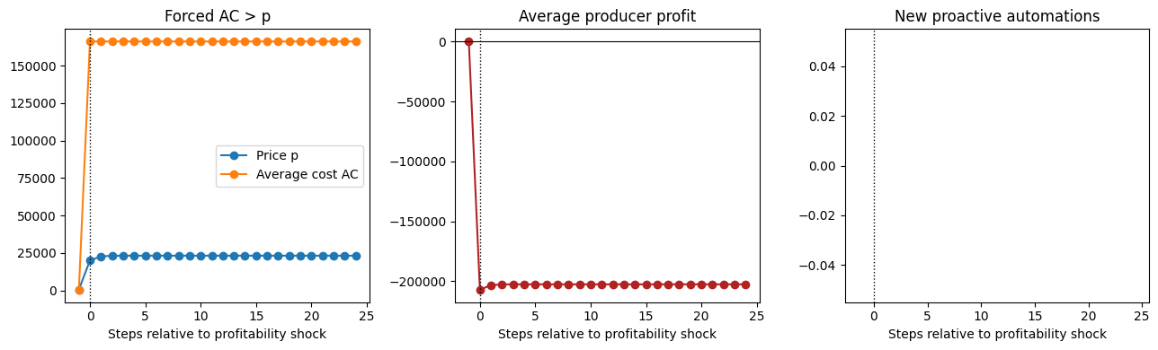
Profitability shock:
shock step: 240; wage shock: 10000; AI cost shock: 10000
Share of post-shock observations with avg AC > p: 100.00%
Share of post-shock observations with negative average profit: 100.00%
Mean gate blocks per post-shock step: 20.00
New automations after shock: 0
New proactive automations after shock: 0
Post-shock automation trace: none
PASS - Pattern 1

Pattern 2 - Expensive AI is adopted less
What we test. If we make AI more expensive, do firms adopt it less?
Two knobs we vary:
- k_ai_floor: the minimum AI cost (higher = AI never gets really cheap)
- k_ai_decay: how fast AI gets cheaper over time (slower decay = stays expensive longer)
Pass criterion. Adoption goes monotonically down as k_ai_floor rises, and monotonically up as k_ai_decay gets faster.
k_floor_levels = [15, 20, 25] # base is 20
k_decay_levels = [0.005, 0.020, 0.080] # slow / base / fast
end_floor = {}
end_decay = {}
for kf in k_floor_levels:
runs = run_sims({**SCENARIO_B, 'k_ai_floor': kf}, seed_base=1200)
end_floor[kf] = np.mean([df['ai_adoption_rate'].iloc[-1] for df in runs])
for kd in k_decay_levels:
runs = run_sims({**SCENARIO_B, 'k_ai_decay': kd}, seed_base=1300)
end_decay[kd] = np.mean([df['ai_adoption_rate'].iloc[-1] for df in runs])
fig, ax = plt.subplots(1, 2, figsize=(11, 4))
ax[0].bar([str(k) for k in k_floor_levels], [end_floor[k] for k in k_floor_levels], color='steelblue')
ax[0].set_xlabel('k_ai_floor'); ax[0].set_ylabel('Final AI adoption')
ax[0].set_title('Higher floor → less adoption')
ax[1].bar([str(k) for k in k_decay_levels], [end_decay[k] for k in k_decay_levels], color='firebrick')
ax[1].set_xlabel('k_ai_decay'); ax[1].set_ylabel('Final AI adoption')
ax[1].set_title('Faster decay → more adoption')
plt.tight_layout(); save_fig(fig, 'fig_5_3_ai_cost.png'); plt.show()
print('\nFinal adoption by k_ai_floor:', {k: round(v, 3) for k, v in end_floor.items()})
print('Final adoption by k_ai_decay:', {k: round(v, 3) for k, v in end_decay.items()})
floor_ok = end_floor[15] >= end_floor[20] >= end_floor[25]
decay_ok = end_decay[0.005] <= end_decay[0.020] <= end_decay[0.080]
verdict = floor_ok and decay_ok
VERDICTS[2] = ('AI cost vs adoption', 'cheap AI → more adoption', verdict,
f'floor monotone: {floor_ok}, decay monotone: {decay_ok}')
print(f'\n{"PASS" if verdict else "FAIL"} - Pattern 2')
figure saved: fig_5_3_ai_cost.png
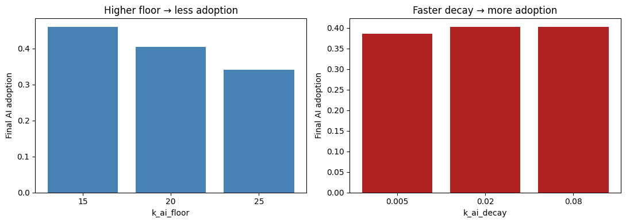
Final adoption by k_ai_floor: {15: np.float64(0.461), 20: np.float64(0.405), 25: np.float64(0.341)}
Final adoption by k_ai_decay: {0.005: np.float64(0.386), 0.02: np.float64(0.403), 0.08: np.float64(0.403)}
PASS - Pattern 2

Pattern 3 - Severance slows automation
What we test. Severance pay (the cost a firm has to pay when firing a worker) should make automation more expensive and therefore slower.
Caveat. In this model the channel is mechanically small: most automation happens on empty slots (where there is nobody to pay severance to). So we expect only a weak effect at best - we just report what the simulation says.
Pass criterion. Adoption at high severance is not higher than at no severance (i.e. effect goes the expected direction, even if small).
sev_levels = [0.0, 1/3, 1.0, 5.0, 20.0] # no / base / high severance
end_adoption = {}
for sev in sev_levels:
runs = run_sims({**SCENARIO_B, 'severance_rate': sev, 'p_convert': 0.95, 'chain_limit': 2}, seed_base=1400)
end_adoption[sev] = np.array([df['ai_adoption_rate'].iloc[-1] for df in runs])
means = {s: end_adoption[s].mean() for s in sev_levels}
stds = {s: end_adoption[s].std() for s in sev_levels}
fig, ax = plt.subplots(figsize=(7, 4))
ax.bar([f'sev={s}' for s in sev_levels],
[means[s] for s in sev_levels],
yerr=[stds[s] for s in sev_levels],
color='steelblue', capsize=4)
ax.set_ylabel('Final AI adoption')
ax.set_title('Higher severance → less adoption (expected)')
plt.tight_layout(); save_fig(fig, 'fig_5_5_severance.png'); plt.show()
print('\nMean final adoption by severance:')
for s in sev_levels:
print(f' severance={s}: mean={means[s]:.3f} std={stds[s]:.3f}')
verdict = means[0.0] >= means[5.0]
VERDICTS[3] = ('Severance vs adoption', 'high severance → not more adoption', verdict,
f'no-sev: {means[0.0]:.3f}, high-sev: {means[5.0]:.3f}')
print(f'\n{"PASS" if verdict else "FAIL"} - Pattern 3')
figure saved: fig_5_5_severance.png
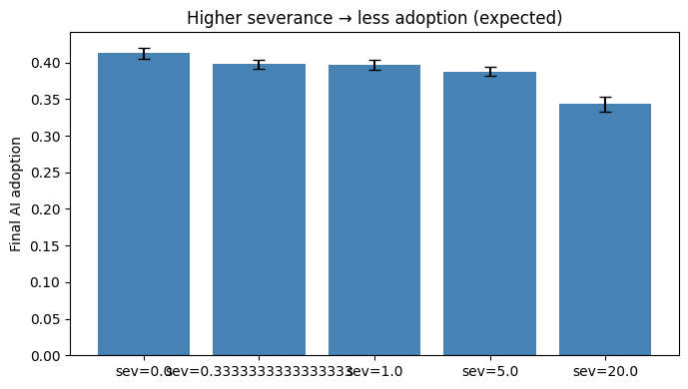
Mean final adoption by severance:
severance=0.0: mean=0.413 std=0.008
severance=0.3333333333333333: mean=0.398 std=0.006
severance=1.0: mean=0.396 std=0.007
severance=5.0: mean=0.388 std=0.006
severance=20.0: mean=0.343 std=0.010
PASS - Pattern 3

Pattern 4 - Job losses depress aggregate demand
What we test. If many workers are forced into unemployment at a selected moment in the run, do aggregate demand $A$ and the goods-market price fall as well?
Mechanism. Demand follows the model's Kaleckian two-class consumption function:
$$A_{t}=A_{\text{base}}+γ⋅W_{t−1}+γ_{π}⋅Π_{t−1}$$
with $γ>γ_{π}$ (workers have a higher MPC than capitalists; Storm & Naastepad 2012). Forced unemployment directly removes wage income from the simulated economy. In this validation shock we immediately refresh the model's lagged-income state, so the fall in the wage bill $W$ is allowed to show up in $A$ at the shock step.
How. In each replication we run to a fixed shock step, randomly select a large share of currently employed workers, and forcibly separate them from their jobs without queuing replacement hires or automation callbacks. We then recalculate output, factor incomes, $A$, and price, and follow employment, $A$, and price for the next two simulated years.
Pass criterion. The forced shock creates a clear employment fall, and both $A$ and price are lower immediately after the shock.
SHOCK_STEP = N_STEPS // 4 # selected moment in the run
SHOCK_SHARE = 0.35 # share of employed workers forced jobless
POST_STEPS = 24 # follow-up window after the shock
def employment_level(m):
return sum(1 for w in m.workers if w.employed)
def refresh_macro_state(m):
"""Recalculate output, demand and price after an out-of-step shock."""
for p in m.producers:
p.produce()
p.trim_ai_capacity()
m.Y = m.calculate_wage_bill()
m.Pi = m.calculate_profit_income()
m.p = m.calculate_market_price()
m._compute_all_stats()
def snapshot(m, rep, horizon, label, n_forced=0):
return {
'rep': rep,
'horizon': horizon,
'label': label,
'n_forced_jobless': n_forced,
'employment': employment_level(m),
'employment_rate': employment_level(m) / len(m.workers),
'A_demand': m.A,
'price': m.p,
'wage_bill': m.calculate_wage_bill(),
'profit_income': m.calculate_profit_income(),
'total_output': sum(p.output for p in m.producers),
}
def force_unemployment_shock(m, share, rng):
"""Force a randomly selected share of employed workers into unemployment."""
employed = [w for w in m.workers if w.employed]
n_shocked = max(1, int(round(share * len(employed))))
shocked_idx = rng.choice(len(employed), size=n_shocked, replace=False)
for i in shocked_idx:
w = employed[int(i)]
task = w.task
employer = w.employer
if task is not None and w in task.employees:
task.employees.remove(w)
if employer is not None and w in employer.employees:
employer.employees.remove(w)
w.employed = False
w.employer = None
w.task = None
w.wage = 0.0
# This is an exogenous demand-side validation shock, not a firm replacement event.
for p in m.producers:
p._pending_requests = []
m.new_displaced_workers_this_step += n_shocked
return n_shocked
shock_records = []
for r in range(N_REPS):
params = BASE_PARAMS.copy()
params.update(SCENARIO_B)
params['seed'] = 1600 + r
m = LabourMarketModel(**params)
for _ in range(SHOCK_STEP):
m.step()
refresh_macro_state(m)
shock_records.append(snapshot(m, r, -1, 'pre-shock'))
rng = np.random.default_rng(1600 + r)
n_shocked = force_unemployment_shock(m, SHOCK_SHARE, rng)
refresh_macro_state(m)
shock_records.append(snapshot(m, r, 0, 'forced unemployment', n_shocked))
for h in range(1, POST_STEPS + 1):
m.step()
shock_records.append(snapshot(m, r, h, 'post-shock'))
shock_df = pd.DataFrame(shock_records)
pre = shock_df[shock_df['horizon'] == -1].set_index('rep')
impact = shock_df[shock_df['horizon'] == 0].set_index('rep')
employment_drop = pre['employment'] - impact['employment']
dA = impact['A_demand'] - pre['A_demand']
dp = impact['price'] - pre['price']
dQ = impact['total_output'] - pre['total_output']
mean_path = shock_df.groupby('horizon')[['employment_rate', 'A_demand', 'price']].mean()
norm_path = 100 * mean_path / mean_path.loc[-1]
fig, axes = plt.subplots(1, 2, figsize=(10, 4))
for col, label, color in [
('employment_rate', 'Employment', 'firebrick'),
('A_demand', 'Aggregate demand A', 'steelblue'),
('price', 'Price', 'darkgreen'),
]:
axes[0].plot(norm_path.index, norm_path[col], marker='o', ms=3, label=label, color=color)
axes[0].axvline(0, color='black', ls='--', lw=0.8)
axes[0].axhline(100, color='grey', lw=0.5)
axes[0].set_xlabel('Steps relative to forced unemployment shock')
axes[0].set_ylabel('Index, pre-shock = 100')
axes[0].set_title('Macro response to forced joblessness')
axes[0].legend(frameon=False)
axes[1].scatter(employment_drop, dA, label='Delta A', color='steelblue', alpha=0.75)
axes[1].scatter(employment_drop, dp, label='Delta price', color='darkgreen', alpha=0.75)
axes[1].axhline(0, color='grey', lw=0.5)
axes[1].set_xlabel('Workers forced jobless')
axes[1].set_ylabel('Immediate change')
axes[1].set_title('Impact at the shock step')
axes[1].legend(frameon=False)
plt.tight_layout(); save_fig(fig, 'fig_5_6_keynes.png'); plt.show()
print('\nForced unemployment shock:')
print(f' shock step: {SHOCK_STEP}; shock share: {SHOCK_SHARE:.0%}; follow-up: {POST_STEPS} steps')
print(f' workers forced jobless: mean={employment_drop.mean():.1f}, min={employment_drop.min():.0f}, max={employment_drop.max():.0f}')
print(f' immediate Delta A: mean={dA.mean():+.3f}')
print(f' immediate Delta price: mean={dp.mean():+.3f}')
print(f' immediate Delta output: mean={dQ.mean():+.3f}')
verdict = (employment_drop.mean() > 0) and (dA.mean() < 0) and (dp.mean() < 0)
VERDICTS[4] = ('Demand decline', 'forced unemployment lowers A and price', verdict,
f'dL={employment_drop.mean():.1f}, dA={dA.mean():+.3f}, dp={dp.mean():+.3f}')
print(f'\n{"PASS" if verdict else "FAIL"} - Pattern 4')
figure saved: fig_5_6_keynes.png
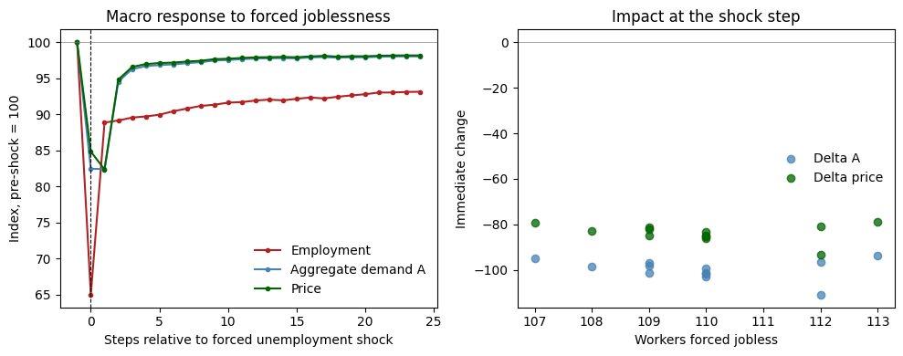
Forced unemployment shock:
shock step: 240; shock share: 35%; follow-up: 24 steps
workers forced jobless: mean=109.9, min=107, max=113
immediate Delta A: mean=-99.607
immediate Delta price: mean=-83.582
immediate Delta output: mean=-32.049
PASS - Pattern 4

Pattern 5 - Higher minimum wage pushes firms to automate
What we test. If labour is more expensive (high w_min), do firms automate more?
How. Sweep w_min over six levels and look at final AI adoption.
Pass criterion. Spearman correlation between w_min and final adoption is positive.
wmin_levels = [0, 14.71, 25, 28, 30, 32] # 14.71 = Dutch statutory minimum hourly wage (2026)
end_adoption = {}
for w in wmin_levels:
runs = run_sims({**SCENARIO_B, 'w_min': w}, seed_base=1700)
end_adoption[w] = np.array([df['ai_adoption_rate'].iloc[-1] for df in runs])
means = [end_adoption[w].mean() for w in wmin_levels]
stds = [end_adoption[w].std() for w in wmin_levels]
rho, p = stats.spearmanr(wmin_levels, means)
fig, ax = plt.subplots(figsize=(7, 4))
ax.errorbar(wmin_levels, means, yerr=stds, fmt='o-', color='steelblue')
ax.axvline(14.71, color='grey', ls=':', lw=0.8, label='Dutch w_min (14.71)')
ax.set_xlabel('Minimum wage'); ax.set_ylabel('Final AI adoption')
ax.set_title(f'Minimum wage vs adoption (Spearman ρ = {rho:+.2f})')
ax.legend()
plt.tight_layout(); save_fig(fig, 'fig_5_8_min_wage.png'); plt.show()
print(f'\nSpearman: ρ = {rho:+.2f} (p = {p:.2g})')
verdict = rho > 0
VERDICTS[5] = ('Minimum wage vs adoption', 'ρ > 0', verdict, f'ρ={rho:+.2f}, p={p:.2g}')
print(f'\n{"PASS" if verdict else "FAIL"} - Pattern 5')
figure saved: fig_5_8_min_wage.png
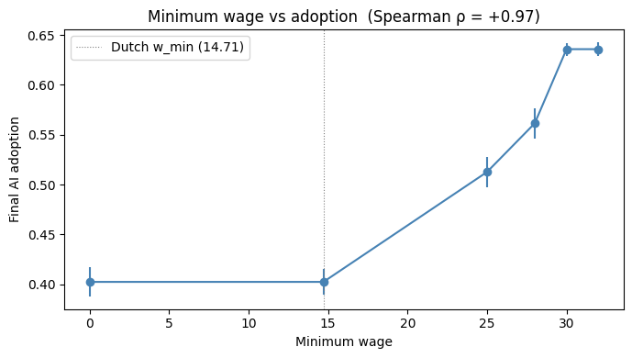
Spearman: ρ = +0.97 (p = 0.0012)
PASS - Pattern 5

Pattern 6 - Polarisation depends on what AI is good at
What we test. When AI is better at routine tasks (low nr_multiplier), low-skilled workers should be hit harder. We look at two signals:
- Skill wage premium $w_{h}/w_{l}$ - should widen at low nr_multiplier.
- Routine share of automation - share of automated tasks that are routine. Should be higher at low nr_multiplier.
Pass criterion. Either signal moves the expected way (premium wider OR routine share higher at low μ).
mu_levels = [0.1, 0.85, 3.0] # AI strongly favours routine / neutral / AI favours non-routine
results = {}
for mu in mu_levels:
runs = run_sims({**SCENARIO_B, 'nr_multiplier': mu, 'w_min': 0.0}, seed_base=1900)
premium_list, routine_share_list = [], []
for rep, df in enumerate(runs):
w_l_end = df['wage_low'].iloc[-1]
w_h_end = df['wage_high'].iloc[-1]
if w_l_end > 0:
premium_list.append(w_h_end / w_l_end)
for r in range(N_REPS):
params = BASE_PARAMS.copy()
params.update({**SCENARIO_B, 'nr_multiplier': mu, 'w_min': 0.0})
params['seed'] = 1900 + r
m = LabourMarketModel(**params)
for _ in range(N_STEPS):
m.step()
nr = sum(1 for p in m.producers for t in p.tasks if t.automated and t.task_type == 'routine')
nnr = sum(1 for p in m.producers for t in p.tasks if t.automated and t.task_type == 'non_routine')
if (nr + nnr) > 0:
routine_share_list.append(nr / (nr + nnr))
results[mu] = dict(premium=float(np.mean(premium_list)) if premium_list else float('nan'),
routine_share=float(np.mean(routine_share_list)) if routine_share_list else float('nan'))
fig, ax = plt.subplots(1, 2, figsize=(11, 4))
mus = list(results.keys())
ax[0].bar([str(m) for m in mus], [results[m]['premium'] for m in mus], color='steelblue')
ax[0].set_xlabel('nr_multiplier'); ax[0].set_ylabel('wh / wl')
ax[0].set_title('Skill wage premium')
ax[1].bar([str(m) for m in mus], [results[m]['routine_share'] for m in mus], color='firebrick')
ax[1].set_xlabel('nr_multiplier'); ax[1].set_ylabel('Routine share of automated tasks')
ax[1].set_title('Routine share of automation')
plt.tight_layout(); save_fig(fig, 'fig_5_9_polarisation.png'); plt.show()
print('\nBy nr_multiplier:')
for mu in mus:
print(f' μ={mu}: premium = {results[mu]["premium"]:.3f}, routine_share = {results[mu]["routine_share"]:.3f}')
prem_ok = results[mus[0]]['premium'] > results[mus[-1]]['premium']
rs_ok = results[mus[0]]['routine_share'] > results[mus[-1]]['routine_share']
verdict = prem_ok or rs_ok
VERDICTS[6] = ('Polarisation', 'low μ → wider premium OR more routine automati on', verdict,
f'premium widens: {prem_ok}, routine share rises: {rs_ok}')
print(f'\n{"PASS" if verdict else "FAIL"} - Pattern 6')
figure saved: fig_5_9_polarisation.png
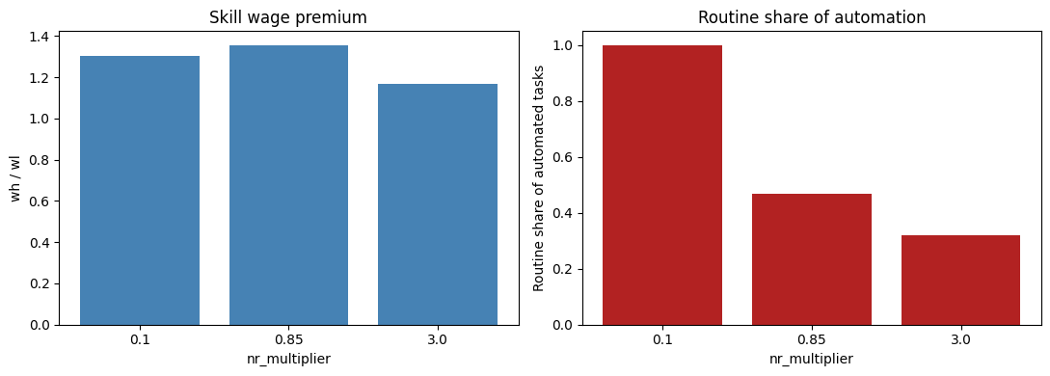
By nr_multiplier:
μ=0.1: premium = 1.306, routine_share = 1.000
μ=0.85: premium = 1.356, routine_share = 0.467
μ=3.0: premium = 1.169, routine_share = 0.319
PASS - Pattern 6

Synthesis
One summary table showing PASS/FAIL for each pattern, plus a one-liner of evidence.
rows = []
for k in sorted(VERDICTS.keys()):
name, expected, ok, evidence = VERDICTS[k]
rows.append([k, name, expected, 'PASS' if ok else 'FAIL', evidence])
table = pd.DataFrame(rows, columns=['#', 'Pattern', 'Expected', 'Result', 'Evidence'])
print('Validation summary')
print('=' * 80)
print(table.to_string(index=False))
n_pass = sum(1 for v in VERDICTS.values() if v[2])
print(f'\nOverall: {n_pass} / {len(VERDICTS)} patterns PASS '
f'(N_REPS={N_REPS}, N_STEPS={N_STEPS})')
Validation summary
================================================================================
# Pattern Expected Result Evidence
1 Profitability gate forced AC > p stops proactive automation PASS AC>p share=100%; profit<0 share=100%; gate blocks=20.0/step; new proactive auto=0
2 AI cost vs adoption cheap AI → more adoption PASS floor monotone: True, decay monotone: True
3 Severance vs adoption high severance → not more adoption PASS no-sev: 0.413, high-sev: 0.388
4 Demand decline forced unemployment lowers A and price PASS dL=109.9, dA=-99.607, dp=-83.582
5 Minimum wage vs adoption ρ > 0 PASS ρ=+0.97, p=0.0012
6 Polarisation low μ → wider premium OR more routine automati on PASS premium widens: True, routine share rises: True
Overall: 6 / 6 patterns PASS (N_REPS=12, N_STEPS=960)

