**University of Engineering & Management, Kolkata**

**Course: MCA**

**Semester: 2**

**Paper Name: OOP Laboratory**

**Paper Code: MCA295**

**Assignment No 1**

**Name:-Bedabrata Patra**

**Enrollment number:-12024006015070**

**Roll-14,Sec-B**

// Question-1

public class Main {  
 public static void main(String[] args) {  
 System.**out**.printf("HELLO JAVA");  
 }  
}

Output:-

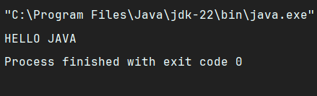

// Question-2

import java.sql.SQLOutput;  
public class Main{  
 public static void main(String[] args){  
 int n=5;  
 int m=6;  
 System.**out**.println(n+m);  
 }

}

Output:-

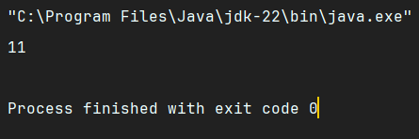

// Question-3  
  
public class Main{  
 public static void main(String[] args){  
 int n=5;  
 int mul=1;  
 for(int i=1;i<=n;i++){  
 mul=mul*i;  
 }  
 System.**out**.println(mul);  
 }  
}

Output:-

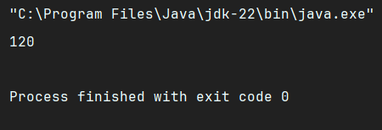

// Question-4  
  
import java.util.Scanner;  
public class Main{  
 public static void main(String[] args){  
 Scanner sc=new Scanner(System.**in**);  
 int num=sc.nextInt();  
 int i=1,result=1;  
 while(i<=num) {  
 result=i*result;  
 i++;  
 }  
 System.**out**.println(result);  
 }  
}

OUTPUT:-

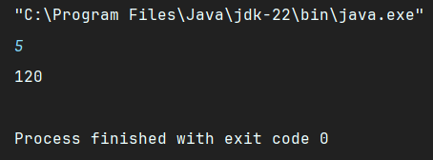

// Question-5  
  
import java.util.Scanner;  
public class Main{  
 public static int factorial(int n) {  
 if(n==0 || n==1)  
 return 1;  
 return n * factorial(n - 1);  
 }  
 public static void main(String[] args){  
 int num=5;  
 int result=factorial(num);  
 System.**out**.println(result);  
 }  
}

OUTPUT:-

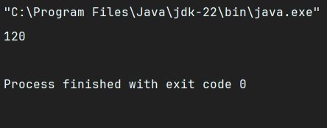

// Question-6  
  
import java.util.Scanner;  
public class Main{  
 public static int factorial(int n) {  
 if(n==0 || n==1)  
 return 1;  
 return n * factorial(n - 1);  
 }  
 public static void main(String[] args){  
 Scanner sc=new Scanner(System.**in**);  
 int num=sc.nextInt();  
 int result=factorial(num);  
 System.**out**.println(result);  
 }  
}

OUTPUT:-

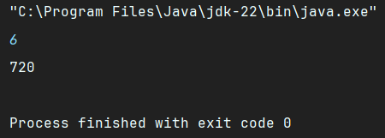

// Question-7  
  
import java.util.Scanner;  
public class Main{  
 public static int oddeven(int n) {  
 if(n%2==0)  
 return 1;  
 return 0;  
 }  
 public static void main(String[] args) {  
 Scanner sc = new Scanner(System.**in**);  
 int num = sc.nextInt();  
 int result = oddeven(num);  
 if (result == 1) {  
 System.**out**.println("The number is Even");  
 } else {  
 System.**out**.println("The number is Odd");  
 }  
 }  
}  
OUTPUT:-

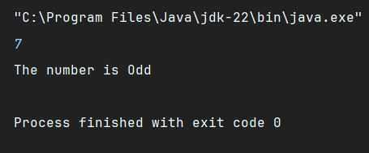

// Question-8

import java.util.Scanner;  
public class Main{  
 public static void Maxofthree(int x,int y,int z) {  
 if (x>y && y>z){  
 System.**out**.println("The maximum number is "+ x);  
 }  
 else if (y>x && x>z) {  
 System.**out**.println("The maximum number is "+ y);  
 }  
 else{  
 System.**out**.println("The maximum number is "+ z);  
 }  
 }  
 public static void main(String[] args) {  
 Scanner sc = new Scanner(System.**in**);  
 int num1 = sc.nextInt();  
 int num2= sc.nextInt();  
 int num3 = sc.nextInt();  
 Maxofthree(num1,num2,num3);  
 }  
}

OUTPUT:-

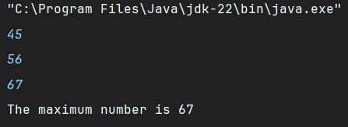

// Question-9

import java.sql.SQLOutput;  
import java.util.Scanner;  
public class Main{  
 public static void Swaping(int x,int y) {  
 int temp;  
 temp=y;  
 y=x;  
 x=temp;  
 System.**out**.println("After swaping the numbers we have x= "+x+",y= "+y);  
 }  
 public static void main(String[] args) {  
 Scanner sc = new Scanner(System.**in**);  
 System.**out**.println("Enter the value of x:");  
 int num1 = sc.nextInt();  
 System.**out**.println("Enter the value of y:");  
 int num2= sc.nextInt();  
 System.**out**.println("Before swaping the numbers we have x= "+num1+",y= "+num2);  
 Swaping(num1,num2);  
 }  
}

OUTPUT:-

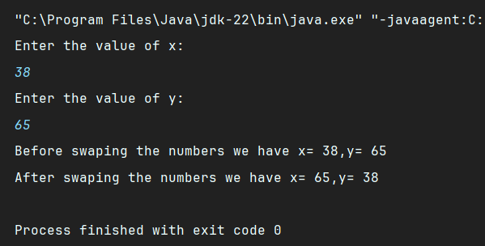

// Question-10

import java.sql.SQLOutput;  
import java.util.Scanner;  
public class Main{  
 public static void Leapyear(int n) {  
 System.**out**.println("The Year is " + n);  
 if ((n % 4 == 0 && n % 100 != 0) || (n % 400 == 0)) {  
 System.**out**.println("The year " + n + " is a leap year ");  
 }  
 else  
 {  
 System.**out**.println("The year "+n+" is not a leap year ");  
 }  
 }  
 public static void main(String[] args) {  
 Scanner sc = new Scanner(System.**in**);  
 int num = sc.nextInt();  
 Leapyear(num);  
 }  
}

OUTPUT:-

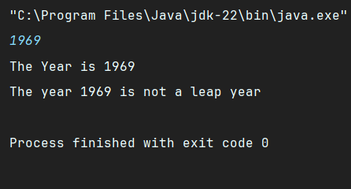

// Question-11

import java.sql.SQLOutput;  
import java.util.Scanner;  
public class Main{  
 public static void Grade(int m) {  
 System.**out**.println("The grade percentage of the student is " +m);  
 if(m>=90)  
 {  
 System.**out**.println("Grade A");  
 }  
 else if( m>=80 && m<=89)  
 {  
 System.**out**.println("Grade B");  
 }  
 else if( m>=70 && m<=79)  
 {  
 System.**out**.println("Grade C");  
 }  
 else if(m>=60 && m<=69)  
 {  
 System.**out**.println("Grade D");  
 }  
 else if(m>=40 && m<=59)  
 {  
 System.**out**.println("Grade E");  
 }  
 else if( m <40)  
 {  
 System.**out**.println("Grade F");  
 }  
 else  
 {  
 System.**out**.println("Not in range");  
 }  
 }  
 public static void main(String[] args) {  
 Scanner sc = new Scanner(System.**in**);  
 int num = sc.nextInt();  
 Grade(num);  
 }  
}

OUTPUT:-

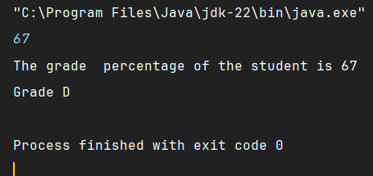

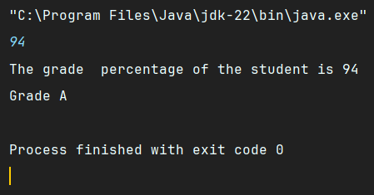

// Question-12

import java.sql.SQLOutput;  
import java.util.Scanner;  
public class Main {  
 public static void Divisibleby5(int n) {  
 if (n % 5 == 0) {  
 System.**out**.println("The number " + n + " is divisible by 5.");  
 } else {  
 System.**out**.println("The number " + n + " is not divisible by 5.");  
 }  
 }  
  
 public static void main(String[] args) {  
 Scanner sc = new Scanner(System.**in**);  
 System.**out**.println("Enter a number to check it's divisible by 5 or not:");  
 int num = sc.nextInt();  
 Divisibleby5(num);  
 }  
}

OUTPUT:-

