**How to Install WooCommerce Plugin?**

**Step 1:**

Login with your wordpress account.

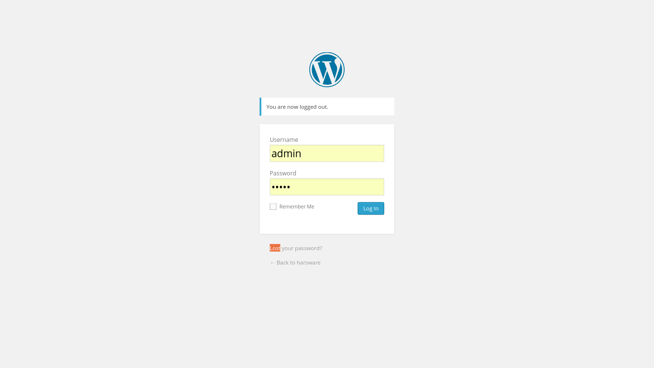

After successfully login, below screen will be shown.

**Step 2:**

Select **Add New button** under the Plugin option.

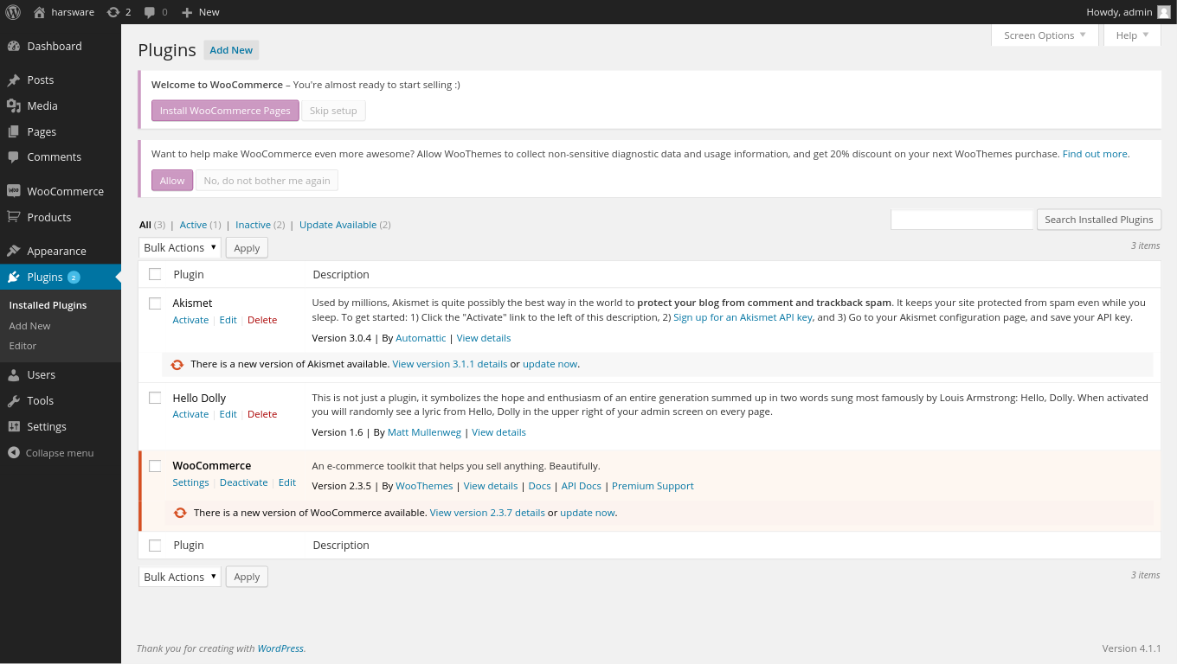

**Step 3:**

User can upload the ST Giftcard commerce plugin by select the upload plugin option.

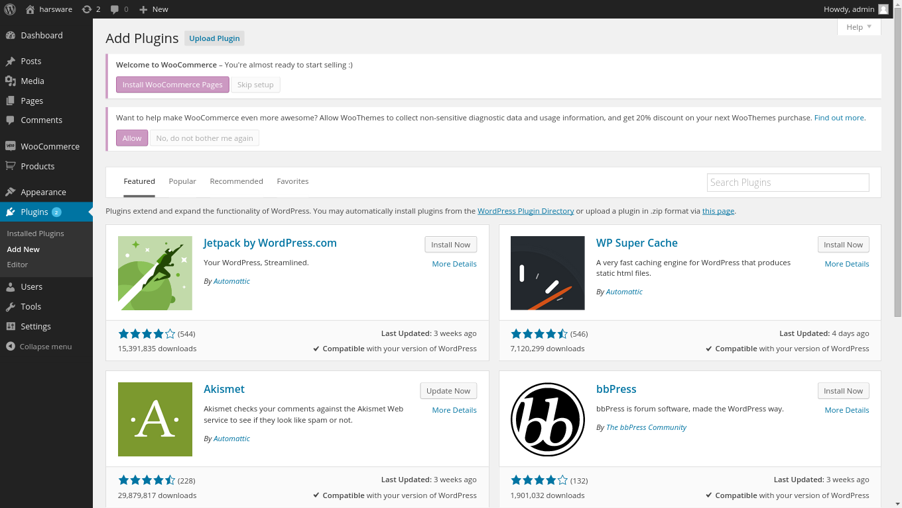

**Step 4:**

Select the ST-Giftcard-WooCommerce plugin (.zip file) and then click on the install now button.

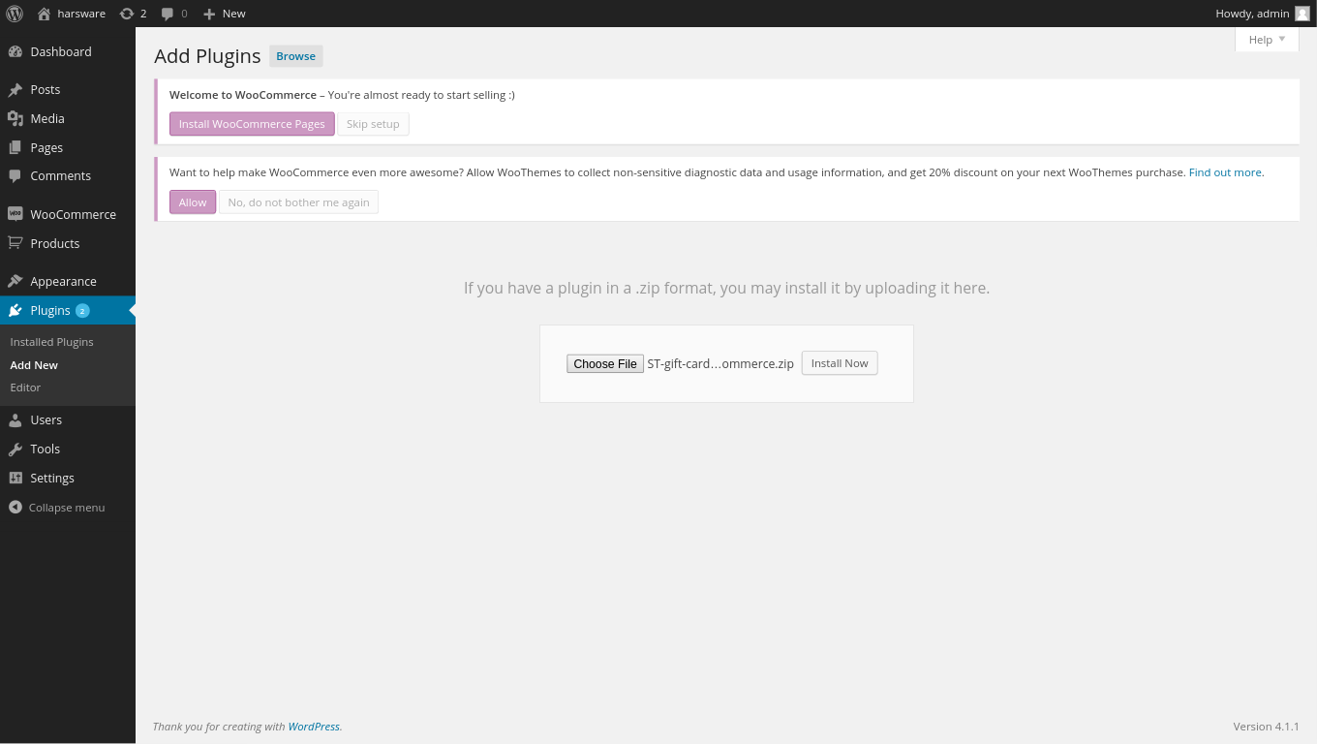

**Step 5:**

After installed the plugin successfully, user can activate it by selecting the **Activate Plugin** link.

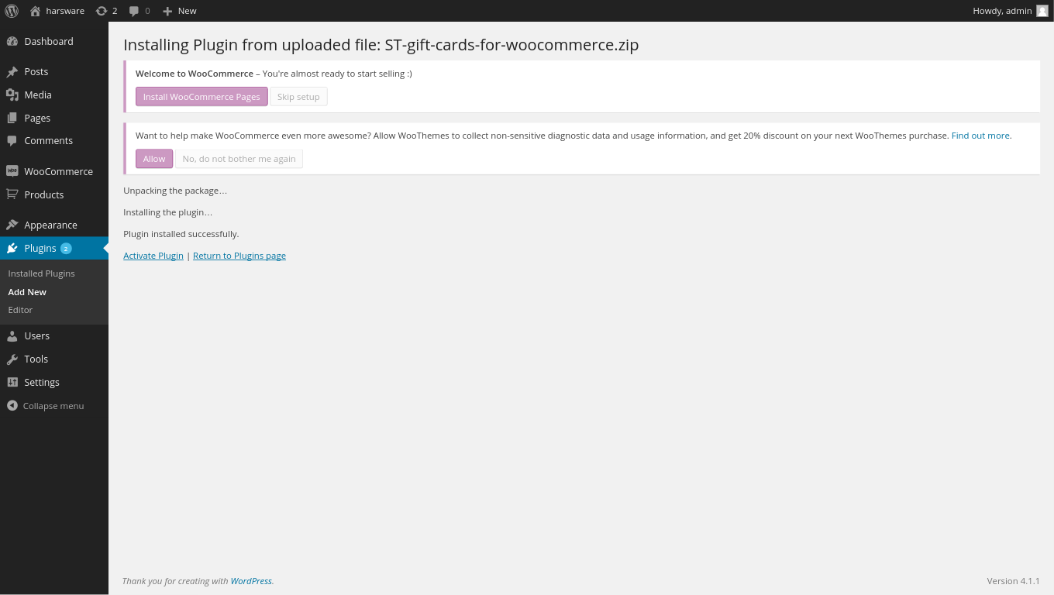

**Step 6:**

Select the **ST-Gift Cards** tab under the **Settings** option and save the Merchant and Terminal id by click on the Save changes button.

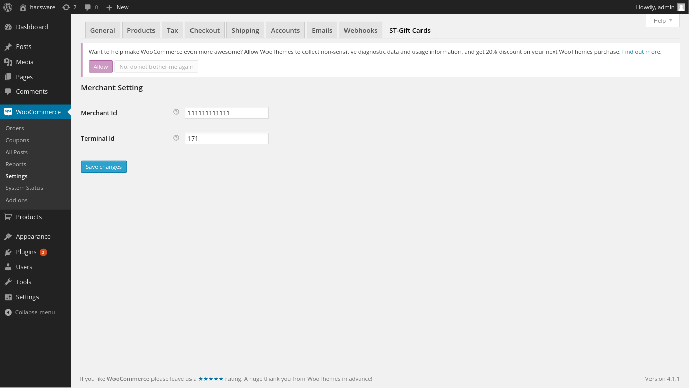

**Create order from website**

Testing url : http://apanishadi.com/elance/hardware/

**Step 1:** Add to cart

User can add the multiple products in there cart.

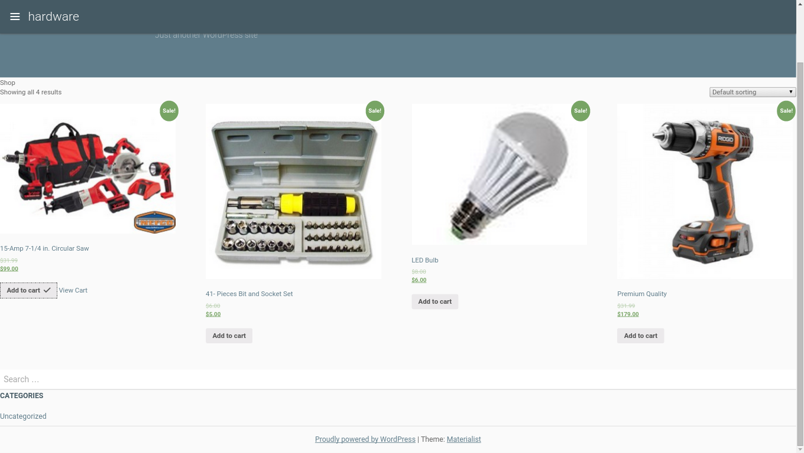

View cart

**Step 2**: View cart

User can update their cart and proceed for the check out.

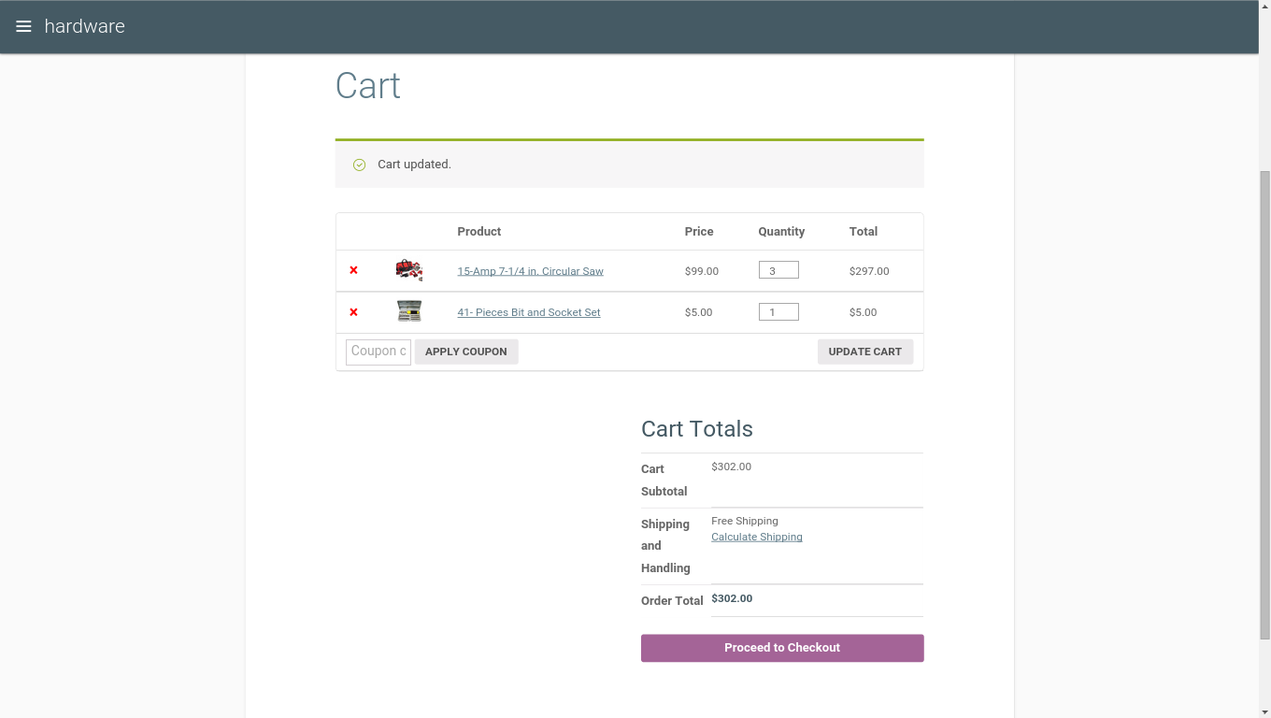

**Step 3**: Apply Giftcard no.

3.1) Make Payment by using single Giftcard: User can enter the Giftcard no. and click on **Apply Giftcard** button.

If there is insufficient balance in the gift card then user can pay the remaining balance by using another card no.

3.2) Make Payment by using multiple gift card: Select the “*click here to enter your gift card*” option again and enter the different gift card no.

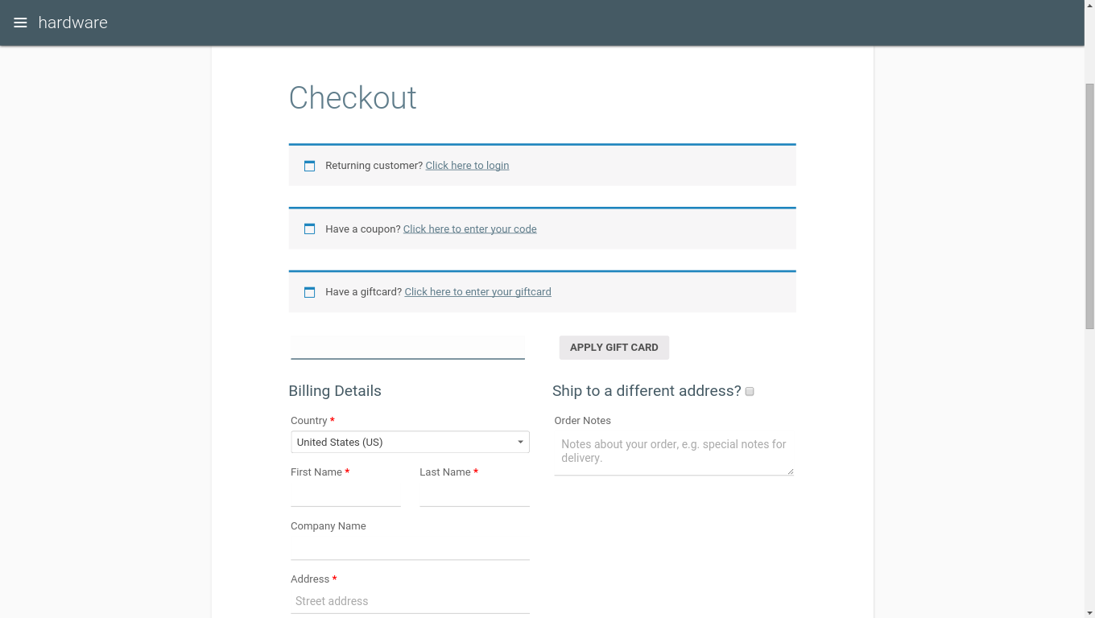

Fill up the billing details and click on **place order** button.

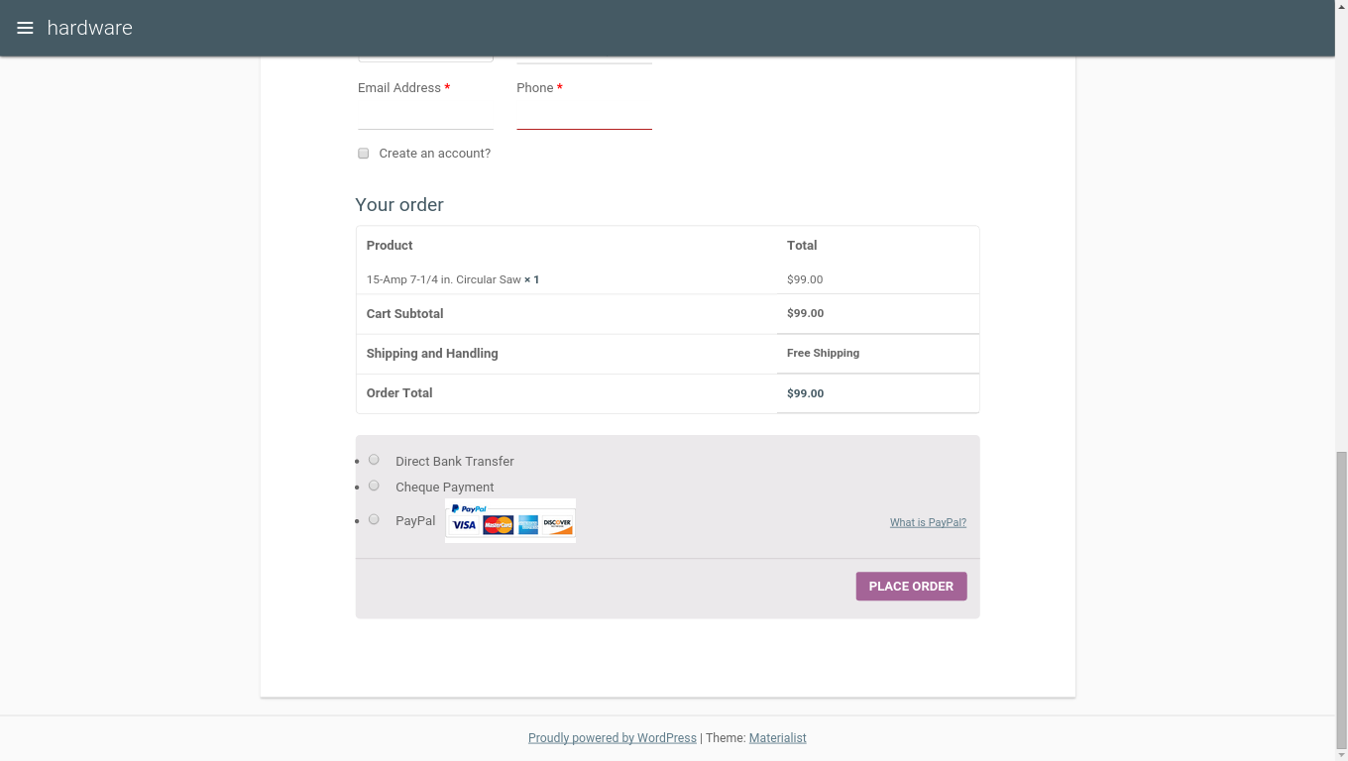

After Place the order successfully user will get the email with order details.

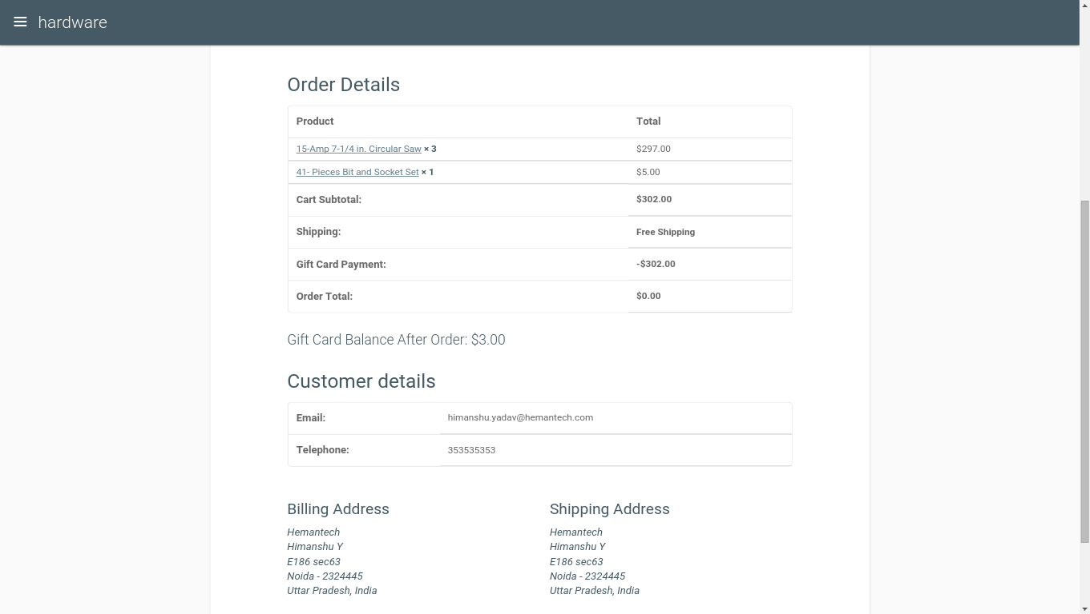

**Verify order status as a shop manager and refund option**

Testing url: http://apanishadi.com/elance/hardware/wp-admin/

Username: ray

Password: hk@123#

**Step 1:** After login, admin need to select WooCommerce and then select Orders under sub category.

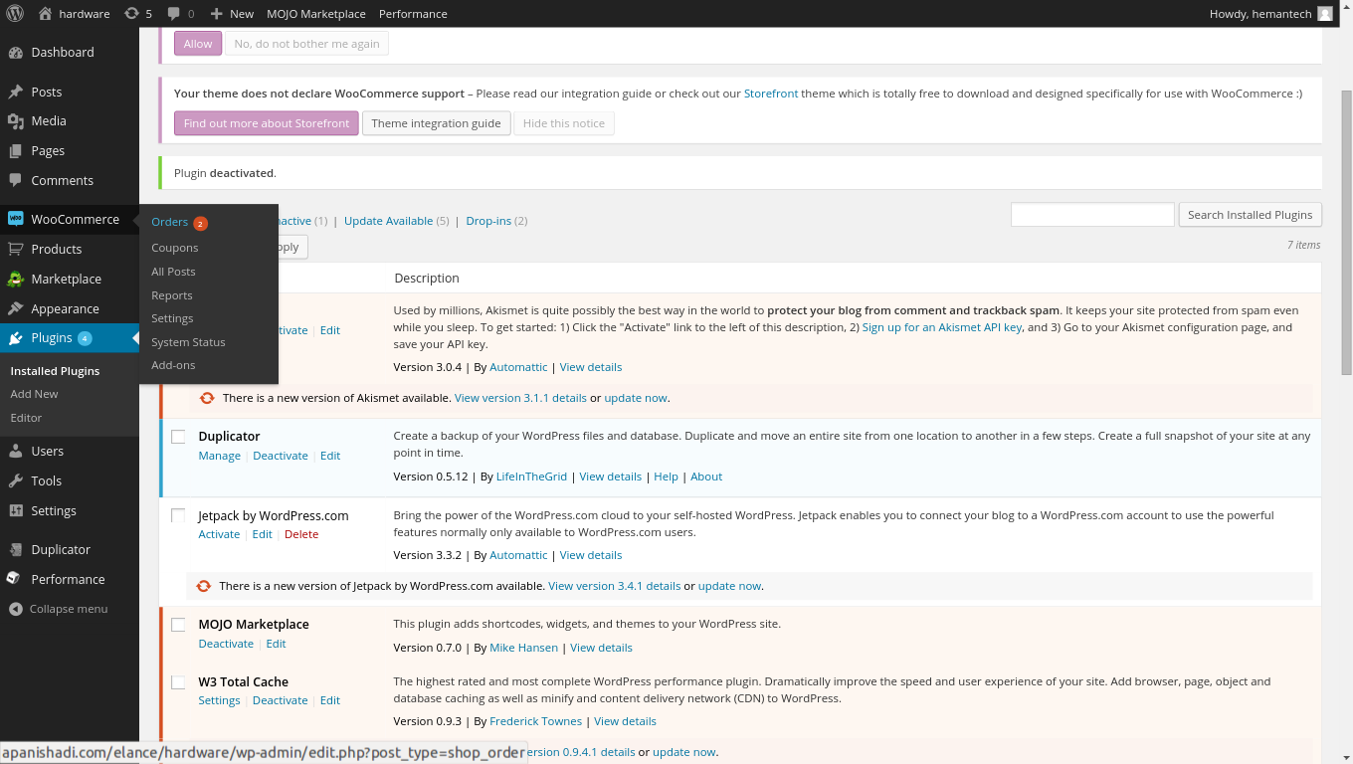

**Step 2:** As soon as admin selects Orders, the next screen will show the list of orders made. Every order has an option of Actions which contains on check box and one eye. Eye icon let admin view the details of the order.

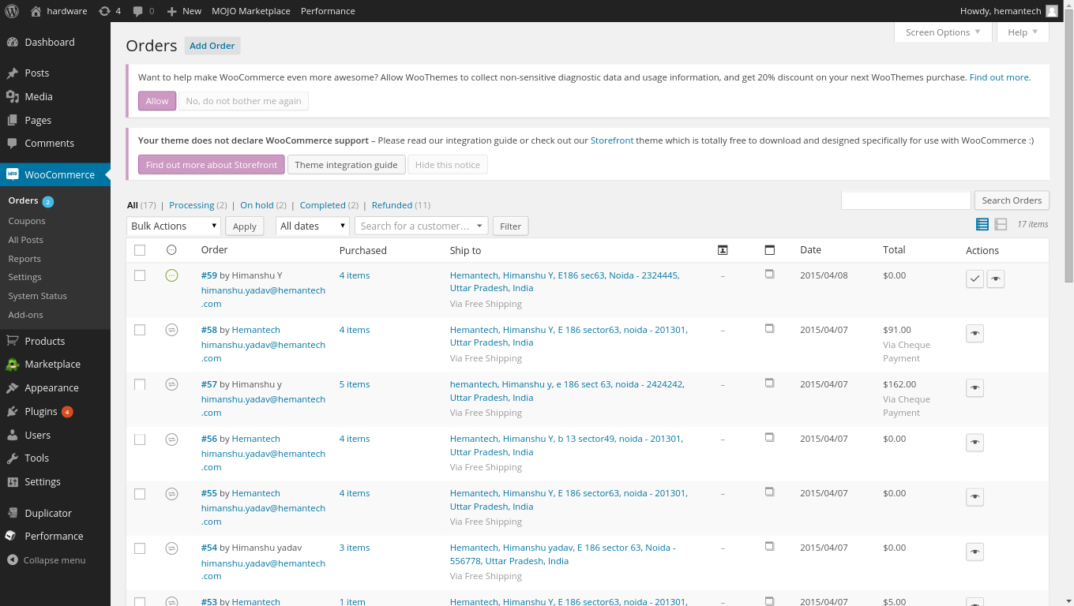

View order detail

**Step 3:** As soon as the view detail gets selected, a detailed page of that order will open. Under General details there is a drop down menu or Order Status. Admin need to select “Refund” option from drop down and click on Save Order.

As soon as the Refund is selected and saved, the refund will take place against the refund request.

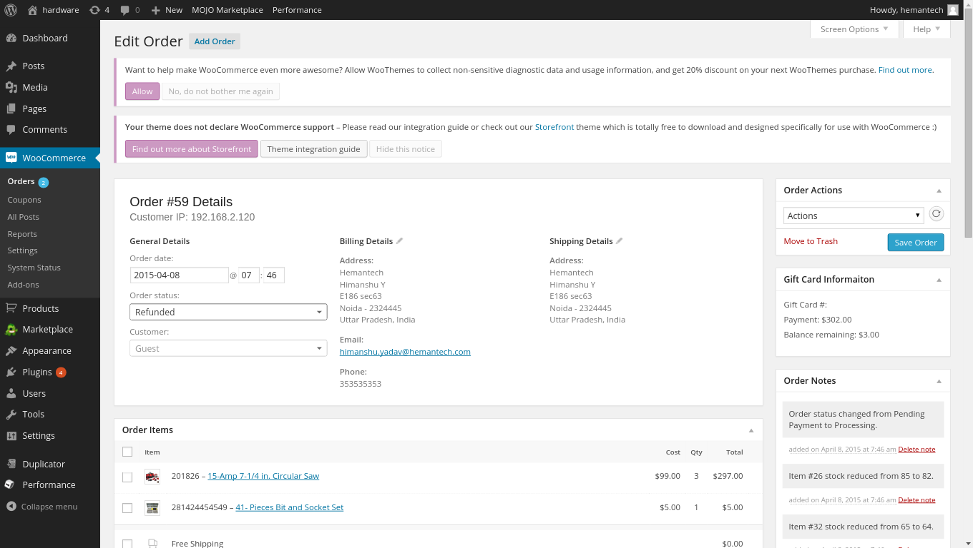

Change order status