1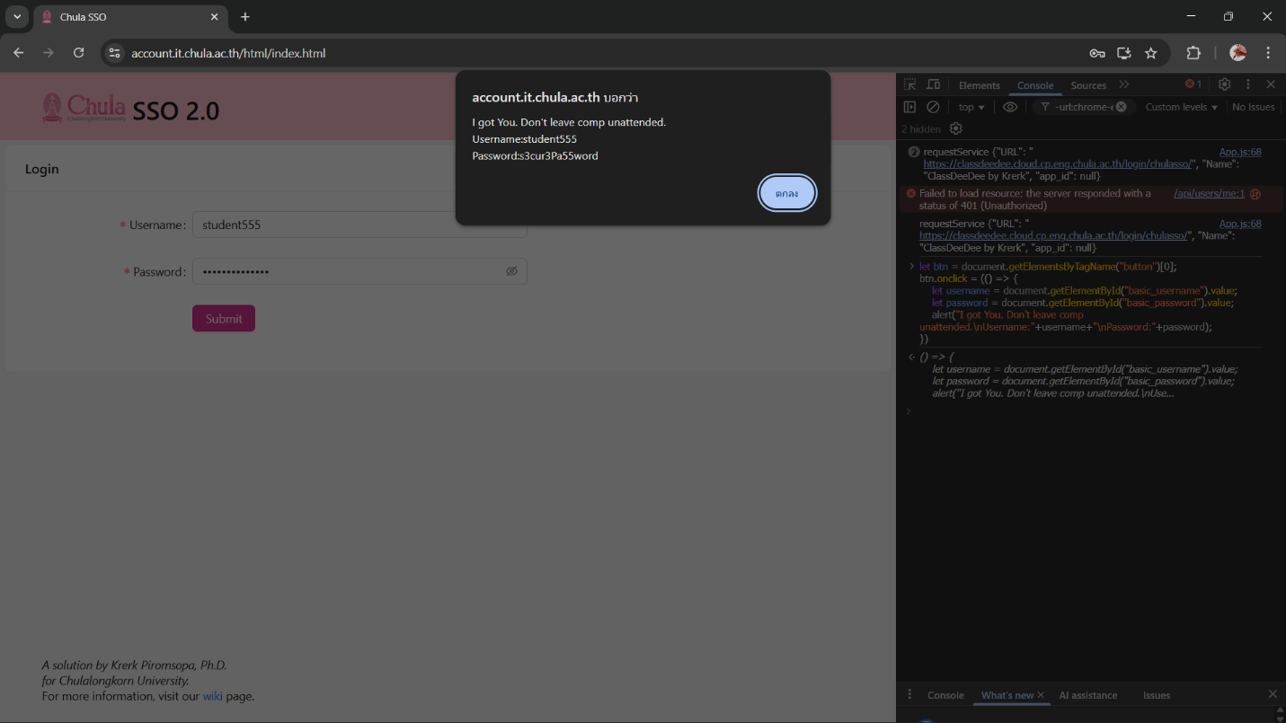

2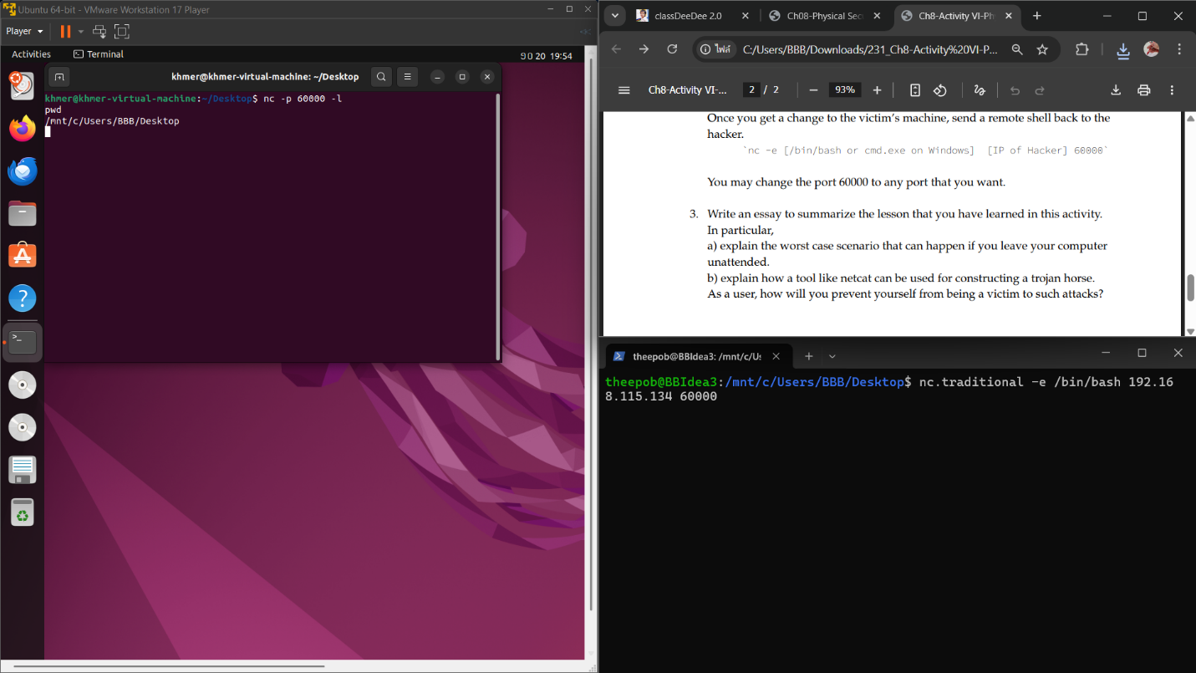

3. Write an essay to summarize the lesson that you have learned in this activity. In particular,

a) explain the worst case scenario that can happen if you leave your computer unattended.

ANS If you leave your computer unattended (even for a few minutes) an attacker with physical access can do many harmful things. They might inject JavaScript into your browser to steal login credentials, install malware or backdoors (for persistent remote control), clone storage devices to exfiltrate sensitive data, or deploy specialized malicious USB devices. One extreme example is a **USB killer**: an attacker could insert this device and permanently damage your computer’s motherboard or USB controllers by delivering high-voltage pulses. In the worst case, the attacker could either gain full remote control of your system and data or physically destroy the hardware, causing complete data loss and costly replacement.

b) explain how a tool like netcat can be used for constructing a trojan horse. As a user, how will you prevent yourself from being a victim to such attacks?

ANS As demonstrated in exercise 2, an attacker can take control of the machine and install any software they want, including a **trojan horse** that acts as a backdoor to regain access later.