1.brute force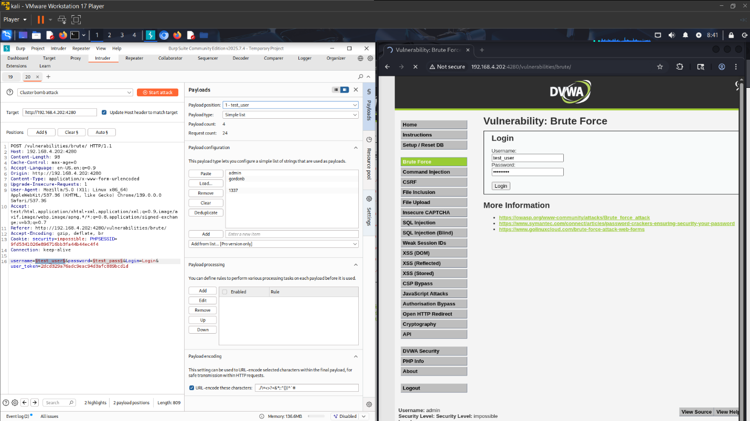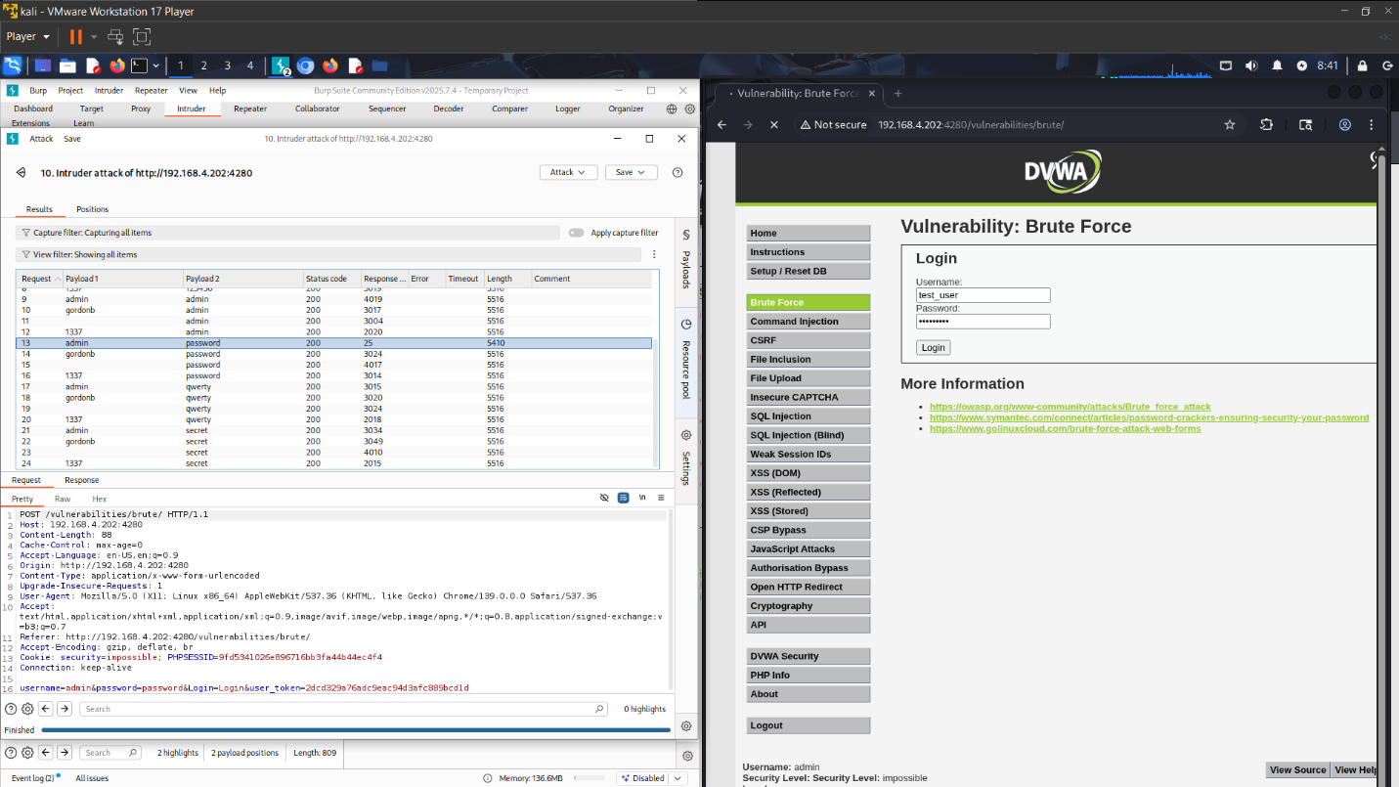

Risk Score: 12/12 (Critical)
- Exploitability: 3 (Easy) – There is no lock-out mechanism or CAPTCHA. An attacker can use automated tools (Hydra/Burp) without being blocked.
- Weakness Prevalence: 3 (Widespread) – Weak passwords are the most common security failure globally.
- Weakness Detectability: 3 (Easy) – High volumes of failed login attempts are easily seen in server logs.
- Technical Impacts: 3 (Severe) – Gaining admin access leads to full compromise of the account.
Mitigation Method:
- Account Lockout: Implement logic to lock the user account for 15 minutes after 3-5 consecutive failed login attempts.
- CAPTCHA: Integrate Google reCAPTCHA to ensure the login request is coming from a human, not a bot.

2. command Injection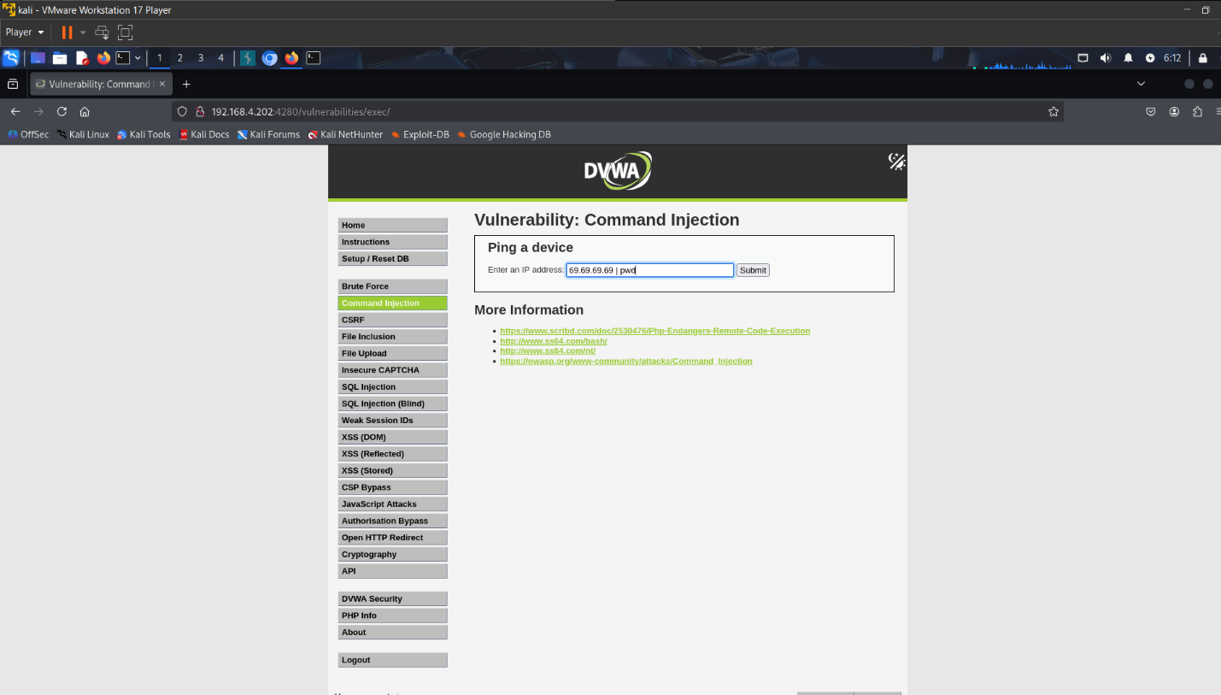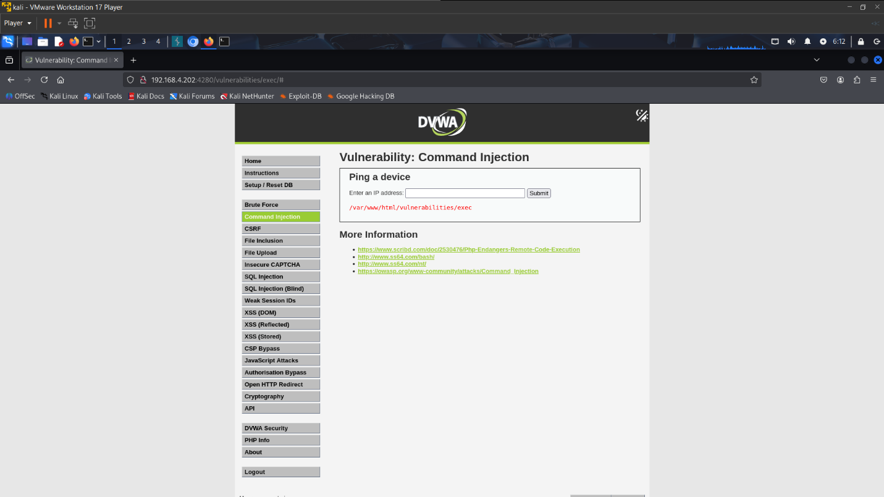

Risk Score: 11/12 (High)
- Exploitability: 3 (Easy) – You simply added a separator (|) to the input. No advanced coding was required.
- Weakness Prevalence: 2 (Common) – While dangerous, it is less common than XSS/SQLi in modern frameworks, but still appears in admin tools.
- Weakness Detectability: 3 (Easy) – Vulnerability scanners pick this up very quickly.
- Technical Impacts: 3 (Severe) – This allows Remote Code Execution (RCE). You can take over the entire server OS.
Mitigation Method:
- Avoid Shell Functions: Replace dangerous functions like shell_exec(), system(), or exec() with language-specific APIs. For example, instead of using ping via shell, use PHP's built-in networking functions.
- Input Validation: Implement strict validation logic to verify that the user input strictly matches the format of an IPv4 address.

3.File Upload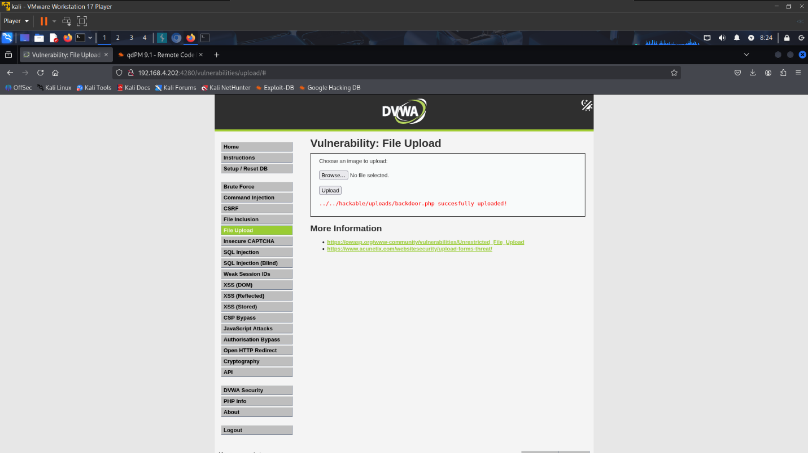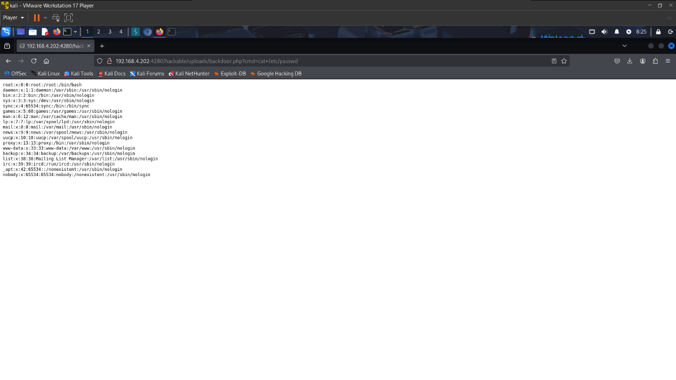

Risk Score: 10/12 (High)
- Exploitability: 3 (Easy) – The system accepted a .php file without checking the extension or content type.
- Weakness Prevalence: 2 (Common) – Many applications fail to properly validate file uploads.
- Weakness Detectability: 2 (Average) – Sometimes difficult to detect if the upload path is hidden, but standard scanners usually find it.
- Technical Impacts: 3 (Severe) – Uploading a web shell (backdoor.php) leads to full server compromise.
Mitigation Method:
- Extension Whitelisting: Only allow specific, safe file extensions (e.g., .jpg, .png, .pdf). Reject everything else.
- Content Verification: Check the file's MIME type and Magic Bytes to ensure the content matches the extension (e.g., checking if a file claiming to be an image is actually an image).

4. SQL injection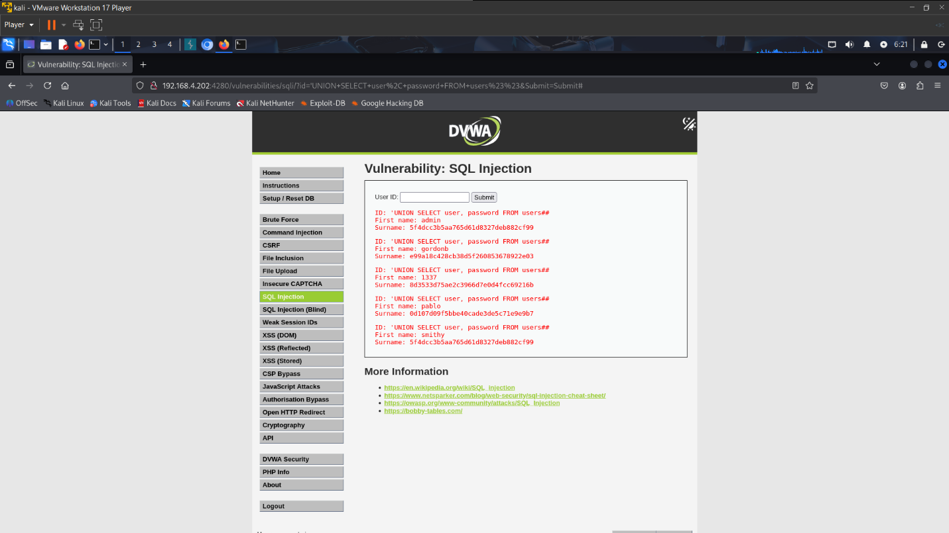
Risk Score: 12/12 (Critical)
- Exploitability: 3 (Easy) – The application returns verbose error messages and data immediately. No guessing is required.
- Weakness Prevalence: 3 (Widespread) – One of the most common web vulnerabilities historically.
- Weakness Detectability: 3 (Easy) – Trivial to find; just typing a single quote ' breaks the page.
- Technical Impacts: 3 (Severe) – Allows dumping the entire database (passwords, emails, etc.).
Mitigation Method:
- Prepared Statements:
  - Separate Code from Data
  - Bind Parameters

5.SQL injection(blind)
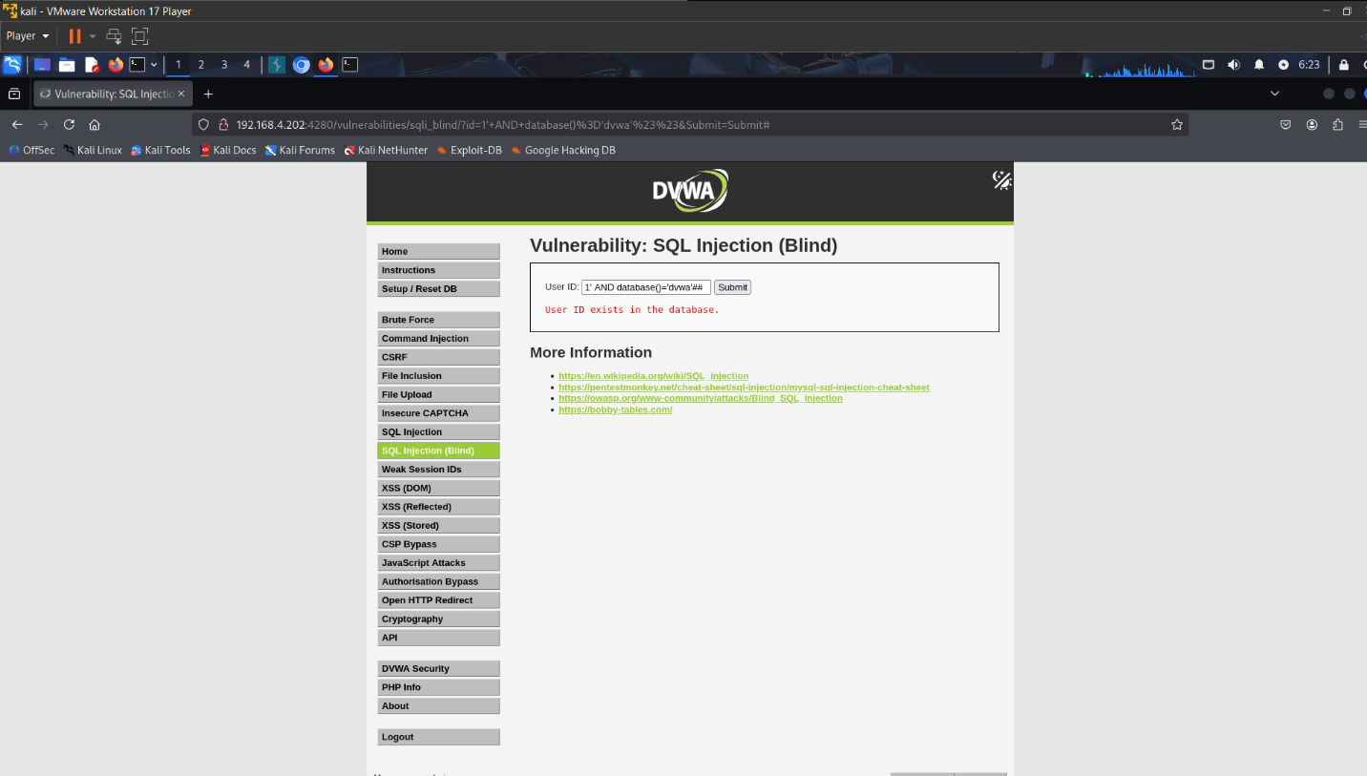
Risk Score: 9/12 (High)
- Exploitability: 2 (Average) – Harder than standard SQLi. You cannot see the data directly; you must ask True/False questions or use tools like SQLMap.
- Weakness Prevalence: 2 (Common) – Very common in backend queries that don't display output.
- Weakness Detectability: 2 (Average) – Harder to detect because it doesn't throw visible error messages. Scanners take longer to find it.
- Technical Impacts: 3 (Severe) – An attacker can still steal the entire database. it just takes more time.
Mitigation Method:
- Prepared Statements:
  - Separate Code from Data
  - Bind Parameters
6. XSS(DOM)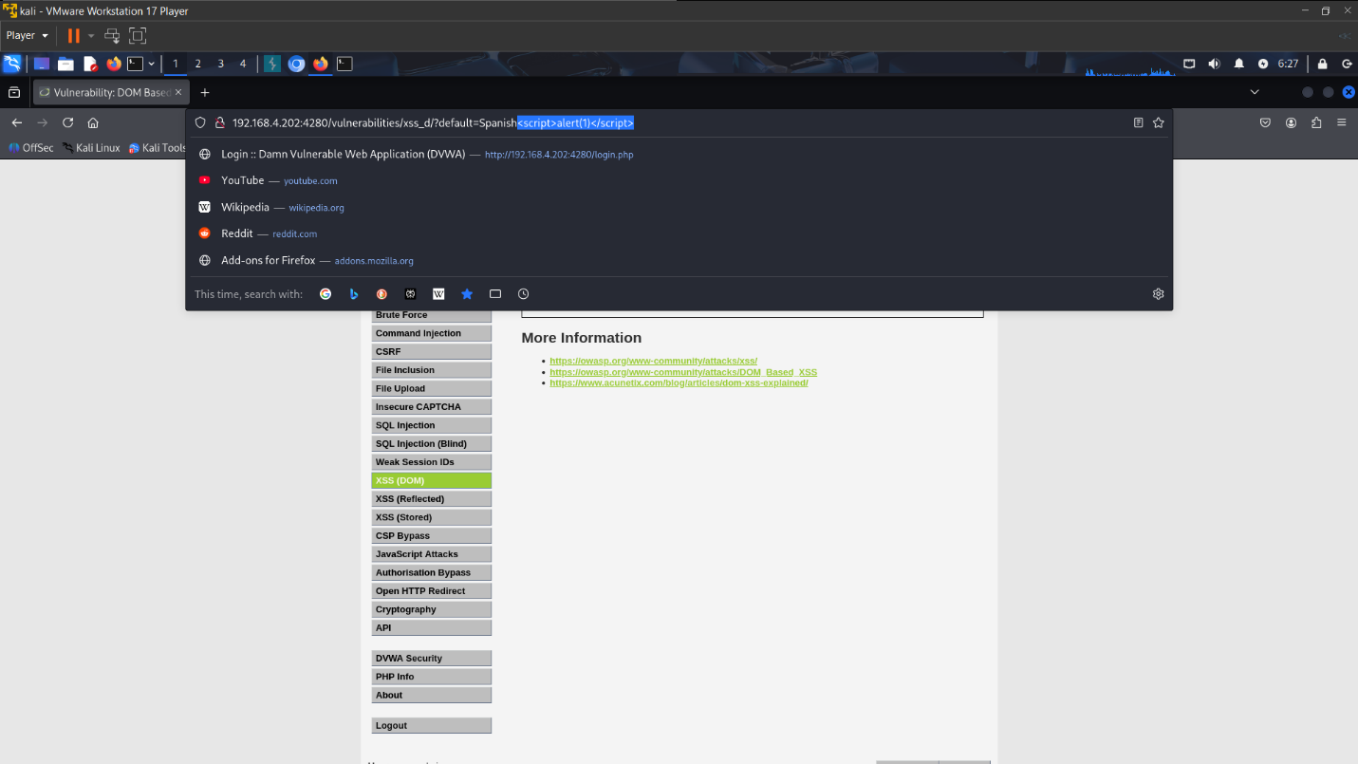 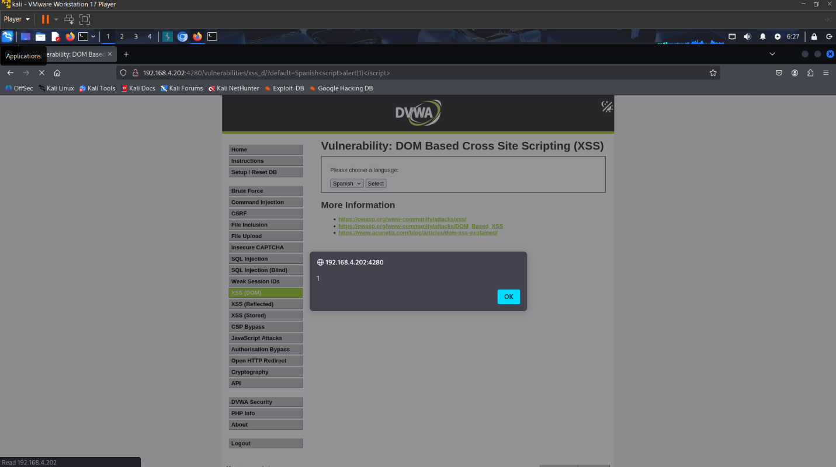

Risk Score: 8/12 (Medium)
- Exploitability: 2 (Average) – Requires social engineering. You must trick a user into clicking a specific link. It is harder to exploit than Stored XSS.
- Weakness Prevalence: 2 (Common) – Very common in Single Page Applications (SPAs) relying heavily on JavaScript.
- Weakness Detectability: 2 (Average) – Server-side scanners often miss this because the vulnerability exists securely in the browser (client-side), not the server logs.
- Technical Impacts: 2 (Moderate) – Can steal session cookies, but affects only the specific user who clicks the link.
Mitigation Method:
- Use Safe Sinks: Avoid using dangerous methods like document.write() or innerHTML which parse HTML. Instead, use safe alternatives like document.textContent or element.innerText.
- Context-Sensitive Encoding: If you must write HTML, use a library like DOMPurify to sanitize untrusted data before inserting it into the DOM.

7. XSS(Reflected)
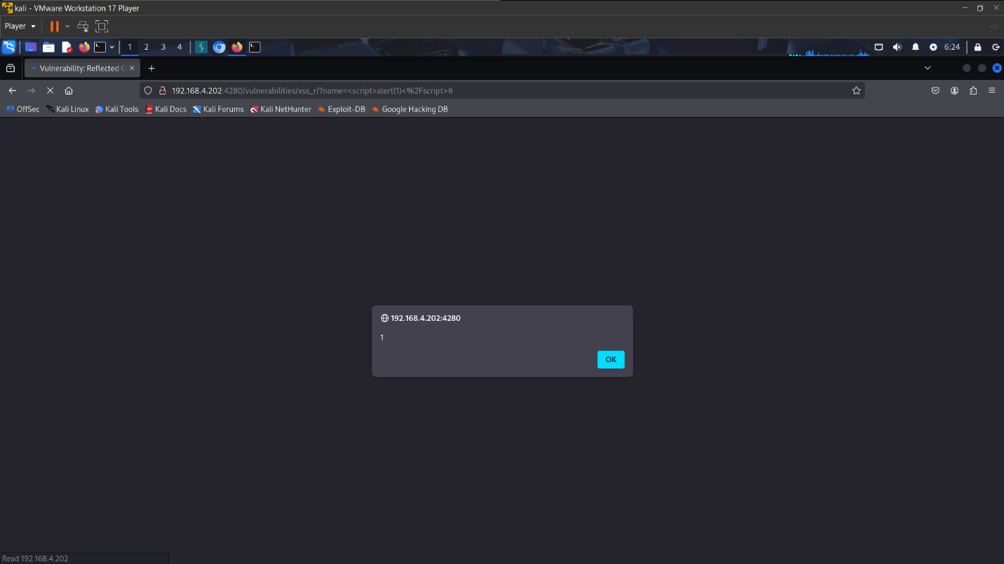
Risk Score: 10/12 (Medium-High)
- Exploitability: 2 (Average) – Similar to DOM, it requires tricking a user into clicking a malicious link.
- Weakness Prevalence: 3 (Widespread) – Extremely common in older applications and search fields.
- Weakness Detectability: 3 (Easy) – Automated scanners find reflected inputs very easily.
- Technical Impacts: 2 (Moderate) – Account hijacking via cookie theft.
Mitigation Method:
- Output Encoding: converts <script> into &lt;script&gt;, which displays as text but does not execute.

8. XSS(Stored)
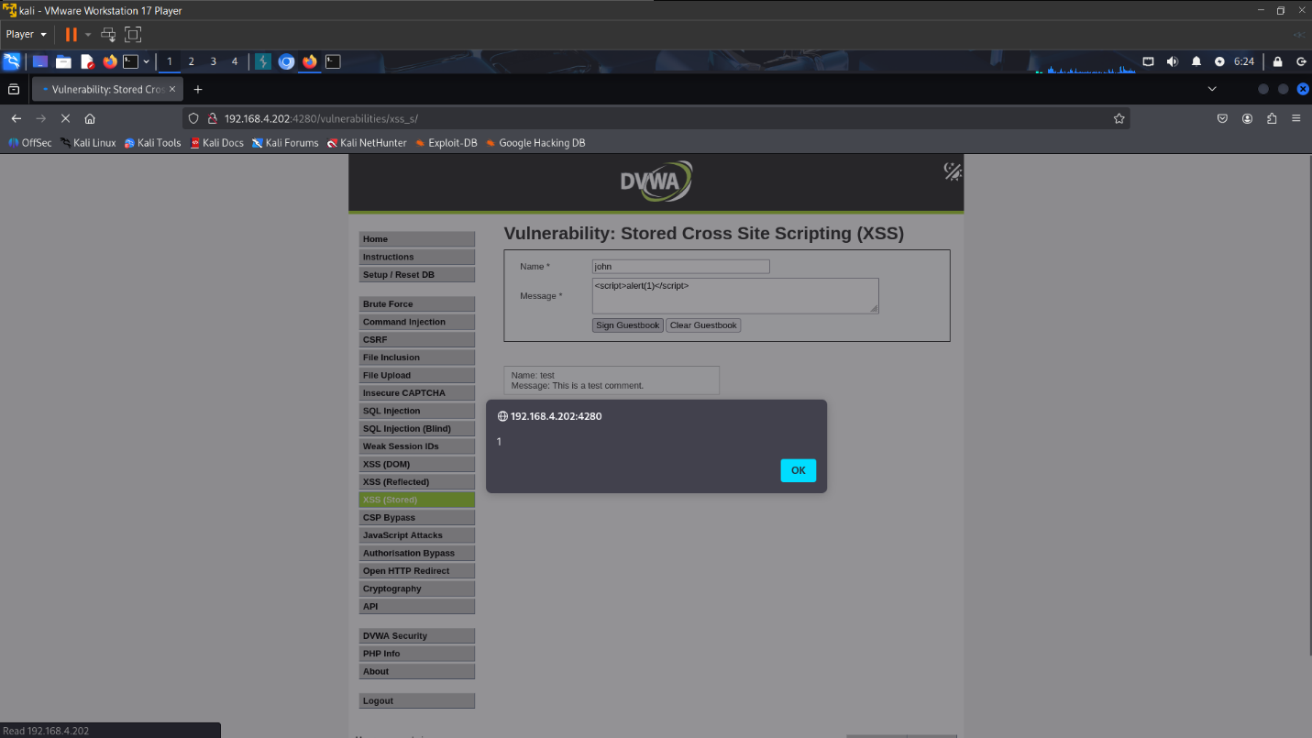
Risk Score: 10/12 (High)
- Exploitability: 3 (Easy) – You just post a comment. You do not need to trick anyone into clicking a link; the trap is "waiting" on the page.
- Weakness Prevalence: 2 (Common) – Common in forums, comment sections, and guestbooks.
- Weakness Detectability: 2 (Average) – Harder to automate because a scanner must post data and then check if it executes elsewhere.
- Technical Impacts: 3 (Severe) – This is the most dangerous XSS. It can infect everyone who views the page, including the Administrator.
Mitigation Method:
- Output Encoding: converts <script> into &lt;script&gt;, which displays as text but does not execute.

