Shading map
Before | After (fixed)
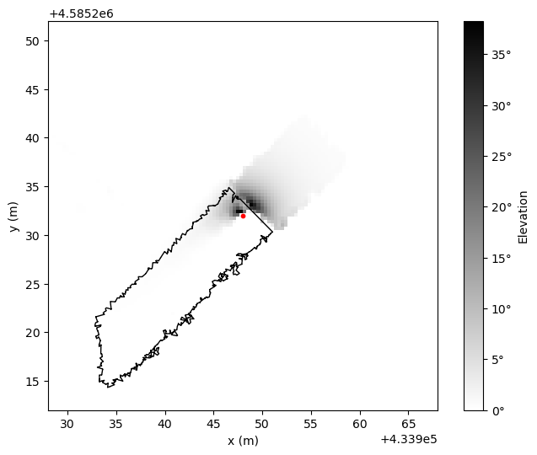 | 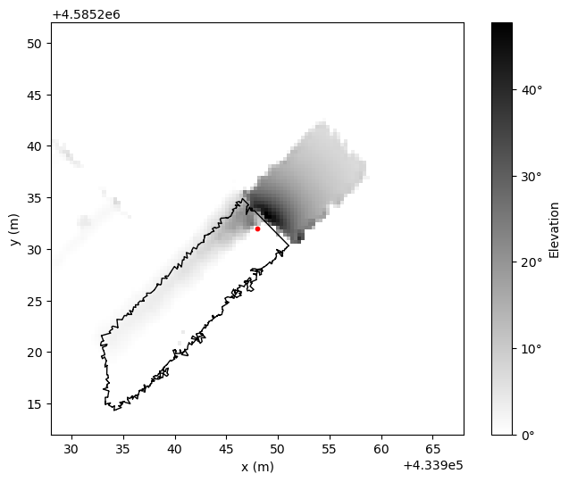

Shading profile:
- Before
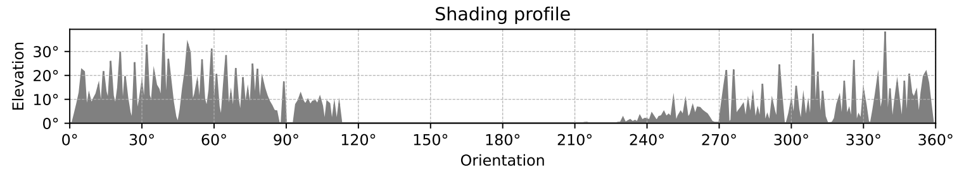

- After (fixed)
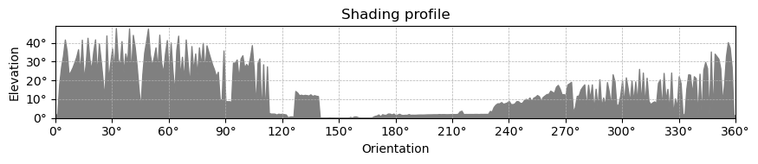

- Max pooling 3degree
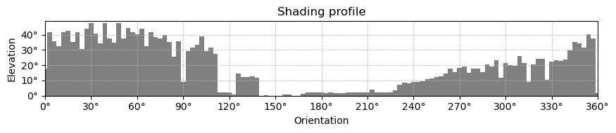

- Hyper resolution:
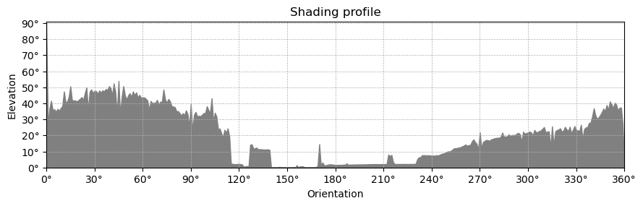

Error (fixed): m’havia deixat l’arrel quadrada en el càlcul de l’altura
