

Mestrado Integrado em Engenharia Informática e Computação

Rome2Rio

Formal Methods in Software Engineering

Turma 3
Ana Denisa Secuiu - up201803342
Ana Margarida Silva - up201505505
Danny Soares - up201505509
07/01/2019

Contents
1.Informal system description and list of requirements
1.1. Informal system description

The system we developed is a multimodal transport search engine.
A user can input a starting point and a destination city and the system will try to build the best path according to the user's preference regarding price, distance and duration of the trip. Users can also specify what means of transportation they want (e.g. Bus, Train, etc).

1.2. List of requirements

ID | Priority | Description
R1 | Mandatory | The administrator can populate the system's database with information.
R2 | Mandatory | The user can search for the path with the shortest distance between two cities.
R3 | Mandatory | The user can search for the path with the lowest price between two cities.
R4 | Mandatory | The user can search for the path with the shortest duration between two cities.
R5 | Mandatory | The user can search for paths with the means of transportation that he wants.
R6 | Mandatory | The user can search for paths without specifying any means of transportation.
R7 | Optional | The user can buy tickets for the path returned by the search engine.

2 Visual UML Model
2.1 Use Case Model

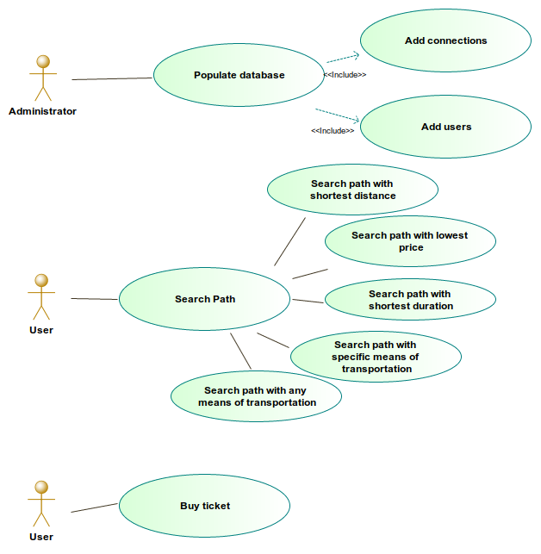

The major use case scenarios are three, the administrator populating the database, the user searching for paths and the user buying tickets for trips. The search case can be split into multiple cases, since the user can search for trips in multiple ways. The search engine accepts searches with or without specification of means of transportation, and accepts searches with one of three factors: shortest distance, lowest price or shortest duration. This cases are described in the following tables.

Scenario | Populate database (connections) (R1)
Description | The administrator can add connections to the transport graph.
Pre conditions | The new connection must have a distance greater that 0 and a timetable filled.
Post conditions | A connection is created with distance and duration greater than 0, price greater or equal to 0 and the timetable filled.
Scenario | Populate database (users) (R1)
Description | The administrator can add users to the database.
Pre conditions | The new user must have an ID and a cash amount greater or equal than 0 and a password between 0000 and 9999.
Post conditions | (unspecified)

Scenario | Search path with shortest distance (R2)
Description | The user searches for a path between two cities, specifying the weight factor to be the distance.
Pre conditions | The weight factor must be set to 1
Post conditions | The maximum duration of the trip is lower than 0 (no maximum specified by the user) or below the maximum duration specified by the user.

Scenario | Search path with lowest price (R3)
Description | The user searches for a path between two cities, specifying the weight factor to be the price.
Pre conditions | The weight factor must be set to 2
Post conditions | The maximum duration of the trip is lower than 0 (no maximum specified by the user) or below the maximum duration specified by the user.

Scenario | Search path with shortest duration (R4)
Description | The user searches for a path between two cities, specifying the weight factor to be the trip’s duration.
Pre conditions | The weight factor must be set to 3
Post conditions | The maximum duration of the trip is lower than 0 (no maximum specified by the user) or below the maximum duration specified by the user.

Scenario | Search path with the means of transportation (R5)
Description | The user searches for a path between two cities, specifying the means of transportation he wants to take.
Pre conditions | The weight factor must be between 1 and 3 (inclusive)
Post conditions | The maximum duration of the trip is lower than 0 (no maximum specified by the user) or below the maximum duration specified by the user.

Scenario | Search path with shortest distance (R6)
Description | The user searches for a path between two cities, without specifying the means of transportation he wants to take.
Pre conditions | The weight factor must be between 1 and 3 (inclusive)
Post conditions | The maximum duration of the trip is lower than 0 (no maximum specified by the user) or below the maximum duration specified by the user.

Scenario | Buy tickets for a trip (R7)
Description | The user buys one or more tickets for the trip returned by the search engine.
Pre conditions | The user needs to be on the database and have enough money to complete the transaction. The trip’s price must be greater or equal to 0 and the trip’s empty seats must be greater or equal to 1.
Post conditions | (unspecified)

2.2 Class Diagram

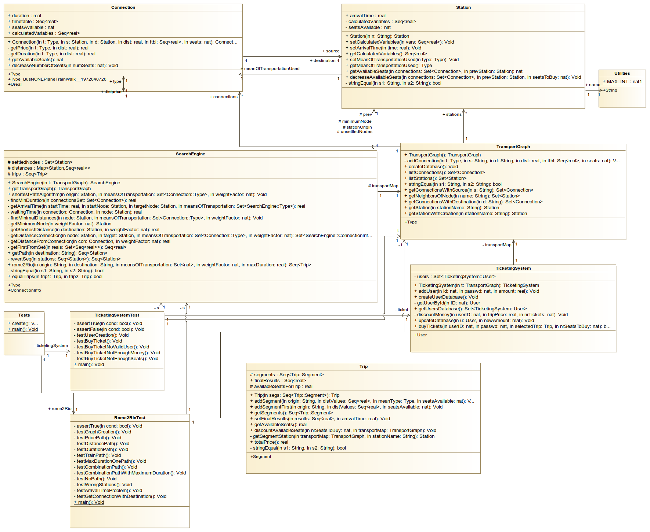
2.2.1. Classes
Class | Description
SearchEngine | Core model; defines the variables and operations available for users. One user can choose to get the best path to get from source to destination on the following criteria: price, duration and distance.
Connection | Defines a connection between a source Station and a destination Station, keeping data regarding the mean of transportation, distance and the timetable available in that connection. It also contains methods to compute the price and duration of each connection depending of the corresponding mean of transportation.
TransportGraph | Defines the transportation graph, the abstraction of a map containing all the available connections between cities, each connection having information regarding the distance, the means of transportation available and the timetables. Furthermore, this class contains methods to get connections with specific particularities.
Trip | Defines the path to follow from a source to a destination as a succession of segments, with information regarding time duration, distance, price and means of transportation.
Station | Defines a station with name, arrival time in the station, the distance, price and duration of the trip up to that station and the mean of transportation used.
TicketingSystem | Defines the ticketing system, managing the user database and the transactions from users buying tickets for trips.
Utilities | Defines general types and constants used in the model.

2.2.2. Test classes
Class | Description
Tests | Creates and runs all the tests from Rome2RioTest and TicketingSystemTest classes.
Rome2RioTest | Defines the usage scenarios and test cases for the Rome2Rio search engine.
TicketingSystemTest | Defines the usage scenarios and test cases for the ticketing system.

3 Formal VDM++ Model
3.1 Connection
3.2 SearchEngine
3.3 Station
3.4 TransportGraph
3.5 Trip
3.6 Utilities

4. Model Validation
4.1. Class Tests
class Tests
/*
Class that creates and runs all the tests from Rome2RioTest and TicketingSystemTest classes.
*/
instance variables
public rome2Rio : Rome2RioTest := new Rome2RioTest();
ticketingSystem : TicketingSystemTest := new TicketingSystemTest();
operations

-- Calls the entry points of Rome2RioTest and TicketingSystemTest classes
public create: () ==> ()
create() == (
rome2Rio.main();
ticketingSystem.main();
);

-- Entry point that runs all tests
public static main: () ==> ()
main() == (
new Tests().create();
);

end Tests

4.2. Class Rome2RioTest
class Rome2RioTest

instance variables
t : TransportGraph := new TransportGraph();
s : SearchEngine := new SearchEngine(t);
operations
-- Simulates assertion checking by reducing it to pre-condition checking.
-- If 'cond' does not hold, a pre-condition violation will be signaled.
private assertTrue: bool ==> ()
assertTrue(cond) == return
pre cond;

-- Simulates the creation of connections and their insertion on the database.
-- Related to requirement R1
private testGraphCreation: () ==> ()
testGraphCreation() == (
assertTrue(card s.getTransportGraph().listConnections() > 0);
);

-- Simulates the search of a path with the lowest price.
-- Related to requirement R3
private testPricePath: () ==> ()
testPricePath() == (
dcl answer : seq of Trip := s.rome2Rio(['P','o','r','t','o'], ['M','a','d','r','i','d'], {1,2}, 2, -1);
dcl segments : seq of Trip`Segment := answer(1).getSegments();
dcl price : real := segments(3).price;

assertTrue(price = 57);
assertTrue(len segments = 3);
assertTrue(segments(1).startCity = ['P','o','r','t','o']);
assertTrue(segments(2).startCity = ['L','i','s','b','o','n']);
assertTrue(segments(3).startCity = ['M','a','d','r','i','d']);
);

-- Simulates the search of a path with the shortest distance.
-- Related to requirement R2
private testDistancePath: () ==> ()
testDistancePath() == (
dcl answer : seq of Trip := s.rome2Rio(['P','o','r','t','o'], ['M','a','d','r','i','d'], {1,2}, 1, -1);
dcl segments : seq of Trip`Segment := answer(1).getSegments();
dcl distance : real := segments(3).distance;

assertTrue(distance = 950);
assertTrue(len segments = 3);
assertTrue(segments(1).startCity = ['P','o','r','t','o']);
assertTrue(segments(2).startCity = ['L','i','s','b','o','n']);
assertTrue(segments(3).startCity = ['M','a','d','r','i','d']);
);

-- Simulates the search of a path with the shortest duration.
-- Related to requirement R4
private testDurationPath: () ==> ()
testDurationPath() == (
dcl answer : seq of Trip := s.rome2Rio(['P','o','r','t','o'], ['M','a','d','r','i','d'], {1,2}, 3, -1);
dcl segments : seq of Trip`Segment := answer(1).getSegments();
dcl duration : real := segments(3).timeDuration;

assertTrue(duration = 1.25);
assertTrue(len segments = 3);
assertTrue(segments(1).startCity = ['P','o','r','t','o']);
assertTrue(segments(2).startCity = ['L','i','s','b','o','n']);
assertTrue(segments(3).startCity = ['M','a','d','r','i','d']);
);

-- Simulates the search of a path with a specific means of transportation.
-- Related to requirement R5
private testTrainPath: () ==> ()
testTrainPath() == (
dcl answer : seq of Trip := s.rome2Rio(['P','o','r','t','o'], ['M','a','d','r','i','d'], {3}, 3, -1);
dcl segments : seq of Trip`Segment := answer(1).getSegments();
dcl duration : real := segments(2).timeDuration;

assertTrue(duration = 1);
assertTrue(len segments = 2);
assertTrue(segments(1).startCity = ['P','o','r','t','o']);
assertTrue(segments(2).startCity = ['M','a','d','r','i','d']);
);

-- Simulates the search of a path with a maximum trip duration, with means of transportation.
-- Related to requirements R2,R3,R4,R5
private testMaxDurationOnePath: () ==> ()
testMaxDurationOnePath() == (
dcl answer : seq of Trip := s.rome2Rio(['P','o','r','t','o'], ['M','a','d','r','i','d'], {1,2}, 3, 1);
assertTrue(answer = []);
);

-- Simulates the search of a path with no specific means of transportation.
-- Related to requirement R6
private testCombinationPath: () ==> ()
testCombinationPath() == (
dcl answer : seq of Trip := s.rome2Rio(['P','o','r','t','o'], ['M','a','d','r','i','d'], {}, 3, -1);
dcl segments1 : seq of Trip`Segment := answer(1).getSegments();
dcl segments2 : seq of Trip`Segment := answer(2).getSegments();
dcl segments3 : seq of Trip`Segment := answer(3).getSegments();

assertTrue(segments1(1).startCity = ['P','o','r','t','o']);
assertTrue(segments1(2).startCity = ['M','a','d','r','i','d']);
assertTrue(segments1(2).timeDuration = 1);

assertTrue(segments2(1).startCity = ['P','o','r','t','o']);
assertTrue(segments2(2).startCity = ['L','i','s','b','o','n']);
assertTrue(segments2(3).startCity = ['M','a','d','r','i','d']);
assertTrue(segments2(3).timeDuration = 1.25);

assertTrue(segments3(1).startCity = ['P','o','r','t','o']);
assertTrue(segments3(2).startCity = ['L','i','s','b','o','n']);
assertTrue(segments3(3).startCity = ['M','a','d','r','i','d']);
assertTrue(segments3(3).timeDuration = 13.125);
);

-- Simulates the search of a path with a maximum trip duration, with means of transportation.
-- Related to requirements R2,R3,R4,R6
private testCombinationPathWithMaximumDuration: () ==> ()
testCombinationPathWithMaximumDuration() == (
dcl answer : seq of Trip := s.rome2Rio(['P','o','r','t','o'], ['B','a','r','c','e','l','o','n','a'], {}, 2, 13);
dcl segments1 : seq of Trip`Segment := answer(1).getSegments();
dcl segments2 : seq of Trip`Segment := answer(2).getSegments();

assertTrue(segments1(1).startCity = ['P','o','r','t','o']);
assertTrue(segments1(2).startCity = ['M','a','d','r','i','d']);
assertTrue(segments1(3).startCity = ['B','a','r','c','e','l','o','n','a']);
assertTrue(answer(1).finalResults(3) = 10.167105263157895);

assertTrue(segments2(1).startCity = ['P','o','r','t','o']);
assertTrue(segments2(2).startCity = ['L','i','s','b','o','n']);
assertTrue(segments2(3).startCity = ['M','a','d','r','i','d']);
assertTrue(segments2(4).startCity = ['B','a','r','c','e','l','o','n','a']);
assertTrue(answer(2).finalResults(3) = 12.822368421052632);
);

-- Simulates the search of a path with with no possible result, to check error behaviour.
-- Related to requirements R2,R3,R4,R5,R6
private testNoPath: () ==> ()
testNoPath() == (
dcl answer : seq of Trip := s.rome2Rio(['P','o','r','t','o'], ['M','a','d','r','i','d'], {4}, 3, -1);
assertTrue(answer = []);

answer := s.rome2Rio(['G','a','i','a'], ['K','r','a','k','o','w'], {}, 3, -1);
assertTrue(answer = []);
);

-- Simulates the search of a path with wrong station names, to check error behaviour.
-- Related to requirements R2,R3,R4,R5,R6
private testWrongStations: () ==> ()
testWrongStations() == (
dcl answer : seq of Trip := s.rome2Rio(['P','e','r','t','o'], ['M','a','d','r','i','d'], {1,2}, 3, -1);
assertTrue(answer = []);
answer := s.rome2Rio(['P','o','r','t','o'], ['M','e','d','r','i','d'], {1,2}, 3, -1);
assertTrue(answer = []);
);

-- Simulates the search of a path with no possible transfers between segments, to check error behaviour.
-- Related to requirements R2,R3,R4,R5,R6
private testArrivalTimeProblem: () ==> ()
testArrivalTimeProblem() == (
dcl answer : seq of Trip := s.rome2Rio(['M','a','d','r','i','d'], ['M','o','s','c','o','w'], {1,2,3,4}, 2, -1);
assertTrue(answer = []);
);

-- Simulates the build of connections until the destination.
-- Related to requirements R2,R3,R4,R5,R6
private testGetConnectionWithDestination: () ==> ()
testGetConnectionWithDestination() == (
dcl answer : set of Connection := t.getConnectionsWithDestination("Lisbon");
assertTrue(card answer = 3);

);

-- Entry point that runs all the tests.
public static main: () ==> ()
main() == (
new Rome2RioTest().testGraphCreation();
new Rome2RioTest().testPricePath();
new Rome2RioTest().testDistancePath();
new Rome2RioTest().testTrainPath();
new Rome2RioTest().testDurationPath();
new Rome2RioTest().testMaxDurationOnePath();
new Rome2RioTest().testCombinationPath();
new Rome2RioTest().testCombinationPathWithMaximumDuration();
new Rome2RioTest().testNoPath();
new Rome2RioTest().testWrongStations();
new Rome2RioTest().testArrivalTimeProblem();
new Rome2RioTest().testGetConnectionWithDestination();
);

end Rome2RioTest

4.3. Class TicketingSystemTest

class TicketingSystemTest
/*
Class that defines the usage scenarios and test cases for the ticketing system.
*/
instance variables
t : TransportGraph := new TransportGraph();
ticket : TicketingSystem := new TicketingSystem(t);
s : SearchEngine := new SearchEngine(t);
operations

-- Simulates assertion checking by reducing it to pre-condition checking.
-- If 'cond' does not hold, a pre-condition violation will be signaled.
private assertTrue: bool ==> ()
assertTrue(cond) == return
pre cond;

-- Simulates assertion checking by reducing it to pre-condition checking.
-- If 'cond' holds, a pre-condition violation will be signaled.
private assertFalse: bool ==> ()
assertFalse(cond) == return
pre not cond;

-- Simulates the creation of a user and its insertion on the database.
-- Related to requirement R1
private testUserCreation: () ==> ()
testUserCreation() == (
assertTrue(card ticket.getUsersDatabase() > 0);
);

-- Simulates the bought of tickets by a user
-- Related to requirement R7
private testBuyTicket: () ==> ()
testBuyTicket() == (
dcl answer : seq of Trip := s.rome2Rio(['P','o','r','t','o'], ['M','a','d','r','i','d'], {1,2}, 3, -1);
dcl resBuy : bool := ticket.buyTickets(12, 1234, answer(1), 1);

assertTrue(resBuy);
);

-- Simulates the bought of tickets by a user, with a non existing user, to check error behaviour
-- Related to requirement R7
private testBuyTicketNoValidUser: () ==> ()
testBuyTicketNoValidUser() == (
dcl answer : seq of Trip := s.rome2Rio(['P','o','r','t','o'], ['M','a','d','r','i','d'], {1,2}, 3, -1);
dcl resBuy : bool := ticket.buyTickets(12123123, 1234, answer(1), 1);

assertFalse(resBuy);
);

-- Simulates the bought of tickets by a user without enough money, to check error behaviour
-- Related to requirement R7
private testBuyTicketNotEnoughMoney: () ==> ()
testBuyTicketNotEnoughMoney() == (
dcl answer : seq of Trip := s.rome2Rio(['P','o','r','t','o'], ['M','a','d','r','i','d'], {1,2}, 3, -1);
dcl resBuy : bool;
ticket.addUser(12345, 1234, 10);
resBuy := ticket.buyTickets(12345, 1234, answer(1), 1);

assertFalse(resBuy);
);

-- Simulates the bought of tickets by a user, for a trip without enough empty seats, to check error behaviour
-- Related to requirement R7
private testBuyTicketNotEnoughSeats: () ==> ()
testBuyTicketNotEnoughSeats() == (
dcl answer : seq of Trip := s.rome2Rio(['P','o','r','t','o'], ['M','a','d','r','i','d'], {1,2}, 3, -1);
dcl resBuy : bool;
ticket.addUser(12345, 1234, 10000000);
resBuy := ticket.buyTickets(12345, 1234, answer(1), 20);

assertFalse(resBuy);
);

-- Entry point that runs all the tests.
public static main: () ==> ()
main() == (
new TicketingSystemTest().testUserCreation();
new TicketingSystemTest().testBuyTicket();
new TicketingSystemTest().testBuyTicketNoValidUser();
new TicketingSystemTest().testBuyTicketNotEnoughMoney();
new TicketingSystemTest().testBuyTicketNotEnoughSeats();
);

end TicketingSystemTest
5 Model Verification
5.1 Domain Verification Example
5.2 Invariant Verification Example

6. Code Generation

After concluding the VDM++ code, we generated Java code from the project, with Overture. After fixing some minor problems in the Java code, we tested the functionalities of the project and everything worked as supposed. Then we built a simple user interface on the terminal, so that the user can interact with the system with a user friendly menu, instead of having to call the functions with the right arguments.
To run the program in Java, INSTRUCTIONS TO RUN JAVA CODE (probably best with a .jar)

7. Conclusions

After finishing the project, the group is happy with the results, since all the requirements were covered by the model developed, and we developed more than we initially predicted.
If we had more time, one thing that could be improved would be the user interface, since all interactions with the user are done on a terminal. It would be better and more user friendly to have a GUI to interact with the user.
WORK DISTRIBUTION

8 References
[1] W. Clocksin.
Programming in Prolog
. W. Clocksin, Springer, 5ª edição, 2003.
[2]
SICStus prolog
. [ONLINE] Available at: https://sicstus.sics.se . [Accessed 11
November 2017].
[3]
Swi-prolog
.[ONLINE] Available at:
http://www.swi-prolog.org/. [Accessed 29
November 2017]

