# Bug Report

1. In very rare cases, the drawn tile doesn’t get removed from the stock.

# Features Implemented

1. The computer uses AI logic, a version of best-first-search, to come up with its move and provides hint with the same logic
2. Very clear and beautiful looking UI

# Missing Features

1. None

# Description of Data Structures

1. Domino – list of pips in the domino e.g. [6 6]
2. Move – list of side and domino e.g. [L 6 6]
3. Hand – list of all dominos in hand e.g. [[6 6] [5 5]…..]
4. Layout – list of all dominos in layout e.g. ([… [1 6] [6 6] [6 2] … ]
5. Stock – list of all dominos is stock
6. gameState – list containing the current gameState
   1. Format:

( Tournament Score

Round Number

Computer Hand

Computer Score

Human Hand

Human Score

Layout

Stock

Previous player Passes ( T or NIL )

Next Player (Computer or Human)

)

* 1. In case of a new round, gameState has only Tournament Score and Round Number

1. Hint – list with the same format as move

# How to Run:

1. The function **longana** kicks off the game.
2. To run the program, locate the Longana.pl file from your prolog interprator and run “longana(_).”

# Log:

Commits on Dec 7, 2017

* Worked Input Validation

 -1 hr

Commits on Dec 4, 2017

* Printing format also done. Pretty much everything is done! Testing with example code.
* Ending the round when both player pass works. Minor fixes with hint logic.

-2 hrs

Commits on Dec 3, 2017

* got the hint and everything working but a couple of bugs like placing arrangement for hints.
* getAllPossibleMoves works for now at least

-4 hrs

Commits on Dec 2, 2017

* Serialization is good
* Reading from file and some round play logic is done

-2 hrs

Commits on Nov 30, 2017

* Input validation, hooking up round together and everything

- 3 hrs

Commits on Nov 29, 2017

* Pass logic and menu implemented
* Passed logic in placing human tile is done
* hasMoreMovesHuman done and tested

-3 hrs

Commits on Nov 28, 2017

* Engine drawing and first player logic is done
* User move validation without pass done. Updating the layout and hand.

-3 hrs

Commits on Nov 26, 2017

* Move validation before placing in layout done
* Human player input validations

-2 hrs

Commits on Nov 23, 2017

* Generated game state

-1 hr

Commits on Nov 22, 2017

* Generating and shuffling the stock is done

-2 hrs **Total: 22 hrs**

# Screenshots:

# ../../../../Desktop/Screen%20Shot%202017-12-07%20at%2010.57.22%20

Figure 1: Start of the game

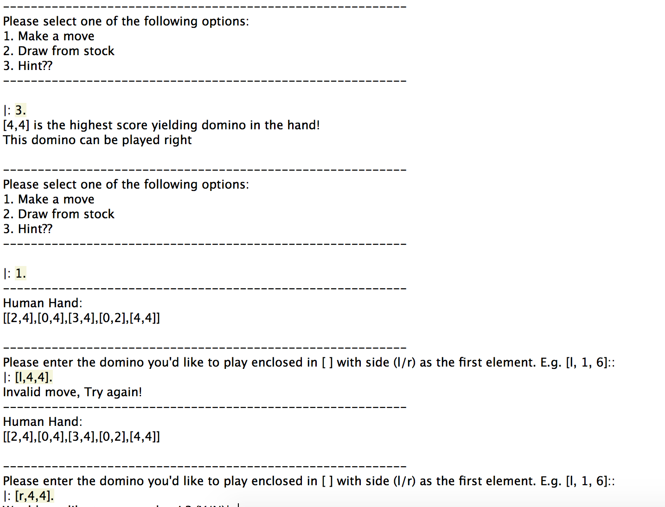

Figure 2: Human player making the move with after asking hint

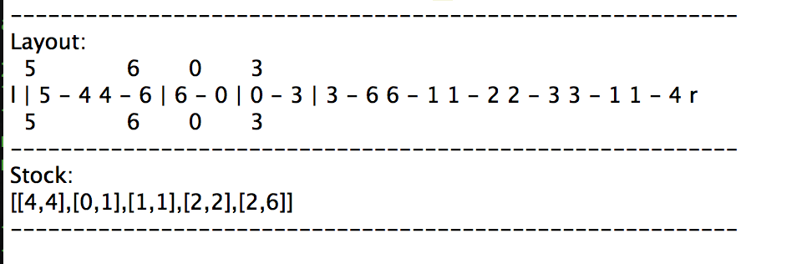

Figure 3: Game components

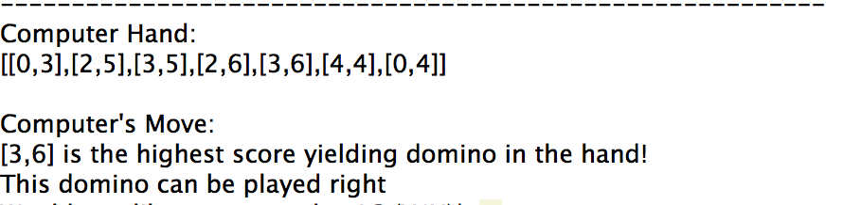

Figure 4: Computer player making the move