Git

* Version Control System
  + To maintain all your code in Central Repository
  + Versioning to keep track of the changes
  + Parallel Development
* Centralized VCS
  + SVN

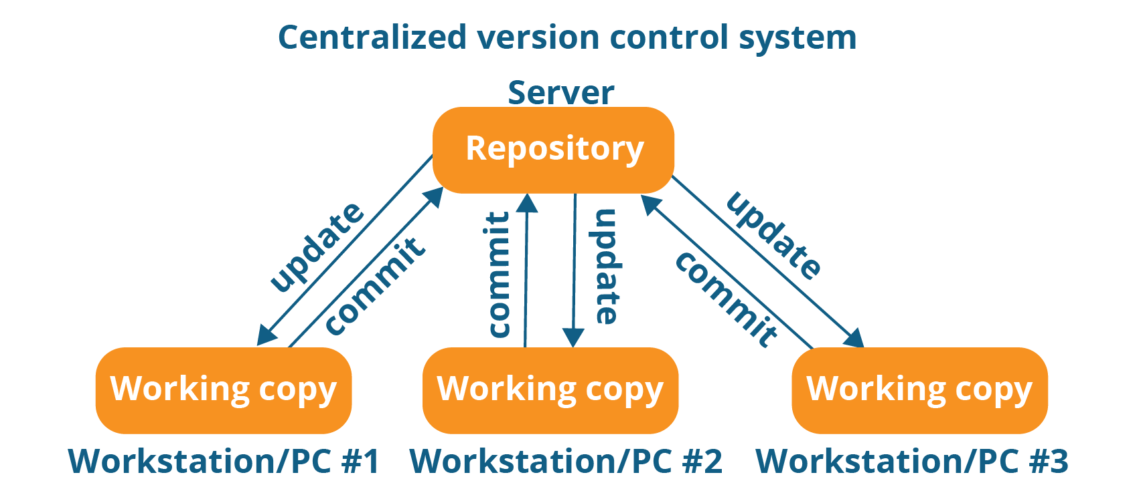

* Decentralized VCS OR Distributed VCS
  + git

