Does conversation modality (VR vs Text) affect self-disclosure?
AI Companion Lab Study — disclosure-depth analysis
Prepared 3 June 2026

The short version
- Yes — there is a difference: participants disclosed MORE deeply in the Text condition than in VR.
- It looked like “no difference” at first because VR participants talked far more (≈322 vs ≈149 words). Sheer volume nudges depth scores up, which masked the text advantage.
- Once we account for word count (and topic sensitivity), the text advantage is large and highly significant: odds of deeper disclosure are about 5× higher on the 0–3 scale and 7.7× higher on the 0–6 scale (both p < .001).
- Plain-English mechanism: typing is more deliberate and lower-pressure, so people open up more per word; speaking produces lots of words but much of it is filler and external description, not personal disclosure.

What we measured
Every participant's full conversation transcript (n = 187 with codeable data) was scored for disclosure depth on two rubrics: Rubric 1 (0–3: none / surface / moderate / deep) and Rubric 2 (0–6, a finer split of the same construct). Scoring followed the project rubric and the multi-turn rules — content only (never length), crediting only what the participant originated (not the AI's emotional reframes). We compared the two randomised conditions: VR (spoken) vs Text (chat).

Headline numbers
Group sizes: VR n = 94, Text n = 93.
Measure | VR (mean) | Text (mean) | Test | p | Effect size
Disclosure depth R1 (0–3) | 1.59 | 1.77 | Mann–Whitney | = 0.076 | r = +0.14 (small)
Disclosure depth R2 (0–6) | 2.90 | 3.33 | Mann–Whitney | = 0.025 | r = +0.18 (small)
Word count | 321.55 | 148.96 | Mann–Whitney | < .001 | r = -0.83 (large)
Read raw, the depth difference is small — significant on the finer R2 scale (p = .025) and just short of significance on R1 (p = .076). The word-count gap, by contrast, is enormous (p < .001): VR participants produced more than twice as many words.

Why it looked like “no difference” (the important part)
Word count and disclosure depth are positively related — a longer transcript has more opportunity for a personal signal to appear. Because VR transcripts are much longer, VR scores got an artificial “volume boost” that cancelled out the genuine text advantage. This is a classic suppression effect: the real effect is hidden until you control for the nuisance variable.
We ran an ordinal logistic regression predicting disclosure depth from modality, while controlling for word count and topic sensitivity. Odds ratios (OR) above 1 mean greater odds of a deeper disclosure level.
Rubric 1 (0–3):
Predictor | Odds ratio | 95% CI | p
Text vs VR | 5.08 | 2.17 – 11.91 | < .001
Topic sensitivity (per level) | 7.89 | 4.54 – 13.73 | < .001
Word count (per SD) | 2.40 | 1.52 – 3.78 | < .001
Rubric 2 (0–6):
Predictor | Odds ratio | 95% CI | p
Text vs VR | 7.70 | 3.46 – 17.14 | < .001
Topic sensitivity (per level) | 7.27 | 4.45 – 11.88 | < .001
Word count (per SD) | 2.93 | 1.92 – 4.46 | < .001
Adjusted for word count and topic sensitivity, Text raises the odds of deeper disclosure about 5× on R1 and 8× on R2 (both p < .001). Topic sensitivity and word count are also significant positive predictors, as expected.

Figures
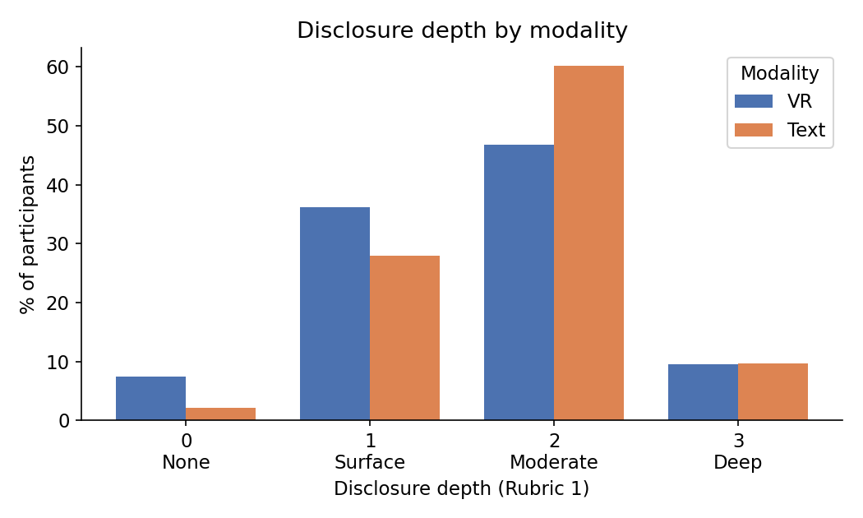
Figure 1. Disclosure-depth distribution (Rubric 1) by modality. Text shifts toward the Moderate level; VR has more None/Surface.
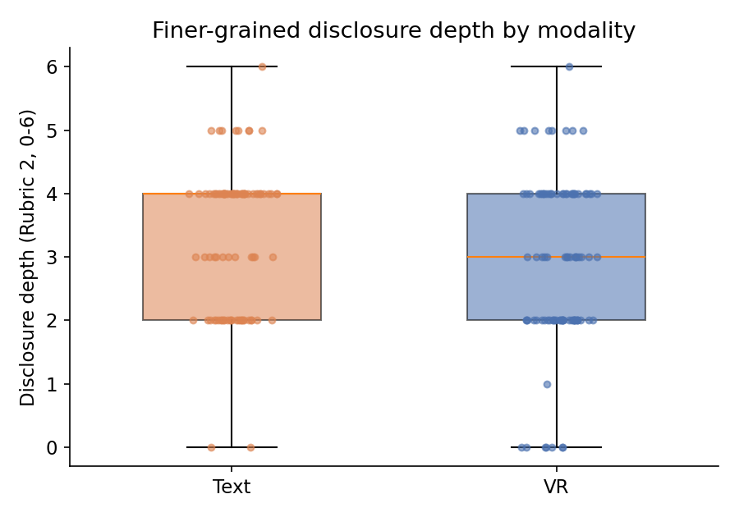
Figure 2. Finer-grained depth (Rubric 2) by modality. Text's median is higher.
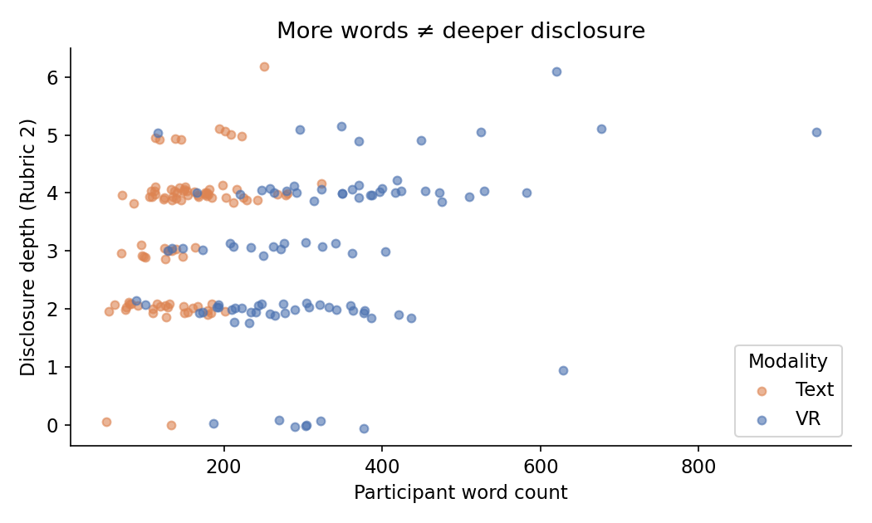
Figure 3. Word count vs disclosure depth. VR transcripts (blue) are far longer but not deeper — length is not depth.
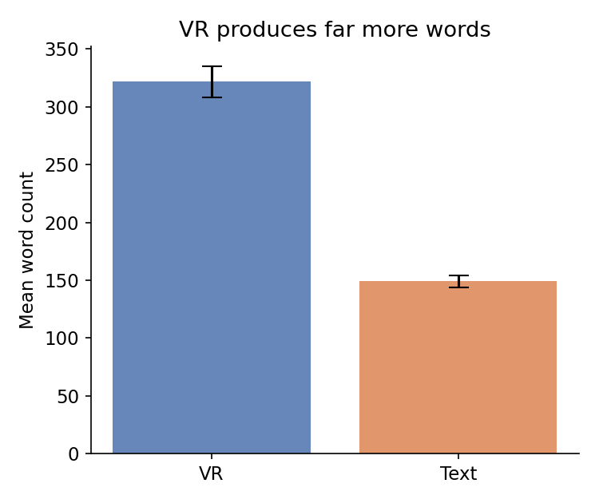
Figure 4. Mean word count by modality (± SE). VR produces more than twice as many words.

What it means
Your instinct was right: people disclose more in text. The effect was hidden in a simple comparison because the voice condition generates a high volume of words — filler, false starts, and external narration — that inflates raw scores without reflecting genuine personal disclosure. Per unit of content, text participants reveal substantially more. This fits the wider computer-mediated-communication literature: text lowers social presence and lets people edit and pace themselves, which encourages self-disclosure, whereas real-time voice raises self-presentation pressure.

Caveats & recommended next steps
- Depth scores are AI-coded by a single rater. Before publishing, have a human second-code a random subset (e.g. 20–30 transcripts) and report inter-rater reliability (weighted kappa). The justification column in the spreadsheet supports this.
- Raw between-group effect sizes are small (r ≈ .14–.18); the strong effect emerges only after adjusting for word count. Report both the unadjusted and adjusted results honestly.
- Consider pre-registering / clearly labelling the word-count-adjusted model as the primary test, since it is the theoretically meaningful comparison (depth independent of verbosity).
- Optional robustness checks: rerun excluding the No-Disclosure (0) cases, and excluding off-task transcripts flagged in the coding notes (e.g. 15253, 14854).

Where the data lives
The SPSS file now contains four new variables: DD_R1 (0–3), DD_R2 (0–6), WordCount, and TopicSensitivity (0 None – 3 High), plus the full Transcript text. Condition is labelled 1 = VR, 2 = Text. Per-participant scores with justifications are in Transcripts_participant_only.xlsx.

