Study 5 — Does modality (VR vs Text) affect self-disclosure?
AI Companion Study 5 — disclosure-depth analysis (analysis filter applied)
Prepared 3 June 2026

The short version
- Filter applied: 2 case(s) excluded by filter_$, leaving 179; 177 had complete disclosure scores and were analysed (88 VR, 89 Text).
- Same result as the Lab Study: participants disclosed MORE deeply in Text than in VR.
- It again looks like “no difference” at first glance because VR participants talked far more (≈326 vs ≈147 words), which inflates raw depth scores and masks the text advantage.
- Adjusted for word count, the Text advantage is large and highly significant: odds of deeper disclosure are about 6× higher on the 0–3 scale and 8× higher on the 0–6 scale (both p < .001).

What we measured
Disclosure depth was taken from the scores already in the dataset: DD_S (0–3) and DD_L (0–6, a finer split of the same construct), with WC = participant word count. We compared the two randomised conditions, VR (spoken) vs Text (chat), on the filtered analysis sample.

Headline numbers
Group sizes (filter on): VR n = 88, Text n = 89.
Measure | VR (mean) | Text (mean) | Test | p | Effect size
Disclosure depth DD_S (0–3) | 1.58 | 1.78 | Mann–Whitney | = 0.093 | r = +0.13 (small)
Disclosure depth DD_L (0–6) | 2.88 | 3.33 | Mann–Whitney | = 0.030 | r = +0.18 (small)
Word count | 325.82 | 147.37 | Mann–Whitney | < .001 | r = -0.85 (large)
Raw, the depth difference is small — significant on DD_L (p = .030) and just short on DD_S (p = .093) — while the word-count gap is enormous (p < .001).

Why it looks like “no difference” (the important part)
Longer transcripts have more opportunity for a personal signal to appear, so word count is positively related to depth. Because VR transcripts are far longer, VR scores get a “volume boost” that cancels out the genuine text advantage — a classic suppression effect. Controlling for word count reveals the real effect.
Ordinal logistic regression predicting disclosure depth from modality, controlling for word count. Odds ratios (OR) above 1 mean greater odds of a deeper disclosure level.
DD_S (0–3):
Predictor | Odds ratio | 95% CI | p
Text vs VR | 6.05 | 2.66 – 13.76 | < .001
Word count (per SD) | 2.75 | 1.76 – 4.28 | < .001
DD_L (0–6):
Predictor | Odds ratio | 95% CI | p
Text vs VR | 7.89 | 3.65 – 17.03 | < .001
Word count (per SD) | 3.14 | 2.09 – 4.72 | < .001
Adjusted for word count, Text raises the odds of deeper disclosure about 6× on DD_S and 8× on DD_L (both p < .001). Word count is also a significant positive predictor.

Figures
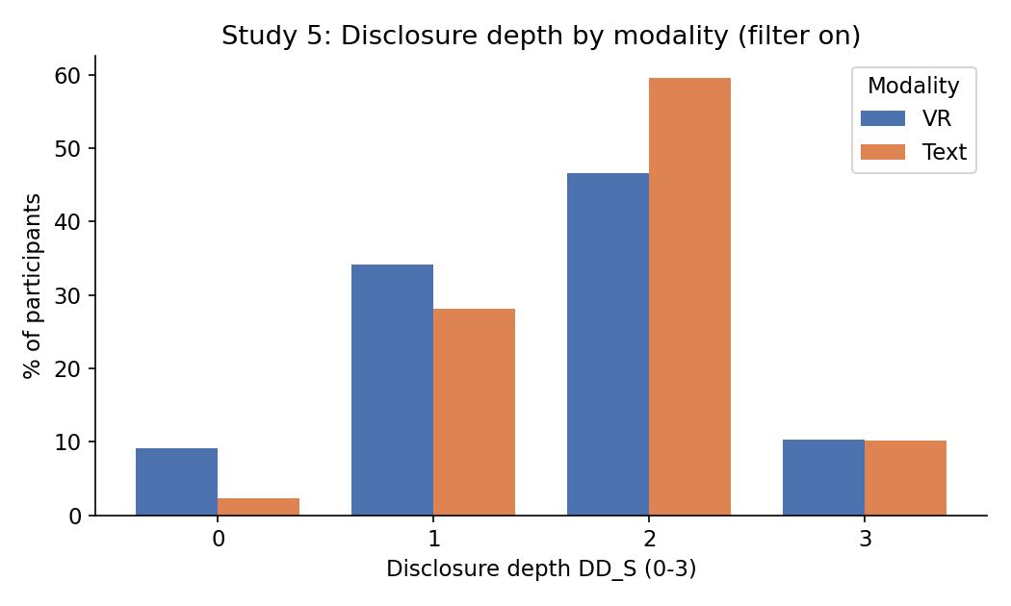
Figure 1. Disclosure-depth distribution (DD_S) by modality.
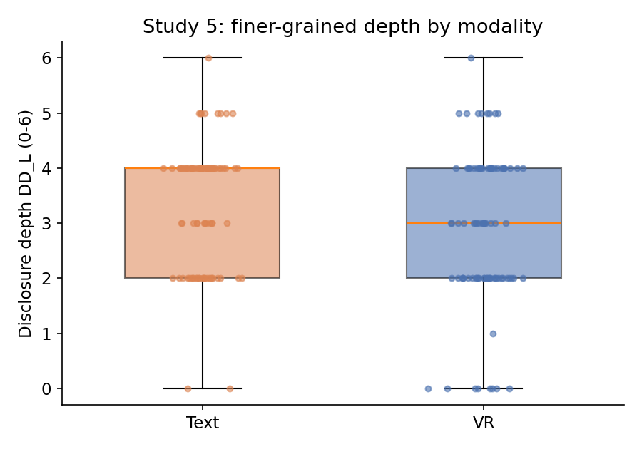
Figure 2. Finer-grained depth (DD_L) by modality; Text's median is higher.
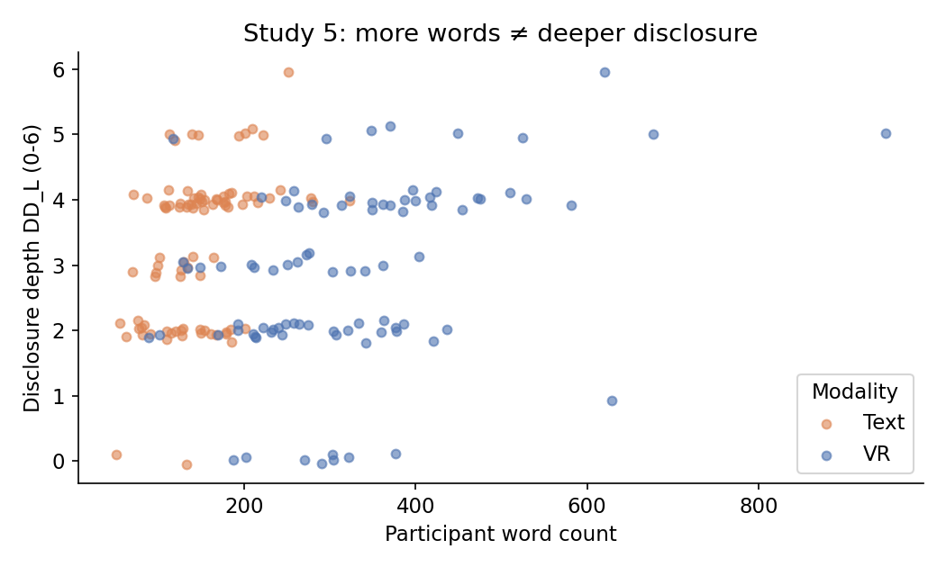
Figure 3. Word count vs depth: VR is longer (blue) but not deeper.
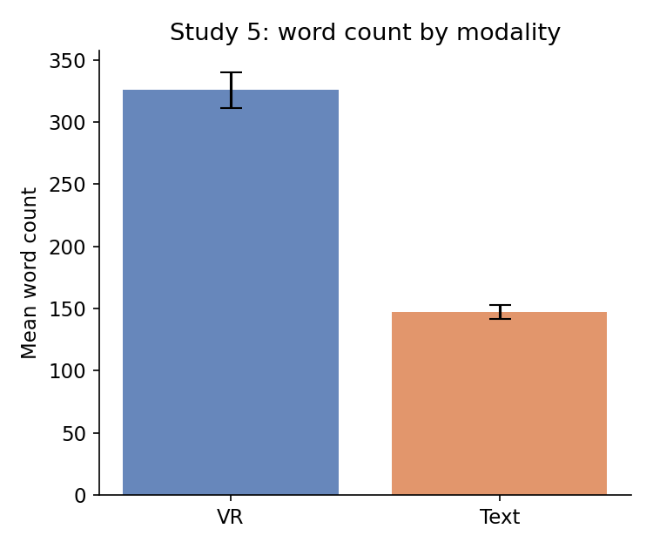
Figure 4. Mean word count by modality (± SE).

What it means
Study 5 replicates the Lab Study: people disclose more in text. The effect hides in a simple comparison because the voice condition generates a high volume of words (filler, false starts, external narration) that inflates raw scores without reflecting genuine personal disclosure. Per unit of content, text participants reveal substantially more — consistent with the idea that text lowers social-presence pressure and lets people edit and pace their self-disclosure.

Caveats & notes
- The analysis filter (filter_$) was applied: 2 cases excluded; 177 analysed.
- This file had no topic-sensitivity variable, so the model controls for word count only (the key suppressor). I can add a topic-sensitivity control if you code/supply that variable.
- Depth scores (DD_S/DD_L) were taken as given in the file; if they are AI-coded, a human reliability check on a subset is still recommended before publication.
- Raw between-group effects are small (r ≈ .13–.18); the strong effect is the word-count-adjusted model. Report both honestly.

