

**LA GRANDEE INTERNATIONAL COLLEGE**

**Simalchaur-8, Pokhara, Nepal**

An Internship Report

on

**Freelanzo**

**Submitted to**

La Grandee International College

Bachelor of Computer Application (BCA) program

In partial fulfillment of the degree of program name under Pokhara University

**Submitted by**

Bidhan Bhuwai Niraj Bohara Raj Poudel

BCA, 8th semester BCA, 8th semester BCA, 8th semester

2018-01-53-0104 2018-01-53-0118 2018-01-53-0122

Date: 12/05/2023

Table of Contents

1. Introduction 1

2. Problem Statement 3

3. Objectives 4

4. Methodology 5

4.1 Design 6

4.1.1 Class Diagram 6

5. Project Gantt Chart 7

6. Deliverables 8

7. Conclusion 9

8. References 10

**List of Figure**

Figure 1 Agile Methodology 5

Figure 2 Class Diagram 6

Figure 3 Gantt Chart 7

# 1. Introduction

The number of freelancers in the world is growing rapidly. In fact, according to a recent study by Upwork, there are now over 57 million freelancers worldwide. This growth is being driven by a number of factors, including the rise of the gig economy, the increasing demand for specialized skills, and the flexibility that freelancing offers.

Freelancers face a number of challenges, however. One of the biggest challenges is managing their relationships with clients. Freelancers need to be able to keep track of leads, proposals, contracts, invoices, and payments. They also need to be able to communicate effectively with clients and keep them updated on their progress.

A CRM (customer relationship management) system can help freelancers to overcome these challenges. A CRM system is a software application that helps businesses to manage their relationships with customers. A CRM system can help freelancers to:

* Keep track of leads and prospects
* Manage proposals and contracts
* Track invoices and payments
* Communicate with clients
* Stay organized
* Improve productivity

A CRM system can be a valuable tool for freelancers who want to improve their business and grow their income.

Benefits of a CRM for Freelancers

A CRM system can offer a number of benefits to freelancers, including:

* Improved client management: A CRM system can help freelancers to keep track of their clients, including their contact information, project history, and payment status. This can help freelancers to stay organized and avoid missing deadlines or losing track of important information.
* Increased productivity: A CRM system can help freelancers to automate tasks, such as sending out invoices and reminders. This can free up time for freelancers to focus on their work and grow their business.
* Improved sales: A CRM system can help freelancers to track leads and prospects, identify opportunities, and close deals. This can help freelancers to increase their sales and revenue.
* Improved customer service: A CRM system can help freelancers to provide better customer service by keeping track of client interactions and resolving issues quickly and efficiently. This can help freelancers to build strong relationships with their clients and improve their customer satisfaction.

The Client Relationship Management (CRM) system is a crucial tool for freelancers to manage their clients and maintain healthy relationships with them. In this report, we will discuss the development of a CRM system for freelancers, which will help them streamline their client management process and improve their overall productivity.

# 2. Problem Statement

Freelancers often struggle to manage their clients effectively, resulting in missed deadlines, miscommunication, and ultimately, loss of business. The lack of a centralized system to manage client information and communication makes it difficult for freelancers to maintain a healthy relationship with their clients. There is a need for a CRM system specifically designed for freelancers that can help them manage their clients more efficiently.

Here are some specific examples of the challenges that freelancers face:

Managing leads and prospects: Freelancers often have to juggle a large number of leads and prospects. A CRM system can help freelancers to keep track of all of their leads and prospects in one place, and to track their progress through the sales pipeline. Managing proposals and contracts: Freelancers often have to create and manage proposals and contracts. A CRM system can help freelancers to create and store proposals and contracts, and to track their progress through the approval process. Tracking invoices and payments: Freelancers often have to track invoices and payments.

A CRM system can help freelancers to create and send invoices, and to track payments. Communicating with clients: Freelancers often have to communicate with clients. A CRM system can help freelancers to track their communication with clients, and to ensure that they are staying on top of client needs. Staying organized: Freelancers often have to stay organized. A CRM system can help freelancers to stay organized by providing them with a central place to store all of their client data. Improving productivity: A CRM system can help freelancers to improve their productivity by automating tasks, such as sending out invoices and reminders.

# 3. Objectives

The main objectives of the system are as follows:

* To improve client management for freelancers.
* To provide a streamline communication channels between freelancers and their clients.
* To provide a centralized location for client information.
* To increase productivity and efficiency for freelancers.

# 4. Methodology

The development of the CRM system will follow an agile development methodology. The project will be divided into sprints, each sprint being a two-week period. The development team will work closely with freelancers to understand their requirements and feedback during the development process.

It is an iterative approach to software development that emphasizes collaboration, flexibility, and rapid prototyping. This methodology involves breaking down large projects into smaller, more manageable tasks, and continuously testing and iterating on those tasks.

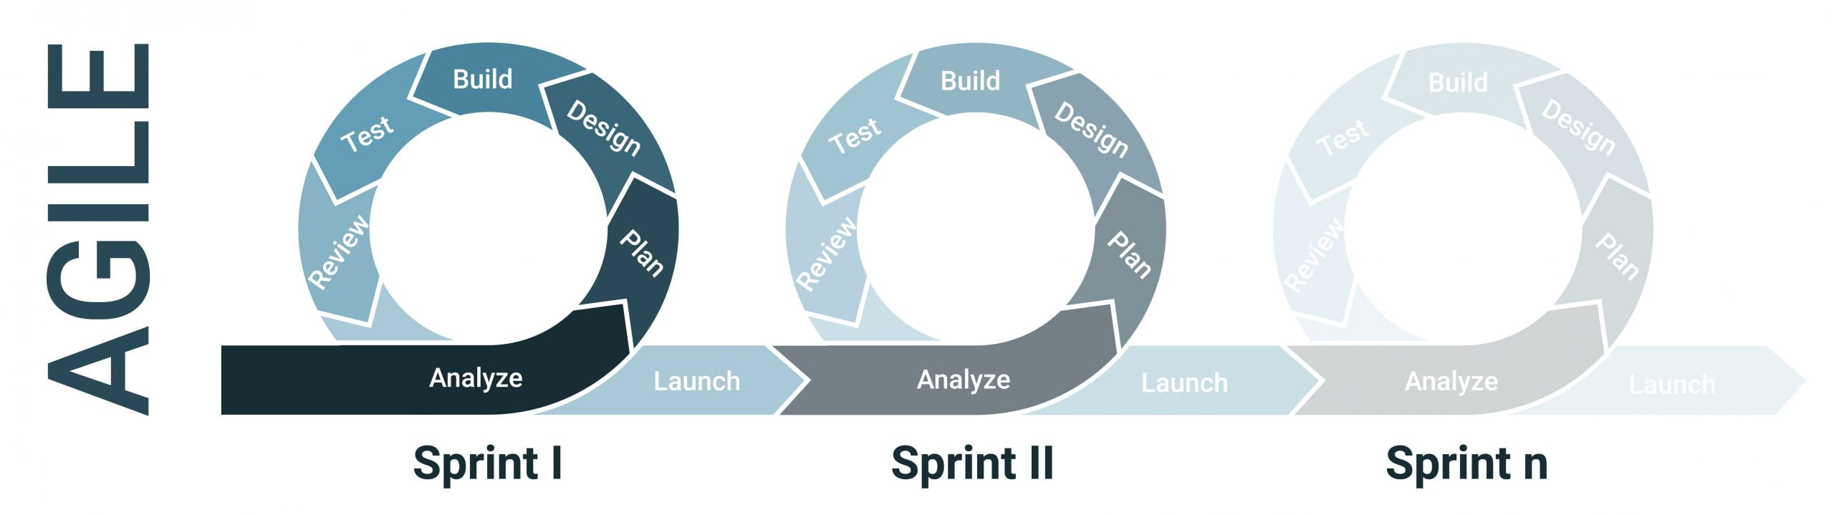

Figure 1 Agile Methodology

## 4.1 Design

### 4.1.1 Class Diagram

The class diagram for our project is shown below.

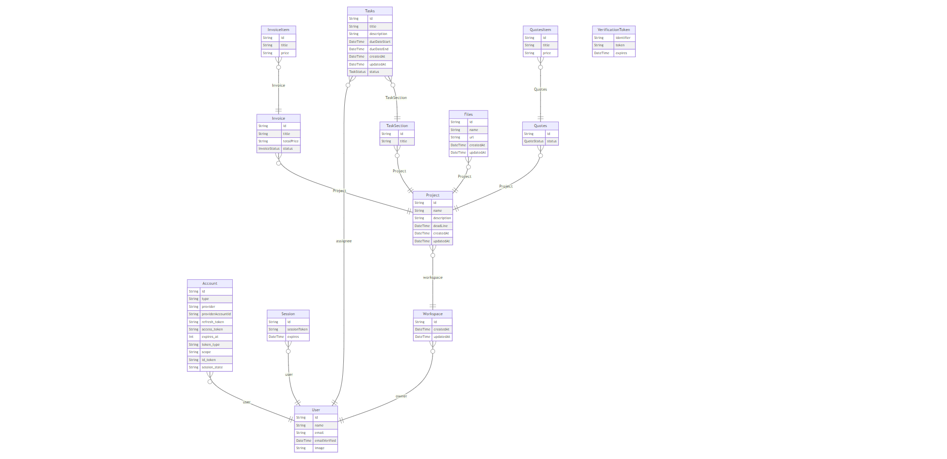

Figure 2 Class Diagram

# 5. Project Gantt Chart

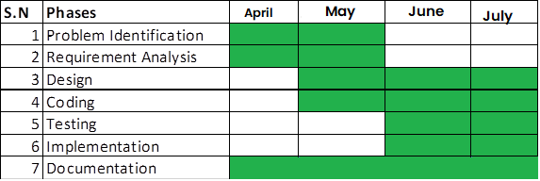

Figure 3 Gantt Chart

# 6. Deliverables

The following deliverables are expected to be produced as part of this project:

* A fully functional CRM system for freelancers.
* User documentation and training materials.
* A way to keep track of leads and prospects, and track their progress through the sales pipeline.
* The ability to create and store proposals and contracts, and track their progress through the approval process.

# 7. Conclusion

The development of the Client Relationship Management (CRM) system for freelancers is an important step towards improving client management and communication for freelancers. The system developed as part of this project is designed to cater to the specific needs of freelancers, providing a centralized location for client information and streamlining communication channels.

Overall, the CRM system for freelancers is expected to increase productivity and efficiency for freelancers, ultimately leading to better client relationships and increased business opportunities. As freelancing continues to grow in popularity, the development of such systems will become increasingly important, and this project serves as a foundation for future developments in this field.

# 8. References

* Payne, A., & Frow, P. (2013). The Complete Guide to Customer Relationship Management. Routledge.
* Upwork. (2021). Freelance Forward 2021. Retrieved from https://www.upwork.com/research/freelance-forward-2021