Lab 1

UDP Connection
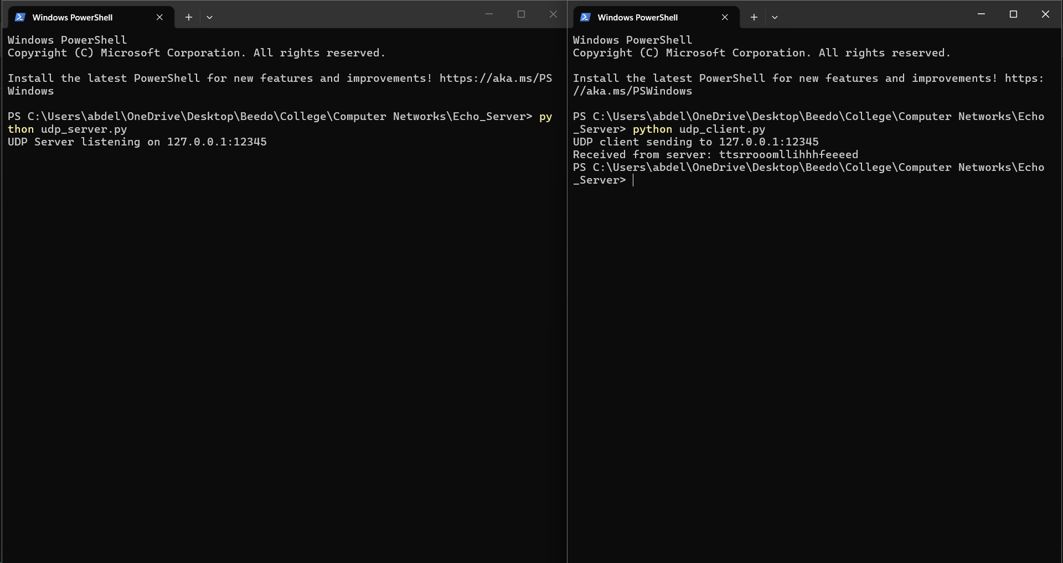
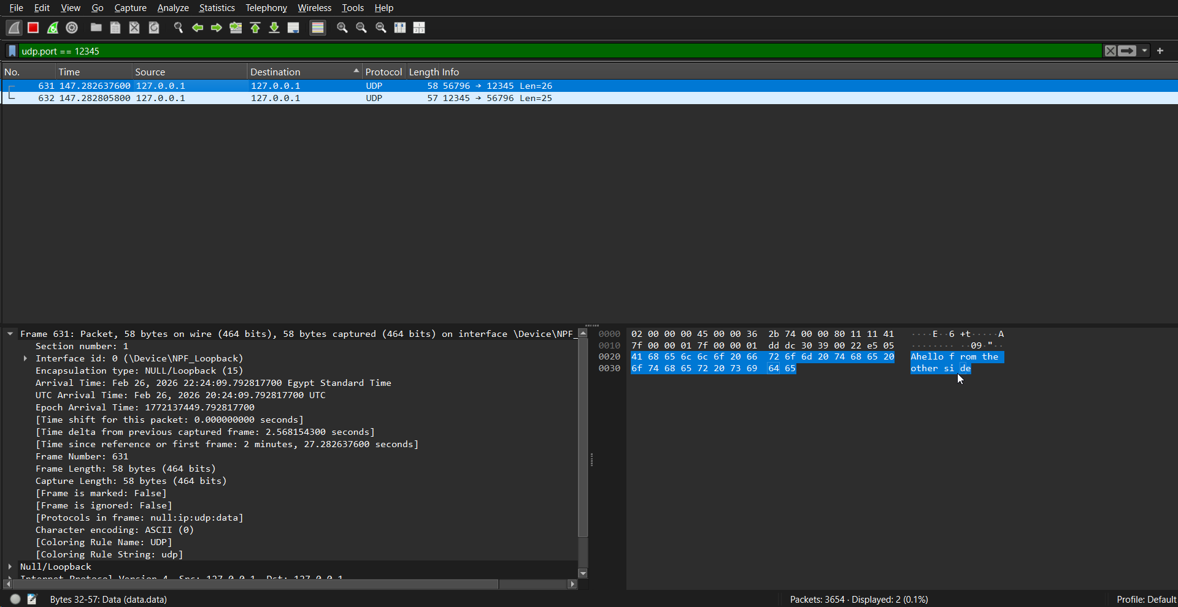

Server code
import socket

IP_address = "127.0.0.1"
port = 12345

s = socket.socket(socket.AF_INET, socket.SOCK_DGRAM)
s.bind((IP_address, port))

print(f"UDP Server listening on {IP_address}:{port}")

while True:
data, addr = s.recvfrom(1024)

msg = data.decode('utf-8').strip()

if not msg:
continue # Skip empty messages to prevent crashes on msg[0]

# Used "".join() to convert the sorted list back into a string
if msg[0] == 'A':
new_msg = "".join(sorted(msg[1:], reverse=True))
elif msg[0] == 'C':
new_msg = "".join(sorted(msg[1:]))
elif msg[0] == 'D':
new_msg = msg[1:].upper()
else:
new_msg = msg

s.sendto(new_msg.encode('utf-8'), addr)

Client code
import socket

IP_address = "127.0.0.1"
port = 12345
msg = "Ahello from the other side"

s = socket.socket(socket.AF_INET, socket.SOCK_DGRAM)

print(f"UDP client sending to {IP_address}:{port}")

s.sendto(msg.encode('utf-8'), (IP_address, port))

data, server_addr = s.recvfrom(1024)

print(f"Received from server: {data.decode('utf-8')}")

s.close()

TCP Connection
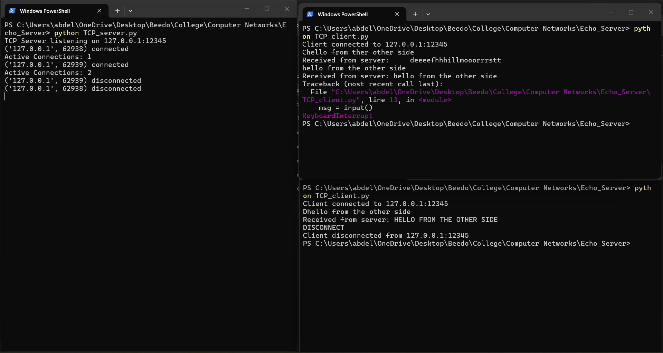
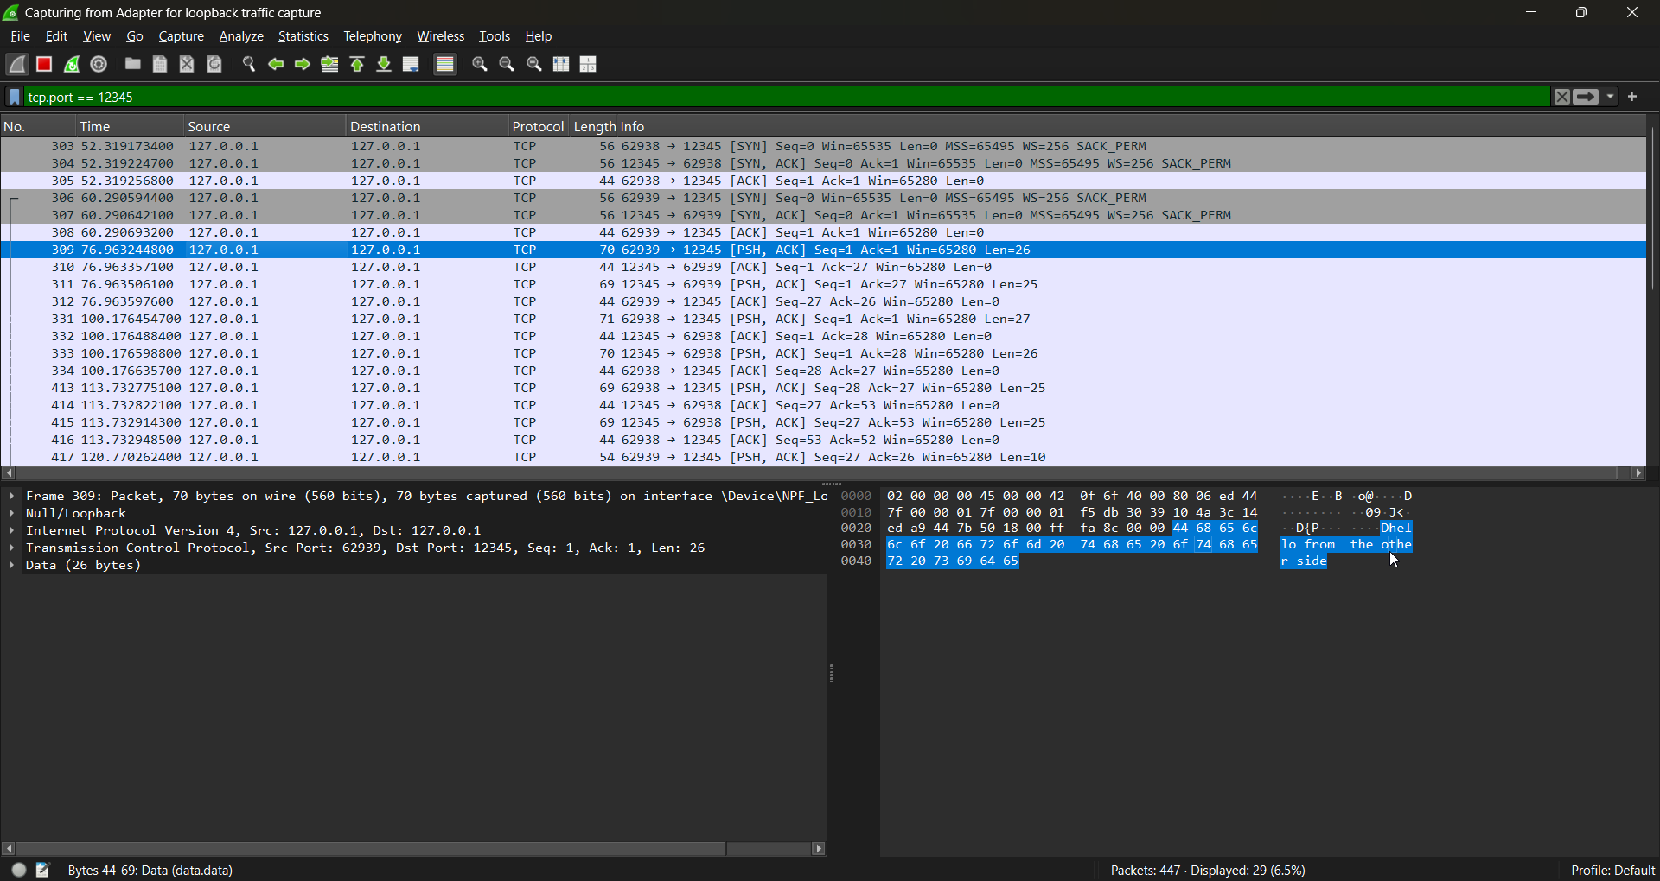

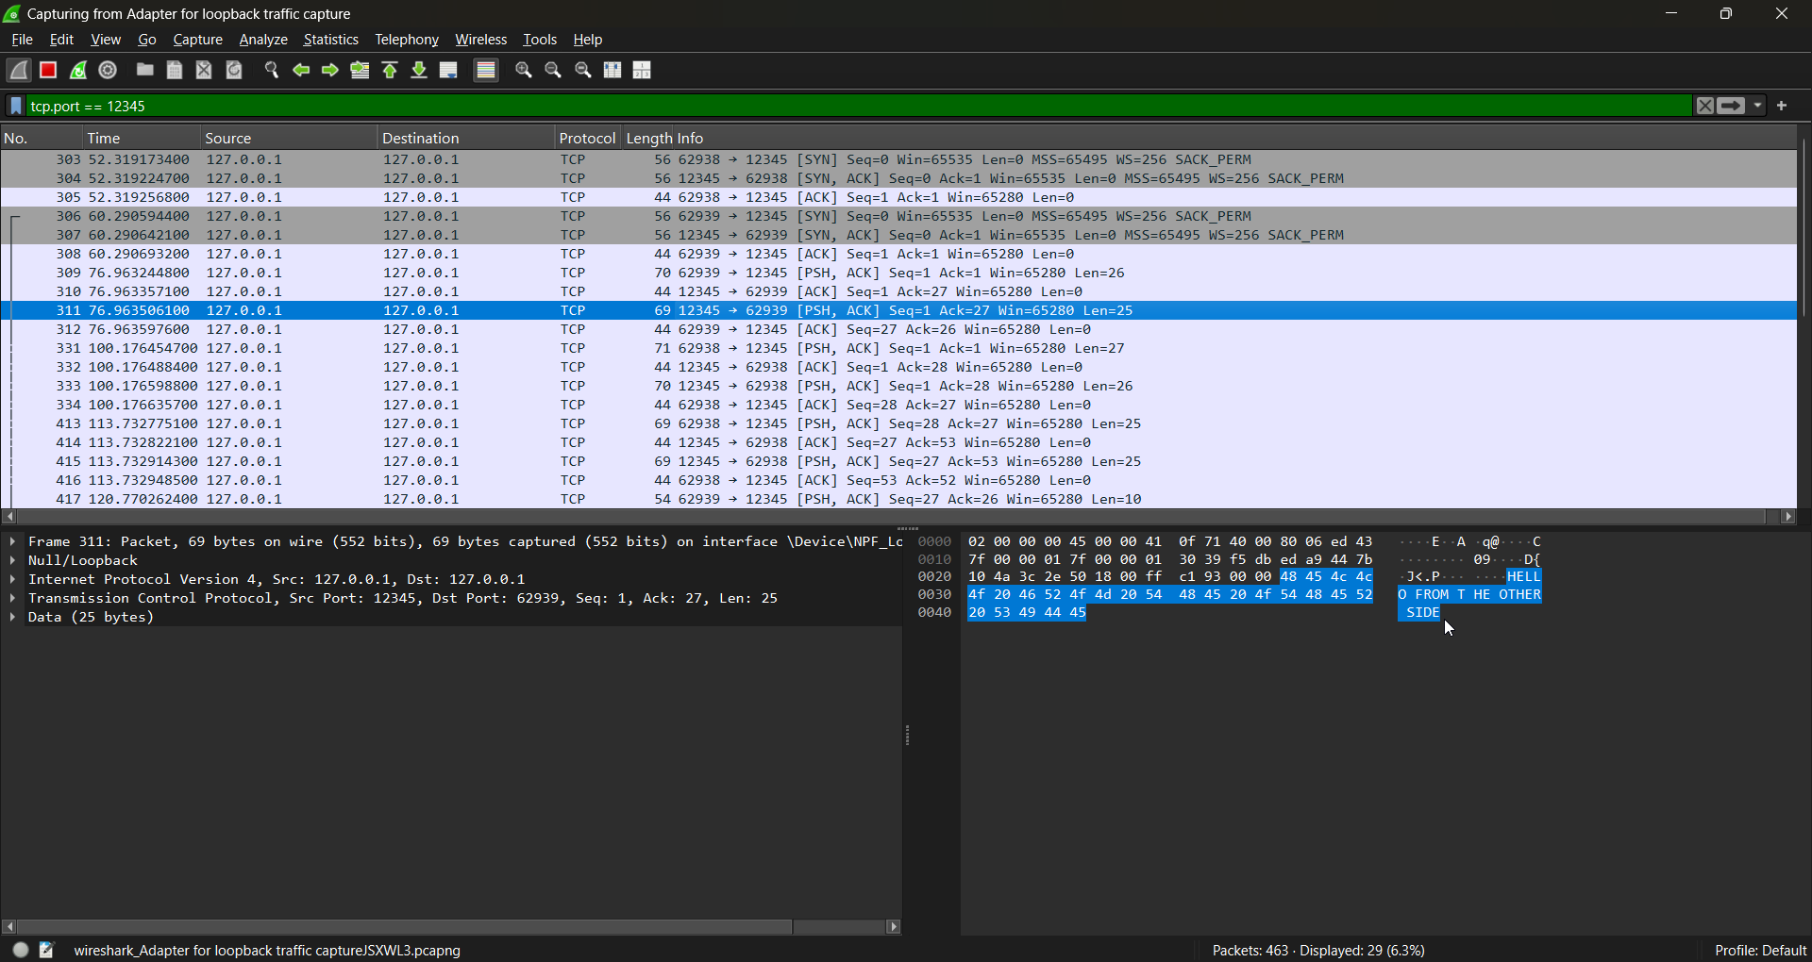

Server code
import socket
import threading

def handle_client(conn, addr):
print(f"{addr} connected")

connection = True

while connection:
try:
msg = conn.recv(1024).decode('utf-8')

if msg == "DISCONNECT":
connection = False
print(f"{addr} disconnected")
# In TCP empty msg means connection failed
elif not msg:
connection = False
print(f"{addr} disconnected")
else:
if msg[0] == 'A':
new_msg = "".join(sorted(msg[1:], reverse=True))
elif msg[0] == 'C':
new_msg = "".join(sorted(msg[1:]))
elif msg[0] == 'D':
new_msg = msg[1:].upper()
else:
new_msg = msg

conn.send(new_msg.encode('utf-8'))
except ConnectionResetError:
connection = False
print(f"{addr} disconnected")

conn.close()

IP_address = "127.0.0.1"
port = 12345

s = socket.socket(socket.AF_INET, socket.SOCK_STREAM)
s.bind((IP_address, port))
s.listen()

print(f"TCP Server listening on {IP_address}:{port}")

while True:
conn, addr = s.accept()
thread = threading.Thread(target=handle_client, args=(conn, addr))
thread.start()
print(f"Active Connections: {threading.active_count() - 1}")

Client code
import socket

IP_address = "127.0.0.1"
port = 12345

s = socket.socket(socket.AF_INET, socket.SOCK_STREAM)
s.connect((IP_address, port))
print(f"Client connected to {IP_address}:{port}")

connection = True

while connection:
msg = input()

if not msg:
print("Cannot send an empty message. Try again.")
continue

s.send(msg.encode('utf-8'))

if msg == "DISCONNECT":
connection = False
print(f"Client disconnected from {IP_address}:{port}")
else:
data = s.recv(1024)
print(f"Received from server: {data.decode('utf-8')}")

s.close()

