Network Design Report

Youssef Mohamed 8821
Abdelrahman Hussein 8976

Network Topology & Design
The network consists of two autonomous systems separated by a Service Provider (SP) cloud link. Cairo forms AS 100 and Alexandria forms AS 200. Within Cairo, two buildings each have a dedicated access router (R1 for Building 1, R2 for Building 2) that connect upward to a central border gateway router (R3). R3 handles both internal EIGRP routing and external BGP peering with Alexandria's router (R4).

2.1 Topology Overview
Device | Role | Location | Connected To
R1 | Access Router | Cairo B1 | SW1 (Sales), SW2 (HR), R3
R2 | Access Router | Cairo B2 | SW3 (IT), R3
R3 | Border Gateway | Cairo Hub | R1, R2, SP Cloud (BGP)
R4 | Border Gateway | Alexandria B1 | SW4 (Operation), SP Cloud (BGP)
SW1–SW4 | Ethernet Switch | Per building | Department PCs + access router

Routing Architecture
The routing design uses a two-layer approach:
- Internal layer: EIGRP AS 100 runs between R1, R2, and R3 within Cairo. EIGRP AS 200 runs between R4 and its internal networks in Alexandria.
- External layer: eBGP runs between R3 (AS 100) and R4 (AS 200) over the SP cloud link using the 10.1.3.0/30 point-to-point subnet.
- Redistribution: R3 redistributes EIGRP routes into BGP (so Cairo networks are advertised externally) and redistributes BGP routes back into EIGRP (so internal Cairo routers learn the Alexandria route). R4 performs the same mutual redistribution on the Alexandria side.
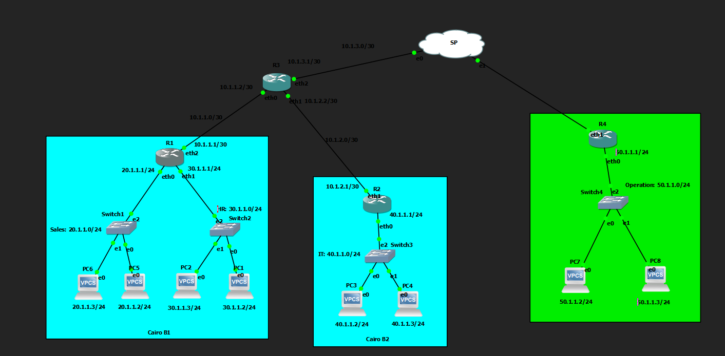

3. IP Addressing Scheme
All department networks use Fixed Length Subnet Masking (FLSM) with /24 prefix length, providing 254 usable host addresses per subnet — sufficient for the 2-PC departments specified in the project brief. Router interconnect links use /30 subnets (2 usable hosts) to conserve address space on point-to-point links.

3.1 Department Networks (LAN Subnets)
Branch | Building | Department | Network | Gateway | PCs
Cairo | B1 | Sales (SW1) | 20.1.1.0/24 | 20.1.1.1 (R1 eth0) | PC5, PC6
Cairo | B1 | HR (SW2) | 30.1.1.0/24 | 30.1.1.1 (R1 eth1) | PC1, PC2
Cairo | B2 | IT (SW3) | 40.1.1.0/24 | 40.1.1.1 (R2 eth0) | PC3, PC4
Alexandria | B1 | Operation (SW4) | 50.1.1.0/24 | 50.1.1.1 (R4 eth0) | PC7, PC8

3.2 Router Interconnect Links (/30 Point-to-Point)
Link | Subnet | Router A IP | Router B IP
R1 ↔ R3 | 10.1.1.0/30 | 10.1.1.1 (R1 eth2) | 10.1.1.2 (R3 eth0)
R2 ↔ R3 | 10.1.2.0/30 | 10.1.2.1 (R2 eth1) | 10.1.2.2 (R3 eth1)
R3 ↔ R4 (SP) | 10.1.3.0/30 | 10.1.3.1 (R3 eth2) | 10.1.3.2 (R4 eth1)

3.3 End Device IP Assignments
PC | Department | IP Address | Default Gateway | Subnet
PC6 | Sales | 20.1.1.3 | 20.1.1.1 | /24
PC5 | Sales | 20.1.1.2 | 20.1.1.1 | /24
PC1 | HR | 30.1.1.2 | 30.1.1.1 | /24
PC2 | HR | 30.1.1.3 | 30.1.1.1 | /24
PC3 | IT | 40.1.1.2 | 40.1.1.1 | /24
PC4 | IT | 40.1.1.3 | 40.1.1.1 | /24
PC7 | Operation | 50.1.1.2 | 50.1.1.1 | /24
PC8 | Operation | 50.1.1.3 | 50.1.1.1 | /24

4. Routing Protocol Configuration

4.1 EIGRP — Internal Cairo Routing (AS 100)
EIGRP was chosen as the internal routing protocol for the Cairo branch. It is a Cisco-enhanced distance-vector protocol that supports fast convergence and classless routing. All three Cairo routers participate in EIGRP AS 100.

R1 Configuration
interface eth0
ip address 20.1.1.1/24
no shutdown
interface eth1
ip address 30.1.1.1/24
no shutdown
interface eth2
ip address 10.1.1.1/30
no shutdown
router eigrp 100
network 20.1.1.0/24
network 30.1.1.0/24
network 10.1.1.0/30

R2 Configuration
interface eth0
ip address 40.1.1.1/24
no shutdown
interface eth1
ip address 10.1.2.1/30
no shutdown
router eigrp 100
network 40.1.1.0/24
network 10.1.2.0/30

4.2 BGP — Inter-Branch Routing
BGP (Border Gateway Protocol) was used to connect the two autonomous systems across the SP cloud. R3 (AS 100) peers with R4 (AS 200) using eBGP over the 10.1.3.0/30 link. Mutual redistribution bridges the EIGRP and BGP domains on both border routers.

R3 Configuration (Cairo Border Gateway)
interface eth0 -> 10.1.1.2/30 (to R1)
interface eth1 -> 10.1.2.2/30 (to R2)
interface eth2 -> 10.1.3.1/30 (to SP / R4)
router eigrp 100
network 10.1.1.0/30
network 10.1.2.0/30
redistribute bgp
router bgp 100
no bgp ebgp-requires-policy
neighbor 10.1.3.2 remote-as 200
address-family ipv4 unicast
redistribute eigrp

R4 Configuration (Alexandria Border Gateway)
interface eth0 -> 50.1.1.1/24 (to SW4 / Operation dept)
interface eth1 -> 10.1.3.2/30 (to SP / R3)
router eigrp 200
network 50.1.1.0/24
redistribute bgp
router bgp 200
no bgp ebgp-requires-policy
neighbor 10.1.3.1 remote-as 100
address-family ipv4 unicast
redistribute eigrp

4.3 Key Design Decisions
Decision | Rationale
EIGRP for internal routing | Fast convergence, supports classless subnets, easy configuration in FRR
BGP for inter-AS routing | Industry standard for inter-AS routing; mandatory when crossing autonomous system boundaries
/30 on router links | Minimises address waste on point-to-point links (only 2 hosts needed)
/24 on LANs (FLSM) | Provides 254 host addresses per subnet, simple to manage, meets project FLSM requirement
Mutual redistribution | Allows EIGRP routes to be advertised via BGP externally, and BGP-learned routes to be injected into EIGRP internally
Ethernet Switch as SP | GNS3 Cloud node cannot forward between internal ports; Ethernet Switch correctly passes traffic between R3 and R4

5. Verification & Testing
The following verification steps confirm that the network is fully operational end-to-end.

5.1 Verification Commands
Command | Run On | Expected Result
show ip bgp summary | R3 and R4 | State/PfxRcd shows a number (not Active), confirming BGP session is established
show ip route | R1 / R2 | 50.1.1.0/24 appears as D EX (External EIGRP redistributed from BGP)
show ip route | R4 | 20.1.1.0/24, 30.1.1.0/24, 40.1.1.0/24 appear as D EX routes
ping 10.1.3.2 | R3 | 100% success — confirms L3 connectivity across the SP switch
ping 50.1.1.3 | PC6 (Sales) | Successful ping — full end-to-end path Cairo Sales to Alexandria Operation

5.2 Troubleshooting Encountered
Issue | Root Cause | Resolution
BGP stuck in Active state | GNS3 Cloud node used as SP — cannot forward between internal ports | Replaced Cloud node with Ethernet Switch, which forwards automatically
BGP shows (Policy) — no prefixes exchanged | FRR requires explicit route policy; blocks all prefixes by default on eBGP sessions | Added 'no bgp ebgp-requires-policy' on both R3 and R4
Destination unreachable from PC | 50.1.1.0/24 missing from R1 routing table due to BGP not being established | Fixed by resolving BGP issues above; route appeared automatically after redistribution

6. Conclusion
The Company X network was successfully designed and implemented, connecting four departments across two branches in Cairo and Alexandria. The design meets all project requirements:
- FLSM /24 subnets assigned to each department with correct gateway configuration
- EIGRP AS 100 provides fast, reliable internal routing within the Cairo branch
- BGP eBGP peering between AS 100 and AS 200 enables inter-branch communication
- Mutual redistribution on R3 and R4 ensures all routes are propagated correctly
- Full end-to-end reachability verified by pinging across both branches

The key lesson from implementation was that GNS3's Cloud node is designed for bridging to real network interfaces and cannot be used as an SP simulation node. Replacing it with an Ethernet Switch resolved the BGP connectivity issue. Additionally, FRR's default policy-based filtering required the 'no bgp ebgp-requires-policy' command to allow route exchange without explicit route maps.

