**Add a new column called DOB in Persons table with data type as Date.**

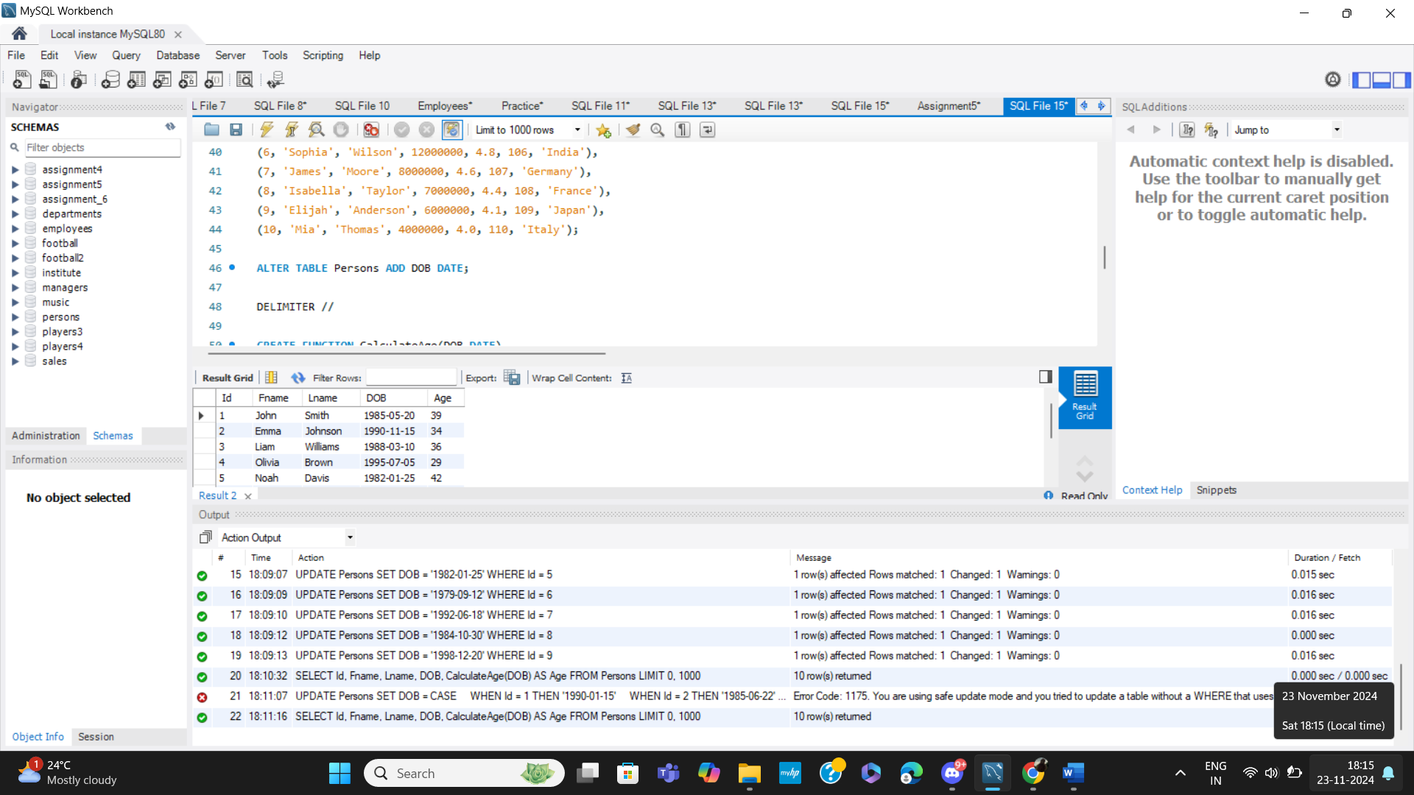

**User-defined function to calculate age using DOB.**

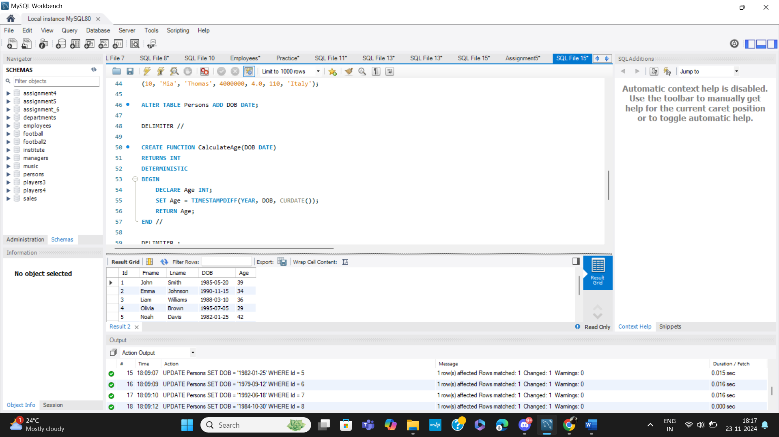

**Query to fetch the Age of all persons using the function that has been created.**

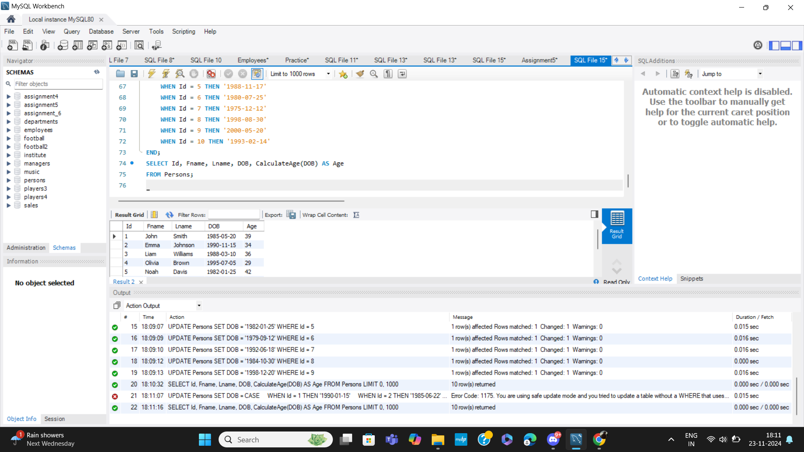

**The length of each country name in the Country table.**

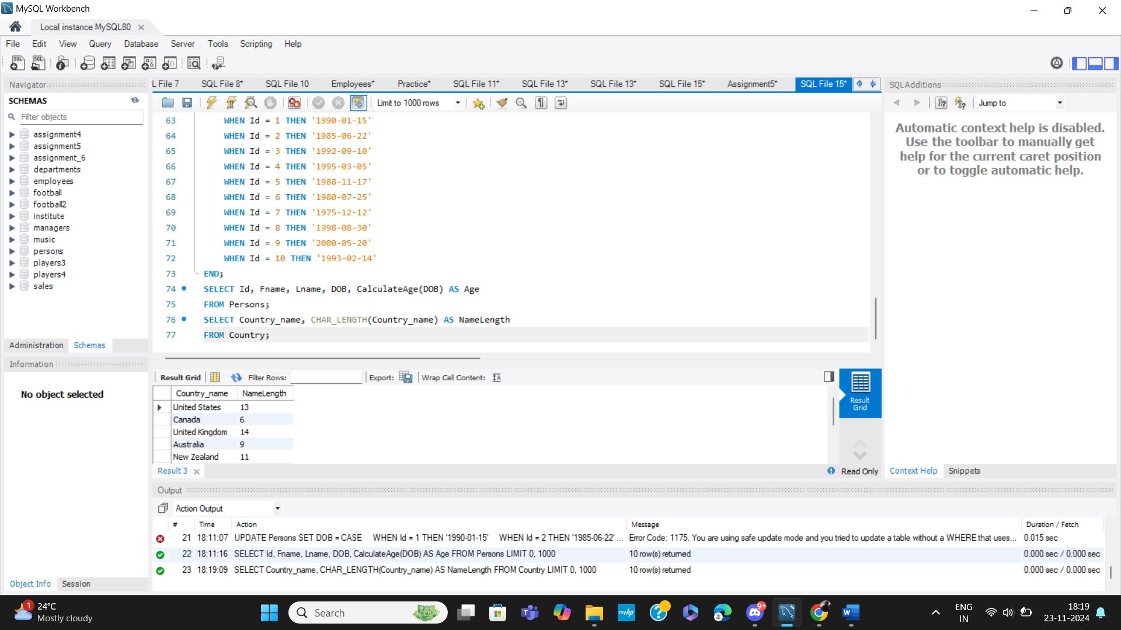

**First three characters of each country's name in the Country table.**

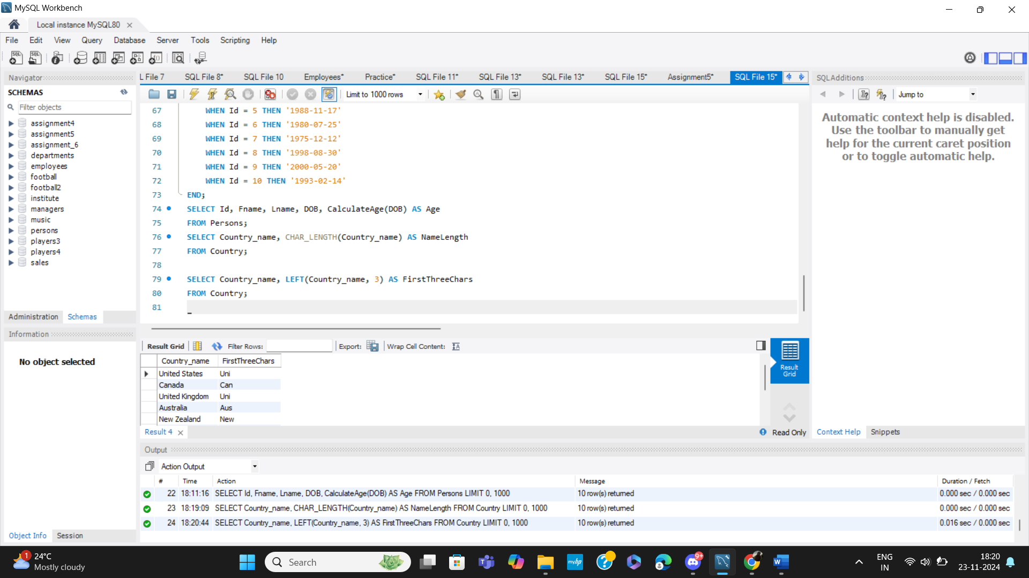

**Convert all country names to uppercase and lowercase in the Country table.**

