National University of Computer & Emerging Sciences, Karachi
FAST School of Computing | Spring 2026
CS3001 – Computer Networks

Final Project Report
Chat Portal with FTP-Enabled File Transfer
A Web-Based Real-Time Messaging System with FTP-Integrated Multimedia Transfer

Submitted By
24K-2002 – Anas Haider
24K-2031 – Abeeha Shaikh

Submitted To:
Shohaib Raza

1. Motivation
Modern communication platforms such as WhatsApp and Telegram have made real-time multimedia messaging a daily necessity. However, these systems are closed-source and do not expose their underlying networking mechanics for study or experimentation. For students of Computer Networks, there is significant educational value in constructing a messaging system from scratch — one that makes the network protocols explicit rather than hidden.
This project was motivated by the desire to bridge the gap between theoretical networking concepts studied in CS3001 and a practical, functional application. The File Transfer Protocol (FTP), while traditionally associated with server file management, presents an interesting challenge when repurposed as the media-transfer backbone of a real-time chat application. Integrating FTP into a Flask-based web chat portal requires students to apply knowledge of client-server architecture, TCP sockets, HTTP request handling, and FTP command sequences in a unified system.
The resulting application serves both as an academic demonstration and as a genuinely usable communication tool, making the project valuable beyond the classroom.

2. Overview

2.1 Significance of the Project
The Chat Portal with FTP-Enabled File Transfer is significant on multiple levels. Academically, it provides a hands-on consolidation of the core topics covered in CS3001: client-server architecture, TCP-based communication, HTTP (via Flask), and FTP as an application-layer protocol. Building the system requires students to simultaneously apply these concepts, reinforcing understanding far beyond what lecture or problem sets alone can achieve.
Practically, the project demonstrates that FTP — a protocol from the early internet era — can be integrated into a modern, browser-based communication system. This has implications for organizations that operate their own FTP infrastructure and require an internal messaging platform that uses their existing file-transfer systems. If successfully deployed, the portal could serve as a lightweight, self-hosted alternative to proprietary messaging tools, particularly in environments where control over data storage and transfer is important.
The difficulty of the project lies in coordinating two distinct protocol stacks (HTTP/WebSocket for messaging and FTP for file transfer) within a single coherent application, managing concurrent users, and ensuring that file transfers and message delivery are reliable and consistent.

2.2 Description of the Project
The Chat Portal is a Flask-based web application. A Flask server hosts the chat application and serves the web interface to clients. Users access the portal through a standard web browser and must first register with a username and password before using any features.
Once logged in, a user can:
- Send and receive real-time text messages in private one-to-one chats or multi-user group chats. Both parties in any conversation act symmetrically as both sender and receiver, mirroring the bidirectional communication model of applications like WhatsApp.
- Send multimedia files — specifically images, voice notes (audio), and video files — to other users. These files are uploaded to the FTP server by the sender's client and retrieved from the FTP server by the recipient's client, with a reference link delivered through the messaging layer.
- Create and join groups, enabling broadcast communication among multiple registered users.
- Delete sent messages or media, removing them from the conversation for all parties and purging the corresponding file from the FTP server.
The server handles message exchange between connected users using TCP-based communication (via Flask's request/response cycle and Socket.IO for real-time push), while the FTP server manages the storage and retrieval of all binary media files. The system scope is a local network or controlled server deployment; large-scale public internet deployment is outside the immediate scope.

2.3 Background of the Project
The File Transfer Protocol (FTP), standardized in RFC 959 [1], is one of the foundational application-layer protocols of the TCP/IP suite. It uses a dual-channel model: a persistent control connection (port 21) for issuing commands and a separate data connection for transferring file contents. Despite its age, FTP remains widely used for bulk file operations and forms the backbone of this project's media-transfer subsystem.
Flask is a lightweight Python web framework [3] that provides an HTTP server, routing, templating, and session management with minimal boilerplate. It is well-suited for academic projects requiring rapid development of RESTful APIs and server-rendered web interfaces. Python's built-in ftplib library [4] provides the client-side FTP primitives (STOR, RETR, DELE commands) used to interact with the FTP server from within the Flask application.
Real-time bidirectional messaging typically requires either WebSockets (RFC 6455) or a polling mechanism. Flask-SocketIO provides a WebSocket-compatible interface for Flask, enabling the server to push new messages to connected clients without requiring them to poll repeatedly.
The foundational networking theory underpinning this project is covered in the standard references for the course: Tanenbaum and Feamster's Computer Networks [1-textbook] and Kurose and Ross's Computer Networking: A Top-Down Approach [2-textbook], both of which treat client-server architecture, TCP, HTTP, and FTP in depth.

2.4 Project Category
This project is a Product-based project. The primary deliverable is a functional web application that can be installed and used in a real network environment. While it draws on academic knowledge of networking protocols, it is not a research contribution, nor was it commissioned by an external organization.

3. Features / Scope / Modules
The features below define the Chat Portal and establish what makes it a substantive networking project. They are listed in order of significance.
Feature 1: User Registration and Username-Based Login
Every user must register with a unique username and password before accessing the portal. The server validates credentials on login and establishes a session. This is the entry point for all other features: without a registered identity, the system cannot route messages to the correct user or enforce access control to group chats and FTP-stored files.
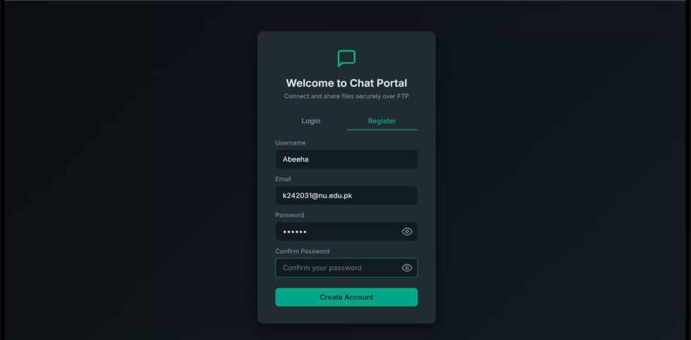
Feature 2: Real-Time Bidirectional Text Messaging
Registered users can send and receive text messages in real time. The Flask server handles message routing between connected users using TCP-based communication, and Flask-SocketIO pushes incoming messages to the recipient's browser without requiring a page refresh. Both the sender and receiver in any conversation can send messages at any time — the communication is fully symmetric and bidirectional, consistent with the behavior of mainstream messaging applications.
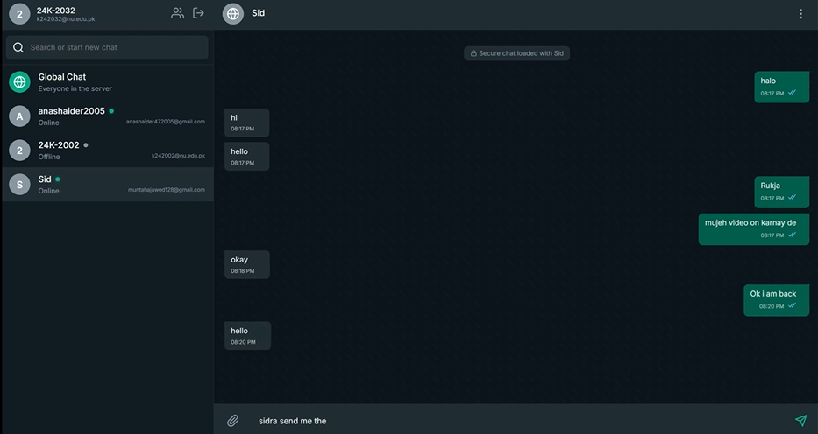
Feature 3: FTP-Based Multimedia File Transfer (Images, Audio, Video)
Users can attach and send images, voice notes (audio files), and video files within any chat. When a file is sent, the Flask application uses the ftplib library to issue an FTP STOR command, uploading the file to the configured FTP server. A reference to the stored file is recorded in the message database and sent to the recipient through the messaging layer. The recipient's browser fetches the file from the FTP server via an FTP RETR command (mediated by the Flask server) and renders it inline in the chat window. This feature is the central networking contribution of the project, directly demonstrating FTP in a real-time communication context.

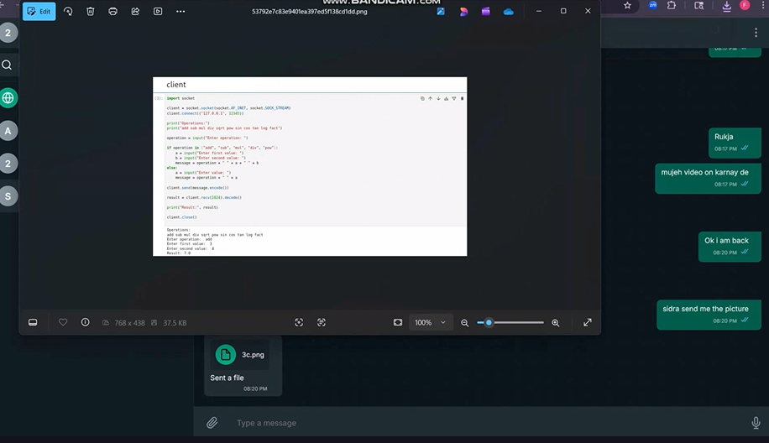
Feature 4: Multi-User Group Chat
Users can create named groups and add other registered users as members. All members of a group can send and receive messages and media within the group conversation. The Flask server maintains a group member list and broadcasts each incoming group message to all active members. This feature requires correct handling of concurrent socket connections and server-side fan-out logic.
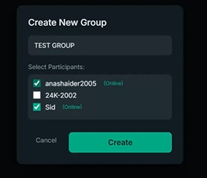
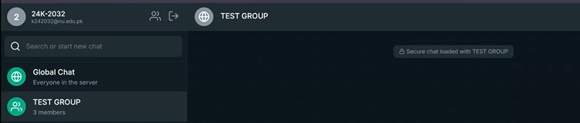
Feature 5: Message and Media Deletion
A user can delete any message or media file they have sent. Text message deletion removes the message record from the database and hides it from the conversation view for all parties. For media files, deletion additionally issues an FTP DELE command to remove the file from the FTP server, freeing storage. This feature mirrors the 'Delete for Everyone' capability found in commercial messengers and is important for user privacy and data management.
Feature 6: Server-Side Storage of Uploaded Files
All uploaded media files are stored on the FTP server under organized directory paths (e.g., /uploads/images/, /uploads/audio/, /uploads/video/). File references (paths and metadata) are stored in the server-side database, ensuring that files are persistently accessible across sessions and to all conversation participants. This persistent storage also enables chat history: when a user logs in, previously shared media is still accessible and renderable.
Feature 7: Support for Multiple Concurrent Users
The Flask server and FTP server are configured to handle multiple simultaneous user connections. Flask-SocketIO manages concurrent WebSocket sessions, and the FTP server is configured with appropriate connection limits. This ensures that the system degrades gracefully under load rather than failing when more than two users are active simultaneously.

4. Project Planning
The project was planned over a five-week timeline as defined in the original project proposal. The table below details the weekly schedule, the tasks completed in each phase, and the team member responsibilities. Both members collaborate on system design, debugging, and final documentation.
Week | Phase | Tasks | Responsible
Week 1 | Research & Design | Review Flask framework and FTP protocol concepts; design overall system architecture, database schema, and UI wireframes. | Both Members
Week 2 | Core Backend | Develop basic Flask application; implement username-based login and session management; set up database for users and messages. | Anas Haider (lead) + Abeeha Shaikh (login)
Week 3 | Chat Functionality | Implement real-time text messaging using Flask-SocketIO; enable bidirectional communication between multiple users; implement group chat logic. | Anas Haider (chat) + Abeeha Shaikh (multi-user)
Week 4 | FTP Integration | Configure FTP server (vsftpd); implement file upload (STOR), download (RETR), and deletion (DELE) using Python ftplib; integrate media sharing into chat. | Abeeha Shaikh (FTP) + Anas Haider (integration)
Week 5 | Integration, Testing & Documentation | Integrate chat and FTP modules end-to-end; perform functional testing and debugging; implement message/media deletion; prepare final report and demonstration. | Both Members

Team Contribution Division
Anas Haider (24K-2002)
- Lead development of real-time chat functionality and WebSocket message routing.
- Assist in multi-user communication handling and group broadcast logic.
- Participate in system integration and testing.
Abeeha Shaikh (24K-2031)
- Lead implementation of FTP file transfer (upload, download, deletion via ftplib).
- Assist in username-based login and session management.
- Participate in system integration and testing.
Both members collaborate on system architecture design, debugging, and final documentation.

5. Project Feasibility

5.1 Technical Feasibility
The project is technically feasible with readily available, well-documented open-source technologies. Python and Flask are mature frameworks with extensive community support. Python's ftplib library provides direct access to FTP STOR, RETR, and DELE commands, making FTP integration straightforward. Flask-SocketIO provides WebSocket support without requiring a separate server process.
Technical risks include:
- FTP Passive Mode: Firewall or NAT configurations may interfere with FTP passive mode data connections. This is mitigated by using a controlled local network environment and explicitly configuring the FTP server's passive port range.
- Concurrent Connections: Handling multiple simultaneous WebSocket and FTP sessions requires careful resource management. Flask's development server is single-threaded; for the project, Flask-SocketIO with eventlet or gevent will be used to support concurrency.
- File Size: Large video files may cause upload delays. A file size limit (e.g., 50 MB) will be enforced at the application layer.
- FTP Security: Standard FTP transmits credentials in plaintext. For this project's local network scope, this is acceptable; FTPS could be adopted if the system were deployed publicly.

5.2 Economic Feasibility
The project has zero software cost. All required technologies are free and open-source:
- Python 3.x and Flask — free, open-source.
- vsftpd FTP server — free, open-source (Linux).
- Flask-SocketIO and ftplib — free Python libraries.
- SQLite or MySQL — free database engines.
- Development hardware — standard university lab machines or personal laptops.
Operational costs for a real deployment (hosting, domain) are outside the project scope. Total development cost is limited to team members' time.

5.3 Schedule Feasibility
The five-week plan is feasible given the team's prior exposure to Python web development and the networking concepts covered in CS3001. Each week has a clearly scoped deliverable, and the sequencing ensures that foundational components (login, Flask server) are complete before dependent features (FTP integration, group chat) are built. Week 5 provides buffer time for integration debugging and final documentation.

6. Hardware and Software Requirements

6.1 Hardware Requirements
Component | Minimum Specification | Purpose
Server Machine | Any PC/laptop (4 GB RAM, dual-core CPU, Ubuntu/Windows) | Host Flask app, FTP server, and database
Client Machines | Any PC/laptop with a modern web browser | Access the chat portal via browser
Network | 100 Mbps LAN (Ethernet or Wi-Fi) | Connect clients and server; carry TCP/FTP traffic
Storage (Server) | Minimum 20 GB free disk space | Store SQLite/MySQL database and FTP-uploaded media files

6.2 Software Requirements
Software | Version | Purpose
Python | 3.10+ | Primary programming language for backend
Flask | 2.x / 3.x | Web framework: HTTP server, routing, templates, session management
Flask-SocketIO | 5.x | WebSocket layer for real-time bidirectional text messaging
ftplib (Python stdlib) | Built-in | FTP client — STOR, RETR, DELE commands for media file management
vsftpd | 3.x | FTP server for storing and serving uploaded media files
SQLite / MySQL | 3.x / 8.x | Relational database for users, messages, groups, media references
eventlet / gevent | Latest | Async worker for Flask-SocketIO concurrent connection handling
HTML / CSS / JS | Standard | Frontend chat portal UI (served by Flask templates)
Web Browser | Chrome / Firefox (latest) | Client-side access to the chat portal
Git | 2.x | Version control for collaborative development
VS Code / PyCharm | Latest | Development IDE

7. Diagrammatic Representation of the Overall System
The diagrams below illustrate the architecture and key interaction flows of the Chat Portal with FTP-Enabled File Transfer.

7.1 High-Level System Architecture
The system follows a three-tier architecture: a client layer (web browser), an application server layer (Flask + Flask-SocketIO), and a data layer (FTP server + SQLite/MySQL database). Figure 1 shows this structure.

┌──────────────────────────────────────────────────────────────┐
│ CLIENT LAYER │
│ [Web Browser – User A] ←── WebSocket/HTTP ──→ [Web Browser – User B] │
└──────────────────────────────┬───────────────────────────────┘
│ HTTP Requests / WebSocket
┌──────────────────────────────▼───────────────────────────────┐
│ APPLICATION SERVER LAYER (Flask) │
│ ┌──────────────┐ ┌─────────────────┐ ┌────────────────┐ │
│ │ Auth Module │ │ Chat / SocketIO │ │ FTP Handler │ │
│ │ (register / │ │ (msg routing, │ │ (ftplib: │ │
│ │ login) │ │ group broadcast│ │ STOR/RETR/DELE│ │
│ └──────┬─────────┘ └────────┬────────┘ └───────┬────────┘ │
└─────────┼───────────────────┼──────────────────┼────────────┘
│ │ │ FTP commands (port 21/20)
┌─────────▼───────────────────▼──────────────────▼────────────┐
│ DATA LAYER │
│ ┌──────────────────────┐ ┌─────────────────────────┐ │
│ │ SQLite / MySQL DB │ │ FTP Server (vsftpd) │ │
│ │ - users │ │ /uploads/images/ │ │
│ │ - messages │ │ /uploads/audio/ │ │
│ │ - groups │ │ /uploads/video/ │ │
│ │ - media_refs │ │ │ │
│ └──────────────────────┘ └─────────────────────────┘ │
└─────────────────────────────────────────────────────────────┘

Figure 1. Three-tier architecture of the Chat Portal: client browsers, Flask application server, and data layer (FTP server + database).

7.2 Media File Transfer Flow
Figure 2 shows the sequence of steps when a user sends a media file (e.g., an image) to another user.

User A (Sender) Flask Server FTP Server (vsftpd) User B (Receiver)
| | | |
|--[1] Select file-->| | |
| HTTP POST |--[2] ftplib STOR()---->| |
| |<--[3] Transfer OK------| |
| |--[4] Save media ref--->| (DB write) |
| |--[5] SocketIO emit (file link)--------------->|
| | |<--[6] ftplib RETR()----|
| | |---[7] File stream----->|
| | | [8] Render inline in chat

Figure 2. Sequence diagram for media file transfer: User A uploads via ftplib STOR, Flask notifies User B via SocketIO, User B retrieves via ftplib RETR.

7.3 Database Schema
Table | Key Columns | Description
users | user_id, username, password_hash, created_at | Stores registered user accounts
messages | msg_id, sender_id, receiver_id, group_id, content, msg_type, timestamp, deleted | All messages; msg_type: text / image / audio / video
groups | group_id, group_name, created_by, created_at | Group chat metadata
group_members | group_id, user_id, joined_at | Maps users to groups
media_refs | ref_id, msg_id, ftp_path, file_type, file_size | FTP file paths linked to messages

Figure 3. Database schema: five tables covering users, messages (text and media), groups, group membership, and FTP file references.

8. References
- J. Postel and J. Reynolds, "FILE TRANSFER PROTOCOL (FTP)," RFC 959, Internet Engineering Task Force (IETF), October 1985. Available: https://www.rfc-editor.org/rfc/rfc959
- Tanenbaum, A. S., & Feamster, N. (2021). Computer Networks. Pearson.
- Kurose, J. F., & Ross, K. W. (2021). Computer Networking: A Top-Down Approach. Pearson.
- Python Official Documentation – Flask Framework. Available: https://flask.palletsprojects.com/
- Python Documentation – ftplib (FTP protocol client). Available: https://docs.python.org/3/library/ftplib.html
- Flask-SocketIO Documentation. Available: https://flask-socketio.readthedocs.io/
- I. Fette and A. Melnikov, "The WebSocket Protocol," RFC 6455, IETF, December 2011. Available: https://tools.ietf.org/html/rfc6455
- vsftpd – Very Secure FTP Daemon. Available: https://security.appspot.com/vsftpd.html

