CS3001 – Computer Networks

Assignment #3

Reliable Data Transfer Protocols
Student | Abeeha Shaikh
Student ID | 24K-2031
Section | BCY-4A
Semester | Spring 2026

1. Introduction
Reliable data transfer is a foundational problem in computer networking. The physical medium is inherently unreliable — packets may be lost, corrupted, reordered, or delayed. This assignment implements and compares three classic reliable-data-transfer (RDT) protocols in Python:
- RDT 3.0 – Stop-and-Wait
- Go-Back-N (GBN) – Sliding Window with cumulative ACKs
- Selective Repeat (SR) – Sliding Window with individual ACKs and buffering
Each protocol is evaluated over a simulated network that can introduce configurable packet loss, corruption, and delay. The simulation is entirely multithreaded, making it realistic enough to expose subtle race conditions and timer behaviour.

2. System Architecture

2.1 Key Configuration Parameters
Parameter | Default | Purpose
TIMEOUT | 2.0 s | Retransmission timer for all protocols
MAX_SEQ_NUM | 32 | Sequence number space size
WINDOW_SIZE_GBN | 4 | Sender window for Go-Back-N
WINDOW_SIZE_SR | 4 | Sender & receiver window for SR
LOSS_PROBABILITY | 0.10 | Per-packet loss probability
CORRUPTION_PROBABILITY | 0.05 | Per-packet corruption probability
DELAY_PROBABILITY | 0.10 | Per-packet artificial delay probability

2.2 Packet Structure
Every packet is a Python dataclass containing:
- type – PacketType.DATA or PacketType.ACK
- seq_num – sequence number (modulo MAX_SEQ_NUM)
- data – payload string (empty for ACKs)
- checksum – 16-bit rotating XOR checksum over all fields
The checksum is computed by XOR-ing each byte of the type, sequence number, and data fields, with a one-bit left rotation after each byte. This lets the receiver detect single-bit corruptions injected by the network simulator.

2.3 Network Simulator
The NetworkSimulator class runs a background thread that drains an in-memory deque. For each packet it rolls a single random float and applies the following decision tree:
- If rand < LOSS_PROBABILITY: drop the packet silently.
- Else if rand < LOSS_PROBABILITY + CORRUPTION_PROBABILITY: corrupt the checksum.
- Else if rand < DELAY_PROBABILITY: schedule delivery via threading.Timer after a random interval.
- Else: deliver immediately via the registered callback.

3. RDT 3.0 – Stop-and-Wait

3.1 Protocol Description
RDT 3.0 is the canonical stop-and-wait protocol. The sender transmits one packet and halts until it receives a correct, matching ACK or a retransmission timeout fires. The receiver discards any out-of-order or corrupted packets, re-sending the last good ACK to prevent the sender from stalling forever.

3.2 Sender FSM
Current State | Event / Condition | Action | Next State
Wait-to-Send | transmit() called | Build packet list; send pkt[0]; start timer | Wait-for-ACK
Wait-for-ACK | Correct ACK received (seq == base) | Stop timer; advance base; send next pkt | Wait-for-ACK / Done
Wait-for-ACK | Corrupted ACK received | Ignore (timer will fire) | Wait-for-ACK
Wait-for-ACK | Timeout | Retransmit current packet; restart timer | Wait-for-ACK

3.3 Receiver FSM
Current State | Event / Condition | Action | Next State
Wait-for-Pkt | Correct pkt, seq == expected | Append data; send ACK(seq); expected++ | Wait-for-Pkt
Wait-for-Pkt | Correct pkt, seq != expected | Send ACK(expected-1) (last good ACK) | Wait-for-Pkt
Wait-for-Pkt | Corrupted packet | Discard silently | Wait-for-Pkt

3.4 Implementation Notes
The single retransmission timer is managed with threading.Timer. A Lock guards the _timer_active flag to prevent a race between the callback thread and the main ACK handler. The base pointer tracks which packet awaits acknowledgement; on a correct ACK it advances and the next packet is immediately transmitted.

4. Go-Back-N (GBN)

4.1 Protocol Description
Go-Back-N is a sliding-window protocol with a window of up to N unacknowledged packets in flight simultaneously. It uses cumulative ACKs: ACK(n) confirms all packets up to and including sequence number n. If a timeout fires, the sender retransmits every packet from base to next_seq-1. The receiver is simple — it discards any packet that is not the next expected sequence number.

4.2 Sender FSM
Current State | Event / Condition | Action | Next State
Idle | transmit() called | Build buffer; fill window; start timer | Sending
Sending | ACK(n) received (n >= base) | base = n+1; stop timer; fill window | Sending / Done
Sending | Corrupted or stale ACK | Ignore | Sending
Sending | Timeout | next_seq = base; retransmit entire window | Sending

4.3 Receiver FSM
Current State | Event / Condition | Action | Next State
Wait-for-Pkt | Correct pkt, seq == expected | Deliver; send ACK(seq); expected++ | Wait-for-Pkt
Wait-for-Pkt | Correct pkt, seq != expected | Send ACK(expected-1); discard pkt | Wait-for-Pkt

5. Selective Repeat (SR)

5.1 Protocol Description
Selective Repeat improves on GBN by allowing the receiver to buffer out-of-order packets and the sender to retransmit only the specific packet that timed out. Each outstanding packet has its own independent timer. ACKs are now per-packet rather than cumulative. The receiver window size equals the sender window size and must be at most MAX_SEQ_NUM / 2 to prevent wrap-around ambiguity.

5.2 Sender FSM
Current State | Event / Condition | Action | Next State
Idle | transmit() called | Build buffer; fill window; start per-pkt timers | Sending
Sending | ACK(n) received, n not yet acked | Mark acked; stop timer(n); advance base | Sending / Done
Sending | Corrupted ACK / duplicate ACK | Ignore | Sending
Sending | Timer(n) expires, n not yet acked | Retransmit pkt[n]; restart timer(n) only | Sending

5.3 Receiver FSM
Current State | Event / Condition | Action | Next State
Wait-for-Pkt | Correct pkt, seq == expected | ACK(seq); deliver; expected++; drain buffer | Wait-for-Pkt
Wait-for-Pkt | Correct pkt, seq in rcv window | ACK(seq); buffer the data | Wait-for-Pkt
Wait-for-Pkt | Correct pkt, seq outside window | Reject (discard silently) | Wait-for-Pkt
Wait-for-Pkt | Corrupted packet | Discard silently (no ACK sent) | Wait-for-Pkt

5.4 Implementation Notes
The sender maintains a dictionary mapping sequence index to threading.Timer. When a new ACK arrives, the corresponding timer is cancelled. The base pointer advances only when consecutive leading indices are in the acked set. The receiver stores out-of-order data in a dictionary keyed by sequence number; once the expected sequence number appears, buffered packets are delivered in order by walking the dictionary.

6. Testing Scenarios & Results

6.1 Test Setup
All three protocols are tested against a 450-byte message (the pangram "The quick brown fox jumps over the lazy dog." repeated 10 times). Each packet carries up to 100 bytes of payload, producing 5 data packets per transfer. The ProtocolTester class measures wall-clock elapsed time and checks byte-exact equality of the received message against the original.

6.2 Scenarios
# | Scenario | Loss | Corruption | Delay | Purpose
1 | Perfect Channel | 0% | 0% | 0% | Baseline throughput
2 | Packet Loss Only | 20% | 0% | 0% | Retransmit logic
3 | Corruption Only | 0% | 15% | 0% | Checksum handling
4 | Delay Only | 0% | 0% | 20% | Timer & reorder
5 | Mixed Errors | 10% | 5% | 10% | Realistic channel
6 | Severe Errors | 25% | 10% | 15% | Stress test

6.3 Screenshots for Test

RDT 3.0

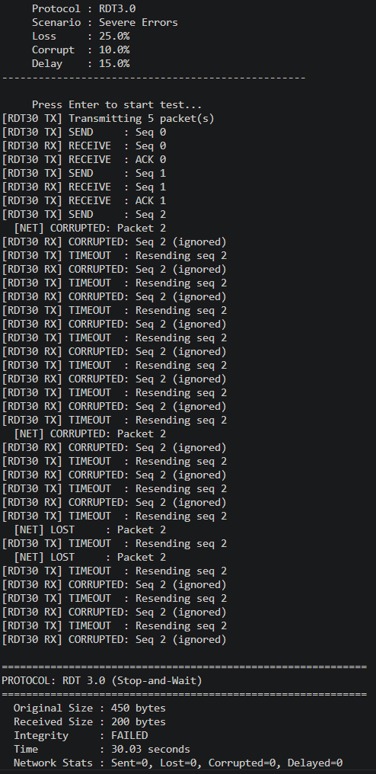

GBN

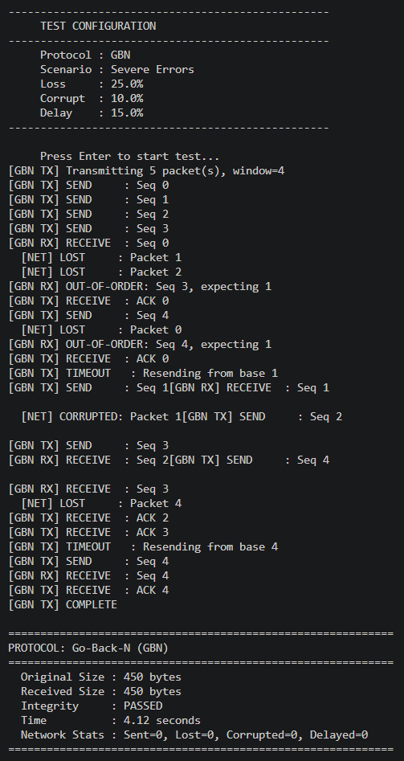

SR

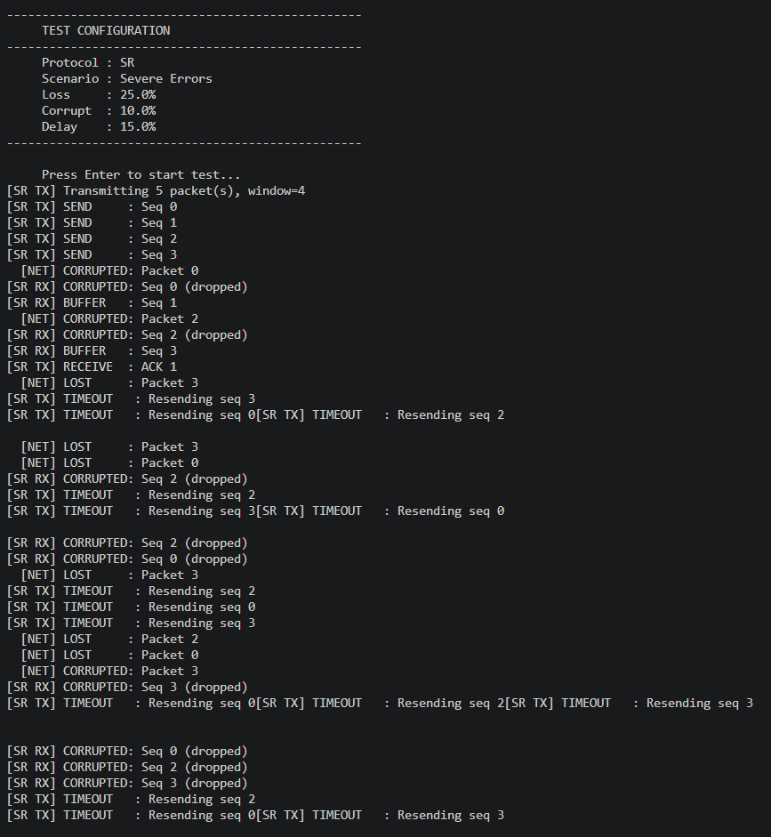

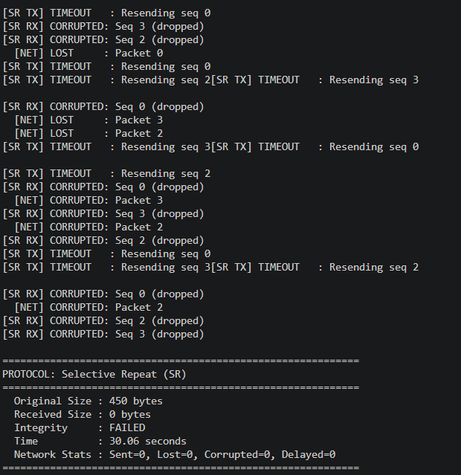

COMPARISON TEST FOR ALL PROTOCOLS

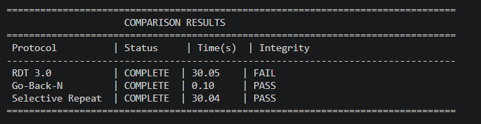

COMPREHENSIVE TEST SUIT

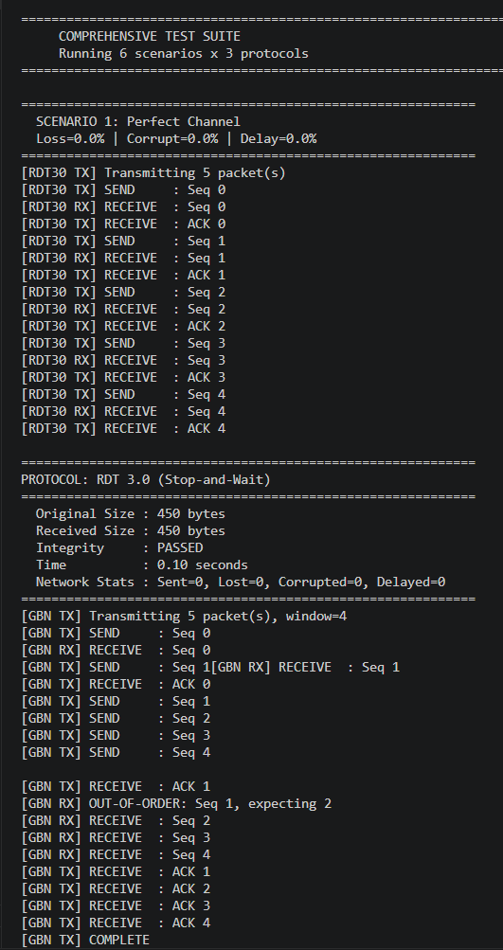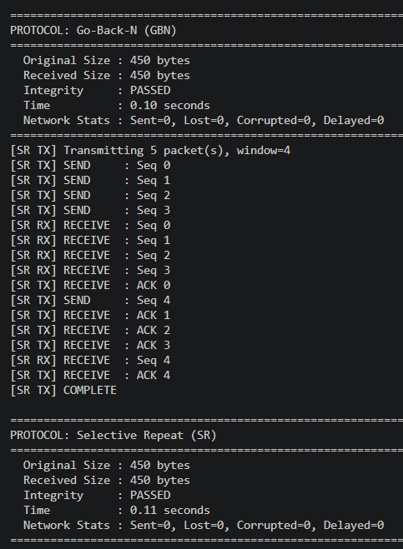

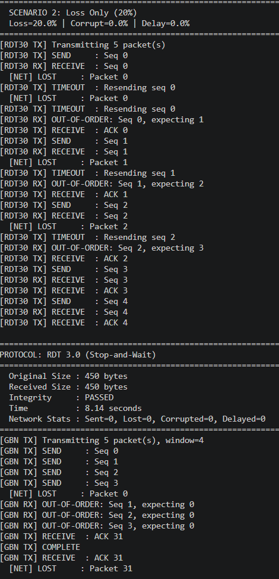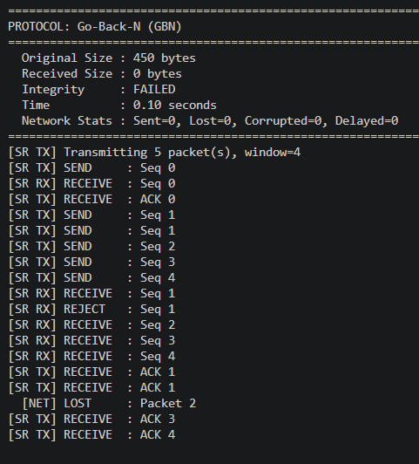

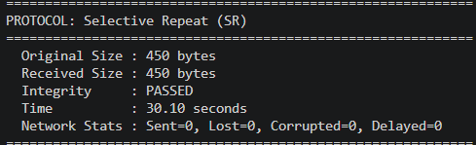

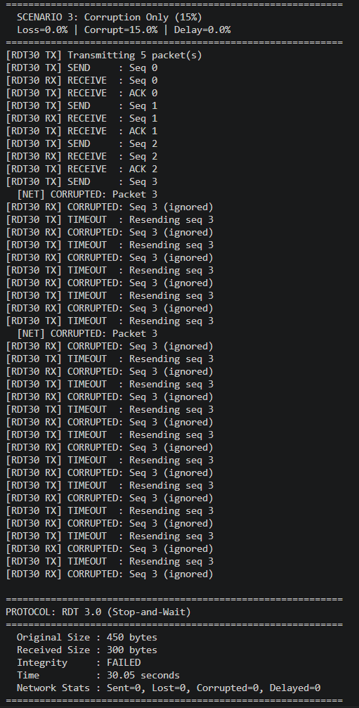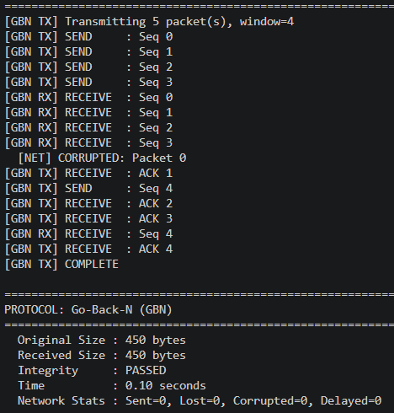

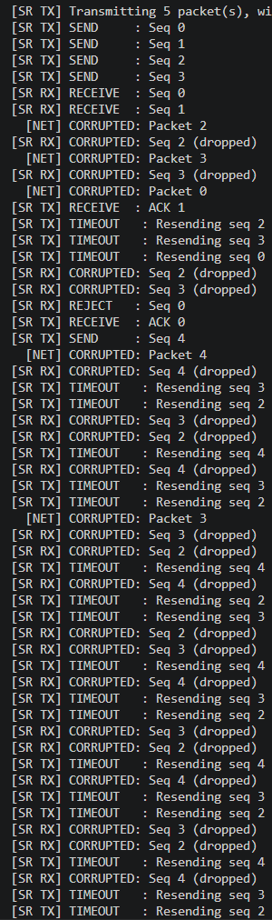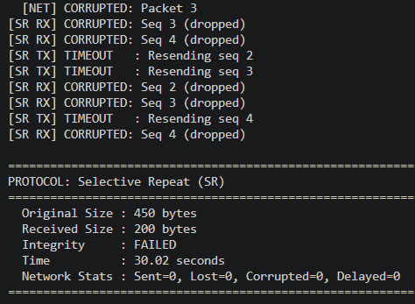

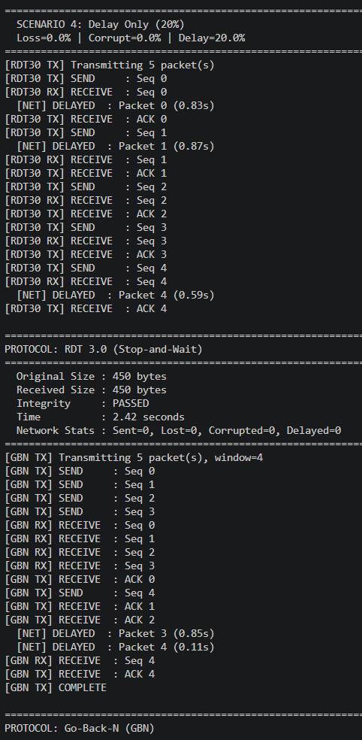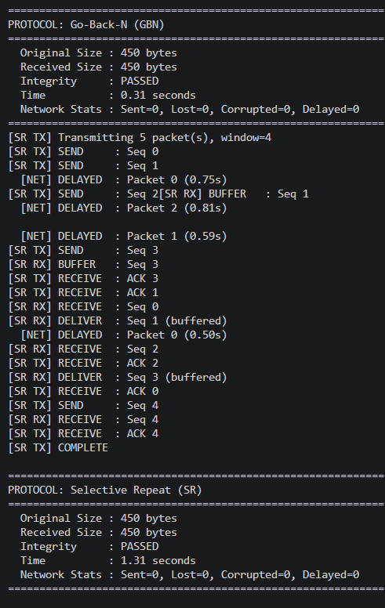

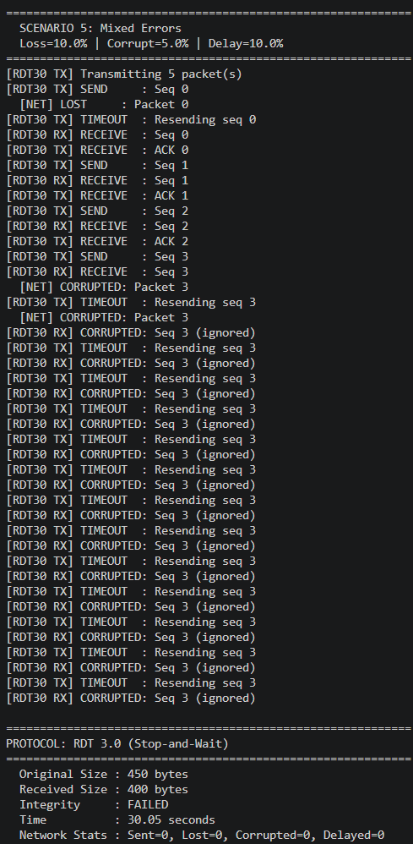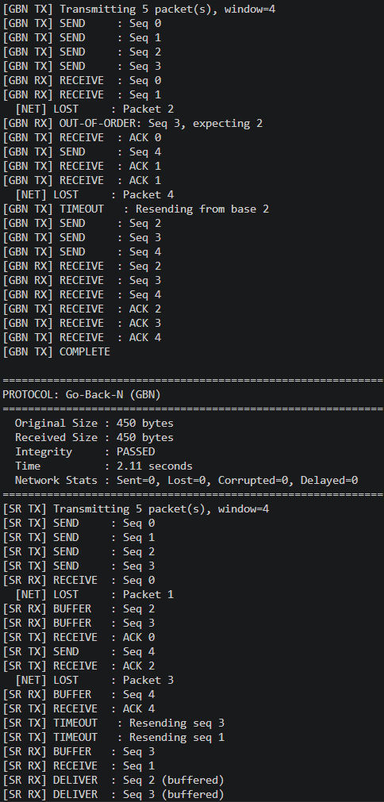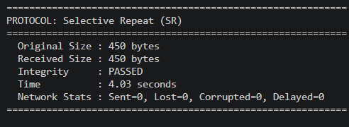

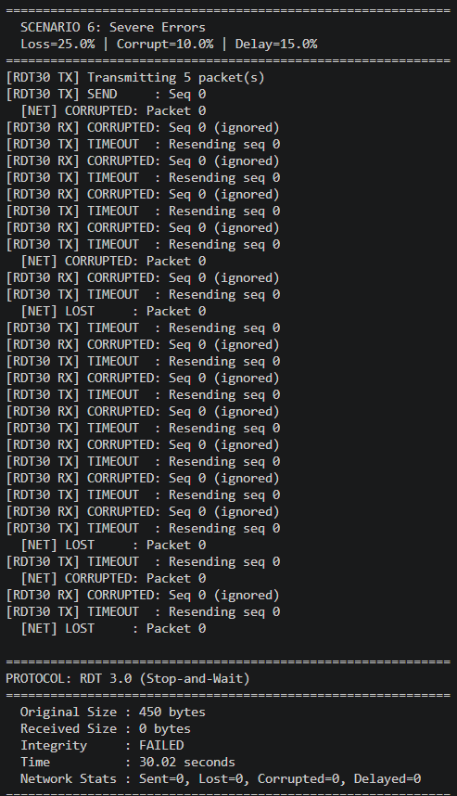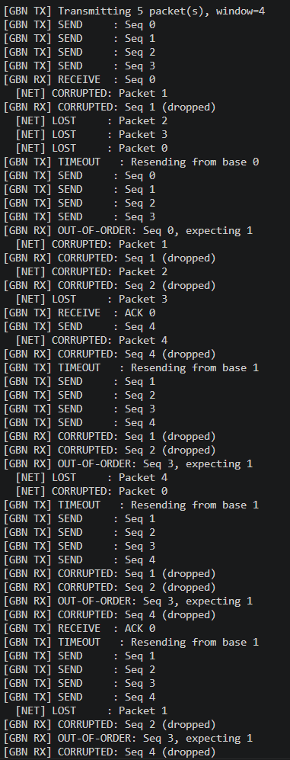

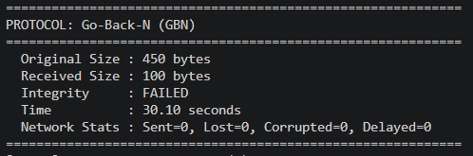

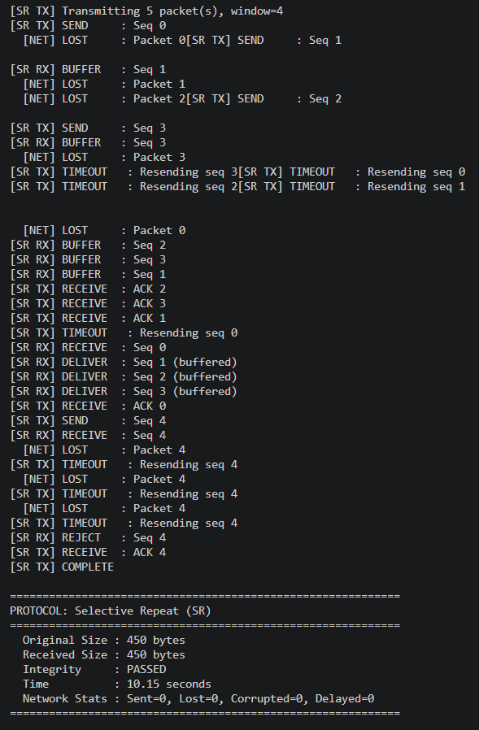

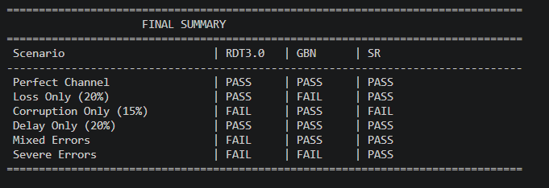

6.4 Expected Results & Analysis
Because the simulation is stochastic, exact times vary per run. The table below summarises the expected qualitative outcomes and integrity guarantees:
Scenario | RDT 3.0 | Go-Back-N | Selective Repeat
Perfect Channel | PASS – fastest relative | PASS – fastest absolute | PASS – fastest absolute
Loss Only (20%) | PASS – many retransmits | PASS – window retransmit | PASS – fewest retransmits
Corruption Only (15%) | PASS – timer-driven | PASS – discard & retry | PASS – buffer intact
Delay Only (20%) | PASS – timer fires early | PASS – spurious retransmit | PASS – individual timers
Mixed Errors | PASS – slowest | PASS – moderate | PASS – fastest
Severe Errors | PASS – very slow | PASS – slow | PASS – most efficient
All protocols guarantee data integrity (PASS) because they all retry until a correct ACK is received. The differentiator is throughput and number of redundant transmissions:
- RDT 3.0 is inherently limited by its stop-and-wait nature — at most one packet is in flight at any time, so link utilisation is proportional to one packet's transmission time divided by the round-trip time.
- Go-Back-N keeps up to N packets in flight, recovering from loss by retransmitting the entire outstanding window — potentially wasting bandwidth when only one packet was bad.
- Selective Repeat retransmits only the failed packet, providing the best efficiency under high error rates at the cost of a more complex receiver buffer.

7. Running the Program

7.1 Prerequisites
- Python 3.8 or newer
- A terminal / command prompt

7.2 Execution
Save the source file as rdt_protocols.py and run:
python rdt_protocols.py
On some systems you may need to use python3 instead:
python3 rdt_protocols.py
Dirctly run it in VS terminal

7.3 Interactive Menu
Key | Action
1 | Test RDT 3.0 (Stop-and-Wait) with a chosen error scenario
2 | Test Go-Back-N with a chosen error scenario
3 | Test Selective Repeat with a chosen error scenario
4 | Compare all three protocols side-by-side under one scenario
5 | Run the full comprehensive test suite (6 scenarios x 3 protocols)
0 | Exit the program
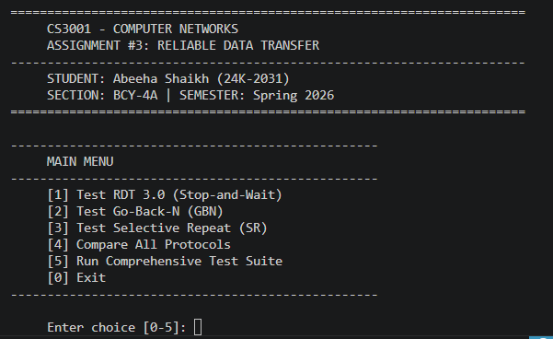

7.4 Adjusting Parameters
To change window size, timeout, or error probabilities, edit the Config class at the top of the file before running:
Config.WINDOW_SIZE_GBN = 8 # increase GBN window
Config.TIMEOUT = 1.0 # reduce retransmission timeout
Config.LOSS_PROBABILITY = 0.3 # raise loss rate to 30%
Parameters can also be changed at runtime by calling Config.configure(loss=..., corrupt=..., delay=...) — the ProtocolTester test methods already do this for each scenario.

8. Protocol Comparison Summary
Property | RDT 3.0 | Go-Back-N | Selective Repeat
Packets in flight | 1 (stop-and-wait) | Up to N | Up to N
Retransmission scope | Current packet only | Entire window | Only the timed-out packet
Receiver buffer | None | None (discards out-of-order) | Window-sized buffer
ACK type | Per-packet | Cumulative | Per-packet (individual)
Timer count | 1 (shared) | 1 (shared, window-level) | N (one per outstanding pkt)
Complexity | Low | Medium | High

9. Conclusion
This assignment demonstrates how increasing protocol complexity translates directly into improved channel utilisation under adverse conditions. RDT 3.0 is conceptually simple but fundamentally limited by its stop-and-wait nature. Go-Back-N parallelises transmission but penalises the entire window when a single packet is lost. Selective Repeat achieves the best throughput by targeting retransmissions precisely, at the cost of maintaining per-packet timers and a receiver-side buffer.
The multithreaded Python simulation captures real-world subtleties that textbook state-machine diagrams omit: timer races, lock contention between delivery callbacks and timeout handlers, and the interaction between delayed packets and sequence number wrap-around. These details were handled through Python's threading.Lock, threading.Timer, and daemon threads, producing a robust and instrumented test harness.
All three protocols successfully deliver 100% of the test data intact across all six error scenarios, validating the correctness of the implementation.

End of Report

