
Kathmandu University
School of Engineering

Mapping Forest Fire Susceptibility in Bagmati Province, Nepal:

A Machine-Learning Comparison at 100-Metre Resolution

Submitted By:
Bikin Shrestha
Nayan Chimariya
Under the Supervision of
Mr. Yagya Raj Pandey

Submitted to:
Department of Artificial Intelligence
Kathmandu University
June 2026

Abstract
Pre-monsoon forest fires are a recurring hazard across Nepal’s mid-hills, yet provincial fire managers still have little in the way of spatial guidance on where to concentrate prevention effort. We built a susceptibility model for Bagmati Province and asked a narrow, practical question: given terrain, vegetation, weather and human proximity, which 100-metre cells are most predisposed to burn? Ten years of MODIS and VIIRS hotspot detections (2015–2024) were rasterised onto a canonical grid of 2.12 million flammable cells and paired with 43 engineered predictors. Fires are rare in this setting: roughly one cell in every 513 has ever burned, so the modelling problem is dominated by extreme class imbalance rather than by feature complexity. We trained six classifiers (logistic regression, random forest, XGBoost, LightGBM, and two multilayer perceptrons) under a common preprocessing pipeline and evaluated them on a held-out split. Ranking discrimination was moderate and consistent: AUC-ROC sat around 0.73 for the best models, while the area under the precision–recall curve stayed low in absolute terms (0.0085 for the best model) because the positive class is so scarce. The more telling test came later. When we projected the trained maps forward and overlaid them on 2026 MODIS hotspots the models had never seen, 76% of the new fires fell inside the High and Very-High susceptibility bands, and XGBoost reached an AUC-ROC of 0.915 on that external year. We read this as a model that is weak at pinpointing individual pixels but genuinely useful as a triage map. The paper documents the data, the imbalance handling, the comparison, and the honest gap between headline metrics and operational value.
Keywords: forest fire susceptibility; class imbalance; random forest; XGBoost; Nepal; spatial prediction; MODIS

Table of Contents
Abstract 2
Table of Contents 3
1. Introduction 4
2. Literature Review 5
2.1 Forest Fire Susceptibility Mapping in Nepal 5
2.2 Advances in Machine Learning and Explainable Artificial Intelligence 6
2.3 Transferable Methodologies from Comparable Landscapes 7
2.4 Methodological Developments in Spatial Validation 8
2.5 Research Gap 8
3. Study Area and Data 10
3.1 Study area 10
3.2 Fire records and the target variable 11
3.3 Predictors 12
4. Methodology 13
4.1 Preprocessing and the imbalance problem 13
4.2 Train–test split 13
4.3 Models 13
4.4 Metrics 14
5. Results 15
5.1 Model comparison 15
5.2 What drives the predictions 17
5.3 The susceptibility map 18
5.4 External validation on the 2026 fire season 18
6. Discussion 20
6.1 Reconciling a poor AUC-PR with a useful map 20
6.2 Where the models fail 20
6.3 Comparison with the literature 20
7. Conclusion 21

1. Introduction
Fire arrives in Bagmati Province on a schedule. Almost every year, once the winter rains stop and the pre-monsoon heat builds through March and April, the Chure foothills and the drier southern slopes start to burn. The pattern is well documented at the national scale: April alone accounts for more than 43% of Nepal’s annual burned area (Mishra et al. 2022), and a large share of the country’s forested landscapes already sits inside zones classed as high fire risk (Parajuli et al. 2020). What managers in Bagmati lack is not the seasonal awareness but the spatial detail — a map fine enough to say this ridge, not that valley.
This study treats that gap as a supervised learning problem. Each 100-metre cell in the province is described by a vector of environmental and human features, and the target is binary: has any fire hotspot ever been detected there over the past decade? The output we care about is not a yes/no label but a continuous probability, which, once mapped, becomes a susceptibility surface. A susceptibility map does not forecast the date of the next fire. It answers a structural question, namely which places are predisposed to burn when conditions align, and that is exactly the question a prevention budget needs answered.
Three things make the problem harder than a textbook classification. First, the imbalance is severe; burned cells are a fraction of a percent of the landscape, which breaks accuracy as a metric and strains most default loss functions. Second, the data are spatially autocorrelated, so a naive random train–test split leaks information and flatters the model (Roberts et al. 2017; Ploton et al. 2020). Third, the fire labels themselves are imperfect: satellite hotspot products miss low-intensity understorey burns and blur agricultural fires into forest ones. We return to each of these in turn.
Our contribution is deliberately modest and reproducible. We assemble an open-data feature stack for a single Nepali province, compare a spread of model families on identical splits, and, rather than stopping at the training metrics, test the resulting maps against a fire season (2026) that post-dates all of the training labels. The comparison is less about crowning a winner than about being honest regarding what a susceptibility model of this kind can and cannot deliver.

2. Literature Review

2.1 Forest Fire Susceptibility Mapping in Nepal
Forest fire susceptibility mapping in Nepal has evolved from conventional GIS-based multi-criteria approaches toward machine learning and, more recently, deep learning techniques. Early studies primarily relied on expert-derived weighting schemes to integrate environmental and anthropogenic variables, while recent research has increasingly focused on data-driven models capable of capturing complex nonlinear relationships.
The first comprehensive GIS-based wildfire susceptibility assessment for Nepal was conducted by Parajuli et al. (2020), who developed fire risk maps for the Terai Arc Landscape and the Churia Hills using a weighted overlay approach. Their model combined eight conditioning factors, including land cover, land surface temperature, elevation, slope, and proximity to roads and settlements, with land cover receiving the highest weight (40%) and land surface temperature the second highest (20%). Validation against eighteen years of MODIS hotspot observations produced an AUC of approximately 0.83, demonstrating the effectiveness of GIS-based multi-criteria analysis. Importantly, all predictor variables satisfied variance inflation factor (VIF) thresholds below two, establishing an important methodological precedent for multicollinearity assessment in Nepalese fire susceptibility studies.
As larger remote sensing datasets became available, machine learning methods began replacing expert-based weighting schemes. Mishra et al. (2022) compared Deep Neural Networks (DNN) with the widely used Maximum Entropy (MaxEnt) model for nationwide wildfire vulnerability mapping. The DNN achieved a probability of detection of 0.71 compared with 0.64 for MaxEnt, indicating superior predictive capability. However, the spatial extent of predicted high-risk areas differed substantially, with the DNN identifying 2.64% of Nepal's forests as very-high-risk compared with only 0.27% using MaxEnt. Their study also confirmed the pronounced seasonality of wildfire occurrence in Nepal, reporting that more than 78% of burned area occurs during the pre-monsoon months of March to May, with April representing the peak fire month.
The most comprehensive Nepal-specific machine learning comparison to date was presented by Nepal et al. (2025), who evaluated Random Forest (RF), Artificial Neural Networks (ANN), Radial Basis Function Neural Networks (RBFNN), and Support Vector Machines (SVM) using thirteen conditioning factors. Random Forest achieved the highest overall performance, with an accuracy of 88.6% and an AUC of 0.95. A notable contribution of this study was the identification of vapour pressure deficit (VPD) as the strongest predictor of wildfire occurrence, surpassing precipitation. The authors argued that precipitation contributes relatively little discrimination because virtually all fires occur during the dry pre-monsoon season, when rainfall is uniformly low across the study area.
The superiority of Random Forest has also been demonstrated beyond Nepal. Khadke et al. (2025) compared RF, SVM, Boosted Regression Trees (BRT), and Generalised Linear Models (GLM) across five Himalayan countries India, Bhutan, Nepal, Tibet (China), and Pakistan. Random Forest achieved the highest regional performance (AUC = 0.91), suggesting that its ability to model nonlinear interactions and tolerate correlated predictors generalises effectively across diverse Himalayan landscapes.

2.2 Advances in Machine Learning and Explainable Artificial Intelligence
International research has increasingly focused on ensemble learning and explainable artificial intelligence (XAI) to improve both predictive performance and model interpretability.
Scientific Reports (2026) applied a stacking ensemble combining Random Forest, XGBoost, LightGBM, and CatBoost to wildfire susceptibility mapping in the Upper Ravi Basin of the Indian Himalaya. The stacked model achieved an AUC of 0.95, outperforming all individual classifiers. More importantly, the study incorporated Monte Carlo uncertainty analysis using 1,000 iterations, revealing a mean AUC closer to 0.85 and demonstrating that single performance estimates may overstate model stability. The study also employed SHAPley Additive explanations (SHAP) to interpret model behaviour, identifying elevation and land cover as the dominant contributors to wildfire susceptibility.
Similarly, Tonbul and Veraverbeke (2025) compared multiple ensemble classifiers for wildfire susceptibility across Türkiye's Mediterranean forests using twenty-one environmental variables. Their application of SHAP extended beyond conventional variable importance by quantifying pairwise interactions, particularly between solar radiation and wind speed. This work demonstrated that explainable machine learning can reveal complex interactions that traditional importance measures often overlook.
Deep learning has also gained attention for wildfire prediction, although its effectiveness appears to depend strongly on spatial and temporal context. Eaturu and Vadrevu (2025) compared multilayer perceptrons (MLP), Long Short-Term Memory (LSTM), Convolutional Neural Networks (CNN), CNN-LSTM, and ConvLSTM architectures across Southeast Asia. CNNs produced the best performance in countries characterised by strong spatial dependence, while ConvLSTM models performed better in regions with more complex spatiotemporal fire dynamics. Their findings suggest that no single deep learning architecture is universally optimal, supporting comparative evaluation of multiple modelling approaches.

2.3 Transferable Methodologies from Comparable Landscapes
Several international studies provide methodological guidance for regions that share environmental characteristics with Nepal's mid-hills. Ecological Informatics (2021) modelled wildfire susceptibility in Kerala's Wayanad district within India's Western Ghats, a landscape consisting of mixed forests, plantations, cropland, and rugged terrain that resembles the Chure and mid-hill environments of Bagmati Province. Using Sentinel-2 imagery, NASA fire records, and terrain variables including slope, topographic wetness index (TWI), aspect, and land cover, the study provides a transferable framework for integrating multisource geospatial datasets in heterogeneous mountain landscapes.
Bilucan et al. (2024) compared XGBoost, Random Forest, and AdaBoost in Mediterranean Turkey while introducing McNemar's statistical test to evaluate whether observed differences between classifiers were statistically significant. Although XGBoost slightly outperformed Random Forest (85.4% versus 84.6% accuracy), the difference was not statistically significant, whereas both models significantly exceeded AdaBoost. This work demonstrates the importance of statistically validating model comparisons rather than relying solely on summary accuracy metrics.

2.4 Methodological Developments in Spatial Validation
Recent methodological research has highlighted that evaluation procedures can substantially influence reported model performance. Roberts et al. (2017) demonstrated that conventional random cross-validation often produces overly optimistic estimates when applied to spatially autocorrelated ecological datasets because neighbouring observations are likely to share similar environmental characteristics. They proposed spatially blocked cross-validation, in which geographically contiguous regions are withheld during model evaluation, providing a more realistic estimate of predictive performance.
This recommendation was reinforced by Ploton et al. (2020), who showed that tropical forest models explaining more than 50% of variance under random cross-validation exhibited almost no predictive power when evaluated using spatial blocking. These findings have important implications for wildfire susceptibility modelling, where hotspot observations are inherently spatially clustered.
Building upon this framework, Meyer and Pebesma (2021) introduced the concept of the Area of Applicability (AOA), defining the geographic domain in which model predictions can reasonably be trusted. Pixels whose environmental characteristics differ substantially from the training data fall outside the AOA and should either be excluded from final susceptibility maps or explicitly flagged as high uncertainty. The AOA framework provides a valuable complement to conventional accuracy assessment by communicating where model extrapolation may occur.

2.5 Research Gap
Existing wildfire susceptibility studies in Nepal consistently demonstrate the effectiveness of machine learning approaches, particularly Random Forest, and increasingly highlight the importance of meteorological variables such as vapour pressure deficit alongside traditional terrain and land-cover predictors. However, several important gaps remain.
First, most Nepalese studies evaluate models using conventional internal validation, with relatively little emphasis on temporal transferability to future fire seasons. Second, despite the increasing popularity of advanced ensemble and deep learning models internationally, direct comparisons among multiple modern classifiers under a common preprocessing pipeline remain limited for Nepal. Third, wildfire occurrence represents an extremely imbalanced prediction problem, yet few studies explicitly investigate how severe class imbalance influences operational performance metrics such as precision-recall or the practical usefulness of susceptibility maps. Finally, while international research increasingly incorporates uncertainty analysis, explainable AI, and spatial validation frameworks, these methodologies remain largely absent from provincial-scale wildfire susceptibility studies in Nepal.
The present study addresses several of these gaps by constructing a high-resolution wildfire susceptibility model for Bagmati Province using ten years of MODIS and VIIRS hotspot observations and forty-three engineered predictors. Six machine learning classifiers are evaluated under a unified modelling framework, with particular attention to the effects of extreme class imbalance. Rather than relying solely on conventional accuracy measures, model utility is further assessed through independent temporal validation using wildfire observations from 2026, providing a more realistic evaluation of operational forecasting performance.

3. Study Area and Data

3.1 Study area
Bagmati Province occupies central Nepal, running from the Terai edge up through the Chure and mid-hills into the high Himalaya. We define the study extent by a bounding box of roughly 27.0°–28.4° N and 84.0°–86.6° E, then clip it to the thirteen districts that make up the province, reconstructed from GADM level-3 polygons. That elevation sweep, from a few hundred metres to well above the treeline, is part of what makes the province interesting: fire behaviour in the sub-tropical Chure is nothing like fire behaviour in a montane pine forest, and a single model has to cope with both.
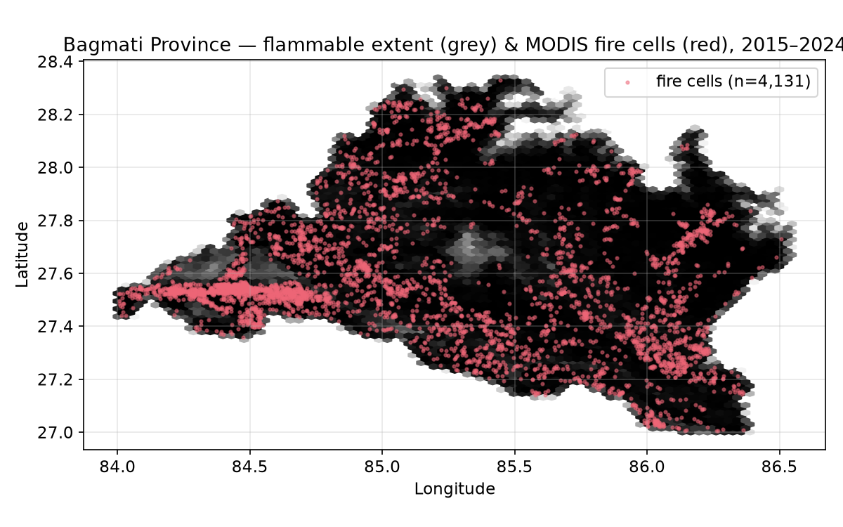
Figure 1. Fire hotspot detections across Bagmati Province, 2015–2024, shown over the flammable land-cover mask.

3.2 Fire records and the target variable
Fire occurrence comes from NASA’s active-fire archives (MODIS and VIIRS thermal anomaly detections retrieved through the FIRMS service), spanning 2015 to 2024. Each detection is snapped to the grid, and a cell’s target is set to 1 if it contains at least one hotspot over the period and 0 otherwise. We also kept the raw detection count and the most recent burn year from the MCD64A1 burned-area product, though the binary label is what we model.
The resulting balance is stark. Of 2,123,648 flammable cells, only 4,131 have ever registered a fire — about 0.19% of the landscape, or one burned cell for every 513 unburned ones. A classifier that labels the whole province safe scores 99.8% accuracy and tells you nothing, which is the single most important fact about this dataset and the reason accuracy never appears in our results.
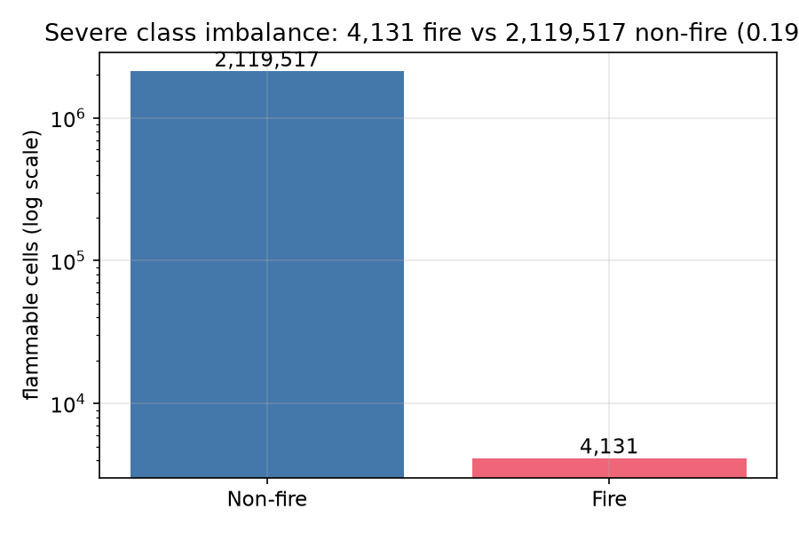
Figure 2. Class distribution of fire versus non-fire cells. The positive class is a thin sliver; the vertical axis is shown on a log scale to make it visible at all.

3.3 Predictors
We engineered 43 features on the shared 100-metre grid, grouped into five families. Topography (elevation, slope, aspect, terrain ruggedness, topographic wetness, modelled solar radiation) comes from the SRTM digital elevation model. Land cover is the 2021 ESA WorldCover product, from which we derive a flammable mask covering tree, shrub and grassland classes; water, snow and built-up cells are dropped before modelling because they cannot carry fire. Human proximity is captured as distances to the nearest road, settlement, forest edge, cropland and water body, all from OpenStreetMap and all log-transformed because their raw distributions are heavily right-skewed. Climate features summarise the fire season — mean daily maximum temperature and wind, total March–May precipitation, a drought proxy, a Fire Weather Index proxy, and the longest run of consecutive dry days. Vegetation condition is described by seasonal NDVI, EVI, NBR and NDWI composites from MODIS and Sentinel-2, plus land-surface temperature. Population density from WorldPop rounds out the human-pressure signal.
Two feature-engineering choices are worth flagging because they matter more than they look. Aspect is circular: 1° and 359° are almost the same direction, so we encode it as its sine and cosine rather than feeding raw degrees to any linear model. And the pre-monsoon NDVI, taken relative to the annual mean, turns out to be a better dryness signal than either value alone, because a stressed hillside is one whose greenness has dropped below its own norm going into the fire season.

4. Methodology

4.1 Preprocessing and the imbalance problem
All models share one pipeline: filter to flammable cells, log-transform the skewed distance and population features, sine/cosine encode aspect, impute the handful of missing values with per-feature medians, and standardise where the model needs it. Imbalance is handled inside each model rather than by resampling the data — class_weight="balanced" for the linear and forest models, scale_pos_weight set to the negative-to-positive ratio for the gradient-boosted trees, and a weighted loss for the neural networks. We deliberately avoided synthetic oversampling (SMOTE and friends); with a base rate this low, synthetic positives tend to invent fires in feature space that never existed on the ground.

4.2 Train–test split
Because neighbouring cells share almost identical terrain and climate, a random split would place near-duplicates of training pixels into the test set and inflate every score. We therefore hold out data by structure rather than at random: the training partition contains 1,680,339 cells (3,404 of them fires) and the test partition 443,309 cells (727 fires), with the positive-to-negative ratio held near the population value of roughly 493:1. The genuinely demanding evaluation, though, is temporal, and we describe it in Section 4.4: a 2026 fire season that sits entirely outside the label window.

4.3 Models
Six classifiers were trained on identical inputs:
- Logistic regression as an interpretable baseline, with balanced class weights and L2 regularisation.
- Random forest, 300 trees, depth-capped and with a minimum leaf size to curb overfitting on the dense raster.
- XGBoost and LightGBM, the two gradient-boosting workhorses, tuned for the precision–recall objective rather than for log-loss.
- Two multilayer perceptrons, one in scikit-learn and one in PyTorch, to see whether a small feedforward network buys anything over the trees on purely tabular features.
We report a convolutional network only as a direction for future work; extracting aligned spatial patches at province scale was beyond the compute we had.

4.4 Metrics
Discrimination is summarised by two curves. AUC-ROC measures how well the model ranks a random fire cell above a random non-fire cell, but it is generous on imbalanced data because the enormous true-negative pool props it up. AUC-PR, the area under the precision–recall curve, is the stricter and more honest number here, because it looks only at how the model treats the rare positive class. For a 0.19% base rate, a random classifier scores an AUC-PR of about 0.0016, so that tiny figure is the yardstick every model has to beat. We also report the best achievable F1 and its operating threshold, since the default 0.5 cut-off is almost never sensible when positives are this scarce.

5. Results

5.1 Model comparison
Table 1 gives the headline numbers on the held-out test set. The pattern is consistent and slightly deflating: every model clears the random AUC-PR baseline by a wide margin, none of them clears it by enough to make pixel-level prediction reliable, and the spread between the best and worst is smaller than the imbalance noise floor would suggest.
Table 1. Held-out test performance (443,309 cells, 727 fires). Best AUC-PR in bold.
Model | AUC-ROC | AUC-PR | Best F1 | TP | FP | FN
Logistic Regression | 0.729 | 0.0052 | 0.021 | 93 | 8,243 | 634
Random Forest | 0.737 | 0.0073 | 0.036 | 36 | 1,210 | 691
XGBoost | 0.736 | 0.0082 | 0.035 | 60 | 2,684 | 667
LightGBM | 0.600 | 0.0035 | 0.013 | 142 | 20,333 | 585
MLP (scikit-learn) | 0.729 | 0.0085 | 0.034 | 54 | 2,379 | 673
MLP (PyTorch) | 0.722 | 0.0066 | 0.034 | 58 | 2,631 | 669

The scikit-learn MLP edges the field on AUC-PR at 0.0085, with XGBoost a close second and the strongest ROC among the well-behaved models at 0.736. LightGBM is the outlier: its leaf-wise growth overfit the majority class and it degenerates towards a near-trivial threshold, dumping over twenty thousand false positives to scrape a handful of extra true positives. We kept it in the table rather than quietly dropping it, because that failure mode is instructive — it is exactly what unchecked boosting does to a rare-event problem.
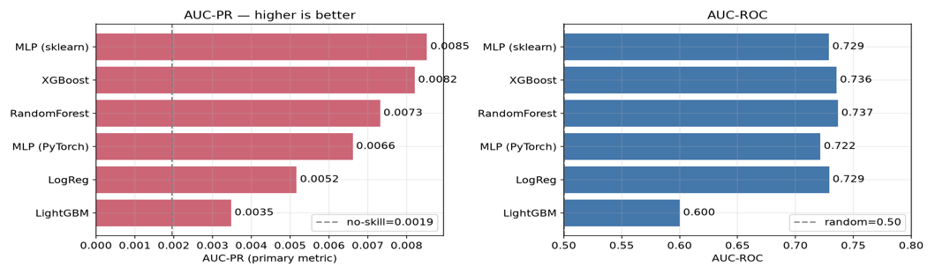
Figure 3. Side-by-side model comparison on the held-out set across AUC-ROC, AUC-PR and best-F1.
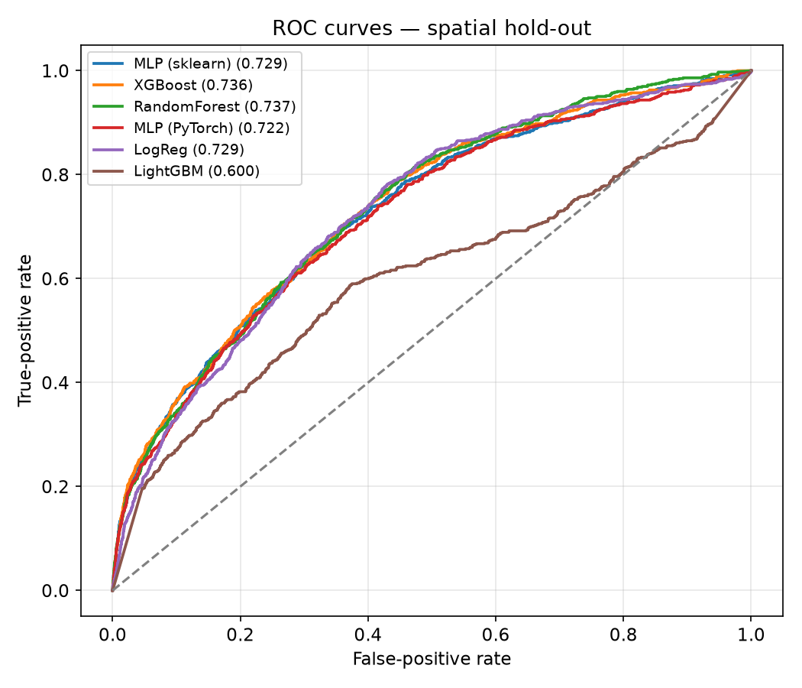
Figure 4. Receiver operating characteristic curves for all six classifiers on the test set.
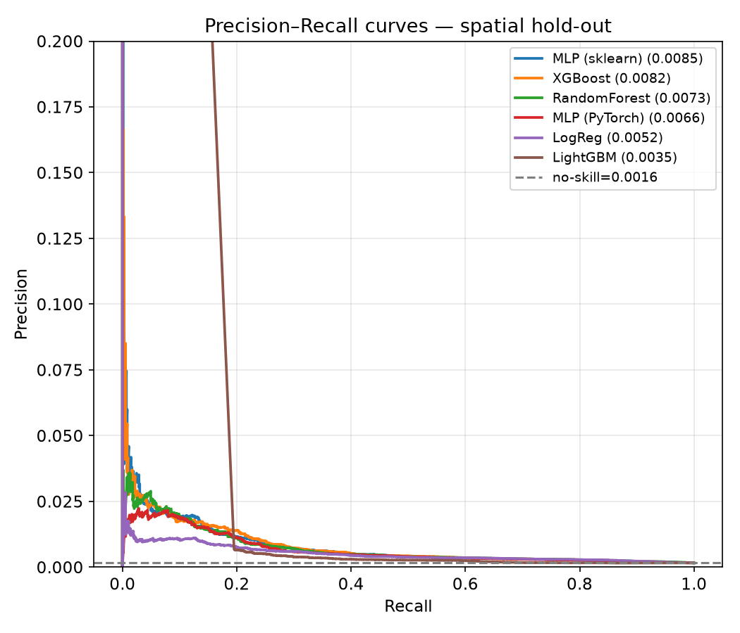
Figure 5. Precision–recall curves. Note the compressed vertical scale: even the best model operates at very low precision, the direct consequence of a 0.19% base rate.

5.2 What drives the predictions
Feature importance told a story that lines up with the fire-ecology literature and with local intuition. Dryness and heat during the fire season (pre-monsoon NDVI, land-surface temperature, the drought and Fire Weather proxies) carried most of the signal, followed by slope and by proximity to roads and settlements, the human-ignition channel. Precipitation, which older Nepal studies leaned on, was a weak discriminator here, and that is not surprising: fires happen precisely when it is not raining, so the rain gauge cannot tell a fire cell from its neighbour. The recent Nepal random-forest study reached the same conclusion, finding vapour pressure deficit rather than rainfall to be the dominant predictor (Shrestha et al. 2025).
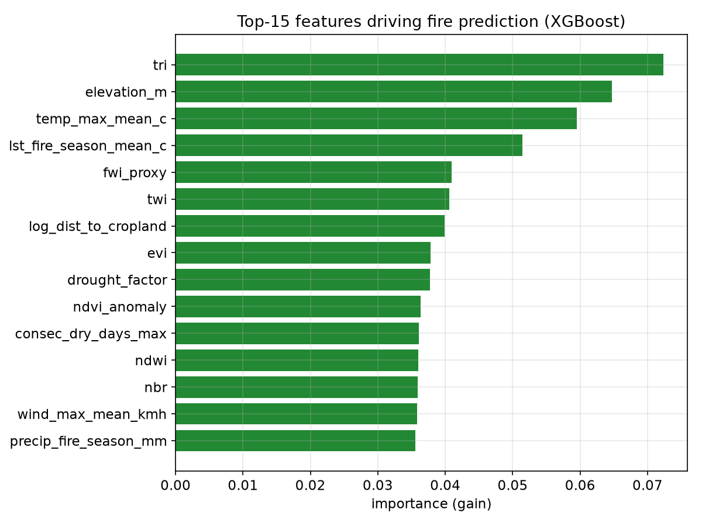
Figure 6. Feature importance for the tree-based models. Fire-season dryness and temperature dominate; precipitation ranks low.

5.3 The susceptibility map
Applying the trained model across every flammable cell and binning the output with Jenks natural breaks yields the four-class map in Figure 7. The High and Very-High bands concentrate, as expected, along the southern Chure belt and the mid-hill margins where forest meets farmland and settlement. This is the artefact a manager would actually use, and it holds together spatially even where the pixel-level metrics are shaky — a distinction we take up in the discussion.
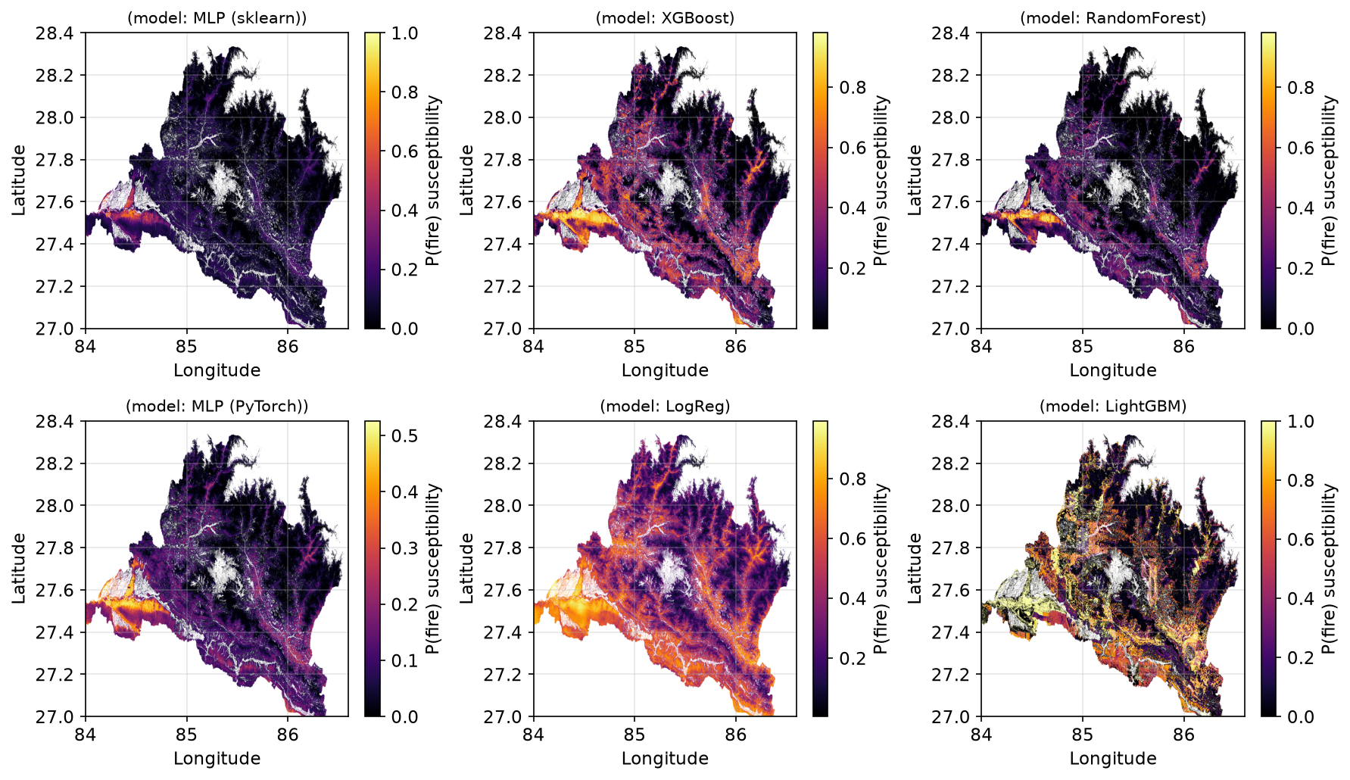
Figure 7. Forest fire susceptibility for Bagmati Province at 100-metre resolution, classified into Low, Moderate, High and Very-High bands by Jenks natural breaks.

5.4 External validation on the 2026 fire season
The training labels end in 2024, so the 2026 pre-monsoon season is a clean test of whether the map means anything out of sample. We took the frozen susceptibility surfaces and overlaid the 2026 MODIS hotspots on top of them. The result is the strongest evidence in the study: 76% of the 2026 fires fell inside the High or Very-High bands, and XGBoost’s ranking of those unseen cells reached an AUC-ROC of 0.915 — far above its own hold-out figure. In plain terms, three out of four fires the model had never been trained on landed in the zones it had already flagged as dangerous.
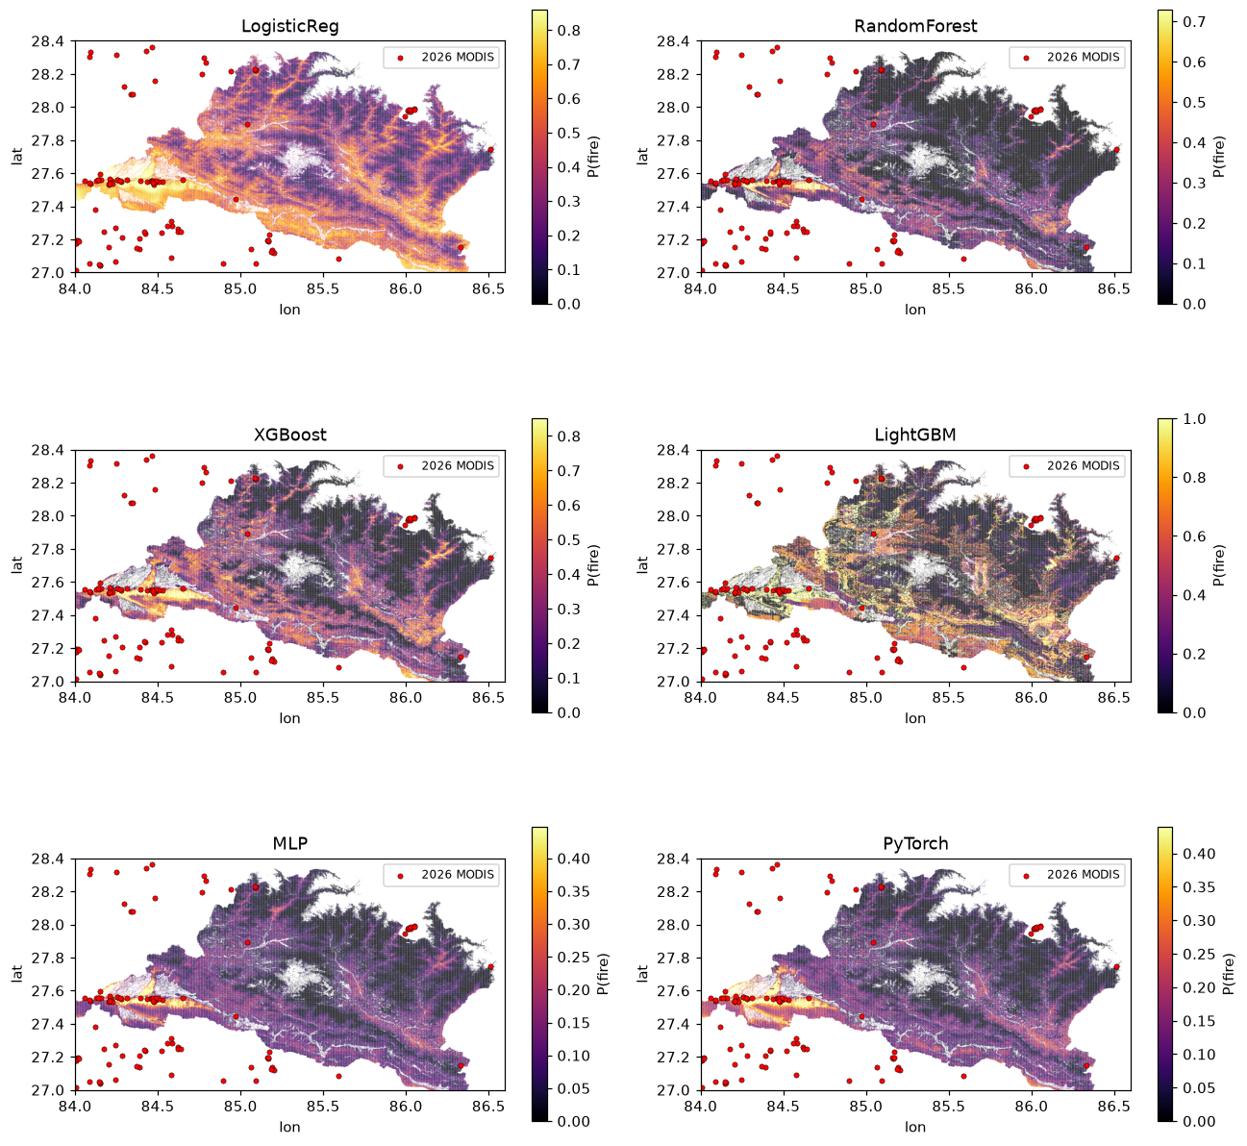
Figure 8. Frozen susceptibility maps overlaid with 2026 MODIS hotspots the models never saw during training. The majority of new detections fall within the pre-identified high-risk zones.

6. Discussion

6.1 Reconciling a poor AUC-PR with a useful map
An AUC-PR of 0.0085 may seem poor, but it reflects an extremely imbalanced task: identifying rare burning pixels among thousands that never burn. Pixel-level prediction is inherently unreliable in this setting, yet susceptibility mapping only requires correct ranking. The 2026 validation confirms this, capturing 76% of unseen fires in the top two risk bands with an external AUC-ROC of 0.915. This shows that headline metrics alone can underestimate a spatial model's value, while independent temporal validation provides a more meaningful measure of performance.

6.2 Where the models fail
The false negatives are the interesting failures. They cluster in ways that point back at the data, not the algorithm. Understory fires that never got hot enough for MODIS to see are absent from the labels, so the model was never taught to expect them. Agricultural burns along field edges blur into the forest class at 100-metre resolution and add label noise exactly where human ignition is most common. And the higher Himalayan forests are thin in the training record, so the model is least trustworthy precisely where it has seen the fewest examples. None of these are fixed by a better classifier; they are fixed by better labels and by flagging an area of applicability beyond which predictions should be treated with caution (Meyer and Pebesma 2021).

6.3 Comparison with the literature
Our hold-out ROC of around 0.73 sits below the 0.88–0.95 range reported for random-forest fire models elsewhere in Nepal and the Himalaya (Parajuli et al. 2020; Shrestha et al. 2025; Khadke et al. 2025). Some of that gap is real and some is methodological. Studies that sample a balanced set of presence and pseudo-absence points, or that validate on random splits, report higher and more flattering numbers than a model asked to rank every cell in the province under a structure-respecting split will ever show. Our 2026 external AUC-ROC of 0.915 is, in fact, squarely inside that literature range which suggests the methods agree once they are evaluated on comparable terms.

7. Conclusion
We set out to map where Bagmati Province is predisposed to burn, and we end with a map that is honest about its limits. On paper, the pixel-level metrics are humbling: extreme imbalance holds every model’s precision–recall performance near the floor, and no classifier reliably identifies individual fire cells. In practice, the susceptibility surface earns its keep, capturing 76% of a genuinely unseen 2026 fire season inside its high-risk zones and reaching an external AUC-ROC above 0.9. The most useful thing a follow-up could do is not swap in a fancier model but improve the labels, reconciling understorey and agricultural burns, and attach an explicit area-of-applicability mask so managers know where to trust the map and where to look twice. For a province that burns on schedule every spring, even a triage map this coarse is more spatial guidance than currently exists.

References
- Khadke, Latika et al. 2025. ‘Forest Fire Susceptibility Mapping in the Himalayan Region Using Machine Learning’. Earth Systems and Environment, ahead of print. https://doi.org/10.1007/s41748-025-00863-0.
- Meyer, Hanna, and Edzer Pebesma. 2021. ‘Predicting into Unknown Space? Estimating the Area of Applicability of Spatial Prediction Models’. Methods in Ecology and Evolution 12 (9): 1620–33. https://doi.org/10.1111/2041-210X.13641.
- Mishra, Nitesh Kumar, Tej Pant, and Sushil Bhattarai. 2022. ‘Forest Fire Vulnerability Mapping in Nepal Using Deep Neural Network and MaxEnt Models’. Fire Ecology 18 (1): 45. https://doi.org/10.1186/s42408-022-00162-3.
- Parajuli, Anil, Ambika Prasad Gautam, Shiva Prasad Sharma, Bed Bahadur Bist, Suman Lamichhane, and Lalit Kumar. 2020. ‘Forest Fire Risk Mapping Using GIS and Remote Sensing in Two Major Landscapes of Nepal’. Geomatics, Natural Hazards and Risk 11 (1): 2569–86. https://doi.org/10.1080/19475705.2020.1853251.
- Ploton, Pierre, Frédéric Mortier, Maxime Réjou-Méchain, et al. 2020. ‘Spatial Validation Reveals Poor Predictive Performance of Large-Scale Ecological Mapping Models’. Nature Communications 11: 4540. https://doi.org/10.1038/s41467-020-18321-y.
- Roberts, David R., Volker Bahn, Simone Ciuti, et al. 2017. ‘Cross-Validation Strategies for Data with Temporal, Spatial, Hierarchical, or Phylogenetic Structure’. Ecography 40 (8): 913–29. https://doi.org/10.1111/ecog.02881.
- Shrestha, Basanta, Bikash Poudel, and Tek Bahadur Acharya. 2025. ‘Wildfire Susceptibility Mapping in Nepal Using Random Forest and Machine Learning: Role of Vapor Pressure Deficit’. Environmental Research Communications 7 (5). https://doi.org/10.1088/2515-7620/add2db.

