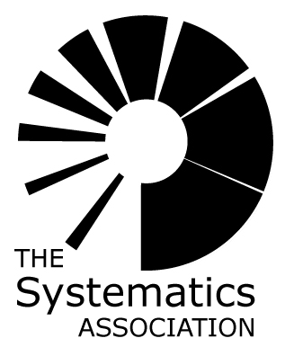
APPLICATION FOR A CONFERENCE ORGANISATION GRANT
FROM THE SYSTEMATICS ASSOCIATION

- The Systematics Association provides grants of up to £3,000 to support the organisation of meetings that are pertinent to the Association’s aims.
- Applications may be submitted at any time of year, but ideally should be received at least 9 months before the date of the proposed meeting. Applications will be evaluated by the Systematics Association’s Council at its meetings in January, April, July and October.
- The Association gives priority to and considers requests for the maximum amount of £3,000 from applicants who submit a viable proposal to publish an Association volume based on the proposed meeting – the Association has a great deal of experience in producing high-quality volumes, many of which become landmark publications in their fields, and add greatly to the profile and value of meetings. Where no Association volume is anticipated then the maximum amount awarded will be £1,500.
- The Systematics Association seeks to support meetings where effort is made to promote diversity and gender balance among the speakers.
- The Association will give priority to applicants who aim to improve access to meetings for participants that would otherwise be unable to attend, especially participants from developing countries.
- Where the maximum amount is awarded, only half of that amount is awarded upfront, the balance being paid on acceptance of a Systematics Association book proposal by Cambridge University Press.
- Any unused funding should be returned to the Systematics Association, who will re-invest it in future meetings
- All successful applicants are expected to provide a report of the meeting to be published in the Systematics Association Newsletter.
- Applications should be returned to Dr. Alex Monro, Herbarium, Royal Botanic Gardens, Kew, Richmond, TW9 3AE, UK. a.monro@kew.org

TITLE OF MEETING:

MAJOR THEMES:

NAMES & ADDRESSES OF ORGANISERS:

PRINCIPAL CONTACT:

PROPOSED VENUE, DURATION & DATE OF THE MEETING:
VENUE:
DURATION: DATE:

ANTICIPATED ATTENDANCE: OPEN / BY INVITATION ONLY?

ANTICIPATED SPEAKERS:

DO YOU PLAN TO PUBLISH A BOOK BASED ON THE MEETING THROUGH THE SYSTEMATICS ASSOCIATION ?

WILL THE MEETING BE ORGANISED JOINTLY WITH ANOTHER SOCIETY OR ORGANISATION?
IF SO, WHICH SOCIETY OR ORGANISATION? WHAT IS THEIR INTENDED INVOLVEMENT IN THE ORGANISATION, FINANCE AND PUBLICATION?

HOW MUCH SUPPORT IS REQUESTED FROM THE SYSTEMATICS ASSOCIATION?

HOW WILL THE SUPPORT BE USED?

WHY IS THIS MEETING TIMELY AND DESERVING OF SUPPORT?

NAMES & ADDRESSES OF 3 SUPPORTERS:

