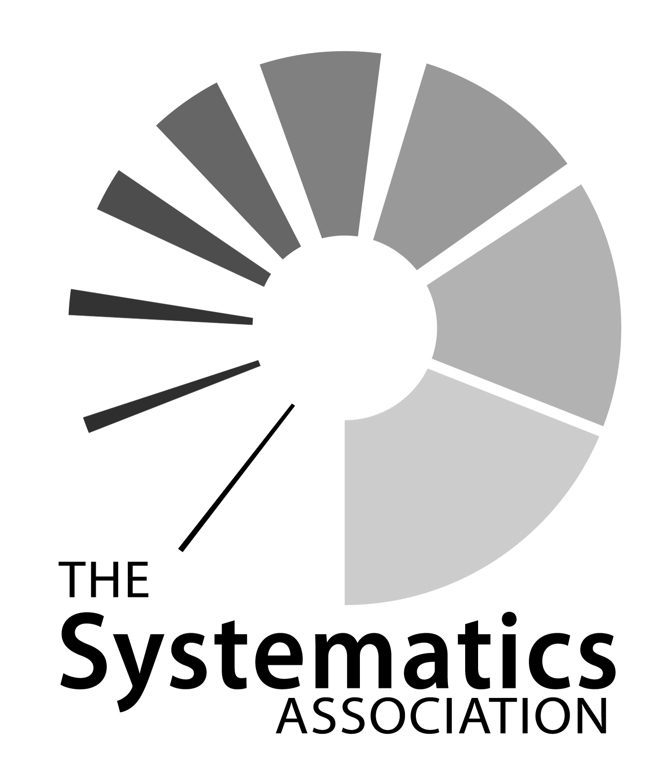
8th Biennial meeting, 4-8th July 2011, Queens University, Belfast

ABSTRACT FORM
Full Name:
Address:
E-mail:
Title of presentation:
Authors’ names (underline presenting author):

I would prefer: A Poster An oral presentation
Please note that we will accommodate as many talks as possible but if we are unable to do so then we will offer you the option of presenting a poster.
I would like my talk to be considered for inclusion in the thematic symposium:
Next Generation Systematics: studying evolution and diversity in an era of ubiquitous genomics | Arthropod Systematics: are morphology, palaeontology and molecules coming together?
Algal Systematics: where next? | Advances in using museum specimens and ancient DNA in systematics research
I do not want my talk to be considered for inclusion in any of these symposia
Top of Form
Bottom of Form

I am a student, and would like to be entered for the student prize session
I would like to be considered for a student bursary
Abstract (max 300 words)

Please email your completed form as a word document to
systass@qub.ac.uk by 19th June 2011

