Scientific-programming committee
Golubets М.А., academician of NAS of Ukraine, Dr., Prof., honorary director of the Institute of Ecology of the Carpathians of NAS of Ukraine, chief of Lviv department of the UBS (head of scientific-programming committee); Mamchur Z.I., PhD, Assist. Prof., Prorector of the scientific-educational work of Ivan Franko LNU (deputy head of scientific-programming committee); Tasenkevich L.O., Dr., Prof., head of botanical department of Ivan Franko LNU (deputy head of scientific-programming committee); Kozlovsky M.P., Dr., director of the Institute of Ecology of the Carpathians of NAS of Ukraine; Chernobay Yu.M., Dr., Prof., director of State Natural History Museum of NAS of Ukraine; Marchenko М.М., Dr., Prof., dean of the faculty of biology, ecology and biotechnology of Yuriy Fedkovich ChNU; Chornej I.I., Dr., Assist. Prof., head of the department of botany and natural protection of Yuriy Fedkovich ChNU; Lobachevska О.V., PhD, s.s.w., chief of the department of plant ecomorphogenesis of the Institute of Ecology of the Carpathians of NAS of Ukraine; Novikoff А.V., j.s.w. of State Natural History Museum of NAS of Ukraine (secretary of scientific-programming committee).

Organizing committee
Tasenkevich L.O., Dr., Prof., head of botanical department of Ivan Franko LNU (head of organizing committee); Prokopiv А.I., PhD, Assist. Prof., director of the Botanical garden of Ivan Franko LNU (deputy head of organizing committee); Budzhak V.V., PhD, Assist. Prof., deputy dean of the faculty of biology, ecology and biotechnology of Yuriy Fedkovich ChNU; Odintsova А.V., PhD, Assist. Prof. of botanical department of Ivan Franko LNU; Danylyuk K.M., PhD, s.w. of State Natural History Museum of NAS of Ukraine; Ragulina М.Ye., j.s.w. of State Natural History Museum of NAS of Ukraine; Dyka О.О., Assist. of botanical department of Ivan Franko LNU; Kazemirska М.А. Phd student of the department of botany and natural protection of Yuriy Fedkovich ChNU; Pochynok Т.V., Phd student of botanical department of Ivan Franko LNU; Izmestieva S.V., Phd student of the Institute of Ecology of the Carpathians of NAS of Ukraine;
Cherepanyn R.М., Phd student of the Institute of Ecology of the Carpathians of NAS of Ukraine.

Contact information
Grushevskogo str. 4, Lviv, 79005, Ukraine
tel.: +38 (067) 17-20-263 (Andrew Novikoff)
e-mail: phytomorphology2012@gmail.com
Organizing payment
Organizing payment consist of registration fee (7 € for personal participation or 4 € – for distant participation) and publishing fee (1 € per one page of publication). If you want to submit several abstracts, you need to pay only one registration fee. In the case of the personal participation of several coauthors of the publication a registration fee must be payed by each of them. The registration fee does not cover hotel accommodations, journey and lunches. Registration fees must be paid by mail transfer on the next address: Novikov Andriy Valeriyovich, Syhivska 17/46, Lviv, 79066, Ukraine. Please write your first and last names on the blank and make a note «Conference payment».

Application form
Name and surname ______________________________________
Place of employment or studying _______________________
Position held ______________________________________________
Scientific degree __________________________________________
Postal address ____________________________________________
E-mail _____________________________________________________
Telephone ________________________________________________
Paper title ________________________________________________
Participation (personal or distant) _____________________
Hotel accommodation (yes or no) ______________________

You must send the application form as a separate file “.doc” or “.docx”. The file name must consist of the first author’s name (e.g. – novikoff_reg.doc).

Important dates
31 January 2012 – deadline for registration, paper submission and payment;
before 1 Mart 2012 – you will get the second circular and official invitation.

Welcome to Lviv!
Ministry of Education and Science, Youth and Sport of Ukraine
Ivan Franko Lviv National University
Biological faculty
Botanical department

Yuriy Fedkovich Chernivtsi National University
Faculty of Biology, Ecology and Biotechnology
Department of Botany and Natural Protection

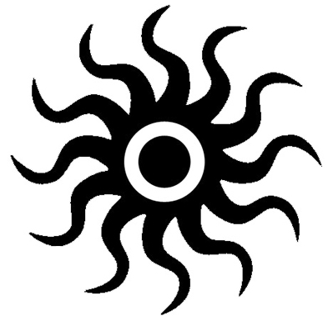

National Academy of Sciences of Ukraine
State Natural History Museum

Institute of Ecology of the Carpathians

Lviv department of the Ukrainian Botanical Society

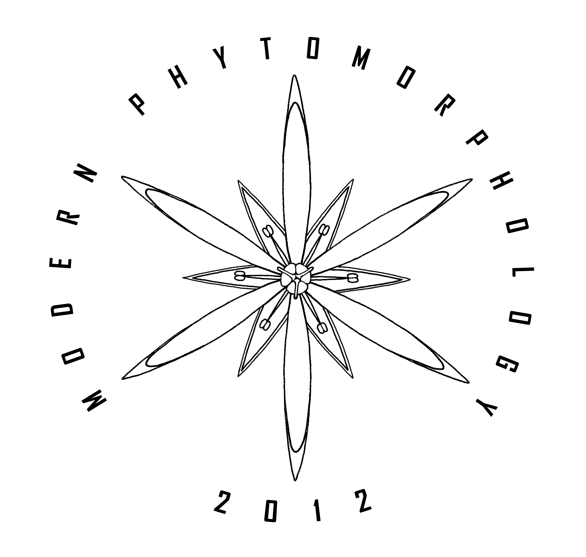

І scientific conference

modern phytomorphology

24-26 April 2012
Lviv
Dear colleagues!
We invite you to participate in the I Scientific Conference “Modern phytomorphology”, which will be held 24-26 April 2012 in Lviv (Ukraine) on the basis of Botanical department of Biological faculty of Ivan Franko Lviv National University.
Especially we invite the scientists, who are specialized in the field of anatomical and morphological studies of plants, fungi and lichens. Also we invite the scientists, who use anatomical and morphological data in own investigations of biology and ecology of underlined organisms.

The papers will be published as a separated conference workbook.

Working areas of conference
♦ theoretical bases and history of structural investigations of plants, fungi and lichens;
♦ anatomical and morphological investigations of plants, and their application in the other fields of botany and ecology;
♦ anatomical and morphological investigations of fungi and lichens, and their application in the other fields of mycology and lichenology.

Working languages
Ukrainian, Russian, English.
Paper format
The paper size shall not exceed 6 А-4 pages; font – Times New Roman, size – 12, indentation – 1,25 сm, 1,5-spaced, width fitted; margins 2 cm on all four sides; file format “.doc” or “.docx”. The file name must consist of the first author name (e.g. – novikoff_text.doc).
Text sequence: article title (12 pt.) ♦ author’s names (12 pt.) ♦ institute, postal address, e-mail (12 pt.) ♦ summary and keywords in the language of main text (10 pt.) ♦ main text (12 pt.) ♦ references (10 pt.) ♦ if the main text language is different from English, than you also must print the article title, institute, postal address, e-mail, summary and keywords in English (10 pt.) ♦ titles for figures and tables in the language of main text and in English (12 pt.).
References (author and year) in the text are cited in the rounded marks. Images are given as separate “.jpg” or “.tiff” files (300 dpi), or they may be placed at the end of the main file on the separated pages. Tables are given as separate “.xls” or “.xlsx” files, or they may be placed at the end of the main file on the separate pages.

Important: a value of the publication of 1 article page is 1 €.

The Organizing committee reserves the right to edit the papers. Papers not corresponding to the recommended format or the topics of the conference will not be accepted.
In this case the organizing payment will be returned (minus transfer fee).
Example of paper

Морфологія аконітів Українських Карпат
Новіков А.В.

Державний природознавчий музей НАН України
вул. Театральна 18, 79008, Львів, Україна
e-mail: novikoffav@gmail.com

Анотація: Виявлено, що аконіти Українських Карпат поділяються на 3 біоморфологічні групи....
Ключові слова: морфологія, Aconitum.

Рід Aconitum L., що належить до родини Ranunculaceae Juss., в Українських Карпатах нараховує 12 видів (Mitka 2003)....

Список використаних джерел
Новіков А.В. (2010): Oсобливості поширення та охорони Aconitum anthora L. (Ranunculaceae) в Українських Карпатах / Природно-заповідний фонд України. Матер. міжнар. наук.-практ. конф.: 446-449.
Kondracki J. (1978): Karpaty. – Warszawa: Wydawnictwo Szkolne i Pedagogiczne. – 158 s.
Capelletti E. & Poldini L. (1984): Seed morphology in some European aconites (Aconitum, Ranunculaceae). – Plant Syst. Evol. 145: 193-201.
Paczoski J. (1927): Aconitum / Szafer W. [ed.] Flora Polska. T. 3: 19-25. – Warszawa-Krakow: PWN.

The morphology of monkshoods from the Ukrainian Carpathians

Novikoff A.V.

State Natural History Museum, NAS of Ukraine
Teatralna str. 18, Lviv, 79008, Ukraine
e-mail: novikoffav@gmail.com

Summary: It was ascertained that monkshoods from the Ukrainian Carpathians are divided into three biomorphological groups...
Keywords: morphology, Aconitum.

Рис. 1. Будова пагона A. anthora L.
Fig. 1. Spear structure of A. anthora L.

Табл. 1. Таксономічні ознаки.
Tab. 1. Taxonomical features.

