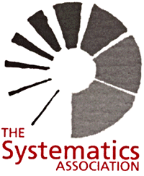

16th YOUNG SYSTEMATISTS’ FORUM

Friday, 28 November 2014, 9:30 am

Venue: Flett Lecture Theatre,
Natural History Museum, London, UK

The annual Young Systematists’ Forum represents an exciting setting for Masters, PhD and young postdoctoral researchers to present their data, often for the first time, to a scientific audience interested in taxonomy, systematics and phylogenetics. This well-established event provides an important opportunity for budding systematists to discuss their research in front of their peers within a supportive environment. Supervisors and other established systematists are also encouraged to attend.

Prizes will be awarded for the most promising oral and poster presentation as judged by a small panel on the day.

Registration is FREE.
Send applications by e-mail to (YSF.SystematicsAssociation@gmail.com), supplying your name, contact address and stating whether or not you wish to give an oral or poster presentation. Space will be allocated subject to availability and for a balanced programme of animal, plant, algal, microbial, molecular and other research. Non-participating attendees are also very welcome - please register as above.

Abstracts must be submitted by e-mail in English no later than Friday 31 October 2014. The body text should not exceed 150 words in length. If the presentation is co-authored, the actual speaker (oral) or presenter (poster) must be clearly indicated in BOLD text.

All registered attendants will receive further information about the meeting, including abstracts, by e-mail one week in advance. This information will also be displayed on the Systematics Association website (www.systass.org).




