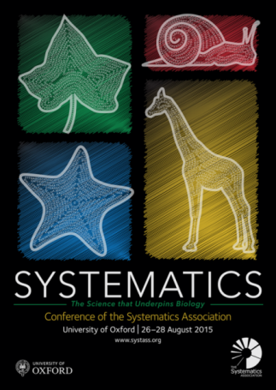



**PhD student scholarships to attend the Biennial meeting of the Systematics Association, 26-28 August 2015**

The Tropical Ecology Group of the British Ecological Society is funding 7 scholarships to enable postgraduate students to attend the Biennial conference of the Systematics Association at the University of Oxford, UK, 26-28 August 2015 (http://www.systass.org/biennial2015/). The meeting comprises a diverse range of thematic sessions on ecological and evolutionary studies in tropical forest ecosystems, recent developments in the analysis of diversification, new approaches to taxonomy and the value of palaeontological studies for systematics. The funding is specifically related to participation in the thematic session on the use of long-term plots for linking ecological and evolutionary studies in the tropics. However, successful applicants will be expected to attend the whole conference and will be encouraged to submit a poster or talk to be presented at the meeting.

The funding consists of:

* Five scholarships of £200 for PhD students of any nationality studying anywhere in the world, to contribute to the costs of registration and accommodation
* Twointernational conference attendance awards of £1500 to cover the travel and subsistence costs of two PhD students from tropical forest countries who are undertaking their PhD research based at a university in a tropical forest country

The scholarships will be awarded based on the fit of student’s research to the thematic session on tropical forests, the potential benefit of the student from attending the meeting, and, for the £1500 scholarships, a demonstrated lack of opportunity for funding at students’ home institution. Applicants cannot apply for both scholarships. Applications should be completed in English.

Please complete the form, and return with a 2-page CV by 30/4/15 to Dr Tim Baker ([t.r.baker@leeds.ac.uk](mailto:t.r.baker@leeds.ac.uk)). Successful applicants will be informed by 15/5/15, and will liaise with Dr Tim Baker to arrange funding.

**Application form for a BESTEG scholarship to attend the Biennial meeting of the Systematics Association, 26-28 August 2015**

**Name:**

**Institution:**

**PhD title:**

**I am applying for:**

1. **£200 scholarship (Y/N)**
2. **£1500 International conference attendance award (Y/N)**

**Describe the topic of your research (max 100 words; expand as necessary)**

**Outline how you would benefit from attending the conference of the Systematics Association (max 100 words; expand as necessary)**

**For applicants for a £1500 award, please describe other sources of travel funding available through your home institution (100 words max; expand as necessary)**

**Please also attach a 2 page CV.**