**MINISTRY OF EDUCATION AND TRAINING**

**FPT UNIVERSITY**

**DOCUMENT REPORT**

Group 4 - Capstone Project 2019

In-Store Customer Heatmap System

Contents

**1. Project Information** 1

**2. Introduction** 1

**3. Current Situation** 2

**4. Problem Definition** 2

**5. Proposed Solution** 2

**5.1. Feature functions** 2

**5.2. Advantages and disadvantages** 3

**6. Functional Requirement** 3

**7. Role and Responsibilities** 3

**A.** **Software Project Management Plan** 3

**1.** **Problem Definition** 3

1.1. Name of This Capstone Project 3

1.2. Problem Abstract 3

1.3. Project Overview 4

**2.** **Project Organization** 4

2.1. Software Process Model 4

2.2. Roles and Responsibilities 4

2.3. Tools and Techniques 4

**3.** **Project Management Plan** 4

3.1. Software Development Life Cycle 4

3.2. Phase Detail 4

3.3. All Meeting Minutes 4

**4.** **Coding Convention** 5

**B.** **Software Requirement Specification** 5

**1.** **User Requirement Specification** 5

**2.** **System Requirement Specification** 6

2.1. External Interface Requirement 6

2.2. System Overview Use Case 6

2.3. List of Use Case 7

**3.** **Software System Attribute** 72

3.1. Usability 72

3.2. Reliability 72

3.3. Availability 72

3.4. Security 72

3.5. Maintainability 72

3.6. Portability 72

3.7. Performance 72

**4.** **Conceptual Diagram** 72

**C.** **Software Design Description** 72

**1.** **Design Overview** 72

**2.** **System Architecture Design** 72

**3.** **Component Diagram** 72

**4.** **Detailed Description** 72

**5.** **User Interface Design** 72

**6.** **Database Design** 72

**7.** **Algorithms** 72

**D.** **System Implementation & Test** 73

**1.** **Introduction** 73

1.1. Overview 73

1.2. Test Approach 73

**2.** **Database Relationship Diagram** 73

2.1. Physical Diagram 73

2.2. Data Dictionary 73

**3.** **Test Plan** 73

3.1. Features to be Tested 73

3.2. Features not to be Tested 73

**4.** **Testing Test Case** 73

4.1. Test Case 73

4.2. .... 73

**E.** **Software User’s Manual** 73

**1.** **Installation Guide** 73

1.1. Hardware Requirement 73

1.2. Software Requirement 73

**2.** **User Guide** 74

**F1.ソフトウェアユーザーマニュアル** 74

**F.** **Appendix** 74

## **1. Project Information**

- Project name: In-Store Customer Heatmap System

- Project Code: ICHS

- Project Type: Web Application

- Start Date:

- End Date:

## **2. Introduction**

In this project, we will introduce a solution in store data analysis. In the current era, information or data is always very important and useful in many fields, especially in analysis.

Our web is using technologies to make data’s analysis easier for users to manage or analyze, in which the camera supports RTSP protocol that supports converting video to the heatmap form shown on screen.

Through this web, along with the features it offers, the team wants to help managers or shop owners have a view of customer’s behavior that they can change their store and make it better.

## **3. Current Situation**

Currently, the use of shop's security cameras is simply used for monitoring purposes and when problems arise, the videos will be extracted. This inadvertently wastes the amazing effects that the camera offers.

What the current camera offers is just quite difficult to exploit all that data effectively.

Nowadays, when information technology is very popular, AI (Artificial Intelligence) is also one of the things that are very interested. So combining cameras with an AI-based application that helps users to make the most of the benefits of the camera is really a good idea.

## **4. Problem Definition**

* Applications included with the camera are usually only used for streaming and video playback.
* Streaming is mainly used for monitoring purposes.
* The extracted videos do not bring much value for analysis.
* Do not bring the most of the benefits that the camera offers.

## **5. Proposed Solution**

Our Proposed Solution is to build a system named In-Store Customer Heatmap System (ICHS), a Web application where users can view stream videos in the heatmap mode and people detection mode, can know the density of areas, count the number of people ... from there, based on reports, they are able to make assessments or reasonable changes.

### **5.1. Feature functions**

- Video streaming

- Detect people on video

- People counting on video

- People analysis on video

- Measure store traffic in real time and show on heatmap

- Get report

- Storing video from store to cloud server

- Manage account, company, camera... (only for Admin).

### **5.2. Advantages and disadvantages**

* **Advantages**

-

* **Disadvantages**

## **6. Functional Requirement**

## **7. Role and Responsibilities**

|  |  |  |  |  |
| --- | --- | --- | --- | --- |
| No | Full Name | Role | Position | Contact |
| 1 | Mr. Lâm Hữu Khánh Phương | Project Manager | Supervisor | phuonglhk@fpt.edu.vn |
| 2 | Vũ Tấn Huy | Developer | Leader | huyvtse62176@fpt.edu.vn |
| 3 | Đỗ Quốc Cường | Developer | Member | cuongdqse62573@fpt.edu.vn |
| 4 | Nguyễn Quang Tuyến | Developer | Member | tuyennqse62069@fpt.edu.vn |
| 5 | Đinh Hoàng Phúc | Developer | Member | phucdhse61768@fpt.edu.vn |

# **Software Project Management Plan**

## **Problem Definition**

* 1. Name of This Capstone Project

**- Official name**: In-Store Customer Heatmap System

**- Vietnamese name**: Xây dựng biểu đồ nhiệt khách hàng trong cửa hàng

**- Abbreviation**: ICHS

* 1. Problem Abstract

Currently, the use of cameras in shops, stores, ... is extremely common and necessary. Cameras here are often used for observation, management or monitoring. But when technology is growing, we can fully utilize cameras to do more things. With that in mind, the develop team decided to develop a software to do it in the most optimal way.

Based on RTSP protocol, combined with camera and a stable internet connection. An web based application has been made, thanks to the combination of machine learning and algorithms, we can now count the number of people in the store through the video screen,measure store traffic in real time and show on heatmap, the owner/manager also can get some reports from the application ... thereby helping store management more proactive.

* 1. Project Overview

## **Project Organization**

* 1. Software Process Model
  2. Roles and Responsibilities
  3. Tools and Techniques

|  |  |
| --- | --- |
| **Tool** | **Name / Version** |
| Web server | Python 3.6.8 |
| Development tool | IntelliJ, IDEA, Visual Code |
| DBMS | MySQL |
| Source control | Github |
| Modeling tool | Star UML |
| Document tool | Microsoft Word 2016 |

Table: Tools List

|  |  |
| --- | --- |
| **Technique** | **Name / version** |
| Frontend | HTML5, CSS, JavaScript, AngularJS |
| Backend | Java, Spring Boot, Python 3.6.8, Flask-SocketIO, OpenCV, Redis |

Table: Techniques List

## **Project Management Plan**

* 1. Software Development Life Cycle
  2. Phase Detail
  3. All Meeting Minutes

All Meeting minutes are contained in folder “Meeting Minutes”.

## **Coding Convention**

# **Software Requirement Specification**

## **User Requirement Specification**

## **System Requirement Specification**

* 1. External Interface Requirement
  2. System Overview Use Case

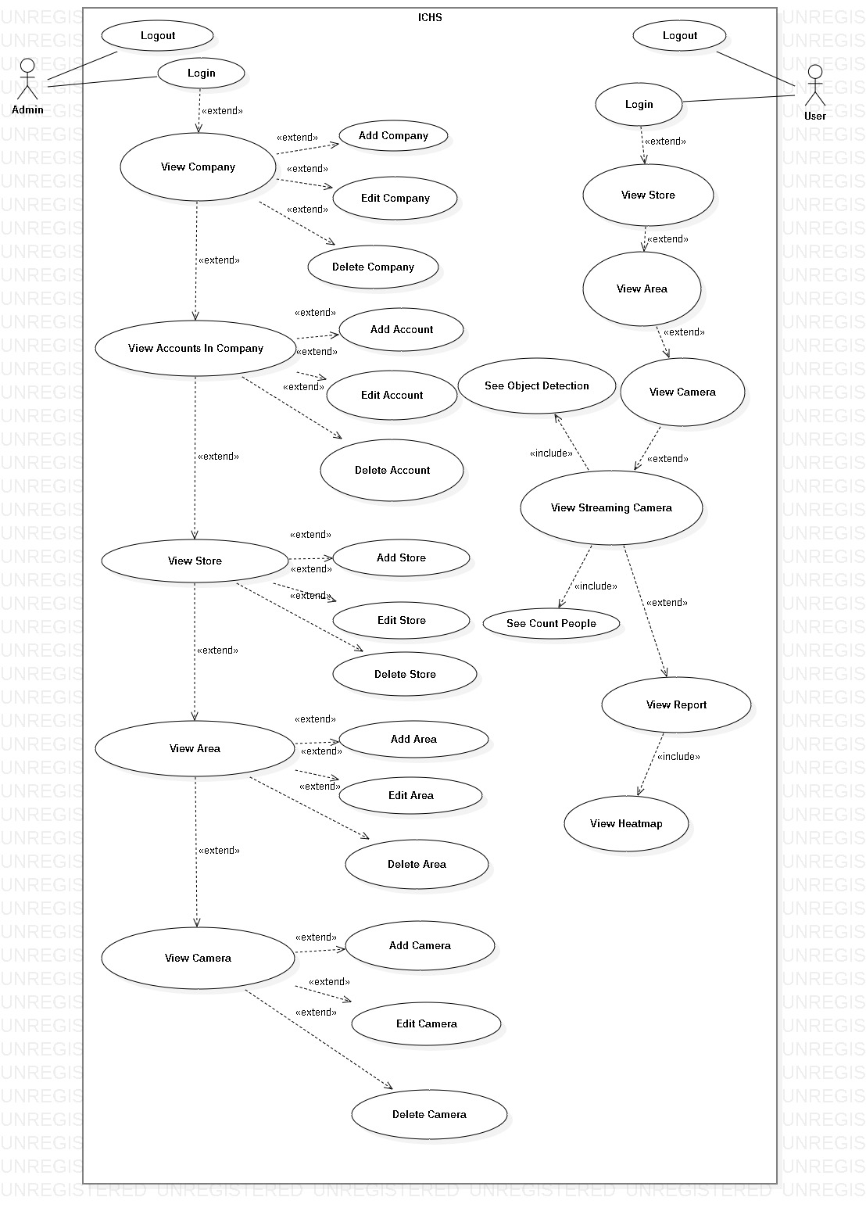

Figure 2- System Overview Use Case Diagram

* 1. List of Use Case
     1. <Admin> Overview Use Case

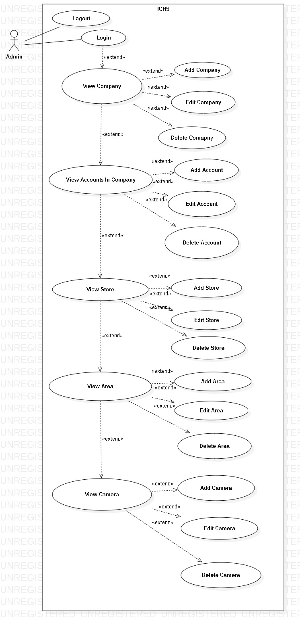

Figure 3- <Admin>Overview Use Case Diagram

##### <Admin> Admin Login

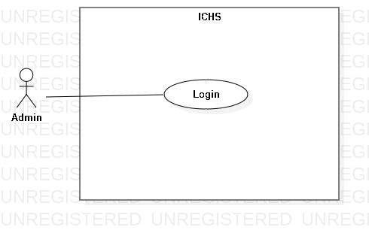

Figure 4- <Admin> Admin Login

|  |  |  |  |
| --- | --- | --- | --- |
| **USE CASE – UC_01** | | | |
| **Use Case No.** | 01 | **Use Case Version** | 1.0 |
| **Use Case Name** | Admin Login | | |
| **Author** | PhucDH | | |
| **Date** | 25/06/2019 | **Priority** |  |
| **Actor:**   * Admin   **Summary:**   * This use case allows the admin login to the system.   **Goal:**   * Admin logged in to the system.   **Triggers:**   * Admin clicks “Login” button. * Admin sends the login command.   **Preconditions:**   * Admin at “Login” page.   **Post Conditions:**   * **Success:** Admin login to the system. * **Fail:** System displays error message.   **Main Success Scenario:**   |  |  |  | | --- | --- | --- | | **Step** | **Actor Action** | **System Response** | | 1 | Admin goes to Login page by clicking “Login” button. | System requires information:   * Username: text input. * Password: text input. | | 2 | Admin inputs information and clicks “Login” button. | System validates the information and displays confirmation message. |   **Alternative:** N/A.  **Exceptions:**   |  |  |  | | --- | --- | --- | | **No** | **Cause** | **System Response** | | 1 | Network problem. | System displays “Login failed!” message. | | 2 | Username is blank. | System displays “Please input Username” message. | | 3 | Password is blank. | System displays “Please input Password” message. |   **Relationships:** N/A.  **Business Rules:**   * After logged in, system redirect to Admin page. * A notification pop-up when admin login success. * System must ensure has no duplicate user. * Password must be in rage of 6 – 30 characters. | | | |

Table - <Admin> Admin Login

##### <Admin> Admin Logout

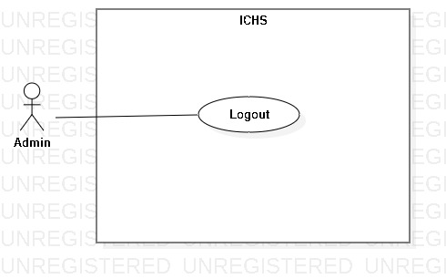

Figure 5- <Admin> Admin Logout

|  |  |  |  |
| --- | --- | --- | --- |
| **USE CASE – UC_02** | | | |
| **Use Case No.** | 02 | **Use Case Version** | 1.0 |
| **Use Case Name** | Admin Logout | | |
| **Author** | PhucDH | | |
| **Date** | 25/06/2019 | **Priority** |  |
| **Actor:**   * Admin   **Summary:**   * This use case allows the admin logout from application.   **Goal:**   * Admin logout from the system.   **Triggers:**   * Admin clicks Settings button. * Admin clicks “Log Out” button. * Admin sends the logout command.   **Preconditions:**   * Admin login success.   **Post Conditions:**   * **Success:** Admin logout from system. * **Fail:** System displays error message.   **Main Success Scenario:**   |  |  |  | | --- | --- | --- | | **Step** | **Actor Action** | **System Response** | | 1 | Admin clicks “Log Out” button. | System displays dialog with “You want to log out?” message. | | 2 | Admin clicks “Yes” button. | Admin logout from the system. |   **Alternative:** N/A.  **Exception:**   |  |  |  | | --- | --- | --- | | **No** | **Actor Action** | **System Response** | | 1 | Admin clicks “Cancel” button. | Close the dialog. |   **Relationships:** N/A.  **Business Rules:**   * After logout from the system, system return Login page. * Admin can login with another account. | | | |

Table - <Admin> Admin Logout

##### <Admin> View Company

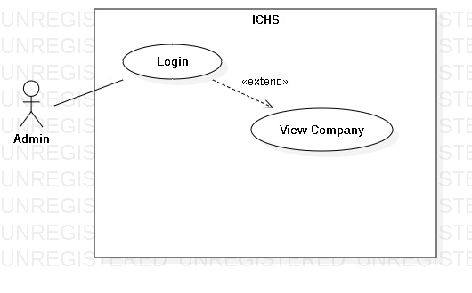

Figure 6- <Admin> View Company

|  |  |  |  |
| --- | --- | --- | --- |
| **USE CASE – UC_03** | | | |
| **Use Case No.** | 03 | **Use Case Version** | 1.0 |
| **Use Case Name** | View Company | | |
| **Author** | PhucDH | | |
| **Date** | 25/06/2019 | **Priority** |  |
| **Actor:**   * Admin   **Summary:**   * This use case allows the admin to view all companies in system.   **Goal:**   * Admin view all companies in the system.   **Triggers:**   * Admin clicks “Company” button. * Admin sends view company command.   **Preconditions:**   * Admin login success.   **Post Conditions:**   * **Success:** Admin view all companies in system. * **Fail:** System displays error message.   **Main Success Scenario:**   |  |  |  | | --- | --- | --- | | **Step** | **Actor Action** | **System Response** | | 1 | Admin clicks “Company” button in Home page. | System displays the “Company” page and shows companies. |   **Alternative:** N/A.  **Exception:** N/A.  **Relationships:** Extend from “Admin Login” use case.  **Business Rules:** N/A. | | | |

Table - <Admin> View Company

##### <Admin> Add Company

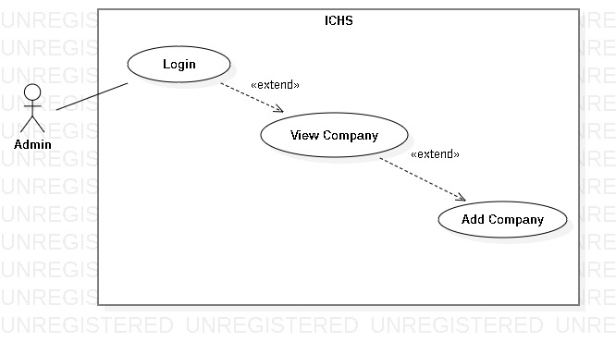

Figure 7- <Admin> Add Company

|  |  |  |  |
| --- | --- | --- | --- |
| **USE CASE – UC_04** | | | |
| **Use Case No.** | 04 | **Use Case Version** | 1.0 |
| **Use Case Name** | Add Company | | |
| **Author** | PhucDH | | |
| **Date** | 25/06/2019 | **Priority** |  |
| **Actor:**   * Admin   **Summary:**   * This use case allows the admin to add company.   **Goal:**   * Admin add new company.   **Triggers:**   * Admin clicks “Add Company” button. * Admin sends add company command.   **Preconditions:**   * Admin login success. * Admin is at “Company” page.   **Post Conditions:**   * **Success:** Admin add company successfully. * **Fail:** System displays error message.   **Main Success Scenario:**   |  |  |  | | --- | --- | --- | | **Step** | **Actor Action** | **System Response** | | 1 | Admin clicks “Add Company” button. | System displays “Add Company” page. Page contains 3 text fields and requires information :   * Company Name: text input * Company Address: text input * Company Phone Number: text input | | 2 | Admin inputs information and clicks “Ok” button | System displays message “Add Company Successfully !” |   **Alternative:** N/A.  **Exception:**   |  |  |  | | --- | --- | --- | | **No** | **Actor Action** | **System Response** | | 1 | Admin clicks “Cancel” button. | Back to Company page. | | 2 | Company Name is blank. | System displays “Please input Company Name” message. | | 3 | Company Address is blank. | System displays “Please input Company Address” message. | | 4 | Company Phone Number is blank. | System displays “Please input Company Phone Number” message. |   **Relationships:** Extend from “View Company” use case.  **Business Rules:**   * After add new company to the system, admin return to Company page. | | | |

Table - <Admin> Add Company

##### <Admin> Edit Company

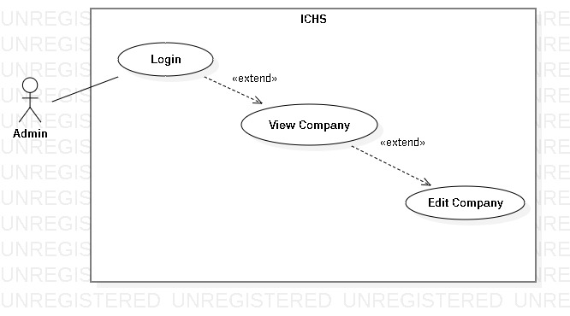

Figure 7- <Admin> Edit Company

|  |  |  |  |
| --- | --- | --- | --- |
| **USE CASE – UC_05** | | | |
| **Use Case No.** | 05 | **Use Case Version** | 1.0 |
| **Use Case Name** | Edit Company | | |
| **Author** | PhucDH | | |
| **Date** | 25/06/2019 | **Priority** |  |
| **Actor:**   * Admin   **Summary:**   * This use case allows the admin to edit company.   **Goal:**   * Admin edit existing company.   **Triggers:**   * Admin clicks “Edit Company” button. * Admin sends edit company command.   **Preconditions:**   * Admin login success. * Admin is at “Company” page.   **Post Conditions:**   * **Success:** Admin edit company successfully. * **Fail:** System displays error message.   **Main Success Scenario:**   |  |  |  | | --- | --- | --- | | **Step** | **Actor Action** | **System Response** | | 1 | Admin clicks “Edit Company” button. | System displays “Edit Company” page. Page contains 3 text fields and requires information:   * Company Name: text input * Company Address: text input * Company Phone Number: text input | | 2 | Admin inputs information and clicks “Ok” button | System displays message “Edit Company Successfully !” |   **Alternative:** N/A.  **Exception:**   |  |  |  | | --- | --- | --- | | **No** | **Actor Action** | **System Response** | | 1 | Admin clicks “Cancel” button. | Back to Company page. | | 2 | Company Name is blank. | System displays “Please input Company Name” message. | | 3 | Company Address is blank. | System displays “Please input Company Address” message. | | 4 | Company Phone Number is blank. | System displays “Please input Company Phone Number” message. |   **Relationships:** Extend from “View Company” use case.  **Business Rules:**   * After edit company, admin return to Company page. | | | |

Table - <Admin> Edit Company

##### <Admin> Delete Company

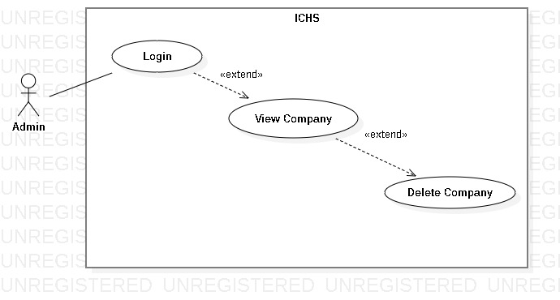

Figure 8- <Admin> Delete Company

|  |  |  |  |
| --- | --- | --- | --- |
| **USE CASE – UC_06** | | | |
| **Use Case No.** | 06 | **Use Case Version** | 1.0 |
| **Use Case Name** | Delete Company | | |
| **Author** | PhucDH | | |
| **Date** | 25/06/2019 | **Priority** |  |
| **Actor:**   * Admin   **Summary:**   * This use case allows the admin to delete company.   **Goal:**   * Admin delete existing company.   **Triggers:**   * Admin clicks “Delete Company” button. * Admin sends delete company command.   **Preconditions:**   * Admin login success. * Admin is at “Company” page.   **Post Conditions:**   * **Success:** Admin delete company successfully. * **Fail:** System displays error message.   **Main Success Scenario:**   |  |  |  | | --- | --- | --- | | **Step** | **Actor Action** | **System Response** | | 1 | Admin clicks “Delete Company” button. | System displays “Do you want to delete this company?” message. | | 2 | Admin clicks “Ok” button | System removes the company from Company page. |   **Alternative:** N/A.  **Exception:**   |  |  |  | | --- | --- | --- | | **No** | **Actor Action** | **System Response** | | 1 | Admin clicks “Cancel” button. | Back to Company page. |   **Relationships:** Extend from “View Company” use case.  **Business Rules:**   * After delete company, admin return to Company page. | | | |

Table - <Admin> Delete Company

##### <Admin> View Accounts In Company

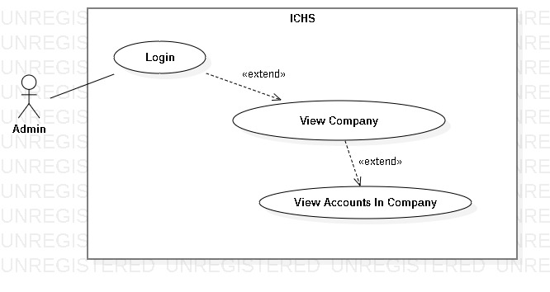

Figure 9- <Admin> View Accounts In Company

|  |  |  |  |
| --- | --- | --- | --- |
| **USE CASE – UC_07** | | | |
| **Use Case No.** | 07 | **Use Case Version** | 1.0 |
| **Use Case Name** | View Accounts In Company | | |
| **Author** | PhucDH | | |
| **Date** | 25/06/2019 | **Priority** |  |
| **Actor:**   * Admin   **Summary:**   * This use case allows the admin to view all accounts in one company.   **Goal:**   * Admin view all accounts in the chosen company.   **Triggers:**   * Admin clicks “View Account” button. * Admin sends view account command.   **Preconditions:**   * Admin login success. * Admin is at the chosen company page.   **Post Conditions:**   * **Success:** Admin view all accounts in chosen company. * **Fail:** System displays error message.   **Main Success Scenario:**   |  |  |  | | --- | --- | --- | | **Step** | **Actor Action** | **System Response** | | 1 | Admin clicks “View Account” button in Home page. | System displays the “Account” page and shows all accounts in the chosen company. |   **Alternative:** N/A.  **Exception:** N/A.  **Relationships:** Extend from “View Company” use case.  **Business Rules:** N/A. | | | |

Table - <Admin> View Accounts In Company

##### <Admin> Add Account

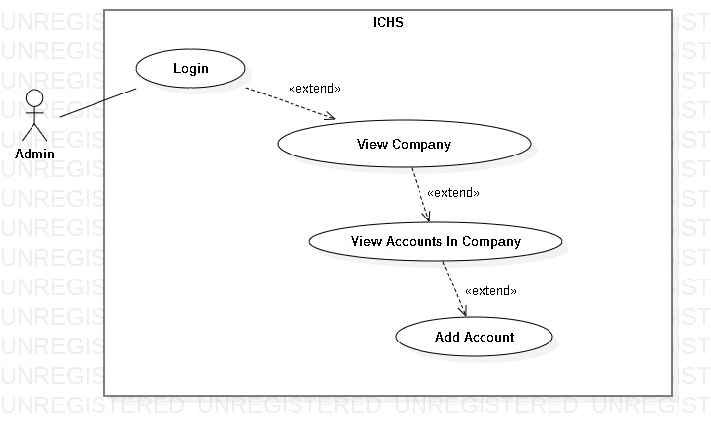

Figure 10- <Admin> Add Account

|  |  |  |  |
| --- | --- | --- | --- |
| **USE CASE – UC_08** | | | |
| **Use Case No.** | 08 | **Use Case Version** | 1.0 |
| **Use Case Name** | Add Account | | |
| **Author** | PhucDH | | |
| **Date** | 25/06/2019 | **Priority** |  |
| **Actor:**   * Admin   **Summary:**   * This use case allows the admin to add new account to company.   **Goal:**   * Admin add new account.   **Triggers:**   * Admin clicks “Add Account” button. * Admin sends add account command.   **Preconditions:**   * Admin login success. * Admin is at “Account” page.   **Post Conditions:**   * **Success:** Admin add account successfully. * **Fail:** System displays error message.   **Main Success Scenario:**   |  |  |  | | --- | --- | --- | | **Step** | **Actor Action** | **System Response** | | 1 | Admin clicks “Add Account” button. | System displays “Add Account” page. Page contains 5 text fields, 2 checkboxes and requires information:   * User Name: text input * Password: text input * Full Name: text input * Email: text input * Gender: checkbox * Phone Number: text input * Role: checkbox | | 2 | Admin inputs information and clicks “Ok” button | System displays message “Add Account Successfully !” |   **Alternative:** N/A.  **Exception:**   |  |  |  | | --- | --- | --- | | **No** | **Actor Action** | **System Response** | | 1 | Admin clicks “Cancel” button. | Back to Account page. | | 2 | Username is blank. | System displays “Please input Username” message. | | 3 | Password is blank. | System displays “Please input Password” message. | | 4 | Fullname is blank. | System displays “Please input Fullname” message. | | 5 | Email is blank. | System displays “Please input Email” message. | | 6 | Phone Number is blank. | System displays “Please input Phone Number” message. | | 7 | Username hase been used. | System displays “This username has been used” message. |   **Relationships:** Extend from “View Accounts In Company” use case.  **Business Rules:**   * After add new account to the company, admin return to Account page. | | | |

Table - <Admin> Add Account

##### <Admin> Edit Account

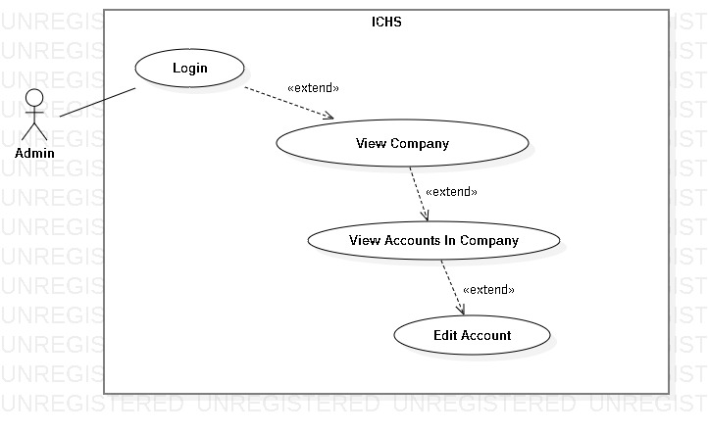

Figure 11- <Admin> Edit Account

|  |  |  |  |
| --- | --- | --- | --- |
| **USE CASE – UC_09** | | | |
| **Use Case No.** | 09 | **Use Case Version** | 1.0 |
| **Use Case Name** | Edit Account | | |
| **Author** | PhucDH | | |
| **Date** | 25/06/2019 | **Priority** |  |
| **Actor:**   * Admin   **Summary:**   * This use case allows the admin to edit account.   **Goal:**   * Admin edit existing account.   **Triggers:**   * Admin clicks “Edit Account” button. * Admin sends edit account command.   **Preconditions:**   * Admin login success. * Admin is at “Account” page.   **Post Conditions:**   * **Success:** Admin edit account successfully. * **Fail:** System displays error message.   **Main Success Scenario:**   |  |  |  | | --- | --- | --- | | **Step** | **Actor Action** | **System Response** | | 1 | Admin clicks “Edit Account” button. | System displays “Edit Account” page. Page contains 5 text fields, 2 checkboxes and requires information:   * User Name: text input * Password: text input * Full Name: text input * Email: text input * Gender: checkbox * Phone Number: text input * Role: checkbox | | 2 | Admin inputs information and clicks “Ok” button | System displays message “Edit Account Successfully !” |   **Alternative:** N/A.  **Exception:**   |  |  |  | | --- | --- | --- | | **No** | **Actor Action** | **System Response** | | 1 | Admin clicks “Cancel” button. | Back to Account page. | | 2 | Username is blank. | System displays “Please input Username” message. | | 3 | Password is blank. | System displays “Please input Password” message. | | 4 | Fullname is blank. | System displays “Please input Fullname” message. | | 5 | Email is blank. | System displays “Please input Email” message. | | 6 | Phone Number is blank. | System displays “Please input Phone Number” message. | | 7 | Username has been used. | System displays “This username has been used” message. |   **Relationships:** Extend from “View Accounts In Company” use case.  **Business Rules:**   * After edit account, admin return to Account page. | | | |

Table - <Admin> Edit Account

##### <Admin> Delete Account

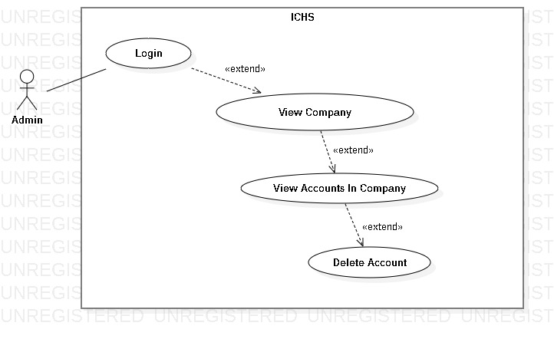

Figure 12- <Admin> Delete Account

|  |  |  |  |
| --- | --- | --- | --- |
| **USE CASE – UC_10** | | | |
| **Use Case No.** | 10 | **Use Case Version** | 1.0 |
| **Use Case Name** | Delete Account | | |
| **Author** | PhucDH | | |
| **Date** | 25/06/2019 | **Priority** |  |
| **Actor:**   * Admin   **Summary:**   * This use case allows the admin to delete account.   **Goal:**   * Admin delete existing account.   **Triggers:**   * Admin clicks “Delete Account” button. * Admin sends delete account command.   **Preconditions:**   * Admin login success. * Admin is at “Account” page.   **Post Conditions:**   * **Success:** Admin delete account successfully. * **Fail:** System displays error message.   **Main Success Scenario:**   |  |  |  | | --- | --- | --- | | **Step** | **Actor Action** | **System Response** | | 1 | Admin clicks “Delete Account” button. | System displays “Do you want to delete this account ?” message. | | 2 | Admin clicks “Ok” button | System removes the account from Account page. |   **Alternative:** N/A.  **Exception:**   |  |  |  | | --- | --- | --- | | **No** | **Actor Action** | **System Response** | | 1 | Admin clicks “Cancel” button. | Back to Account page. |   **Relationships:** Extend from “View Accounts in Company” use case.  **Business Rules:**   * After delete account, admin return to Account page. | | | |

Table - <Admin> Delete Account

##### <Admin> View Store

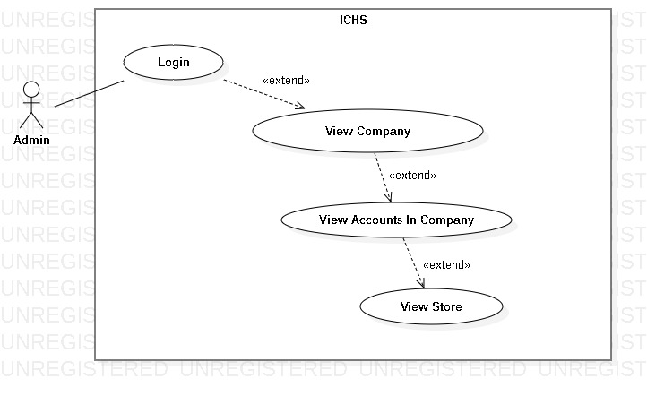

Figure 13- <Admin> View Store

|  |  |  |  |
| --- | --- | --- | --- |
| **USE CASE – UC_11** | | | |
| **Use Case No.** | 11 | **Use Case Version** | 1.0 |
| **Use Case Name** | View Store | | |
| **Author** | PhucDH | | |
| **Date** | 25/06/2019 | **Priority** |  |
| **Actor:**   * Admin   **Summary:**   * This use case allows the admin to view all store in company that the chosen account is allowed to view.   **Goal:**   * Admin view all stores of user within the limits allowed by the admin.   **Triggers:**   * Admin clicks “Store” button. * Admin sends view store command.   **Preconditions:**   * Admin login success. * Admin is at the chosen account page.   **Post Conditions:**   * **Success:** Admin view all stores. * **Fail:** System displays error message.   **Main Success Scenario:**   |  |  |  | | --- | --- | --- | | **Step** | **Actor Action** | **System Response** | | 1 | Admin clicks “Store” button in Account page. | System displays the “Store” page and shows stores. |   **Alternative:** N/A.  **Exception:** N/A.  **Relationships:** Extend from “View Accounts In Company” use case.  **Business Rules:** N/A. | | | |

Table - <Admin> View Store

##### <Admin> Add Store

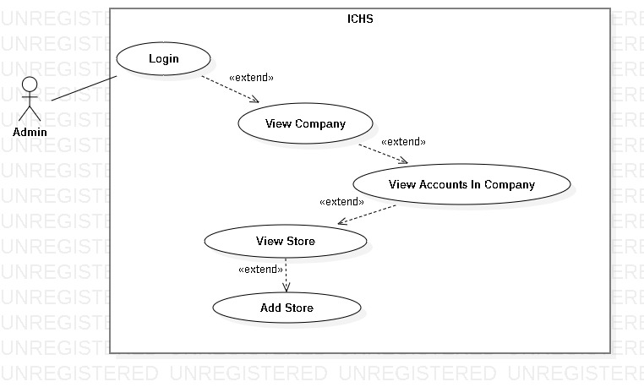

Figure 14- <Admin> Add Store

|  |  |  |  |
| --- | --- | --- | --- |
| **USE CASE – UC_12** | | | |
| **Use Case No.** | 12 | **Use Case Version** | 1.0 |
| **Use Case Name** | Add Store | | |
| **Author** | PhucDH | | |
| **Date** | 25/06/2019 | **Priority** |  |
| **Actor:**   * Admin   **Summary:**   * This use case allows the admin to add store.   **Goal:**   * Admin add new store.   **Triggers:**   * Admin clicks “Add Store” button. * Admin sends add store command.   **Preconditions:**   * Admin login success. * Admin is at “Store” page.   **Post Conditions:**   * **Success:** Admin add store successfully. * **Fail:** System displays error message.   **Main Success Scenario:**   |  |  |  | | --- | --- | --- | | **Step** | **Actor Action** | **System Response** | | 1 | Admin clicks “Add Store” button. | System displays “Add Store” page. Page contains 3 text fields and requires information:   * Store Name: text input * Store Address: text input * Store Phone Number: text input | | 2 | Admin inputs information and clicks “Ok” button | System displays message “Add Store Successfully !” |   **Alternative:** N/A.  **Exception:**   |  |  |  | | --- | --- | --- | | **No** | **Actor Action** | **System Response** | | 1 | Admin clicks “Cancel” button. | Back to Store page. | | 2 | Store Name is blank. | System displays “Please input Store Name” message. | | 3 | Store Address is blank. | System displays “Please input Store Address” message. | | 4 | Store Phone Number is blank. | System displays “Please input Store Phone Number” message. |   **Relationships:** Extend from “View Store” use case.  **Business Rules:**   * After add new store, admin return to Store page. | | | |

Table - <Admin> Add Store

##### <Admin> Edit Store

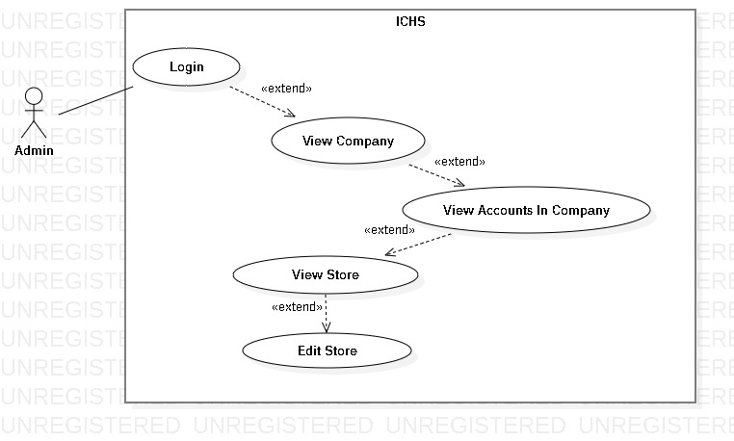

Figure 15- <Admin> Edit Store

|  |  |  |  |
| --- | --- | --- | --- |
| **USE CASE – UC_13** | | | |
| **Use Case No.** | 13 | **Use Case Version** | 1.0 |
| **Use Case Name** | Edit Store | | |
| **Author** | PhucDH | | |
| **Date** | 25/06/2019 | **Priority** |  |
| **Actor:**   * Admin   **Summary:**   * This use case allows the admin to edit store.   **Goal:**   * Admin edit existing store.   **Triggers:**   * Admin clicks “Edit Store” button. * Admin sends edit store command.   **Preconditions:**   * Admin login success. * Admin is at “Store” page.   **Post Conditions:**   * **Success:** Admin edit store successfully. * **Fail:** System displays error message.   **Main Success Scenario:**   |  |  |  | | --- | --- | --- | | **Step** | **Actor Action** | **System Response** | | 1 | Admin clicks “Edit Store” button. | System displays “Edit Store” page. Page contains 3 text fields and requires information:   * Store Name: text input * Store Address: text input * Store Phone Number: text input | | 2 | Admin inputs information and clicks “Ok” button | System displays message “Edit Store Successfully !” |   **Alternative:** N/A.  **Exception:**   |  |  |  | | --- | --- | --- | | **No** | **Actor Action** | **System Response** | | 1 | Admin clicks “Cancel” button. | Back to Store page. | | 2 | Store Name is blank. | System displays “Please input Store Name” message. | | 3 | Store Address is blank. | System displays “Please input Store Address” message. | | 4 | Store Phone Number is blank. | System displays “Please input Store Phone Number” message. |   **Relationships:** Extend from “View Store” use case.  **Business Rules:**   * After edit store , admin return to Store page. | | | |

Table - <Admin> Edit Store

##### <Admin> Delete Store

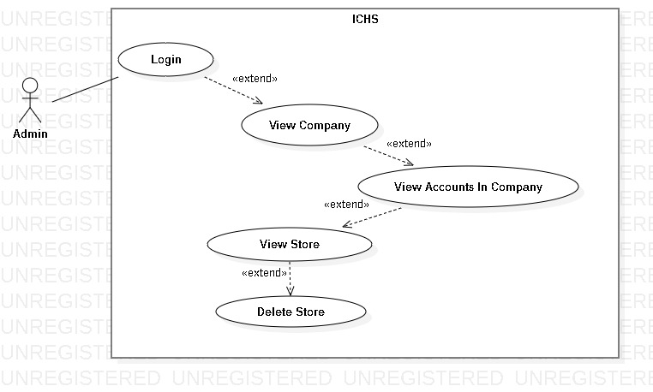

Figure 16- <Admin> Delete Store

|  |  |  |  |
| --- | --- | --- | --- |
| **USE CASE – UC_14** | | | |
| **Use Case No.** | 14 | **Use Case Version** | 1.0 |
| **Use Case Name** | Delete Store | | |
| **Author** | PhucDH | | |
| **Date** | 25/06/2019 | **Priority** |  |
| **Actor:**   * Admin   **Summary:**   * This use case allows the admin to delete store.   **Goal:**   * Admin delete existing store.   **Triggers:**   * Admin clicks “Delete Store” button. * Admin sends delete store command.   **Preconditions:**   * Admin login success. * Admin is at “Store” page.   **Post Conditions:**   * **Success:** Admin delete store successfully. * **Fail:** System displays error message.   **Main Success Scenario:**   |  |  |  | | --- | --- | --- | | **Step** | **Actor Action** | **System Response** | | 1 | Admin clicks “Delete Store” button. | System displays “Do you want to delete this store?” message. | | 2 | Admin clicks “Ok” button | System removes the store from Store page. |   **Alternative:** N/A.  **Exception:**   |  |  |  | | --- | --- | --- | | **No** | **Actor Action** | **System Response** | | 1 | Admin clicks “Cancel” button. | Back to Store page. |   **Relationships:** Extend from “View Store” use case.  **Business Rules:**   * After delete store, admin return to Store page. | | | |

Table - <Admin> Delete Store

##### <Admin> View Area

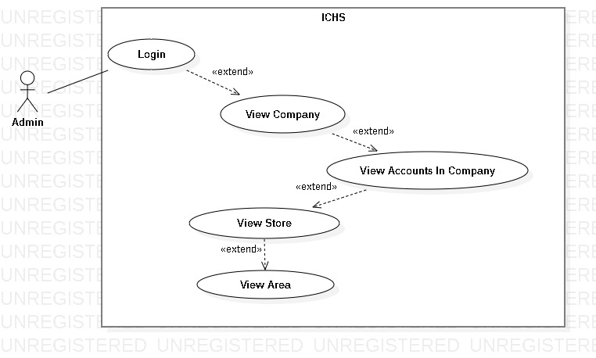

Figure 17- <Admin> View Area

|  |  |  |  |
| --- | --- | --- | --- |
| **USE CASE – UC_15** | | | |
| **Use Case No.** | 15 | **Use Case Version** | 1.0 |
| **Use Case Name** | View Area | | |
| **Author** | PhucDH | | |
| **Date** | 25/06/2019 | **Priority** |  |
| **Actor:**   * Admin   **Summary:**   * This use case allows the admin to view all areas in one store.   **Goal:**   * Admin view all areas in the chosen store.   **Triggers:**   * Admin clicks “Area” button. * Admin sends view area command.   **Preconditions:**   * Admin login success. * Admin is at the chosen store page.   **Post Conditions:**   * **Success:** Admin view all areas. * **Fail:** System displays error message.   **Main Success Scenario:**   |  |  |  | | --- | --- | --- | | **Step** | **Actor Action** | **System Response** | | 1 | Admin clicks “Area” button in Store page. | System displays the “Area” page and shows areas. |   **Alternative:** N/A.  **Exception:** N/A.  **Relationships:** Extend from “View Store” use case.  **Business Rules:** N/A. | | | |

Table - <Admin> View Area

##### <Admin> Add Area

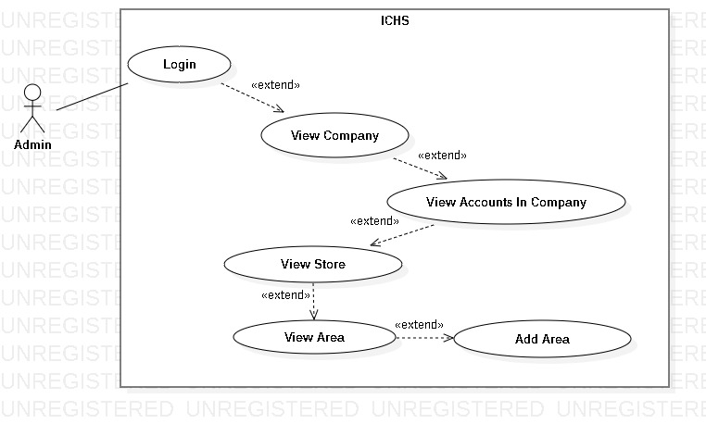

Figure 18- <Admin> Add Area

|  |  |  |  |
| --- | --- | --- | --- |
| **USE CASE – UC_16** | | | |
| **Use Case No.** | 16 | **Use Case Version** | 1.0 |
| **Use Case Name** | Add Area | | |
| **Author** | PhucDH | | |
| **Date** | 25/06/2019 | **Priority** |  |
| **Actor:**   * Admin   **Summary:**   * This use case allows the admin to add area to store.   **Goal:**   * Admin add new area to store.   **Triggers:**   * Admin clicks “Add Area” button. * Admin sends add area command.   **Preconditions:**   * Admin login success. * Admin is at “Area” page.   **Post Conditions:**   * **Success:** Admin add area successfully. * **Fail:** System displays error message.   **Main Success Scenario:**   |  |  |  | | --- | --- | --- | | **Step** | **Actor Action** | **System Response** | | 1 | Admin clicks “Add Area” button. | System displays “Add Area” page. Page contains 2 text fields and requires information:   * Area Floor: text input * Area Name: text input | | 2 | Admin inputs information and clicks “Ok” button | System displays message “Add Area Successfully !” |   **Alternative:** N/A.  **Exception:**   |  |  |  | | --- | --- | --- | | **No** | **Actor Action** | **System Response** | | 1 | Admin clicks “Cancel” button. | Back to Area page. | | 2 | Area Floor is blank. | System displays “Please input Area Floor” message. | | 3 | Area Name is blank. | System displays “Please input Area Name” message. |   **Relationships:** Extend from “View Area” use case.  **Business Rules:**   * After add new area, admin return to Area page. | | | |

Table - <Admin> Add Area

##### <Admin> Edit Area

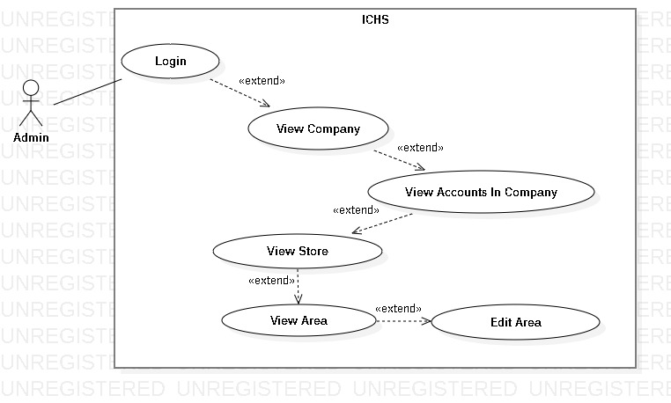

Figure 19- <Admin> Edit Area

|  |  |  |  |
| --- | --- | --- | --- |
| **USE CASE – UC_17** | | | |
| **Use Case No.** | 17 | **Use Case Version** | 1.0 |
| **Use Case Name** | Edit Area | | |
| **Author** | PhucDH | | |
| **Date** | 25/06/2019 | **Priority** |  |
| **Actor:**   * Admin   **Summary:**   * This use case allows the admin to edit area.   **Goal:**   * Admin edit existing area.   **Triggers:**   * Admin clicks “Edit Area” button. * Admin sends edit area command.   **Preconditions:**   * Admin login success. * Admin is at “Area” page.   **Post Conditions:**   * **Success:** Admin edit area successfully. * **Fail:** System displays error message.   **Main Success Scenario:**   |  |  |  | | --- | --- | --- | | **Step** | **Actor Action** | **System Response** | | 1 | Admin clicks “Edit Area” button. | System displays “Edit Area” page. Page contains 2 text fields and requires information:   * Area Floor: text input * Area Name: text input | | 2 | Admin inputs information and clicks “Ok” button | System displays message “Edit Area Successfully !” |   **Alternative:** N/A.  **Exception:**   |  |  |  | | --- | --- | --- | | **No** | **Actor Action** | **System Response** | | 1 | Admin clicks “Cancel” button. | Back to Area page. | | 2 | Area Floor is blank. | System displays “Please input Area Floor” message. | | 3 | Area Name is blank. | System displays “Please input Area Name” message. |   **Relationships:** Extend from “View Area” use case.  **Business Rules:**   * After edit area , admin return to Area page. | | | |

Table - <Admin> Edit Area

##### <Admin> Delete Area

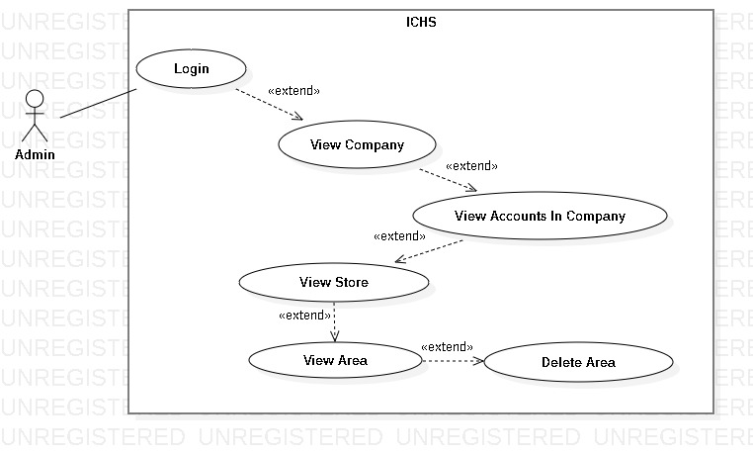

Figure 20- <Admin> Delete Area

|  |  |  |  |
| --- | --- | --- | --- |
| **USE CASE – UC_18** | | | |
| **Use Case No.** | 18 | **Use Case Version** | 1.0 |
| **Use Case Name** | Delete Area | | |
| **Author** | PhucDH | | |
| **Date** | 25/06/2019 | **Priority** |  |
| **Actor:**   * Admin   **Summary:**   * This use case allows the admin to delete one area.   **Goal:**   * Admin delete existing area.   **Triggers:**   * Admin clicks “Delete Area” button. * Admin sends delete area command.   **Preconditions:**   * Admin login success. * Admin is at “Area” page.   **Post Conditions:**   * **Success:** Admin delete area successfully. * **Fail:** System displays error message.   **Main Success Scenario:**   |  |  |  | | --- | --- | --- | | **Step** | **Actor Action** | **System Response** | | 1 | Admin clicks “Delete Area” button. | System displays “Do you want to delete this area?” message. | | 2 | Admin clicks “Ok” button | System removes the area from Area page. |   **Alternative:** N/A.  **Exception:**   |  |  |  | | --- | --- | --- | | **No** | **Actor Action** | **System Response** | | 1 | Admin clicks “Cancel” button. | Back to Area page. |   **Relationships:** Extend from “View Area” use case.  **Business Rules:**   * After delete area, admin return to Area page. | | | |

Table - <Admin> Delete Area

##### <Admin> View Camera

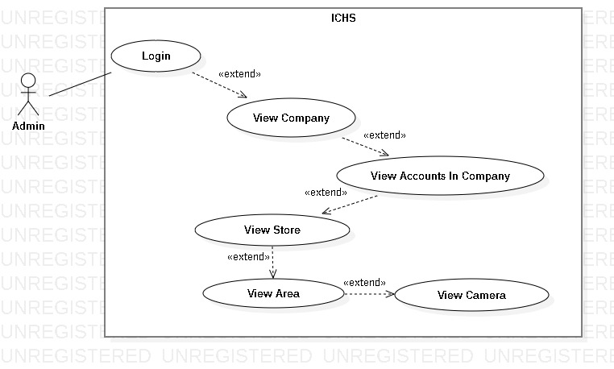

Figure 21- <Admin> View Camera

|  |  |  |  |
| --- | --- | --- | --- |
| **USE CASE – UC_19** | | | |
| **Use Case No.** | 19 | **Use Case Version** | 1.0 |
| **Use Case Name** | View Camera | | |
| **Author** | PhucDH | | |
| **Date** | 25/06/2019 | **Priority** |  |
| **Actor:**   * Admin   **Summary:**   * This use case allows the admin to view all cameras in one area.   **Goal:**   * Admin view all cameras in the chosen area.   **Triggers:**   * Admin clicks “Camera” button. * Admin sends view camera command.   **Preconditions:**   * Admin login success. * Admin is at the chosen area page.   **Post Conditions:**   * **Success:** Admin view all cameras. * **Fail:** System displays error message.   **Main Success Scenario:**   |  |  |  | | --- | --- | --- | | **Step** | **Actor Action** | **System Response** | | 1 | Admin clicks “Camera” button in Area page. | System displays the “Camera” page and shows cameras. |   **Alternative:** N/A.  **Exception:** N/A.  **Relationships:** Extend from “View Area” use case.  **Business Rules:** N/A. | | | |

Table - <Admin> View Camera

##### <Admin> Add Camera

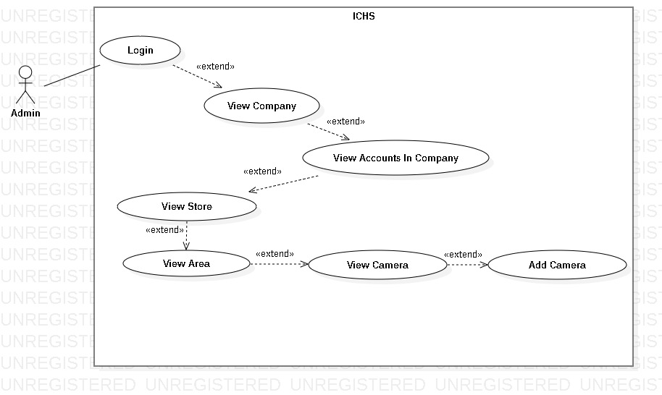

Figure 22- <Admin> Add Camera

|  |  |  |  |
| --- | --- | --- | --- |
| **USE CASE – UC_20** | | | |
| **Use Case No.** | 20 | **Use Case Version** | 1.0 |
| **Use Case Name** | Add Camera | | |
| **Author** | PhucDH | | |
| **Date** | 25/06/2019 | **Priority** |  |
| **Actor:**   * Admin   **Summary:**   * This use case allows the admin to add camera to area.   **Goal:**   * Admin add new camera to area.   **Triggers:**   * Admin clicks “Add Camera” button. * Admin sends add camera command.   **Preconditions:**   * Admin login success. * Admin is at “Camera” page.   **Post Conditions:**   * **Success:** Admin add camera successfully. * **Fail:** System displays error message.   **Main Success Scenario:**   |  |  |  | | --- | --- | --- | | **Step** | **Actor Action** | **System Response** | | 1 | Admin clicks “Add Camera” button. | System displays “Add Camera” page. Page contains 3text fields and requires information:   * Camera IP: text input * Camera Account: text input * Camera Password: text input | | 2 | Admin inputs infomation and clicks “Ok” button | System displays message “Add Camera Successfully !” |   **Alternative:** N/A.  **Exception:**   |  |  |  | | --- | --- | --- | | **No** | **Actor Action** | **System Response** | | 1 | Admin clicks “Cancel” button. | Back to Camera page. | | 2 | Camera IP is blank. | System displays “Please input Camera IP” message. | | 3 | Camera Account is blank. | System displays “Please input Camera Account” message. | | 4 | Camera Password is blank. | System displays “Please input Camera Password” message. |   **Relationships:** Extend from “View Camera” use case.  **Business Rules:**   * After add new camera, admin return to camera page. | | | |

Table - <Admin> Add Camera

##### <Admin> Edit Camera

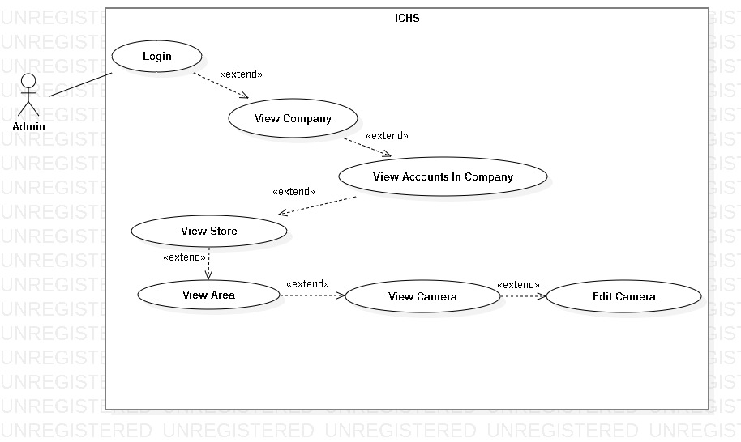

Figure 23- <Admin> Edit Camera

|  |  |  |  |
| --- | --- | --- | --- |
| **USE CASE – UC_21** | | | |
| **Use Case No.** | 21 | **Use Case Version** | 1.0 |
| **Use Case Name** | Edit Camera | | |
| **Author** | PhucDH | | |
| **Date** | 25/06/2019 | **Priority** |  |
| **Actor:**   * Admin   **Summary:**   * This use case allows the admin to edit camera.   **Goal:**   * Admin edit existing camera.   **Triggers:**   * Admin clicks “Edit Camera” button. * Admin sends edit camera command.   **Preconditions:**   * Admin login success. * Admin is at “Camera” page.   **Post Conditions:**   * **Success:** Admin edit camera successfully. * **Fail:** System displays error message.   **Main Success Scenario:**   |  |  |  | | --- | --- | --- | | **Step** | **Actor Action** | **System Response** | | 1 | Admin clicks “Edit Camera” button. | System displays “Edit Camera” page. Page contains 3text fields and requires information:   * Camera IP: text input * Camera Account: text input * Camera Password: text input | | 2 | Admin inputs information and clicks “Ok” button | System displays message “Edit Camera Successfully !” |   **Alternative:** N/A.  **Exception:**   |  |  |  | | --- | --- | --- | | **No** | **Actor Action** | **System Response** | | 1 | Admin clicks “Cancel” button. | Back to Camera page. | | 2 | Camera IP is blank. | System displays “Please input Camera IP” message. | | 3 | Camera Account is blank. | System displays “Please input Camera Account” message. | | 4 | Camera Password is blank. | System displays “Please input Camera Password” message. |   **Relationships:** Extend from “View Area” use case.  **Business Rules:**   * After edit camera, admin return to Camera page. | | | |

Table - <Admin> Edit Camera

##### <Admin> Delete Camera

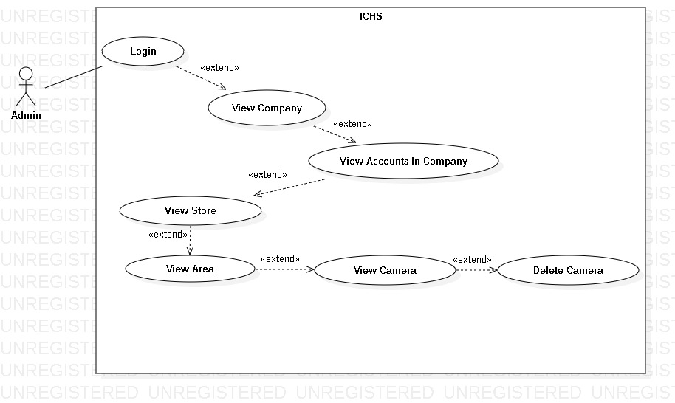

Figure 24- <Admin> Delete Camera

|  |  |  |  |
| --- | --- | --- | --- |
| **USE CASE – UC_22** | | | |
| **Use Case No.** | 22 | **Use Case Version** | 1.0 |
| **Use Case Name** | Delete Camera | | |
| **Author** | PhucDH | | |
| **Date** | 25/06/2019 | **Priority** |  |
| **Actor:**   * Admin   **Summary:**   * This use case allows the admin to delete one camera.   **Goal:**   * Admin delete existing camera.   **Triggers:**   * Admin clicks “Delete Camera” button. * Admin sends delete area command.   **Preconditions:**   * Admin login success. * Admin is at “Camera” page.   **Post Conditions:**   * **Success:** Admin delete camera successfully. * **Fail:** System displays error message.   **Main Success Scenario:**   |  |  |  | | --- | --- | --- | | **Step** | **Actor Action** | **System Response** | | 1 | Admin clicks “Delete Camera” button. | System displays “Do you want to delete this camera?” message. | | 2 | Admin clicks “Ok” button | System removes the camera from Camera page. |   **Alternative:** N/A.  **Exception:**   |  |  |  | | --- | --- | --- | | **No** | **Actor Action** | **System Response** | | 1 | Admin clicks “Cancel” button. | Back to Camera page. |   **Relationships:** Extend from “View Camera” use case.  **Business Rules:**   * After delete camera, admin return to Camera page. | | | |

Table - <Admin> Delete Camera

* + 1. <User> Overview Use Case

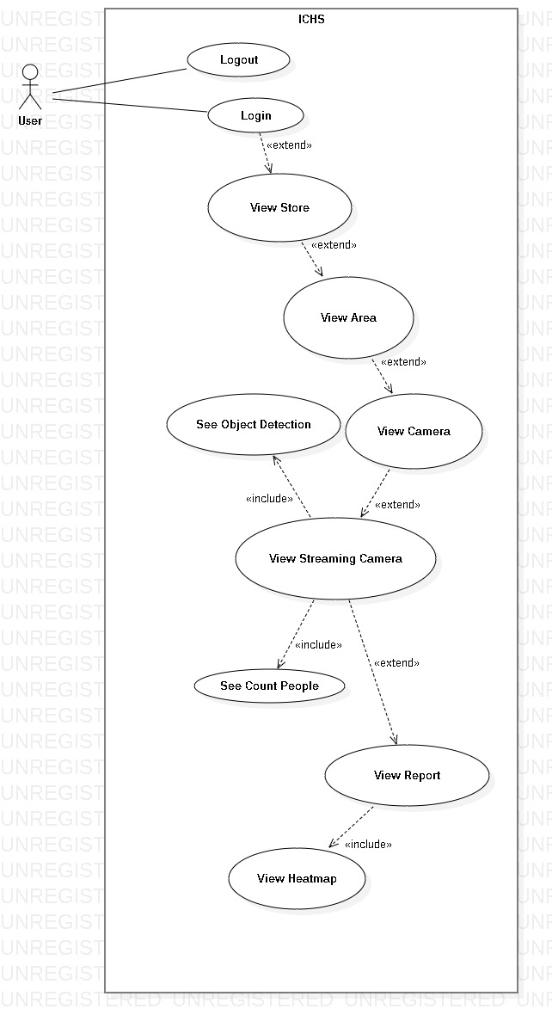

Figure 25- <User> Overview Use Case Diagram

##### <User> User Login

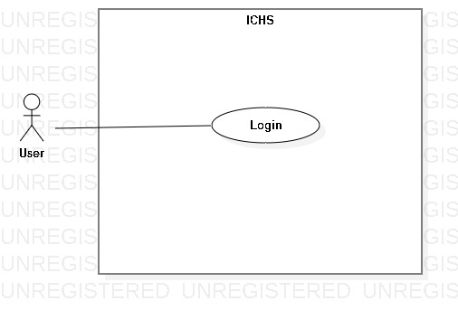

Figure 26- <User> User Login

|  |  |  |  |
| --- | --- | --- | --- |
| **USE CASE – UC_23** | | | |
| **Use Case No.** | 23 | **Use Case Version** | 1.0 |
| **Use Case Name** | User Login | | |
| **Author** | PhucDH | | |
| **Date** | 25/06/2019 | **Priority** |  |
| **Actor:**   * User   **Summary:**   * This use case allows the user login to the system.   **Goal:**   * User logged in to the system.   **Triggers:**   * User clicks “Login” button. * User sends the login command.   **Preconditions:**   * User at “Login” page.   **Post Conditions:**   * **Success:** User login to the system. * **Fail:** System displays error message.   **Main Success Scenario:**   |  |  |  | | --- | --- | --- | | **Step** | **Actor Action** | **System Response** | | 1 | User goes to Login page by clicking “Login” button. | System requires information:   * Username: text input. * Password: text input. | | 2 | User inputs information and clicks “Login” button. | System validates the information and displays confirmation message. |   **Alternative:** N/A.  **Exceptions:**   |  |  |  | | --- | --- | --- | | **No** | **Cause** | **System Response** | | 1 | Network problem. | System displays “Login failed!” message. | | 2 | Username is blank. | System displays “Please input Username” message. | | 3 | Password is blank. | System displays “Please input Password” message. |   **Relationships:** N/A.  **Business Rules:**   * After logged in, system redirect to Home page. * A notification pop-up when user login success. * System must ensure has no duplicate user. * Password must be in rage of 6 – 30 characters. | | | |

Table - <User> User Login

##### <User> User Logout

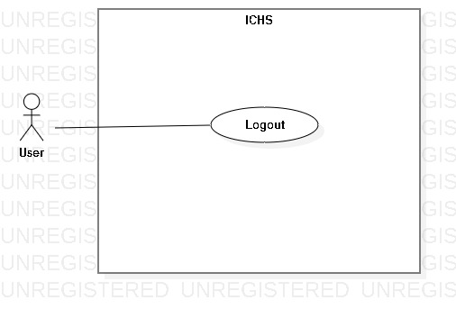

Figure 27- <User> User Logout

|  |  |  |  |
| --- | --- | --- | --- |
| **USE CASE – UC_24** | | | |
| **Use Case No.** | 24 | **Use Case Version** | 1.0 |
| **Use Case Name** | User Logout | | |
| **Author** | PhucDH | | |
| **Date** | 25/06/2019 | **Priority** |  |
| **Actor:**   * User   **Summary:**   * This use case allows the user logout from application.   **Goal:**   * User logout from the system.   **Triggers:**   * User clicks Settings button. * User clicks “Log Out” button. * User sends the logout command.   **Preconditions:**   * User login success.   **Post Conditions:**   * **Success:** User logout from system. * **Fail:** System displays error message.   **Main Success Scenario:**   |  |  |  | | --- | --- | --- | | **Step** | **Actor Action** | **System Response** | | 1 | User clicks “Log Out” button. | System displays dialog with “You want to log out?” message. | | 2 | User clicks “Yes” button. | User logout from the system. |   **Alternative:** N/A.  **Exception:**   |  |  |  | | --- | --- | --- | | **No** | **Actor Action** | **System Response** | | 1 | User clicks “Cancel” button. | Close the dialog. |   **Relationships:** N/A.  **Business Rules:**   * After logout from the system, system return Login page. * User can login with another account. | | | |

Table - <User> User Logout

##### <User> View Store

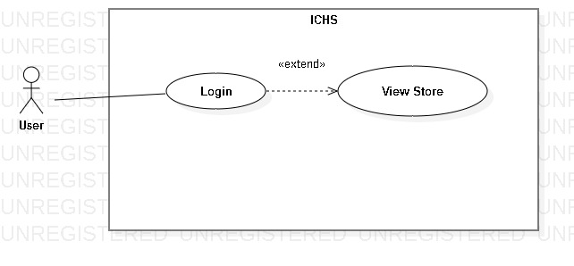

Figure 28- <User> View Store

|  |  |  |  |
| --- | --- | --- | --- |
| **USE CASE – UC_25** | | | |
| **Use Case No.** | 25 | **Use Case Version** | 1.0 |
| **Use Case Name** | View Store | | |
| **Author** | PhucDH | | |
| **Date** | 25/06/2019 | **Priority** |  |
| **Actor:**   * User   **Summary:**   * This use case allows the user to view all store in company that user is allowed to view.   **Goal:**   * User view all stores within the limits allowed by the admin.   **Triggers:**   * User clicks “Store” button. * User sends view store command.   **Preconditions:**   * User login success.   **Post Conditions:**   * **Success:** User view all stores. * **Fail:** System displays error message.   **Main Success Scenario:**   |  |  |  | | --- | --- | --- | | **Step** | **Actor Action** | **System Response** | | 1 | User clicks “Store” button in Home page. | System displays the “Store” page and shows stores. |   **Alternative:** N/A.  **Exception:** N/A.  **Relationships:** Extend from “User Login” use case.  **Business Rules:** N/A. | | | |

Table - <User> View Store

##### <User> View Area

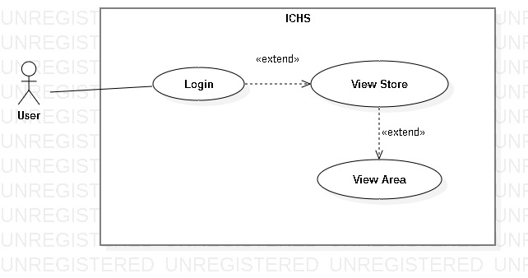

Figure 29- <User> View Area

|  |  |  |  |
| --- | --- | --- | --- |
| **USE CASE – UC_26** | | | |
| **Use Case No.** | 26 | **Use Case Version** | 1.0 |
| **Use Case Name** | View Area | | |
| **Author** | PhucDH | | |
| **Date** | 25/06/2019 | **Priority** |  |
| **Actor:**   * User   **Summary:**   * This use case allows the user to view all areas in one store.   **Goal:**   * User view all areas in the chosen store.   **Triggers:**   * User clicks “Area” button. * User sends view area command.   **Preconditions:**   * User login success. * User is at the chosen store page.   **Post Conditions:**   * **Success:** User view all areas. * **Fail:** System displays error message.   **Main Success Scenario:**   |  |  |  | | --- | --- | --- | | **Step** | **Actor Action** | **System Response** | | 1 | User clicks “Area” button in Store page. | System displays the “Area” page and shows areas. |   **Alternative:** N/A.  **Exception:** N/A.  **Relationships:** Extend from “View Store” use case.  **Business Rules:** N/A. | | | |

Table - <User> View Area

##### <User> View Camera

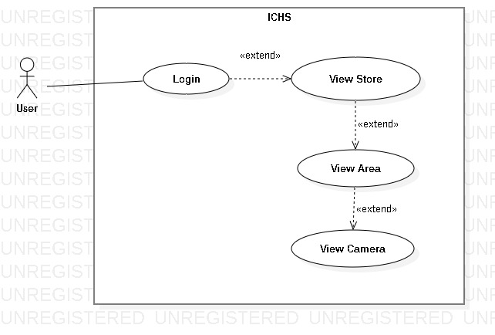

Figure 30- <User> View Camera

|  |  |  |  |
| --- | --- | --- | --- |
| **USE CASE – UC_27** | | | |
| **Use Case No.** | 27 | **Use Case Version** | 1.0 |
| **Use Case Name** | View Camera | | |
| **Author** | PhucDH | | |
| **Date** | 25/06/2019 | **Priority** |  |
| **Actor:**   * User   **Summary:**   * This use case allows the user to view all cameras in one area.   **Goal:**   * User view all cameras in the chosen area.   **Triggers:**   * User clicks “Camera” button. * User sends view camera command.   **Preconditions:**   * User login success. * User is at the chosen area page.   **Post Conditions:**   * **Success:** User view all cameras. * **Fail:** System displays error message.   **Main Success Scenario:**   |  |  |  | | --- | --- | --- | | **Step** | **Actor Action** | **System Response** | | 1 | User clicks “Camera” button in Area page. | System displays the “Camera” page and shows cameras. |   **Alternative:** N/A.  **Exception:** N/A.  **Relationships:** Extend from “View Area” use case.  **Business Rules:** N/A. | | | |

Table - <User> View Camera

##### <User> View Streaming Camera

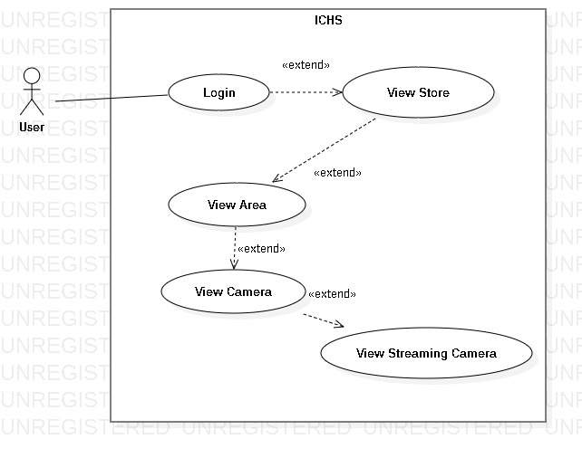

Figure 31- <User> View Streaming Camera

|  |  |  |  |
| --- | --- | --- | --- |
| **USE CASE – UC_28** | | | |
| **Use Case No.** | 28 | **Use Case Version** | 1.0 |
| **Use Case Name** | View Streaming Camera | | |
| **Author** | PhucDH | | |
| **Date** | 25/06/2019 | **Priority** |  |
| **Actor:**   * User   **Summary:**   * This use case allows the user to view the streaming video from the selected camera.   **Goal:**   * User view streaming video from camera.   **Triggers:**   * User clicks the “Detail” button of the camera. * User sends view streaming camera command.   **Preconditions:**   * User login success. * User is at “Camera” page.   **Post Conditions:**   * **Success:** User view streaming camera. * **Fail:** System displays error message.   **Main Success Scenario:**   |  |  |  | | --- | --- | --- | | **Step** | **Actor Action** | **System Response** | | 1 | User clicks “Detail” button of the camera in the Camera page. | System displays the “Camera Detail” page and shows streaming video. |   **Alternative:** N/A.  **Exception:** N/A.  **Relationships:** Extend from “View Camera” use case.  **Business Rules:** N/A. | | | |

Table - <User> View Streaming Camera

##### <User> See Object Detection

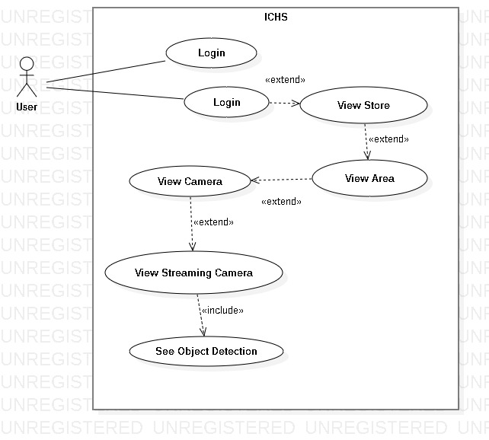

Figure 32- <User> See Object Detection

|  |  |  |  |
| --- | --- | --- | --- |
| **USE CASE – UC_29** | | | |
| **Use Case No.** | 29 | **Use Case Version** | 1.0 |
| **Use Case Name** | See Object Detection | | |
| **Author** | PhucDH | | |
| **Date** | 25/06/2019 | **Priority** |  |
| **Actor:**   * User   **Summary:**   * This use case allows the user to see the object detection in streaming video from the selected camera.   **Goal:**   * User see object detection in streaming video.   **Triggers:**   * User clicks the switch button in streaming video page. * User sends see object detection command.   **Preconditions:**   * User login success. * User is at “Camera Detail” page.   **Post Conditions:**   * **Success:** User see count people. * **Fail:** System displays error message.   **Main Success Scenario:**   |  |  |  | | --- | --- | --- | | **Step** | **Actor Action** | **System Response** | | 1 | User clicks “Object Detection” in Camera Detail page. | System displays the video with count people. |   **Alternative:** N/A.  **Exception:** N/A.  **Relationships:** Extend from “View Camera” use case.  **Business Rules:** N/A. | | | |

Table - <User> View Streaming Camera

##### <User> See Count People

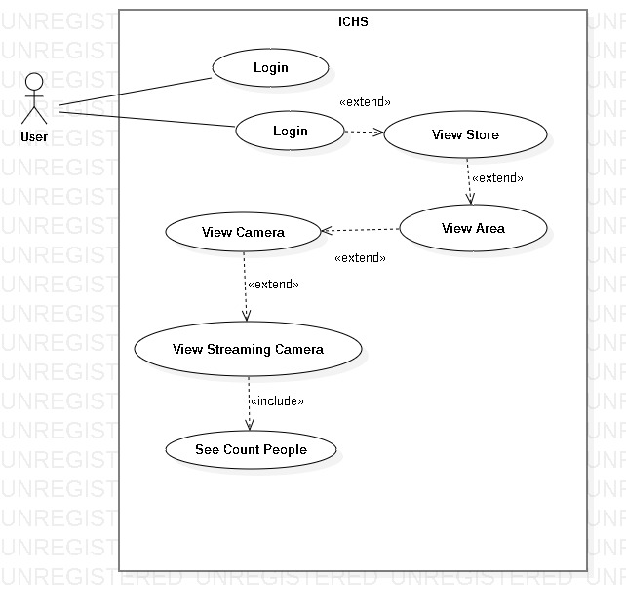

Figure 33- <User> See Count People

|  |  |  |  |
| --- | --- | --- | --- |
| **USE CASE – UC_30** | | | |
| **Use Case No.** | 30 | **Use Case Version** | 1.0 |
| **Use Case Name** | See Count People | | |
| **Author** | PhucDH | | |
| **Date** | 25/06/2019 | **Priority** |  |
| **Actor:**   * User   **Summary:**   * This use case allows the user to see the people counting in streaming video from the selected camera.   **Goal:**   * User see count people in streaming video.   **Triggers:**   * User clicks the switch button in streaming video page. * User sends see count people command.   **Preconditions:**   * User login success. * User is at ”Camera” page.   **Post Conditions:**   * **Success:** User view streaming camera. * **Fail:** System displays error message.   **Main Success Scenario:**   |  |  |  | | --- | --- | --- | | **Step** | **Actor Action** | **System Response** | | 1 | User clicks “Object Detection” in Camera Detail page. | System displays the video with count people. |   **Alternative:** N/A.  **Exception:** N/A.  **Relationships:** Extend from “View Camera” use case.  **Business Rules:** N/A. | | | |

Table - <User> View Streaming Camera

##### <User> View Report

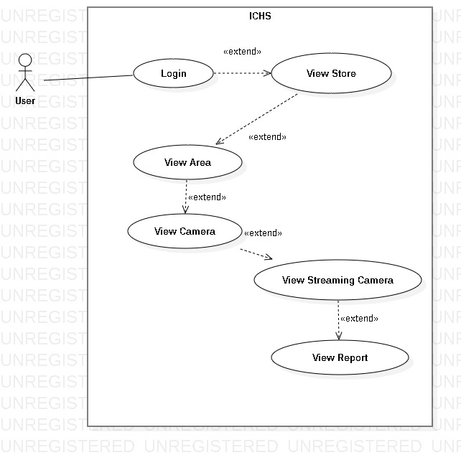

Figure 34- <User> View Report

|  |  |  |  |
| --- | --- | --- | --- |
| **USE CASE – UC_31** | | | |
| **Use Case No.** | 31 | **Use Case Version** | 1.0 |
| **Use Case Name** | View Report | | |
| **Author** | PhucDH | | |
| **Date** | 25/06/2019 | **Priority** |  |
| **Actor:**   * User   **Summary:**   * This use case allows the user to view the streaming video from the selected camera.   **Goal:**   * User view streaming video from camera.   **Triggers:**   * User clicks the thumbnail of the camera. * User sends view streaming camera command.   **Preconditions:**   * User login success. * User is at ”Camera” page.   **Post Conditions:**   * **Success:** User view streaming camera. * **Fail:** System displays error message.   **Main Success Scenario:**   |  |  |  | | --- | --- | --- | | **Step** | **Actor Action** | **System Response** | | 1 | User clicks thumbnail of the selected camera in Camera page. | System displays the selected camera page and shows streaming video. |   **Alternative:** N/A.  **Exception:** N/A.  **Relationships:** Extend from “View Camera” use case.  **Business Rules:** N/A. | | | |

Table - <User> View Streaming Camera

##### <User> View Heatmap

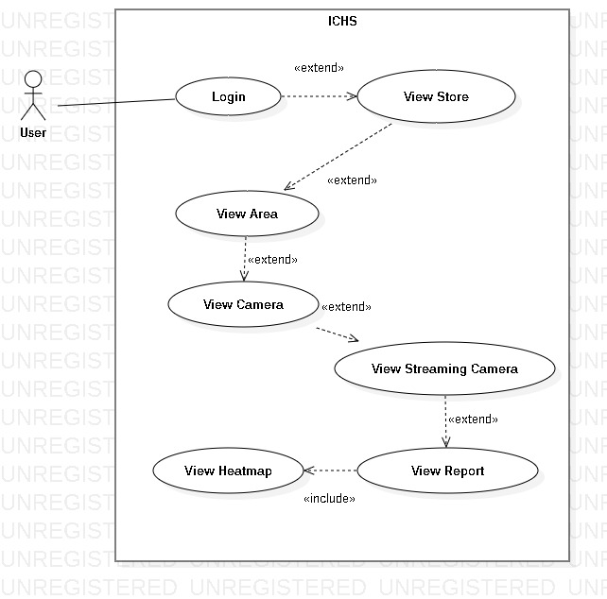

Figure 35- <User> View Heatmap

|  |  |  |  |
| --- | --- | --- | --- |
| **USE CASE – UC_32** | | | |
| **Use Case No.** | 32 | **Use Case Version** | 1.0 |
| **Use Case Name** | View Heatmap | | |
| **Author** | PhucDH | | |
| **Date** | 25/06/2019 | **Priority** |  |
| **Actor:**   * User   **Summary:**   * This use case allows the user to view the streaming video from the selected camera.   **Goal:**   * User view streaming video from camera.   **Triggers:**   * User clicks the thumbnail of the camera. * User sends view streaming camera command.   **Preconditions:**   * User login success. * User is at “Camera” page.   **Post Conditions:**   * **Success:** User view streaming camera. * **Fail:** System displays error message.   **Main Success Scenario:**   |  |  |  | | --- | --- | --- | | **Step** | **Actor Action** | **System Response** | | 1 | User clicks thumbnail of the selected camera in Camera page. | System displays the selected camera page and shows streaming video. |   **Alternative:** N/A.  **Exception:** N/A.  **Relationships:** Extend from “View Camera” use case.  **Business Rules:** N/A. | | | |

Table - <User> View Streaming Camera

## **Software System Attribute**

* 1. Usability
  2. Reliability
  3. Availability
  4. Security
  5. Maintainability
  6. Portability
  7. Performance

## **Conceptual Diagram**

# **Software Design Description**

## **Design Overview**

## **System Architecture Design**

## **Component Diagram**

## **Detailed Description**

## **User Interface Design**

## **Database Design**

## **Algorithms**

# **System Implementation & Test**

## **Introduction**

* 1. Overview
  2. Test Approach

## **Database Relationship Diagram**

* 1. Physical Diagram
  2. Data Dictionary

## **Test Plan**

* 1. Features to be Tested
  2. Features not to be Tested

## **Testing Test Case**

* 1. Test Case
  2. ....

# **Software User’s Manual**

## **Installation Guide**

* 1. Hardware Requirement
  2. Software Requirement

## **User Guide**

# **F1.ソフトウェアユーザーマニュアル**

# **Appendix**